
Medical Laboratory Techniques
Dr Abbas Ali Mahdi
Vice Chancellor, Era University, Lucknow

Dr K Chaudhry
PATRON : Maa Vaishno Diagnostics
Developer of First 1 ml Colorimeter in India 1989
Developer of Stable Indole 3-acetic acid Reagent

Editor : Saksham Chaudhry

Contents
 |  | Page
01 | Laboratory Management | 3
02 | General Techniques | 39
03 | Carbohydrates | 74
04 | Non-protein nitrogen | 101
05 | Protein and Haemoglobin | 133
06 | Lipids | 155
07 | Enzymes | 194
08 | Inorganic Constituents | 233
09 | Liver Function Tests | 255
10 | Kidney Funtion Tests | 276
11 | Gastric Function Tests | 280
12 | Vitamins | 289
13 | Hormones | 297
14 | Toxicology | 314
15 | Blood Examination | 335
16 | Urine Examination | 341
17 | Stool Examination | 352
18 | Sputum Examination | 364
19 | CSF Examination | 371
20 | Semen Examination | 375

Chapter 1 : Laboratory Management & Safety
Code of conduct for medical laboratory personnel
Laboratory Hazards
Medical Laboratory is not the place where a layman joins, works for a few weeks and starts working of his own. The place is prone to accidents requiring immediate thoughtful management and the health hazards nurtured over years. Thus the person working in Medical Laboratory must be aware of all the hazards he is exposed to and take all the precautions warranted for safety.
In biochemisty laboratory, the hazardous material may be classified as corrosive, poisonous, infective and explosive.
General precautions
1. Every laboratory should have a safety manual for ready reference. Every member of staff should have frequent glance at it to. get appraised, with the format and method of use.
2. The laboratory should have warning sign boards suggesting CHEMICAL HAZARD,'EXPLOSION HAZARD, FIRE HAZARDS, etc. at suitable places. Entry of outsiders should be restricted to sample collection space.
3. Smoking, eating, and drinking should be prohibited in the laboratory. A separate space should be provided for relaxing and such activities. Hands should be washed thoroughly while entering or leaving the work area irrespective of the type of work undertaken. Foot operated water cooler should be installed adjacent to,work area.
4. Long hair must be secured and no cosmetrics should be applied.
It should be remembered that a personal indiscipline not only exposes the person to hazards but it also contributes to contamination of the test material.
Infection
Blood samples and urine samples are culture media for many organisms. If the sample's are not properly handled and safely
disposed off, dangerous microorganisms may, grow and disseminate into the laboratory. Deaths have occasionally occurred due to infection acquired in the laboratories.
Safety measures in the laboratory
Safety with chemicals/reagents
Labelling of hazardous reagents/chemicals
chemicals/reagents in secondary containers must be labeled with the full chemical/reagent name, concentration, hazard class, and target organ information. This labeling system also applies to carboys, squirt bottles, and spray bottles.
Primary containers (original containers purchased from a vendor) do not need this labeling
system as they should already have all this information on the label. Temporary tubes or
containers (for immediate or short‐term use) also do not require this labeling system. The
following are the detailed labeling requirements:
1) Full chemical/reagent name: The names of all chemicals stored in secondary
containers should be spelled out (e.g. Ethanol vs. EtOH, Ethidium Bromide vs EtBr,
Sodium Hydroxide vs NaOH). However, common abbreviations may be used if a
“common abbreviations list” is generated and posted in a highly visible area of the
lab (e.g. TAE = Tris Acetate Ethylenediamine tetraacetic acid and PBS = Phosphate
Buffered Saline). The list of abbreviated chemicals should be limited to one standard
size piece of paper (8.5’’x 11’’) using 12 point font or greater. If a reagent has a special
proprietary name from a company, use that name on the secondary container if
making a dilution or solution from the original stock.
2) Concentration: This is the molarity, normality, percentage, or other designation
of concentration (such as 1X or 10X).
3) Hazard class: The basic hazard classes are flammable, corrosive, oxidizer, toxic,
and non‐hazardous. Labs may use a color‐code system to denote hazard class on
each chemical/reagent in secondary containers. The key to this code is then posted
in a highly visible area of the lab where the chemicals/reagents in secondary
containers are used or stored. Color assignment is arbitrary but should be
consistent for the whole lab(s). Always remember that many chemicals that are
hazardous at high concentrations may still be hazardous when diluted. For
example, a reagent containing 5% ethanol may not be considered flammable, but
70% ethanol is or a reagent containing sodium azide (or some other toxin or
carcinogen) would still be considered a toxic even at relatively dilute amounts.

Flammable chemicals
Flammable chemicals are a fire hazard. The lower the flashpoint (the lowest
temperature at which a liquid fuel will give off enough vapour to form a momentarily
ignitable mixture with air.) of the chemical, greater the hazard.
- Flammable chemical bottles must not be kept open without caps. They must not be
kept near ignition sources.
- They must not be left on the lab bench after use, but to be stored in safety cabinets
after use.
A fire in a laboratory can easily get out of control if it involves any flammable
solvents.
Flammable chemicals must not be kept open in beakers or containers as they readily
release vapour. The released vapours can form a flammable vapour air mixture which
can ignite in the presence of a source of ignition.
Open flames must be prohibited where solvents are handled and stored. The amount
of solvent storage inside the labs must be only those required for immediate use.
Flammable chemicals must not be stored along with oxidisers.
Flammable chemical bottles or open containers with flammable chemicals must not
be stored in domestic refrigerators. The vapours released can be ignited by the
lighting unit or the thermostat inside. Intrinsically safe lab-purpose refrigerators must
be used for the purpose of storing flammable chemicals.
Distillation of solvents must only be done inside a chemical fume hood.
Flammable chemicals must not be heated with Bunsen burners, use a water bath for
the same.
Examples of flammable chemicals are
- Acetone
- Toluene
- Methyl alcohol
Control of fire
Fires can be very dangerous and you should always be certain that you will not endanger yourself or others when attempting to put out a fire. For this reason, when a fire is discovered:
Assist any person in immediate danger to safety, if it can be accomplished without risk to yourself.
Activate the building fire alarm system or notify the fire department by dialing 911 (or designating someone else to notify them for you). When you activate the building fire alarm system, some, but not all, will automatically notify the fire department and get help on the way.
Only after having done these two things, if the fire is small, you may attempt to use an extinguisher to put it out.
Classes of Fire
- Ordinary combustibles or fibrous material, such as wood, paper, cloth, rubber, and some plastics.
- Flammable or combustible liquids such as gasoline, kerosene, paint, paint thinners and propane.
- Energized electrical equipment, such as appliances, switches, panel boxes and power tools.
- Certain combustible metals, such as magnesium, titanium, potassium, and sodium.
Fire extinguishers
Use a Fire Extinguisher When:
- The fire is contained and not spreading
- The extinguisher is readily available
- You know how to use it properly
- Personal safety is not compromised
- There is a clear path for escape

Types of Fire extinguishers
- Dry Chemical
- Wet Chemical
- Dry Powder
- Clean agent
- Carbon Dioxide
- Pressurized Water/Foam

Corrosive chemicals
The common corrosives in biochemistry laboratory are mercury salts, acids and alkalies. The following precautions are suggested in handing of corrosives.
1. The staff should wear goggles or a face mask.
2. Strong stirring should be avoided. If it is essential, then a magnetic stirrer should be used.
3. Acids should be added very slowly into water.
4. If a reagent gets into an eye, it should be rinsed up immediately with water for at least 5 minutes. Contact lenses should not be worn.
5. All waste acids and alkalies should be neutralized before disposal.

Toxic Chemicals
1. Cyanides and barbiturates should be kept under a lock.
2. Mouth pipetting of such reagents should be prohibited.
3. Waste reagents should be disposed off with a flow of water.
4. Cyanide reagents must not be disposed off simults' outly with acids to avoid potential liberation of hydrocyanic acid.
5. Cobalt edetate ampoules (cyanide antidote) should be kept handy with disposable syringe.
6. Organic solvents should be kept tightly closed even on working bench. Benzene is toxic to bone marrow, carbon tetrachloride to liver. The effect may cummulate over time.
7. Mercury is volatile at room temperature. Its vapours are highly toxic. Thus spilling mercury should be prevented. if spilling does occur, every particle should be recovered.
8. To avoid dangerous concentrations of toxic gases, the place should be well ventilated.
Oxidising chemicals
Storage
- Reduce dust levels by using solutions of oxidizers instead of dry, solid forms.
- Reduce dangerous reactivity by diluting solutions with water.
- Installation of alarms or automatic shut-off switches on equipment to warn of equipment failure, high temperatures or high pressures.
- Well-designed and well-maintained ventilation systems remove airborne oxidizing materials from the workplace and reduce their hazards.
- Organic materials, such as wood, should not be used in ventilation systems for oxidizing materials. Systems should be free of ignition sources and separate from other systems that might be exhausting incompatible substances.
- Ensure that hoods, ducts, fans and air-cleaning devices, such as dust collectors, are made from materials compatible with the oxidizing agents.
- Laboratories that use perchloric acid need special fume hoods and fume exhaust systems.
- Store oxidizing materials in areas that are:
- Labelled with suitable warning signs.
- Well-ventilated.
- Supplied with adequate firefighting equipment including sprinklers, where appropriate.
- Supplied with suitable spill clean-up equipment and materials.
- Free of ignition sources.
- Accessible at all times.
Safe use
- Be very careful when dispensing oxidizers from storage containers into other containers. Avoid spilling material and contaminating your skin or clothing. Spills from open, unstable or, breakable containers during material transfer have caused serious accidents.
- Dispense from only one container at a time. Finish all the dispensing of one material before starting to dispense another. Dispense the smallest amount possible, preferably only enough for immediate use. Keep containers closed after dispensing to reduce the risk of contaminating their contents.
- Take care that the oxidizing materials do not contact combustible or other incompatible materials when they are dispensed. Use containers and dispensing equipment, such as drum pumps, scoops or spatulas, that the chemical supplier recommends. These items must be made from materials that are compatible with the oxidizing materials you are using. Keep them clean to avoid contamination.
- NEVER transfer liquids by pressurizing their usual shipping containers with air or inert gas. Ordinary barrels or drums may be damaged by the pressure. Moreover, if air is used, it may create a flammable atmosphere inside the container. NEVER pipette oxidizing liquids (or other chemicals) by mouth. Use a pipette bulb or aspirator instead.
- Since some solid oxidizers may be shock sensitive, do not chip or grind lumps to break them up. If crystals have precipitated in containers of an oxidizing agent, contact your health and safety officer about their safe handling and disposal. Follow the chemical supplier's advice. Avoid sliding or skidding heavy metal containers such as drums or barrels across floors.
Explosives
1. Oxidizing agents such as perchloric acid (used for digestion as in phospholipid estimation) may explode. Such procedures should be performed in a fume cupboard. Protective glasses and shields should be worn.
2. Dry picric acid explodes on percussion. Thus the chemical is commercially available as packed under water. The picric acid reagent should not be stored in glass-stoppered bottle. A cork or rubber stopper should be used for closing. Picric acid may form picrate with the pipe metals in autoanalyzers.
3. Ammoniacal silver nitrate should be prepared fresh and discarded after use. On exposure to light, silver azide may form and explode in the bottle.
4. Sodium azide, used as preservative, may form explosive metallic oxides with waste pipe material.
5. Ether, if kept in colourless bottle, may form explosive peroxide. Ether must not be distilled by a person not knowing the specific precaution required.
6. Acetone and chloroform on mixing give explosive reaction. The two may be mixed by a person unaware of this fact or accidentally during waste disposal.
7. Concentrated nitric acid may explode on contact with alcoholic solutions. Thus nitric acid should never be used for cleaning glassware.
8. Solvents such as acetone, ether, benzene, light petroleum have very low flash points. When confined to small space, as in refrigerator, these may explode on contact with electric sparks.
9. Flammable gases stored in cylinders are potential explosion hazard.
Common chemicals may explode on mixing and catch the person awares. A list of such explosive reaction cannot be complete. A single reading source must never be relied upon. A person working in laboratory should go through the 'hazards' section in every book he comes across. New surprises may be encountered on every such review. Fire extinguisher is a must for every laboratory.
Carcinogens
Certain aromatic amines, azo-dyes and N-nitroso compounds used in biochemistry are potential carcinogens. Notable among these are benzidine, o'tolidine (not o' toluidine which is much safer) and o'dianisidine. The former two are used in occult blood testing. o'Dianisidine is present in some glucose oxidase reagents and.is also a constituent of sugar testing strips. Wherever substitute tests are available, use of such reagents should be avoided.
Inhalation of carcinogens is as dangerous as skin contact. The reagents should be kept tightly closed and should not be opened for too long while in use.

Accidents
First aid
Acid/alkali burns
Flush the area for at least 20 minutes. Do not use a hard spray of water, because it can damage the burned area. Have the person with the burn remove the chemical substance if he or she is able. Put on gloves to protect yourself from the chemical, if you need to remove it.

Skin. If you spill an acid or base on your skin, immediately wash well with water. Strong bases react with the oils in your skin to produce a soapy feeling layer. Rinse until well after that feeling is gone. Do not attempt to neutralize a spill on your skin.

Eyes. Flush with lukewarm water for 15 to 30 minutes. For severe burns, continue flushing until you see a doctor or you arrive in an emergency room. The person should keep the eye open as wide as possible. Wash the person's hands thoroughly to make sure no chemical is still on them.
Swallowing alkalis
Make the person drink 5% acetic acid or lemon juice, or vinegar diluted 1:4 with water.
Make the person gargle with same solution.
Make the person drink 3-4 glasses of water.

Poisoning
Treatment for a poison emergency will depend on the situation. First aid steps will depend on the
victim’s age, the size of the victim, the type of poison and the amount of poison.
If the person is not conscious or not breathing:
• Call 1066 right away.
• Take the poison away from the person’s eyes, skin or mouth. Take the victim away from poisonous fumes.
Warning: Sometimes, it may be too dangerous to rescue someone from an area that is filled with
poisonous gas. The 1066 operator will tell you what to do.
If the person is conscious and breathing:
• Call 1066 right away. Do not wait for the person to feel, look or get sick.
• Be ready to answer questions about the person’s age, sex, weight and health.
• Have the poison or its container with you when you call the poison center.
• If you are told to go to the emergency room, take the poison or its container with you to show
the doctor.

Poison in the mouth
• Do not make the person vomit or give the victim something to eat or drink unless the
poison center tells you to. You may be instructed to give the victim sips of water or milk.
• Call the poison center at 1066 even if the poison was not swallowed.
CAUTION: Some out-of-date first-aid charts may contain incorrect treatment information. DO
NOT give raw eggs, salt, vinegar or citrus fruit juices to induce vomiting or to neutralize the
poison. These treatments are not only ineffective, but may be extremely dangerous.

Poison on the skin
• Take off clothes that have poison on them. Wash these clothes separately.
• Rinse the skin very well with water. Then wash the skin gently with soap and water.
• Call the poison center at 1066.

Poison in the eye
• Remove contact lenses if worn.
• Rinse the eyes with water for 15 minutes. Open and close the eyes while rinsing.
• Call the poison center at 1066.

Poison in the air
• Open windows and doors to let in fresh air.
• Leave the area and move to a place where you can breathe fresh air. Help others leave the
area, but be careful not to breathe the poison yourself.
• Call the poison center at 1066.

Heat burns
Severe burns
Minor burns
Glass injuries
Contamination by infected material
Electric shock
Laboratory Setup
Equipment and supplies for a peripheral-level health laboratory
(Courtsey: Manual of basic techniques for a health laboratory – WHO)

Item | Quantity required
Equipment for collection of specimens
Essential equipment
Syringes, graduated, disposable, 20 ml | as needed
Syringes, graduated, disposable, 10 ml | as needed
Syringes, graduated, disposable, 5 ml | as needed
Needles, disposable, 18-gauge (1.2 mm) ¥ 40 mm | as needed
Needles, disposable, 19-gauge (1.0–1.1 mm) ¥ 40 mm | as needed
Needles, disposable, 20-gauge (0.9 mm) ¥ 40 mm | as needed
Needles, disposable, 22-gauge (0.7 mm) ¥ 40 mm | as needed
Needles, disposable, 23-gauge (0.6 mm) ¥ 32 mm | as needed
Needles, disposable, 23-gauge (0.6 mm) ¥ 90 mm | as needed
Rubber tubing for tourniquet, 2–5 mm bore | 2 pieces
Lancets for taking capillary blood | as needed
Cotton wool, white, absorbent | 2 ¥ 500 g
Cotton wool, non-absorbent | 2 ¥ 500 g
Bottles, previously containing antibiotics, reagents, etc. for | as many as
injection (5, 10, 20 ml) | possible
Additional equipment
Scalpel with disposable blades for taking slit skin smear | 1
specimens (for leprosy)
Curved clamp forceps without teeth for taking slit skin smear | 1
specimens (for leprosy)
Boxes, plastic or cardboard, disposable, for stool collection | 50
Applicators, wooden (12 cm ¥ 1 mm) (can be made locally) | 50
Bottles, 2.5 ml and 5 ml, preferably plastic | 50
Bottles, white glass, wide-mouthed, 50 ml, with metal screw cap | 25
and rubber washer, for collection of sputum specimens
Bottles, white glass, 25 ml, with metal screw cap and rubber | 25
washer, for various specimens
Bottles, wide-mouthed, all sizes, for collection of urine | 20–40
specimens
Forceps, punch, for taking skin biopsies (for onchocerciasis) | 1
Tongue depressors, wooden | 50
Glassware
Essential items
Glass rods, solid, 6 mm diameter | 3
Beakers, plastic, flat, 50 ml | 4
Beakers, plastic, flat, 100 ml | 4
Beakers, plastic, flat, 250 ml | 4
Staining troughs, rectangular, for 20 slides | 4
Funnel, glass, 60 mm diameter | 1
Funnels, glass, 90 mm diameter | 2
Funnel, plastic, 200 mm diameter | 1
Measuring cylinders, graduated, glass, 25 ml | 3
Measuring cylinders, graduated, glass, 50 ml | 3
Measuring cylinders, graduated, glass, 100 ml | 3
Measuring cylinders, graduated, glass, 250 ml | 2
Measuring cylinder, graduated, glass, 500 ml | 1
Measuring cylinder, graduated, glass, 1000 ml | 1
Flasks, Erlenmeyer, heat-resistant, wide-mouthed, 250 ml | 3
Flasks, Erlenmeyer, heat-resistant, wide-mouthed, 500 ml |  | 3
Flasks, Erlenmeyer, heat-resistant, wide-mouthed, 1000 ml |  | 3
Drop bottles, plastic or glass, 100 ml |  | 12
Drop bottles, brown glass, 100 ml |  | 3
Reagent bottles, plastic or glass, 100 ml |  | 20
Reagent bottles, plastic or glass, 500 ml |  | 10
Reagent bottles, plastic or glass, 1000 ml |  | 10
Flasks, volumetric, glass, with stoppers, 100 ml |  | 4
Flasks, volumetric, glass, with stoppers, 250 ml |  | 2
Flasks, volumetric, glass, with stoppers, 500 ml |  | 2
Flask, volumetric, glass, with stoppers, 1000 ml |  | 1
Microscope slides, 25 mm ¥ 75 mm |  | 2 | ¥ 1000
Coverslips, 20 mm ¥ 20 mm |  | 20 ¥ 100
Wash bottles, plastic, 500 ml |  | 2
Wash bottles, plastic, 1000 ml |  | 2
Watch glasses, 50 mm diameter |  | 2
Pipettes, graduated from the top (and not to the tip), 1 ml |  | 12
(0.01-ml subdivisions)
Pipettes, graduated from the top (and not to the tip), 2 ml |  | 10
(0.01-ml subdivisions)
Pipettes, graduated from the top (and not to the tip), 5 ml |  | 10
(0.1-ml subdivisions)
Pipettes, graduated from the top (and not to the tip), 10 ml |  | 6
(0.1-ml subdivisions)
Pipettes, Pasteur |  | 2 | ¥ 144
Test-tubes, heat-resistant, 150 mm ¥ 16 mm |  | 50
Test-tubes, heat-resistant, 85 mm ¥ 15 mm (Kahn tubes) |  | 100
Test-tubes, heat-resistant, 50 mm ¥ 6 mm (cross-matching tubes) |  | 20
Centrifuge tubes, conical, 15 ml |  | 40
Centrifuge tubes, conical, graduated, 15 ml (0.1-ml subdivisions) |  | 50
Glass tubing, 1.0–1.5 mm thick, 7–8 mm diameter |  | 1 kg
Additional items
Petri dishes, glass, 112 mm diameter |  | 4
Petri dishes, glass, 156 mm diameter |  | 4
Evaporating dishes, 75 mm diameter (75 ml) |  | 2
Dessicator |  | 1
Equipment for haematology tests
Pipettes, Sahli, 0.02 ml, with rubber tubing |  | 30
Pipettes, blood, 0.05 ml |  | 20
Counting chambers, improved Neubauer (bright line if possible) |  | 3
Counting chamber, Fuchs–Rosenthal |  | 1
Coverslips, optically plane, for counting chambers |  | 12
Tally counter |  | 1
Tubes, Westergren, for determination of erythrocyte |  | 30
sedimentation rate
Stands for Westergren tubes |  | 2
Microhaematocrit centrifuge |  | 1
Microhaematocrit capillary tubes, heparinized |  | 1000
Wax, for sealing microhaematocrit tubes |  | 1 roll
Equipment for bacteriological and biochemical tests
Nichrome wire, 1 mm diameter |  | 1 m

Loop holders |  | 4
Wooden block for loop holders |  | 1
Protein standard tubes |  | 1 set
Test-tube racks, large, for 12 tubes |  | 4
Test-tube racks, small, for 12 tubes |  | 4
Wooden test-tube holders |  | 2
Forceps, stainless steel, for slides |  | 2
Bunsen burner for use with butane gas |  | 1
Butane gas cylinder |  | as needed
Tripod with asbestos gauze |  | 1
Spatulas, various sizes, for weighing reagents |  | 3
Laboratory records and reports
Record books, hardbacked, large |  | 6
Glass-marking pencils, wax, red |  | 12
Glass-marking pencils, wax, blue |  | 12
Glass marker, diamond point |  | 1
Pencils, lead |  | 12
Pens, ballpoint, red ink (for recording positive specimens) |  | 2
Pens, ballpoint, black or blue ink |  | 3
Cellophane tape |  | 3 rolls
Adhesive tape, white |  | 3 rolls
Labels for specimen bottles |  | 1000
Laboratory request forms (preferably standardized centrally) |  | as needed
Miscellaneous equipment
Microscopes |  | 2
Colorimeter |  | 1
Water bath |  | 1
Refrigerator |  | 1
Hot-air oven |  | 1
Centrifuge |  | 1
Balance |  | 2
Deionizer or water still |  | 1
Timer, 0–60 min, with alarm |  | 1
Spirit lamp |  | 1
Hammer |  | 1
Pliers |  | 1 pair
Pliers, electrician’s |  | 1 pair
Screwdriver, small |  | 1
Screwdriver, medium |  | 1
Screwdriver, large |  | 1
Round metal file, 5 mm |  | 1
Small ampoule files |  | 12
Saucepan, flat-bottomed with lid, 30 cm diameter |  | 1
Hot plate |  | 1
Pestle (10 cm diameter) and mortar |  | 1
Bowls, plastic, 50 cm ¥ 30 cm |  | 3
Bucket, plastic, 12 litres |  | 1
Rubber safety bulb |  | 4
Micropipette, 20 ml |  | 1
 | Micropipette, 100 ml | 1
 | Micropipette, 200 ml | 1
 | Micropipette, 500 ml | 1
 | Micropipette tips, plastic, disposable, 20 ml | as needed
 | Micropipette tips, plastic, disposable, 50 ml | as needed
 | Micropipette tips, plastic, disposable, 100 ml | as needed
 | Micropipette tips, plastic, disposable, 200 ml | as needed
 | Micropipette tips, plastic, disposable, 500 ml | as needed
 | Scissors, medium | 1
 | Scissors, large | 1
 | Vacuum pump, metal | 1
 | Thermometer, 0–100 °C | 1
 | Stoppers, rubber | 1 set
 | Stoppers, cork | 1 set
 | Corkscrew | 1
 | Test-tube and bottle cleaning brushes (various sizes) | 6
 | Filter-paper, 15 cm diameter (Whatman’s No. 1 or equivalent) | 4 boxes
 | pH paper, narrow range (6.8–7.2) | 6 books
 | pH paper, wide range (0–12) | 6 books
 | Lens paper | 2 packets
 | Fine paintbrush, soft camel-hair brush or blower (for cleaning lenses) | 1
 | Small rubber bulb (for cleaning lenses) | 1
 | Toilet tissue | 10 rolls
 | Towels and clean rags | as needed
 | Immersion oil | 6 bottles
 |  | (10 ml each)

Laboratory instruments
Microscope
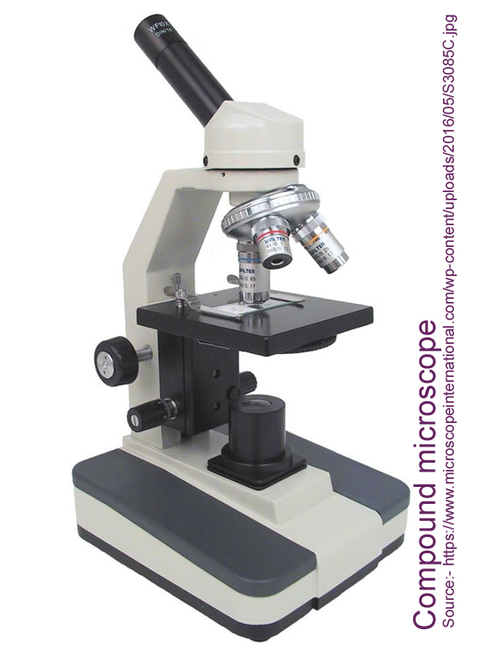

Compound Microscope Parts (Courtsey: microscope.com)
A high power or compound microscope achieves higher levels of magnification than a stereo or low power microscope. It is used to view smaller specimens such as cell structures which cannot be seen at lower levels of magnification. Essentially, a compound microscope consists of structural and optical components. However, within these two basic systems, there are some essential components that every microscopist should know and understand. These key microscope parts are illustrated and explained below.
STRUCTURAL COMPONENTS
The three basic, structural components of a compound microscope are the head, base and arm.
- Head/Body houses the optical parts in the upper part of the microscope
- Base of the microscope supports the microscope and houses the illuminator
- Arm connects to the base and supports the microscope head. It is also used to carry the microscope.
When carrying a compound microscope always take care to lift it by both the arm and base, simultaneously.
OPTICAL COMPONENTS
There are two optical systems in a compound microscope: Eyepiece Lenses and Objective Lenses:
Eyepiece or Ocular is what you look through at the top of the microscope. Typically, standard eyepieces have a magnifying power of 10x. Optional eyepieces of varying powers are available, typically from 5x-30x.
Eyepiece Tube holds the eyepieces in place above the objective lens. Binocular microscope heads typically incorporate a diopter adjustment ring that allows for the possible inconsistencies of our eyesight in one or both eyes. The monocular (single eye usage) microscope does not need a diopter. Binocular microscopes also swivel (Interpupillary Adjustment) to allow for different distances between the eyes of different individuals.
Objective Lenses are the primary optical lenses on a microscope. They range from 4x-100x and typically, include, three, four or five on lens on most microscopes. Objectives can be forward or rear-facing.
Nosepiece houses the objectives. The objectives are exposed and are mounted on a rotating turret so that different objectives can be conveniently selected. Standard objectives include 4x, 10x, 40x and 100x although different power objectives are available.
Coarse and Fine Focus knobs are used to focus the microscope. Increasingly, they are coaxial knobs - that is to say they are built on the same axis with the fine focus knob on the outside. Coaxial focus knobs are more convenient since the viewer does not have to grope for a different knob.
Stage is where the specimen to be viewed is placed. A mechanical stage is used when working at higher magnifications where delicate movements of the specimen slide are required.
Stage Clips are used when there is no mechanical stage. The viewer is required to move the slide manually to view different sections of the specimen.
Aperture is the hole in the stage through which the base (transmitted) light reaches the stage.
Illuminator is the light source for a microscope, typically located in the base of the microscope. Most light microscopes use low voltage, halogen bulbs with continuous variable lighting control located within the base.
Condenser is used to collect and focus the light from the illuminator on to the specimen. It is located under the stage often in conjunction with an iris diaphragm.
Iris Diaphragm controls the amount of light reaching the specimen. It is located above the condenser and below the stage. Most high quality microscopes include an Abbe condenser with an iris diaphragm. Combined, they control both the focus and quantity of light applied to the specimen.
Condenser Focus Knob moves the condenser up or down to control the lighting focus on the specimen.
Precautions When Using a Microscope (courtsey: Lori Weaver; sciencing.com)

If you are interested in getting a close-up view of the world around you, a light microscope could be the right choice. Light microscopes, which employ compound lenses and light, are commonly used in schools and homes. They work by using two lenses: an objective lens close to the specimen being viewed and an ocular lens or eyepiece. Understanding the proper care and use of the microscope can help ensure years of use.

Handling

Although microscopes may seem sturdy, they are actually quite fragile as evidenced by their glass lenses and delicate focusing mechanisms. Microscopes have gone down in price over the past couple of decades, and there are many more microscopes available now that are made with inexpensive materials that may not be as durable as earlier models. Always pick up a microscope using both hands, one holding the arm of the microscope and the other supporting its base. Although it may seem tempting, never grab or carry a microscope by its eyepiece. When you put the microscope down again, be sure to do so on a flat surface, such as a tabletop.

Use

Before using your microscope, look over its various mechanical and optical parts. Even light microscopes differ in how they work, so familiarize yourself with the operations of the particular model you have. You will want to know what each knob does before operating it to avoid overworking or straining the mechanisms. Position the arm of the microscope toward you and the stage--that flat platform used for holding the specimen--directed away from you. If your microscope has built-in light, be sure it is powered on before trying to use it for viewing. Use your microscope in a well-lit room or outdoors. Microscopes often use a mirror to direct available light to the specimen platform, so not enough light will make it difficult to view an object and can cause eye strain. When using your microscope at its highest magnification, some models require special preparation of the specimen or lens.

Cleaning and Care
If your microscope has a cover or case, always put it in place when you aren't using the device. Wet or dirty slides should never be put on the stage, which should always be kept dry. When cleaning your microscope, unplug it first, if applicable, and then clean the outside using a damp, soft cloth only. Never use a dry cloth or paper towel to wipe any optical surface as you could scratch a lens. Use an air blower or a camel hair brush to whisk away dust. If there is dirt on the eyepiece that can't be removed with air or the brush, gently wipe it with a piece of clean cotton. If you must clean the objective lens, use xylitol or absolute alcohol. Never try to clean or take apart the internal pieces of the microscope.
Phase contrast illumination (Courtsy: Wikipedia)
Phase contrast illumination is an optical-microscopy technique that converts phase shifts in light passing through a transparent specimen to brightness changes in the image. Phase shifts themselves are invisible, but become visible when shown as brightness variations.

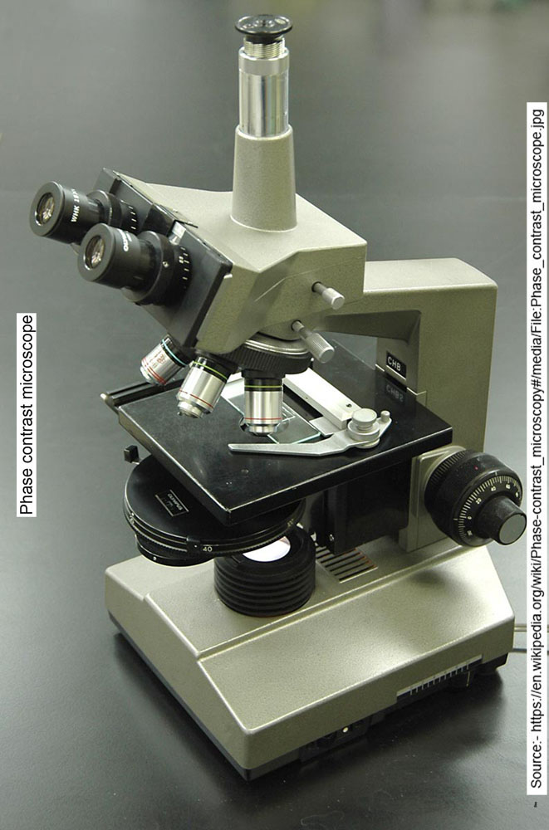
When light waves travel through a medium other than vacuum, interaction with the medium causes the wave amplitude and phase to change in a manner dependent on properties of the medium. Changes in amplitude (brightness) arise from the scattering and absorption of light, which is often wavelength-dependent and may give rise to colors. Photographic equipment and the human eye are only sensitive to amplitude variations. Without special arrangements, phase changes are therefore invisible. Yet, phase changes often carry important information.
The same cells imaged with traditional bright-field microscopy (left) and with phase-contrast microscopy (right)
Phase-contrast microscopy is particularly important in biology. It reveals many cellular structures that are not visible with a simpler bright-field microscope, as exemplified in the figure. These structures were made visible to earlier microscopists by staining, but this required additional preparation and killed the cells. The phase-contrast microscope made it possible for biologists to study living cells and how they proliferate through cell division.[1] After its invention in the early 1930s,[2] phase-contrast microscopy proved to be such an advancement in microscopy, that its inventor Frits Zernike was awarded the Nobel prize (physics) in 1953.[3]

Working principle

File:Dark field and phase contrast microscopies.ogv
Dark field and phase contrast microscopies operating principle
The basic principle to making phase changes visible in phase-contrast microscopy is to separate the illuminating (background) light from the specimen-scattered light (which makes up the foreground details) and to manipulate these differently.

The ring-shaped illuminating light (green) that passes the condenser annulus is focused on the specimen by the condenser. Some of the illuminating light is scattered by the specimen (yellow). The remaining light is unaffected by the specimen and forms the background light (red). When observing an unstained biological specimen, the scattered light is weak and typically phase-shifted by −90° (due to both the typical thickness of specimens and the refractive index difference between biological tissue and the surrounding medium) relative to the background light. This leads to the foreground (blue vector) and background (red vector) having nearly the same intensity, resulting in low image contrast.

In a phase-contrast microscope, image contrast is increased in two ways: by generating constructive interference between scattered and background light rays in regions of the field of view that contain the specimen, and by reducing the amount of background light that reaches the image plane. First, the background light is phase-shifted by −90° by passing it through a phase-shift ring, which eliminates the phase difference between the background and the scattered light rays.

When the light is then focused on the image plane (where a camera or eyepiece is placed), this phase shift causes background and scattered light rays originating from regions of the field of view that contain the sample (i.e., the foreground) to constructively interfere, resulting in an increase in the brightness of these areas compared to regions that do not contain the sample. Finally, the background is dimmed 70-90% by a gray filter ring—this method maximizes the amount of scattered light generated by the illumination (i.e., background) light, while minimizing the amount of illumination light that reaches the image plane. Some of the scattered light (which illuminates the entire surface of the filter) will be phase-shifted and dimmed by the rings, but to a much lesser extent than the background light (which only illuminates the phase-shift and gray filter rings).

The above describes negative phase contrast. In its positive form, the background light is instead phase-shifted by +90°. The background light will thus be 180° out of phase relative to the scattered light. The scattered light will then be subtracted from the background light to form an image with a darker foreground and a lighter background, as shown in the first figure.
Dark-ground illumination

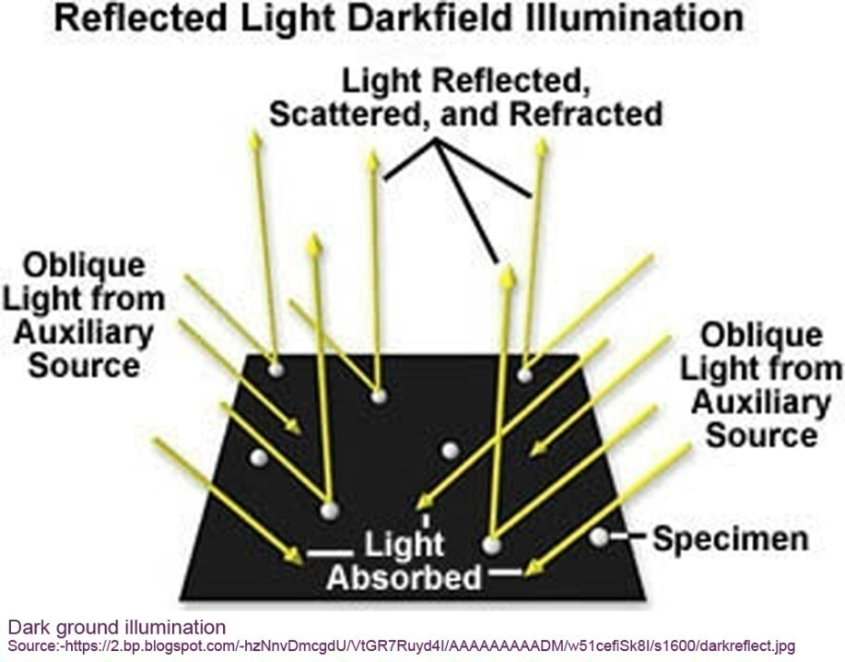
1. Used for examination of serous exudates for the presence of spirochaetes.
2. The microscope has a special condenser in which lenses are arranged so that direct rays of light are stopped and the material under view is illuminated by oblique rays.
3. Bacteria are seen bright against a dark background.
Electron microscopy

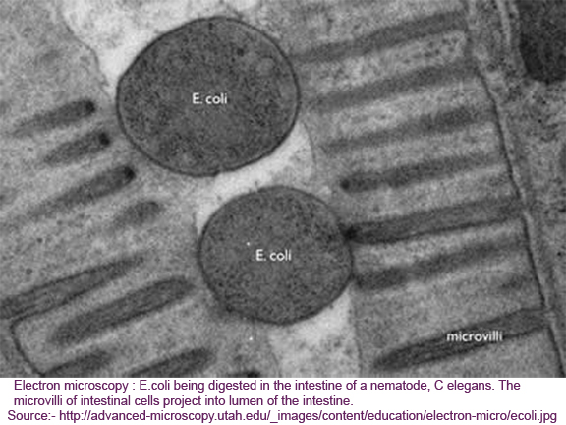

1. Magnifications upto 200,000 can be obtained.
2. A powerful electron beam passes through magnetic fields.
3. The suspension of material is dried on a very thin cellulose film through which the beam passes and the image can be seen.
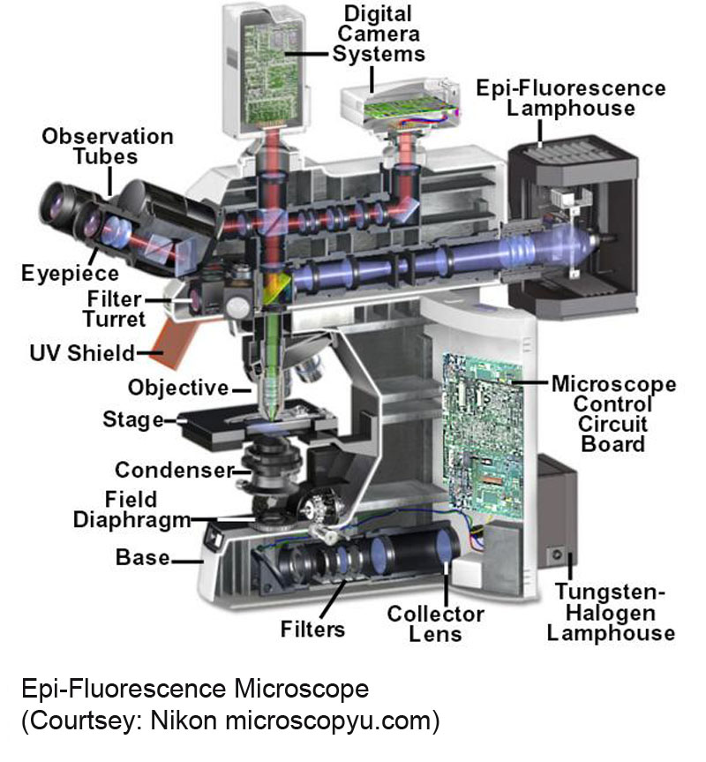

The absorption and subsequent re-radiation of light by organic and inorganic specimens is typically the result of well-established physical phenomena described as being either fluorescence or phosphorescence. The emission of light through the fluorescence process is nearly simultaneous with the absorption of the excitation light due to a relatively short time delay between photon absorption and emission, ranging usually less than a microsecond in duration. When emission persists longer after the excitation light has been extinguished, the phenomenon is referred to as phosphorescence.
British scientist Sir George G. Stokes first described fluorescence in 1852 and was responsible for coining the term when he observed that the mineral fluorspar emitted red light when it was illuminated by ultraviolet excitation. Stokes noted that fluorescence emission always occurred at a longer wavelength than that of the excitation light. Early investigations in the 19th century showed that many specimens (including minerals, crystals, resins, crude drugs, butter, chlorophyll, vitamins, and inorganic compounds) fluoresce when irradiated with ultraviolet light. However, it was not until the 1930s that the use of fluorochromes was initiated in biological investigations to stain tissue components, bacteria, and other pathogens. Several of these stains were highly specific and stimulated the development of the fluorescence microscope.
The technique of fluorescence microscopy has become an essential tool in biology and the biomedical sciences, as well as in materials science due to attributes that are not readily available in other contrast modes with traditional optical microscopy. The application of an array of fluorochromes has made it possible to identify cells and sub-microscopic cellular components with a high degree of specificity amid non-fluorescing material. In fact, the fluorescence microscope is capable of revealing the presence of a single molecule. Through the use of multiple fluorescence labeling, different probes can simultaneously identify several target molecules simultaneously. Although the fluorescence microscope cannot provide spatial resolution below the diffraction limit of specific specimen features, the detection of fluorescing molecules below such limits is readily achieved.
A variety of specimens exhibit autofluorescence (without the application of fluorochromes) when they are irradiated, a phenomenon that has been thoroughly exploited in the fields of botany, petrology, and the semiconductor industry. In contrast, the study of animal tissues and pathogens is often complicated with either extremely faint or bright, nonspecific autofluorescence. Of far greater value for the latter studies are added fluorochromes (also termed fluorophores), which are excited by specific wavelengths of irradiating light and emit light of defined and useful intensity. Fluorochromes are stains that attach themselves to visible or sub-visible structures, are often highly specific in their attachment targeting, and have a significant quantum yield (the ratio of photon absorption to emission). The widespread growth in the utilization of fluorescence microscopy is closely linked to the development of new synthetic and naturally occurring fluorophores with known intensity profiles of excitation and emission, along with well-understood biological targets.

Weighing scales
The balances of larger capacity should be frequently checked up for imbalance and rectified, if necessary. For weighing chemicals in excess of 10g to make colorimetric reagents, the simple hosiery shop balance would do. For smaller quantities, chemical, analytical, electronic or single pan balance should be chosen to give a deviation of less than 1 %. The balance should be kept away from the wind and vibrations.
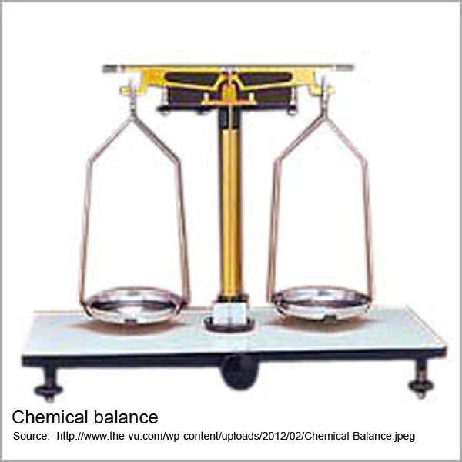
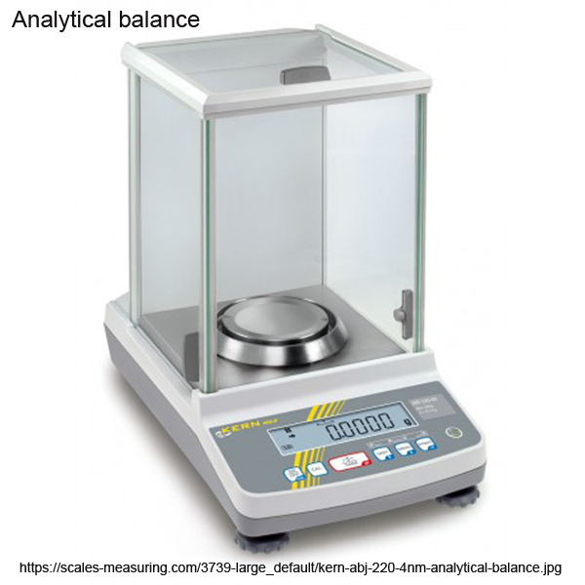
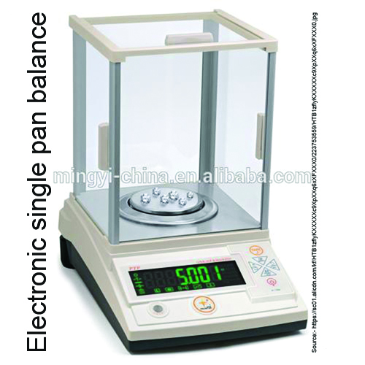

Centrifuge
Relative centrifugal force (RCF)
Relative centrifugal force is a comparison the force generated by various centrifuges on the basis of the speeds of rotation and distances from the center of rotation.
Hand centrifuge
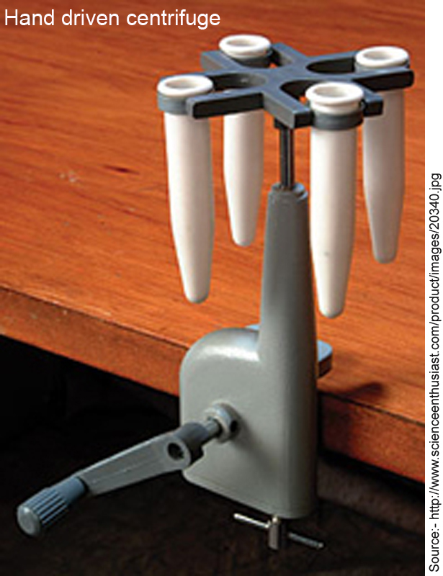
Motor driven

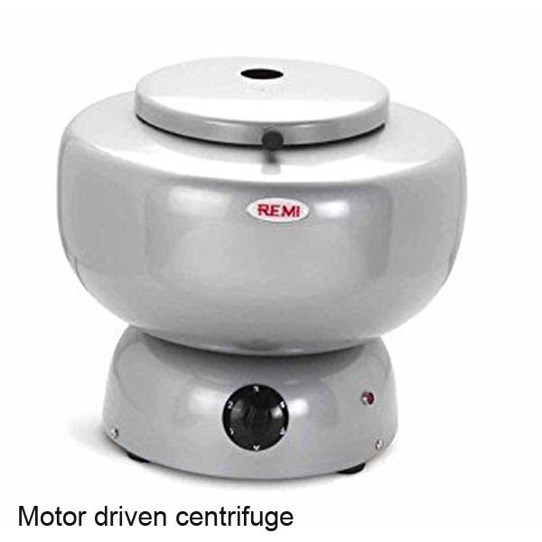
Microhematocrit centrifuge

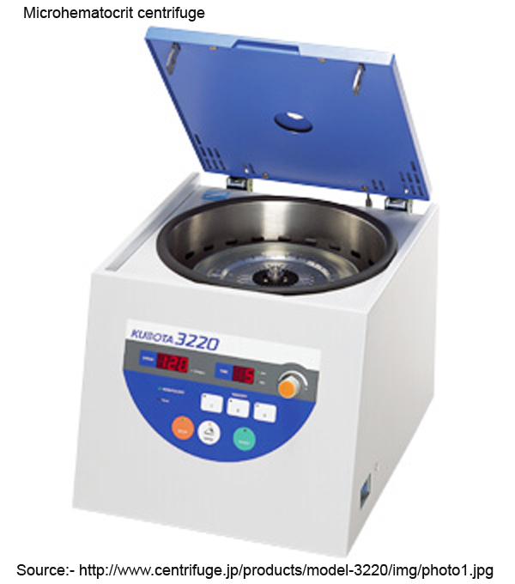
Glassware
Flasks
Erlenmeyer or conical flask

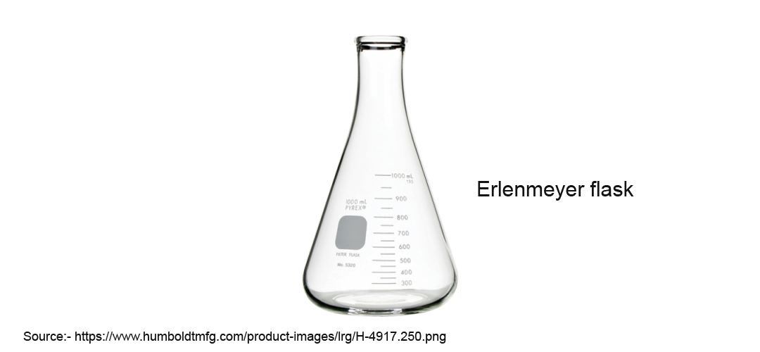
Volumetric flask
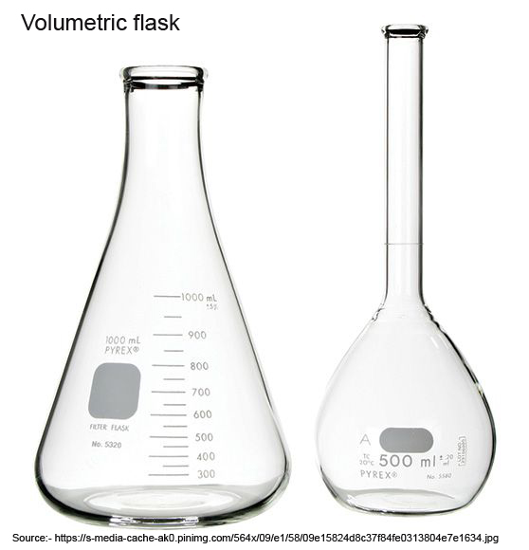
Round bottom flasks
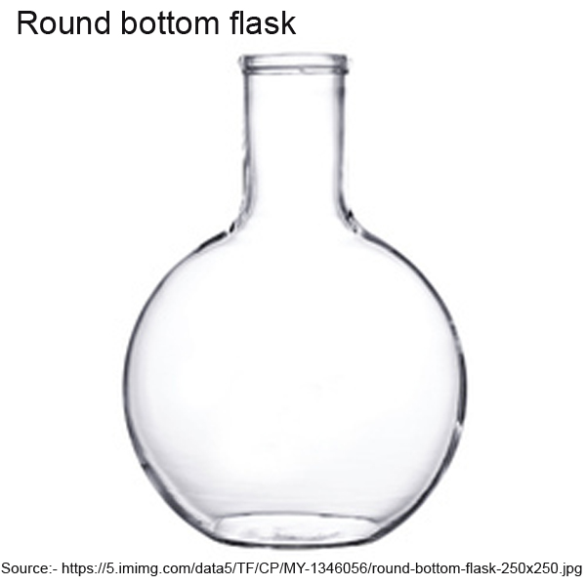
Flat bottom flasks
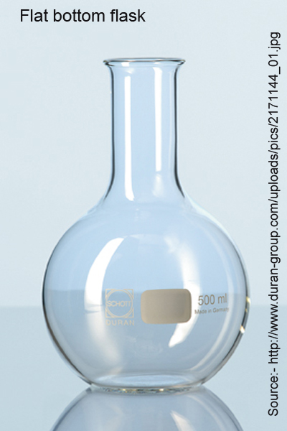
Beakers
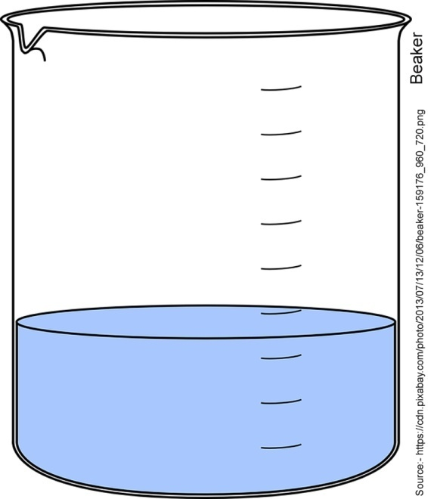
Bottles
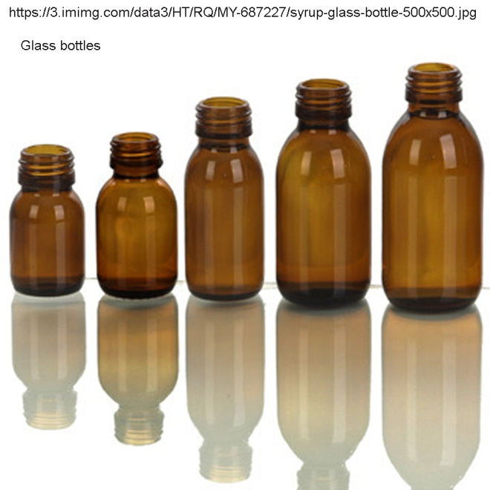
Funnels
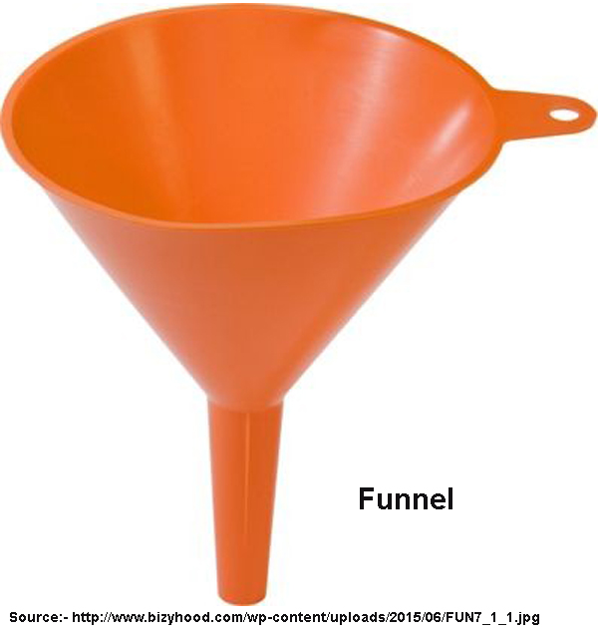
Cylinders
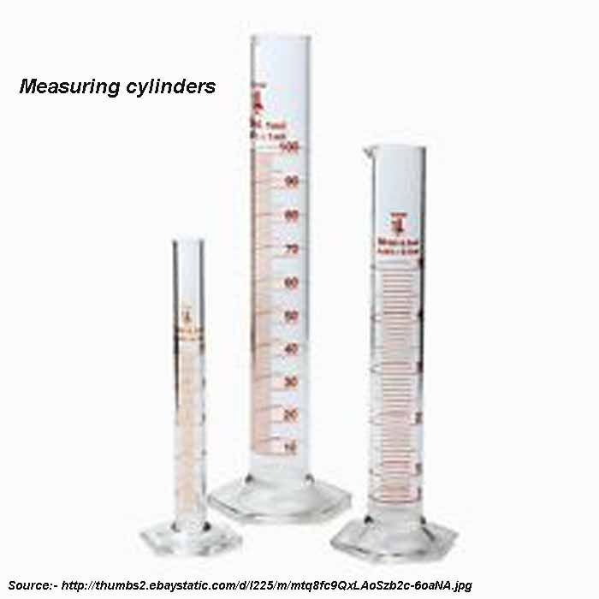
Tubes
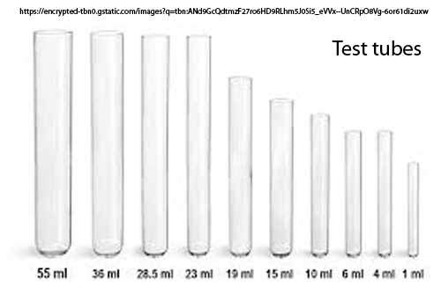
Pipettes
Volumetric
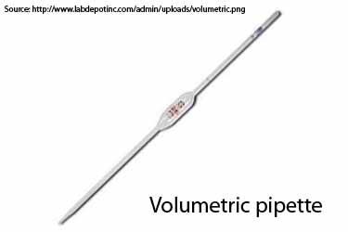
Graduated
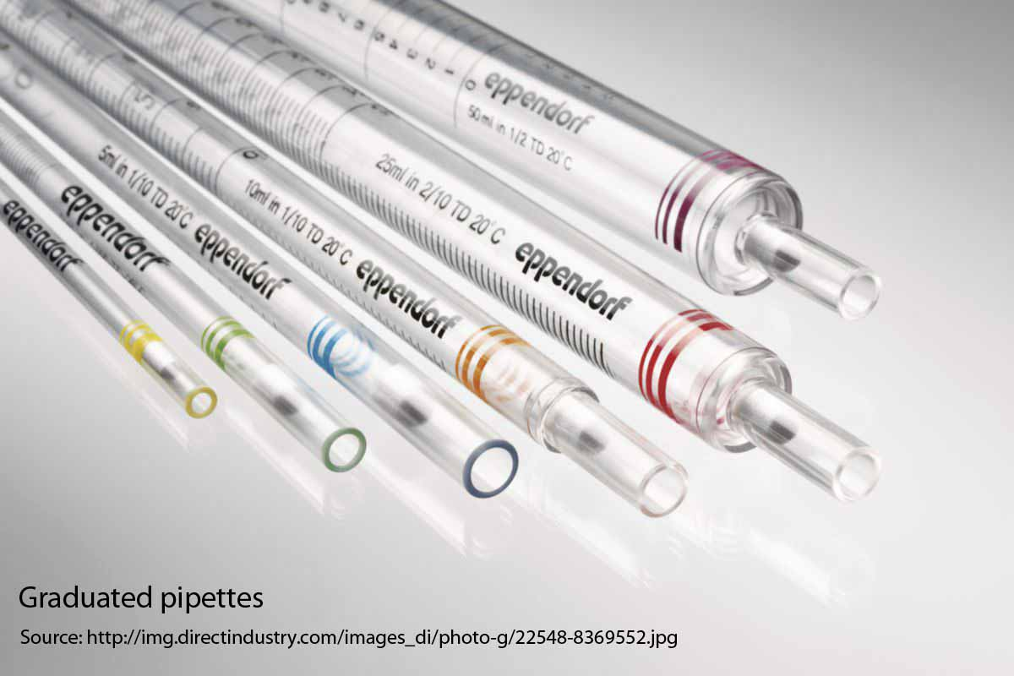
Blood pipettes
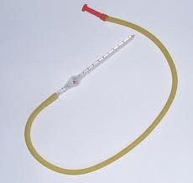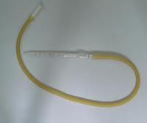
Pasteur
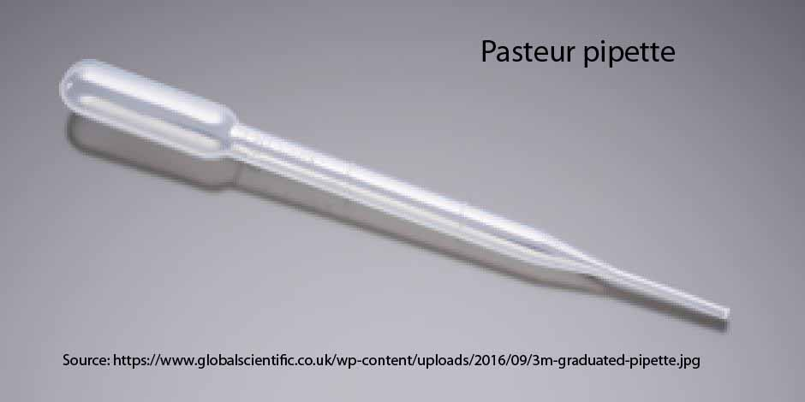
Serological water bath
Incubator
Hot air oven
Reporting
Format
Record keeping
Chapter 2 : General Techniques
Specimen Collection
Blood
In order to maintain standard conditions, blood for chemical analysis is taken in fasting state in hospitals. However in private practice and with out patients, this is not always mandatory. Light breakfast does not affect the estimation of cholesterol, protein, uric acid, urea, creatinine, enzymes and electrolytes.
The lipaemia of samples after moderate meals may disturb the estimation of amylase, bilirubin, protein, transaminases and dye tests.
For lipid estimation and lability tests (thymol turbidity) sample should be drawn at least 12 hours after the last meal.
For blood sugar estimation post prandial sample, taken 90-120 minutes after a meal is more diagnostic. Fasting sample may be taken in addition, only in hospitalized patients.
Capillary blood
Virtually all the biochemical estimations are now performed on plasma or serum for which venous blood is required. Use of capillary blood in biochemistry should be deplored. However, if one opts to draw capillary blood, the following description would be of use.

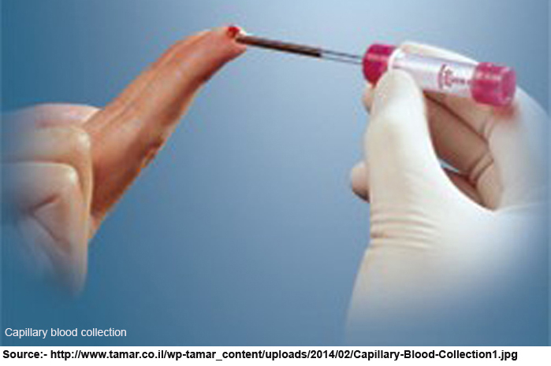

Capillary blood is best taken from the radial side of middle finger tip. In case of infants, the blood can be taken from heel. The puncture site should be cleaned with ether or with 70% ethanol, without undue rubbing. Only the spontaneous welling up blood should be drawn into the pipette allowing gravity force to operate. The used pipettes should be kept in hypochlorite solution, washed later and dried in oven at 110ºC for reuse.
Venipuncture

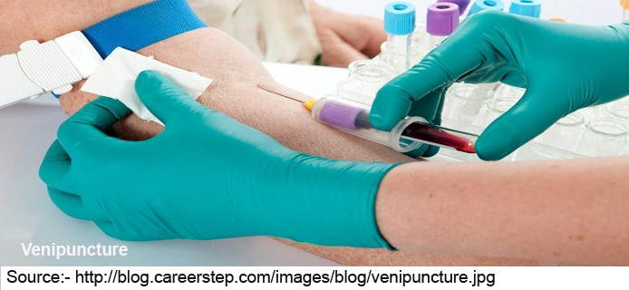
For preparation of serum, blood should be collected in plain vial; for plasma blood should be collected into vial with suitable anticoagulant. Blood is best drawn from the arm veins at the bend of the elbow. The arm is compressed for 30 seconds at a pressure slightly exceeding diastolic pressure - a uniform pressure of 100 mm Hg may be used for 30 seconds. Blood should be drawn with a wide-bore needle into a cannula and dropped into the vial. A syringe should be used only if the veins are poor. Blood should never be pushed out fast from the syringe. It should be dropped slowly over wall of the vial to prevent halmolysis and aerosol formation.
Haemolysis
Haemolysis may grossly change the chemical composition of plasma or serum and may render it unfit for several tests. Plasma is more prone to haemolysis than serum because of inappropriate quantity of anticoagulant in the former. Thus serum should be preferred to plasma in biochemical estimations. The following steps may prevent haemolysis.
1. Moisture should be avoided in needle, cannula, syringe and the vial.
2. The arm should not be over-compressed. The sphygmomanometer cuff is the most suitable appliance for regulated pressure.
3. Blood should not be pushed out fast from the syringe. lt should not be shaken vigorously with the anticoagulant.
4. Only moderate speed should be employed to centrifuge the sample.
5. Serum should be separated within 45 minutes.
Anticoagulants
Vacutainers are used to draw blood into anticoagulant.
A vacutainer has three parts – Vacutainer needle, holder, and Vacutainer tube.
Vacutainer needle is double ended with one end encased in rubber coating. The rubber end of the needle fits into the holder and open end pricks into the patient’s vein.
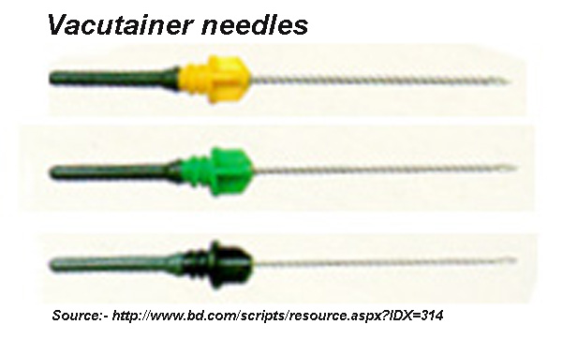
Vacutainer tube has a stopper which fits into the holder. The vacuum built inside the vacutainer tube pulls blood from vein through the needle and the holder.
Vacutainer tubes have either Single cap (without protection cap) or Double cap (with protection cap).
Vacutainer tube stopper colour identifies the coagulant the tube carries.
- Vacutainers containing Coagulants
- Gold red/black top. Clot activator and gel for serum separation
- Red top (plastic, not glass): Clot activator but no serum separation gel
- Orange or grey/yellow top: thrombin, a rapid clot activator, for stat serum testing
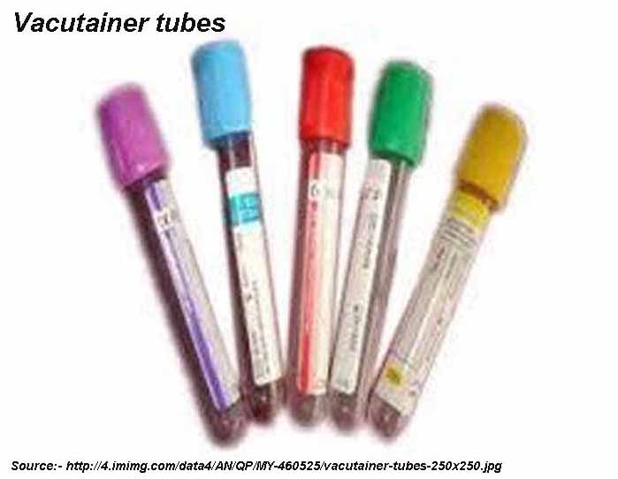
- Vacutainers containing Coagulants
- Green. Heparin
- Light green. For plasma determinations
- Purple. K₂ EDTA for blood counts and blood banking procedures
- Grey. Sodium fluoride and oxalate for glucose
- Light blue. Sodium citrate
- Dark blue. EDTA for trace metal analysis
- Black. Used for ESR
- Red (glass). Plane, with no additive
- Light yellow. Sodium polyanethol sulphate (SPS) used for blood culture, or Acid-citrate-dextrose (ACD), used in blood banking, HLA phenotyping, or paternity testing.
- Tan (glass). Sodium heparin
- Tan (plastic). K2 EDTA used for lead determinations.
Non vacutainers are economical substitute for Vacutainers. The tube has no vacuum to pull out blood from vein. Blood is puched into the tube through a needle.
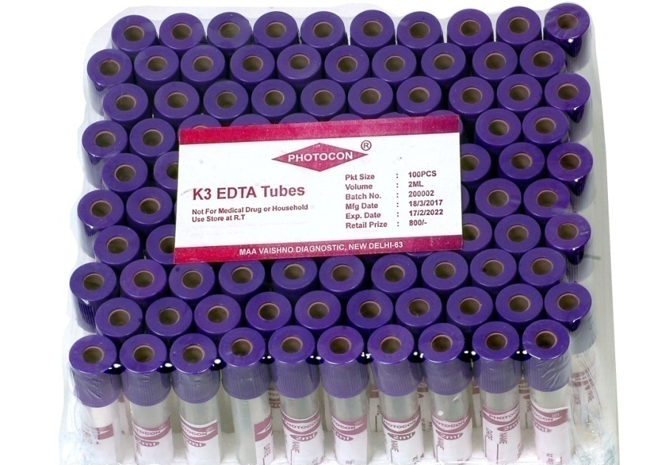

Types of coagulants
- Heparin. This is technically the most suitable anticoagulant as it does not affect the chemical composition of blood. One mg of sodium or calcium salt may be used per 5 ml blood.
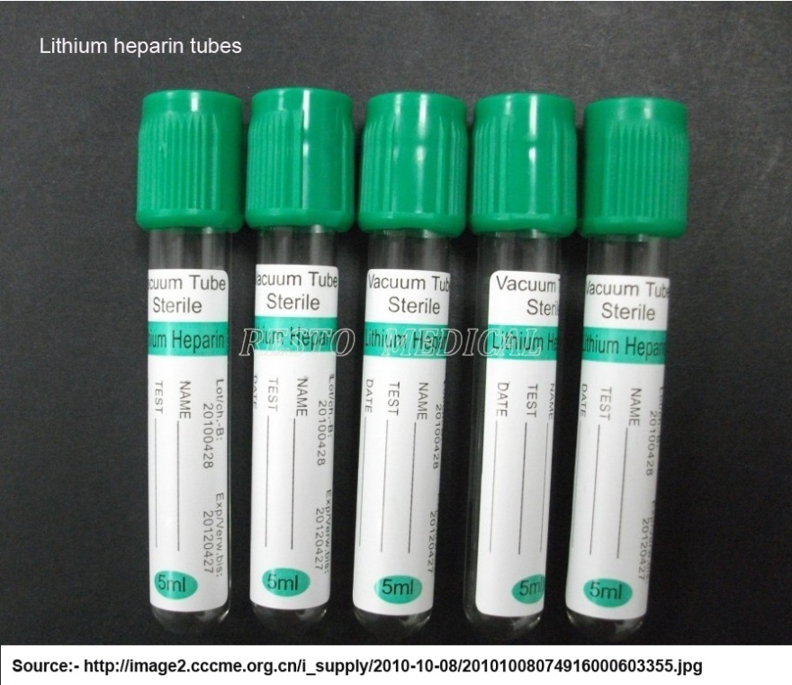
- Oxalate. 2-3 mg per ml blood is required. it may be used either as potassium oxalate alone or as a mixture of potassium oxalate and ammonium oxalate. 0.2 ml of solution containing ammonium oxalate 3%, potassium oxalate 2% and formaldehyde 1% (v/v) may be dried up in a vial and used for 3-5 ml blood.
3. EDTA Disodium or dipotassium salt may be used in quantity of 1 mg per ml blood.
Oxalate or EDTA may be mixed with sodium fluoride to prevent glycolysis in blood sugar estimation. A mixture of potassium oxalate 5% and sodium fluoride 2% may be used in the same quantity as oxalate anticoagulant already described.
Storage
Unless contradicted in the description of individual estimations, plasma and serum can be stored upto 4 hours at room temperature and for 24 hours in a refrigerator. For longer storage, the sample may be frozen. Bilirubin, (in dark), amylase, haemoglobin, uric acid, cholesterol. triglycerides, phospholipids and electrolytes are fairly stable and can be estimated within two days (two weeks for sodium and potassium).
Urine
Spontaneous urine samples are used for qualitative tests and 24-hour pooled samples for quantitative estimations.
For qualitative tests, time of drawing the sample is important since the constituent being sought may be in highest concentration, during particular time of a day. In inflammatory diseases, morning sample should be used. In orthostatic proteinuria, urine should be collected before and after the natient gets up. For sugar test, urine should be collected 90-120 minutes after meals. For urobilinogen the sample should be collected between 2PM and 4PM.
For quantitative estimations, urine passed out over 24 hours (or other specified interval) is pooled up in a clean glass vessels. At the beginning of each collection period, the bladder must be emptied and urine discarded. At the end of collection period, the, bladder must be emptied into the pool.
During the collection period and until examined the urine should be stored in referigerator. After 24-hour sample is pooled up, any of the following preservative may be added.
1. Thymol 10% 5 ml (not suitable for 17-KS)
2. Toluene sufficient to form a thin surface film.
3. Methyl 4-hydroxybenzoate 1.5-2.0 g.
Collection of ascitic fluid, pleural fluid, cerebrospinal fluid etc. is made by respective specialists and the instructions may be found in textbooks of corresponding specialities.
Faeces
Faeces are passed into a bed pan. A polythene sheet may be spread on the inner surface and the faeces wrapped in the sheet.
The faeces should be free from urine. Contamination of faeces with urine may be detected visually or from its chloride content. A portion of faeces is boiled with distilled water and the filtrate mixed with silver nitrate and nitric acid. Urine free faeces show slight opalescence. A precipitate suggests urine contamination.
Faeces are best examined immediately after being passed. For later examination, faeces should be stored in refrigerator. Alternatively the faeces rray be processed for first step of the test and subsequent steps carried later on. Thus for urobilinogen examination, faeces may be mixed with alkaline ferrous sulphate immediately as first step.
For some quantitative determinations over several days, it may be necessary to examine the faeces formed during that period. Markers such as charcoal, carmine, gentian violet are used for the purpose 0 5-1.0 g is administered at the start of the test period and again at the end of the test period. Collection of faeces begins with the first sample containing the marker. Faeces are collected upto but excluding the first sample containing the marker after second dose.
Measurements
The importance of accurate measurements in analysis can not be doubted. However, it is one of the overstressed factors in practical biochemistry, the other ones being quality of distilled water and the difficulty in standardization.
Most biochemical estimations are performed with a colorimeter. Most colorimetric reagents absorb measurement inaccuracies upto 1 % (may be upto 5%). Most reagents. can be made with clean soft tap water and with a little practice, standard solutions of aeceptable accuracy can be easily prepared at the Smallest lab. Spending time staring at the analytical balance pointer or choosing correctly callibrated measuring cylinders may be important at times but one should make sure that in the process he is not just reducing 4-5 per cent overall test error by 0.1 percent.
Once the reagents and the standards are prepared, a fair degree of measurement accuracy is mandatory during biochemical testing.
Measurement of solids
Solids are weighed up with balances. The balances of larger capacity should be frequently checked up for imbalance and rectified, if necessary. For weighing chemicals in excess of 10g to make colorimetric reagents, the simple hosiery shop balance would do. For smaller quantities, chemical, analytical, electronic or single pan balance should be chosen to give a deviation of less than 1 %. The balance should be kept away from the wind and vibrations.
Measurement of liquids
Liquids are measured with measuring cylinders or with pipettes. Some glass flasks also have a capacity mark. Occasionally liquids may have to be weighed in preweighed vessels with a balance.
Measuring cylinders
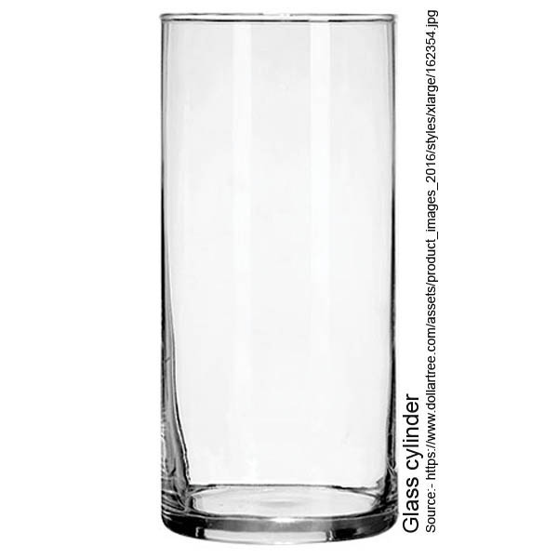
Apart from 'BOROSIL', the author hasn't come across any Indian brand of glass cylinders with desirable accuracy. As already mentioned, some inaccuracy may be acceptable, yet most cheap brand cylinders have inaccuracies exceeding 10 per cent. Inspite of multiplied pricing, only 'BOROSIL' or a reliable imported brand of measuring cylinders should be patronized. In case cheap cylinders must be used, the same should be marked at points of capacity at the lab. A particular quantity of liquid should be measured in a cylinder of next higher capacity. Too large cylinder must not be used for a small quantity.
Pipettes
Graduated Pipettes, and not one mark pipettes,. are used in biochemistry lab, Pipettes of 0.1, 0.2, 1, 2, 5, 10 and 25ml capacity of BOROSIL brand are available 0.5 ml pipettes of cheaper brands are also available for urine sugar estimation (Benedict's test). Pipettes are callibrated to tip or to mark. Pipettes callibrated to mark give greater accuracy yet pipettes callibrated to tip have some plus points which make these more useful.
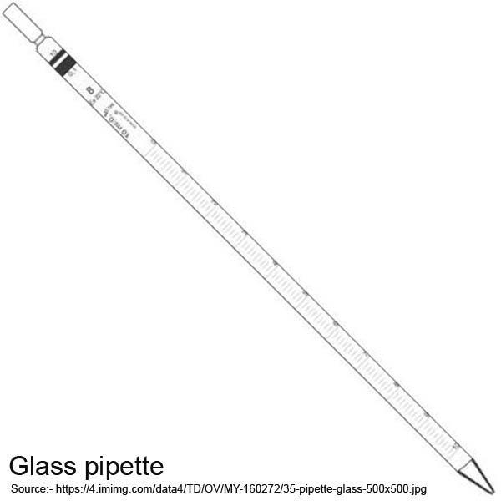
Faded markings may render the Pipettes useless, if the same are callibrated to mark. PiOttes callibrated to tips can be used even if lower markings fade away. Liquids filled up into the pipettes of latter type can be washed out into diluent, this is not possible with pipettes callibrated to mark.
Smaller pipettes of even reputed brands are callibrated correctly only at their full capacity - the markings in between may be deceptive. Thus a 0.2 ml pipette may not deliver two equal alloquets of 0.1 ml each. As far as possible, the quantity to be measured should be congruent wtih full capacity of the pipette. However, since uniformity rather than accuracy is more important in colorimetric estimations, a fractional quantity may be 'delivered from a pipette of slightly higher capacity beginning with 0 mark and not just with any mark.
Micropipettes
Automated micropipettes do make pipetting much more easier and speedier. Non-wetting surface of the micropipettes overcomes a major source of error with glass pipettes. However, with mushrooming of micropipette manufacturers, the micropipette in use must be checked frequently for uniform delivery.

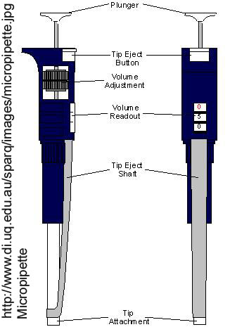
In order to change a micropipette method into glass pipette method, the sample/reagent may be diluted with appropriate liquid so that 0.1 ml volume is required in the procedure in place of the, stated smaller volume.
Measurement of gases
The volume of gas reduces with pressure increase (Boyle's law) and increases with temperature rise (Charle's law). Thus the volume of a gas must be measured at constant pressure and temperature.
ANALYTICAL METHODS
All the methods used in analytical chemistry e.g., titrimetry, colorimetry may be used in biochemistry. The more specialized methods are spectrophotometry, nephelometry,fluorometry, flame photometry, electrophoresis, chromatography and many more.
The scope of the present book is limited to colorimetry and other basic Medical Laboratory Techniques used in an average laboratory. Any more reference to the sophisticated techniques enumerated would serve no purpose.
Colorimetry
The entire biochemical set up of an average lab is pivotted around COLORIMETER, an appliance to measure the colour Intensity of a solution. The following statement may make colorimetry understandable to a laymen who has never seen a colorimeter.
1. in colorimetry we measure a substance (in blood, urine, etc.) by using reagents and a solution containing the substance In known concentration (called standard solution or standard).
2. We mix up reagents with the sample (blood or urine). A colour develops; we measure its intensity.
3. We mix same quantity of reagents with same quantity of standard solution. A colour develops; we measure its colour Intensity.
Now we know that a standard solution of concentration s mg/100 ml gives a colour intensity of S units. If the colour Intensity developed from test sample is T units, the concentration of the substance in test sample is :
T
Substance = ------- x S mg/ 100 ml
S
The preceding paragraph should enable even a novice understand the description of colorimetry which follows :-
Colorimetric reagents
In every colorimetric estimation, we make use of a chemical roaction or a set of chemical reactions which results in colour dovolopment e.g.
1. A+B=C
2. A+B=C+D
D+E=F+G
Among the reactants. one should be the substance to be determined and among the products, one should becoloured. Any
chemical equation or n set of equations which satisfies this criteria can be basis of colorimetric estimation. In the equations above, the substance to be measured is printed in italics and the coloured product is printed in bold face.
A colorimetric reagent may be solid or a liquid and rarely a gas. It may be a fine chemical, a mechanical mixture of chemicals or product of a long chemical process.
Monostep reagents
in case the colorimetric estimation of a substance requires just one reagent (and a standard), the procedure as well as the reagent is termed 'monostep'. The procedures requiring multiple reagents are termed 'multistep'. However the two terms do overlap, for example
i. Two reagents of a 'multistep' kit may be required to be mixed just once for the whole day. The mixture would then make the procedure 'monostep' for rest of the day.
2. A 'monostep' reagent after mixing with the sample may require several steps of heating, cooling, incubating, filtering, etc. and may be much more cumbersome than most, multistep procedures.
Law of limiting factors
The pace of a race team is the same as pace of its slowest member. The calculation on page 9 is based upon a precondition. That is the colour intensity of the coloured product should depend only upon the concentration of the substance to be determined. Concentration of reagents should have no effect upon the colour intensity produced. Thus concentration of substance sought should be the limiting factor, all other reactants (reagents) should be in, excess of the quantities required in the reactions at any stage.
If one of the reagents also determines the colour intensity, a graph will replace the standard calculation. More of it will be described under Beer's Law.
The fact that the reagent concentration is much in excess of reaction requirements should indicate that very careful measurements are not required in making most colorimetric reagents.
Absorbance
The colour intensity during earlier periods of introduction was assessed visually (as in Sahli's haemoglobinometer). It was then termed optical density (O.D.). One criteria was to read standard type print through the coloured solution placed in a test tube. It is still practised in some estimations (haemoglobin-S estimation with dithionite method.)
With the introduction of electronic instruments, the colour Intensity is now measured as capacity of the solution to absorb light passing through it.
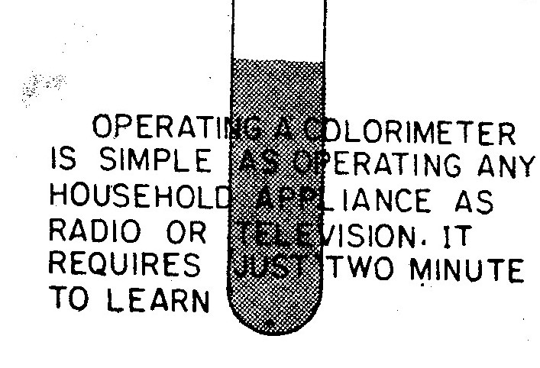
Assessing the optical density (O.D.)
Incident light passing through a colourless liquid (water) is adjusted to produce current in photoelectric cell which gives full deflection in galvanometer. The tube containing coloured solution is put in place of water tube. The absorption of light thus measured as fall in electric current is proportional to the colour intensity of the solution. The colour intensity measured this way on a specified scale is termed 'absorbance' of the solution.
In most Indian literature the term 'optical density (O.D.)' is used for reading in a photocolorimeter. Since the term is fast losing its use elsewhere in the world, we will use the term 'absorbance'. The two terms should be treated as synonymous with reference to photoelectric colotimeter. Another synonym is, 'extinction'.
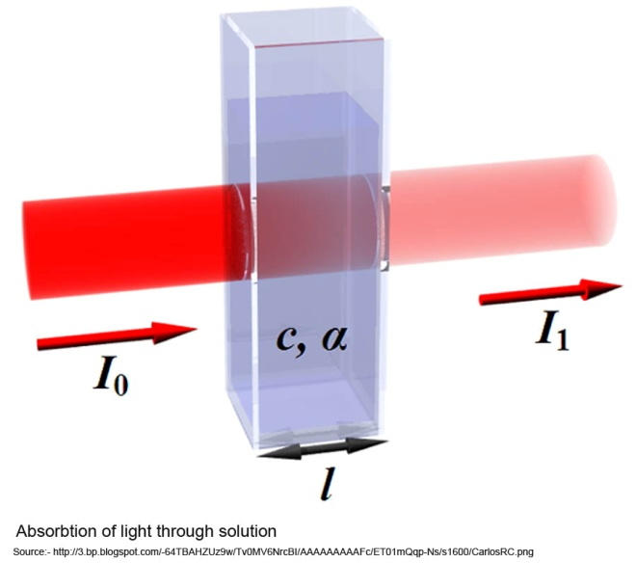
Absorbance Scale
Absorption of light by a coloured solution follows two laws - Beer's law and Lambert's law, collectively known as Beer-Lambert law.
Beer's law states that absorption of light (I/O) is exponentially proportional to colour intensity (C) of the solution traversed by it.
l
--- ∝ e^{c}
O
where e is the base of natural logarithms (2.71828........)
Lambert's law states that absorption of light is exponentially proportional to distance traversed (d or diameter of the tube)
l
--- ∝ e^{d}
O
Combining the two
I
--- ∝ e^{c.d}
O
or
l
--- = e^{k.c.d}
O
Where value of constant depends upon units of c and d.
In a particular colorimeter, tube (or cuvette) diameter is constant. With k also constant, the product k.c.d. varies with colour intensity only. This product is termed absorbance (A).
I
Thus ----- = e^{A}
O
l 100
Or ----- x ------ = e^{A}
O 100
O
--- x 100 is the percentage transmission (%T) of light.
l
100
Hence -------- = e^{A}
%T
100
Or Log -------- = Loge^{A}
%T
Or Log 100 - Log %T = Log e^{A}
Or 2 - Log %T = A
Or A = 2 - Log %T
Thus absorption of light passing through a coloured solution is proportional to (2 - Log %T) and not proportional to fall in transmission (100 - %T). For convenience of calculation, absorbance itself is measured on galvanometer scale. Most colorimeters display both % transmission and absorbance.
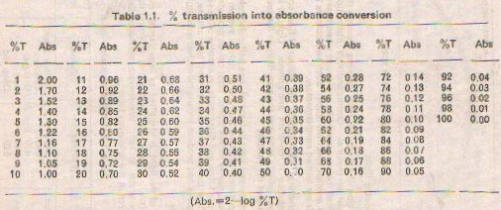
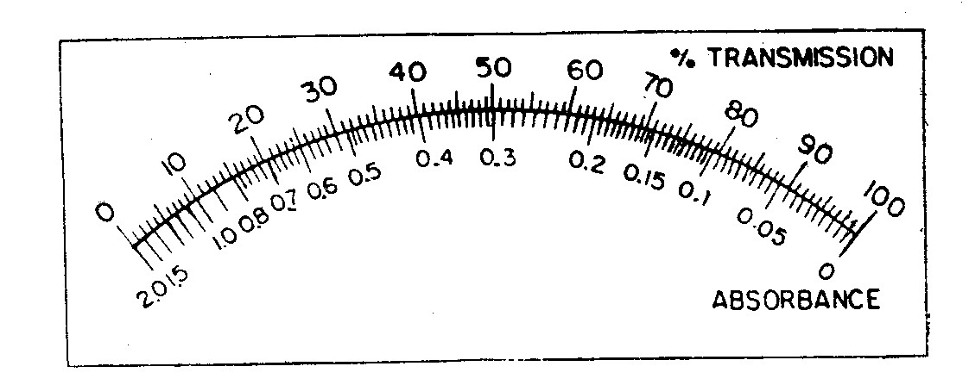
Fig. 2.3. Galvanometer scale
Monochromatic light
Absorption of a coloured light passing through the solution of same colour is minimal. Correspondingly absorption of light with a specified colour would be maximum when passed through a solution of another specified colour. Such two colours forming an optimum pair are termed complementary.
In biochemical estimations, the colour of final solution in a particular solution is constant and known. Light of its complementary colour grossly enhances the sensitivity of the test requiring lesser quantity of the sample.
Monochromatic light or light of one particular colour is produced in a spectrophotometer through an optical system of prisms. In colorimeters, nearly monochromic light can be produced with the help of mercury filter and filter made up of some other substances. In ordinary filter colorimeters used in most laboratories, filters are made up of glass and produce impure monochromatic light.
Wavelength
Colour of the light is identified as wavelength measured in nanometers (nm). Wavelength increases as we count the rainbow colours from violet to red. Wavelength corresponding to filter colours is given in the following table :-
Colour | Wavelength | Colour | Wavelength
Deep violet | 400 | Yellow-green | 550
Violet | 430 | Yellow | 580
Blue | 470 | Orange | 600
Blue-green | 490 | Red | 680
Green | 520 | Deep red | 700
COLORIMETERS
We have already explained the terms relating to colorimetry. That should facilitate our further study about colorimeters.
Photoelectric colorimeter is termed 'Photometer' in modern biochemistry ; the term 'colorimeter' is technically reserved for 'visual colorimeter'. However we will follow the more practical terminology just for the sake of simplicity. Both the terms 'colorimeter' and 'photometer' will be applied to denote the common appliance in our laboratories.
Colorimeter is an electric appliance just like any household appliance (radio, television, fan, etc) rather difficult to explain on paper but requiring just two minutes to learn its operations.
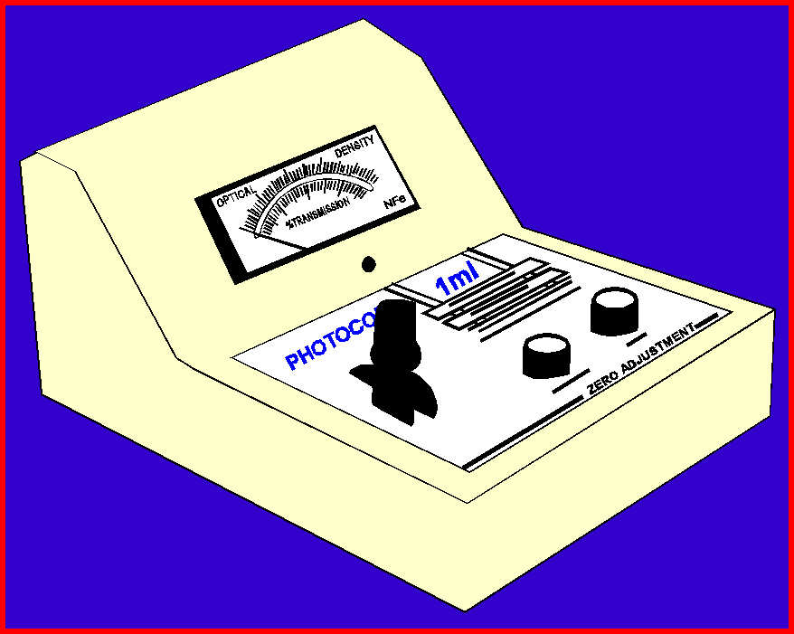 | 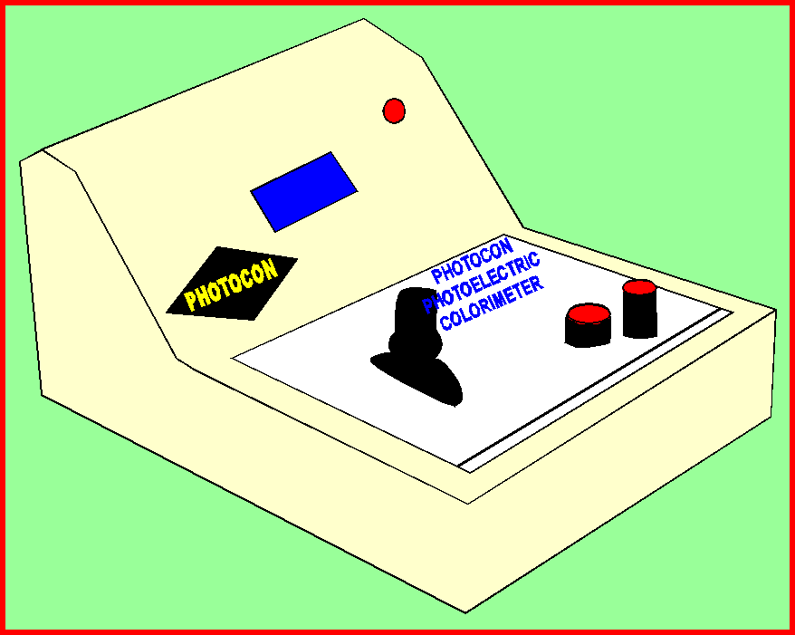
Colorimeter – India’s FIRST 1-ml Colorimeter developed by
Dr K Chaudhry at Clinichem Diagnostics, New Delhi during 1989
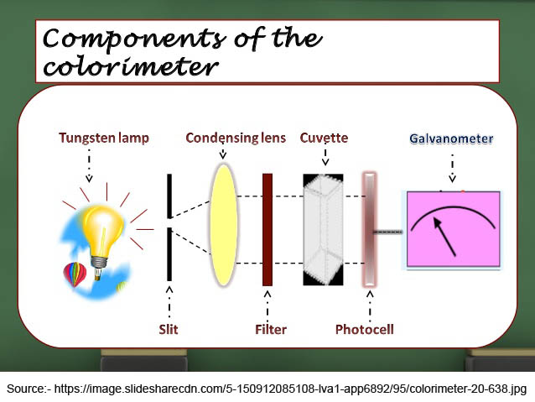
A colorimeter has five components :
1. Light source
Most colorimeters have a 6 volt single filament bulb as the light source. The bulb is connected to the electric mains through a step-down transformer. It can also be illuminated directly with a mobike battery.
The light emitted by the bulb falls upon the concave mirror to make a parallel beam of light which passes through filter and coloured solution to finally fall on photoelectric cell.
The intensity of light in the parallel beam is regulated by
(I) Placing a rheostat in series with the bulb
(ii) Adjusting the shutter hole placed between the bulb and the filter.
2. Wavelength selector (filter wheel)
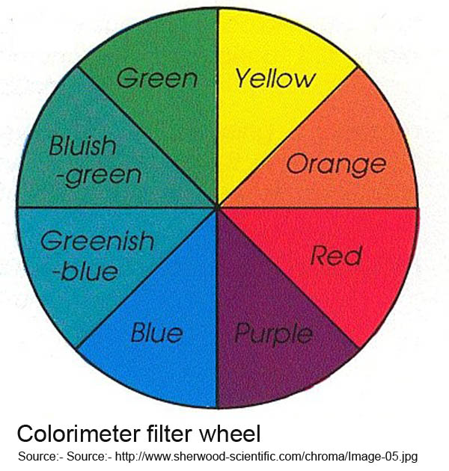
Wavelength selection is accomplished by rotating a plastic wheel, so that filter of desired wavelength falls in the optical pathway. The filter wheel has suitable locking mechanism so that the filter is held only in a pre-set position.
A colorimeter may have any number of filters ranging from 3 to 9. A colorimeter with more filters allows wider choice of wavelength.
3. Cuvette holder
The test tube used to carry solution in a colorimeter is called a cuvette. The diameter varies with the colorimeter make, between 10 mm and 15 mm. The cuvette holder holds the cuvette in position. The cuvette holder has two slits for passage of light, one each at incident and the emergent surface.
The cuvettes may be rectangular or cylinderical - cylinderical cuvette has a vertical line. The optical diameter of the cuvette passing perpendicular to this line is matched perfectly with other cuvettes of the same set. Such cuvettes with vertical lines make a set and are called matched cuvettes. Matched cuvettes of two different sets may not be matched with each other. Cuvette is placed in the holder with vertical line set against a mark over the latter. Obviously, no matching line is required with rectangular cuvettes.
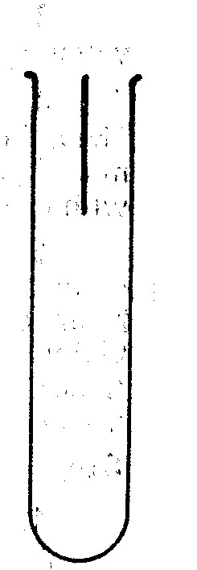
Matched glass cuvette
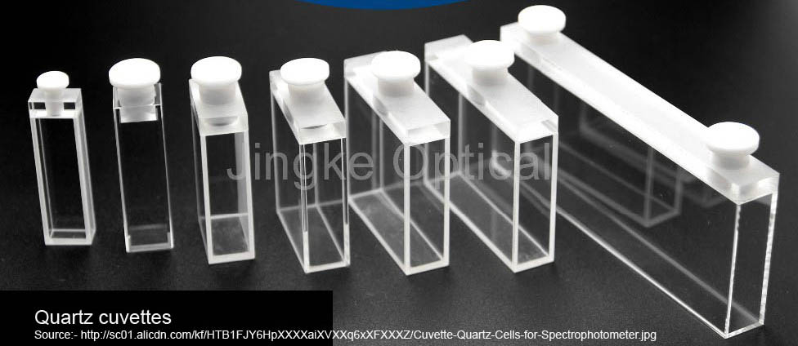
4. Photoelectric Cell

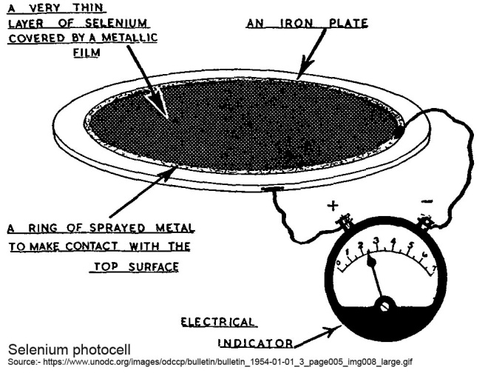
Photoelectric cell or 'photocell' is a device to convert light energy into electrical energy. The photocell is connected with the
galvanometer to produce deflection in the latter corresponding to light falling upon the photocell. Light is allowed to reach photocell only during actual reading time. This is accomplished by a push button or a shutter.
Photoconductive cell is a resistance or a diode. Electric conductivity depends upon intensity of light falling on photoconductive cell. In contrast to limited lifespan of photovoltaic cell, photoconductive cell has unlimited lifespan. Light Dependant Resistance (LDR) was first used as photoconductive cell by Dr K Chaudhry (Author of this book) during 1989, in Photocon-1ml Colorimeter. Now photoconductive cells are widely used and photovoltaic cells are out of date.

Light Dependant Resistance (LDR) is a Cadmium sulphide photoconductive cell with diverse dimensions – 2 mm to 30 mm.

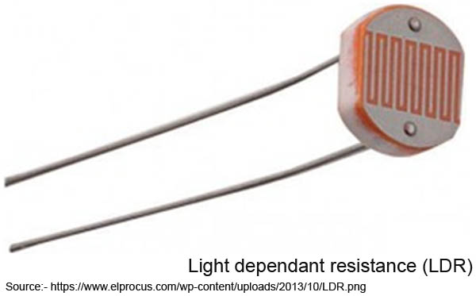
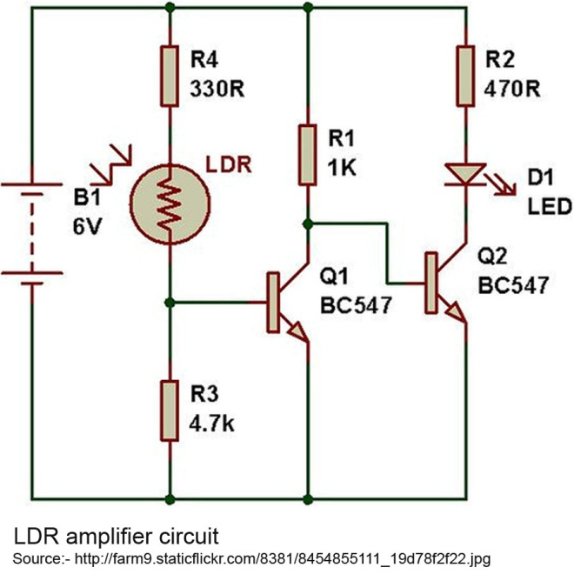
Photodiode is a unidirectional photoconductive cell with electric current moving in one direction.
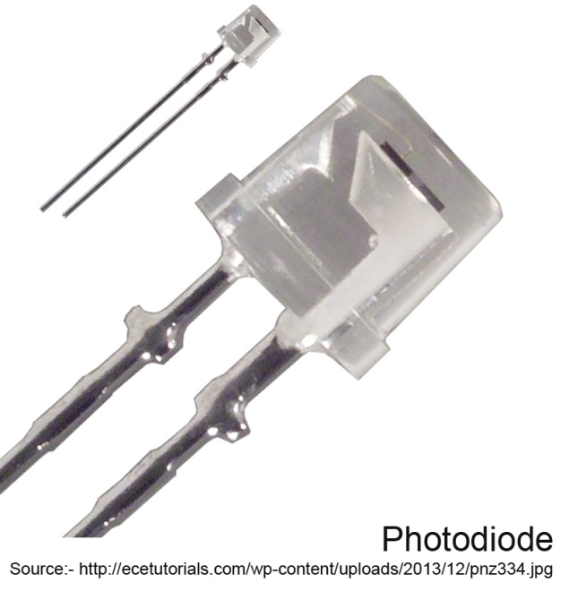

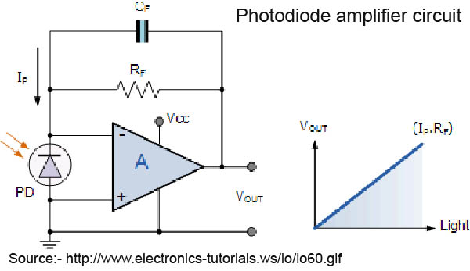
5. Galvanometer
This is a device to measure the minute quantities of the current produced in the photocell. Its dial has two scales - one measuring the absorbance and the other one measuring percent transmission. A screw at the base is used to adjust the position of the pointer.

Checking the colorimeter
In absence of manufacturing defects, colorimeters of all popular makes serve the purpose well. However, defects do crepe in some pieces of any make. With a new user, such defects are often detected years after purchase. While purchasing a colorimeter check particularly the following points :-
1. Switch on the colorimeter and the shutter switch. Position of the pointer should be stable after a minute.
2. Light should reach the photocell only through a specified pathway. Switch on the colorimeter at a darker place in the room and adjust at 100% transmission. Move swiftly with the colorimeter into bright day-light. The galvanometer pointer should not overshoot.
3. Check the actual colour of light transmitted through water against every filter marking.
4. Adjust colorimeter at 100% transmission with every filter. The adjusting knob should not lie at the extreme of its mobility range. At least 1/3 of mobility range should remain in reserve with every filter.
5. In some plugged test tubes, take solutions of different colours, such as saturated picric acid, potassium permanganate, bromocresol green, methylene blue. Read absorbance against various filters in a colorimeter of same make, already in use. Check the absorbance in the new colorimeter. Some variation is acceptable but the absorbance should not be about half or lesser.
Steps of operation
1. Connect the colorimeter to the mains and swich it on.
2. Move the filter wheel to bring the desired filter in position.
3. Place curvette containing water in the holder.
4. Adjust the light intensity to set the pointer at '0' absorbance (100% transmission).
5. Remove the cuvette. Add coloured solution in place of water. Replace the cuvette in position. The pointer will move to the left.
6. Read absorbance from position of the pointer.
7. Close the shutter in between readings.
Calculation of results
As derived from Beer's law, absorbance of the final solution in a test is directly proportional to concentration of the substance being determined in the sample.
Conc. test sample Abs. test
------------------ = -----------
Conc. standard Abs. std
or
Abs. test
Conc. test sample = ----------- x Conc. std.
Abs. std.
The equation holds true under two circumstances :
1. if a reagent or a set of reagents, after steps described in the procedure, but without adding sample or standard, produce(s) a clear colourless final solution with optical density at par with water.
2. If the solution produced from blank reagents as above has some colour intensity and the same solution is used to callibrate the colorimeter in place of water.
In order to save reagents and time the coloured blank is not used for zero adjustment. Instead, a blank reading is also recorded alongwith test reading and standard reading. The calculation then becomes :
Abs. test - Abs. blank
Conc. sample = --------------------------------- x Conc. std.
Abs. std - Abs. blank
Blank reading and standard readings are not repeated every time; the values obtained during first testing are used subsequently.
Graph making
The above calculations are valid for the reactions which follow Beer's law. However, with some reactions, Beer's law may not hold true. The absorbance does increase with sample concentration but not proportionately.
A prerequisite to Beer's law is that the substance to be determined is a limiting factor and the reagents are in infinite concentration. Any further rise in concentration of a reagent should not raise the absorbance, if sample concentration remains unchangad.
Law of limiting factors and consequently the Beer's law is very frequently not followed. Thus in blood glucose concentration, the o'toluidine concentration required to produce maximum absorbance is too high. Such concentration in the reagent would give too high blank and make testing inelegant. Similarly in urea estimation, an increased concentration of diacetylmonoxime in the reagent produces more absorbance in the same sample. In enzyme estimations, the concentration of products in the solution affects the further pace of reaction.
If we plot a graph of absorbance against sample concentration three types of graph result.
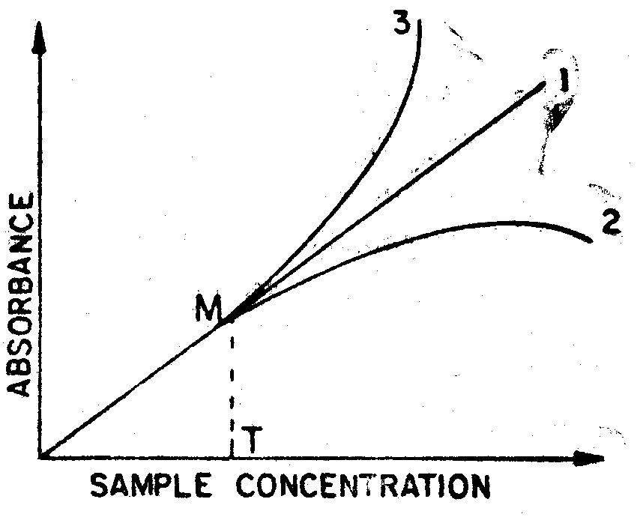
Absorbance graphs.
Graph I results from a perfect colorimetric procedure which follows Beer's law.
Graph 2, the usual one, results from colorimetric procedures where reagent concentration is not infinite or the products have ihibiting effect upon further pace of reaction.
Graph 3 is based upon specific nature of the reaction where certain minimum concentration of the substance is necessary to enhance the pace of reaction.
It would be noticed that in both the aberrant graphs (2 and 3) a portion (0-M) is linear. This is because up to some concentration of the substance, the concentration of the offending reagent is infinite. If the substance is increased, it would consume more
reactant in the reagent and the reagent concentration may no longer be infinite. In such cases, the graph is stated to be linear upto, certain concentration (T) of the substance. In other words the procedure follows Beer's law up concentration T.
In case a procedure follows Beer's law upto about twice the normal concentration and any minor variations in the result beyond that do not affect the course of treatment, accuracy is slightly compromised in favour of simplicity and a graph is avoided. The
results are calculated with usual calculations.
However, where the linearity is poor and where accuracy is of added importance, a graph is plotted with standards of serial concentrations. The results are read off from the graph so obtained.
SPECTROPHOTOMETER

Spectrophotometry is the quantity based study of electromagnetic spectra.
A spectrophotometer measures either the amount of light reflected from a sample object or the amount of light that is absorbed by the sample object.

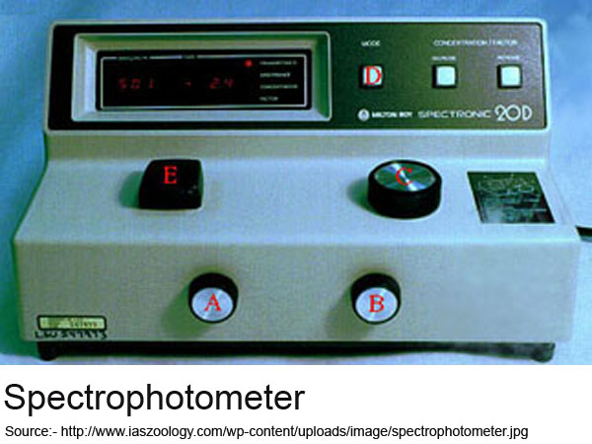

Design
The sequence of events in a modern spectrophotometer is as follows:

The light source shines on the sample.
A fraction of the light is transmitted or reflected from the sample
The light from the sample is directed to the entrance slit of the monochromator
The monochromator separates the wavelengths of light and focuses each of them onto the photodetector sequentially.
There are two kinds of spectrophotometers: single beam and double beam. A double beam spectrophotometer compares the light intensity between two light paths. One path containing a reference sample, the other holding the test sample. A single beam spectrophotometer measures the relative light intensity of the beam before and after a test sample is inserted. A double beam machine makes comparison readings easier and more stable. But a single beam machine can have measure a wider range of light frequencies. Single beam machines have simple optical systems and are more compact. When the spectrophotometer is built into another device (like microscopes or telescopes) only single beam machines will work.

Many older spectrophotometers must be calibrated by a procedure known as "zeroing." The absorbancy of a reference substance is set as a baseline value, so the absorbancies of all other substances are recorded relative to the initial "zeroed" substance. The spectrophotometer then displays % absorbancy (the amount of light absorbed relative to the initial substance).

Spectrophotometers can also measure luminescence. For example, the machine can shine ultraviolet light of one frequency on the sample. This will excite the sample and make it glow. The detectors can then measure the light glowing from the sample at a different frequency.
Auto Analyzer

Auto Analysers are advanced machines designed to measure different chemicals and other characteristics in a number of biological samples quickly, with minimal human assistance.
These measured properties of blood and other fluids may be useful in the diagnosis of disease.
Many methods of introducing samples into the analyser are in use. This can involve placing test tubes of sample into racks, which can be moved along a track, or inserting tubes into circular carousels that rotate to make the sample available. Some analysers require samples to be transferred to sample cups. However, the effort to protect the health and safety of laboratory staff has prompted many manufacturers to develop analysers that feature closed tube sampling, preventing workers from direct exposure to samples.
Samples can be processed singly, in batches, or continuously.
The automation of laboratory testing does not remove the need for human expertise (results must still be evaluated by medical technologists and other qualified clinical laboratory professionals), but it does ease concerns about error reduction, staffing concerns, and safety.
Depending upon the extent of human involvement in operatin steps, an Auto Analyzer may be Semiautomatic (Semi Autoanalyzer) or fully automatic.
STANDARDISATION AND QUALITY CONTROL
Certain amount of quality control is mandatory. However, contrary to the popular belief, level of quality control expected in most biochemical estimations is not very high. Would it affect the treatment much if a laboratory reports blood sugar as 325 mg/dl or 375 mg/dl ? With such acceptability of variation, standardisation poses little problems. Standard reading for the purpose of calculation can be deduced, without making one's own standard solution in a variety of convenient ways :-
- Use of standard solution from a reputed manufacturer.
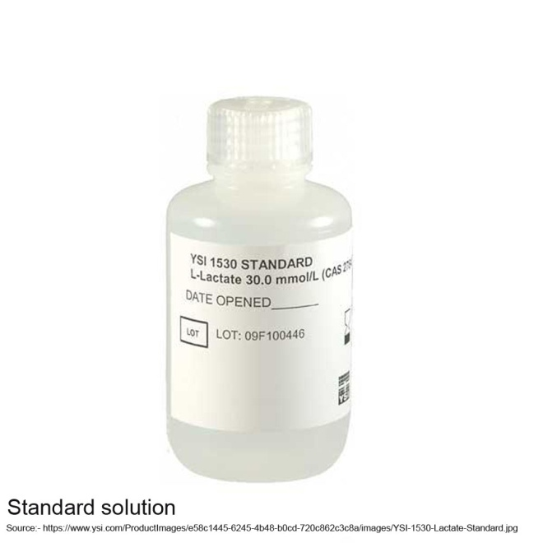
- Use of assayed control serum. Lyophilized serum with accompanying assay report is commercially available. After fresh reconstitution, it may be used in place of standard.
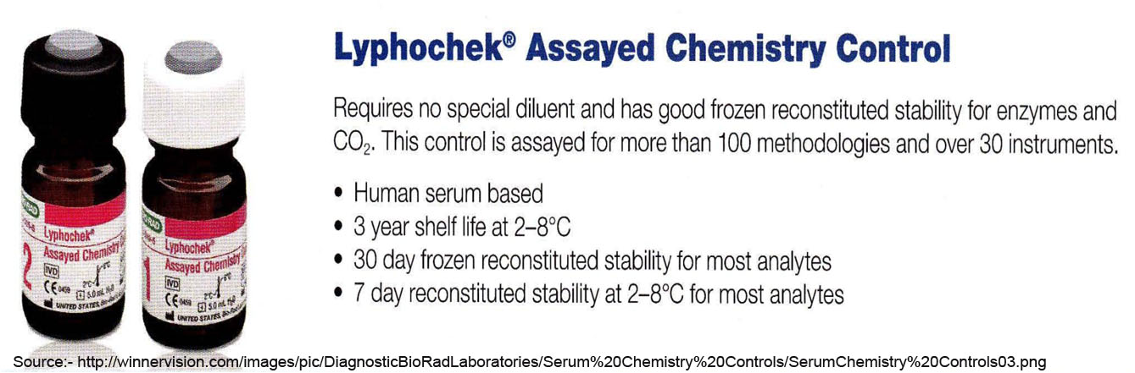
3. Standard average. If a dozen or more serum samples are pooled up during the day, its chemical composition is fairly constant with little day to day variation. If average values for a week or a month are accounted, the variations may be negligible. Thus the left out portions of samples may be pooled up to serve as a standard. In case deviations upto 5% are to be condoned, this method may be most useful.
4. Use of a sample analysed at a reliable source, as a standard.
Preparation of standard
Once the standard reading has been deduced as above, standard solution can be conveniently prepared without accurate weighing. All one requires is to prepare a solution of slightly higher concentration, determine its concentration and dilute the solution to desired concentration.
A standard solution may not neccessarily contain the substance to be determined. A standard solution aims at producing the same colour as the sample being tested. Such colour may be produced by :-
1. The solution containing the substance to be determined.
2. The solution of a substitute chemical which produces identical colour in the procedure.
3. Use of comparison solution with the same colour as produced in the reaction.
Most unstable standards can be substituted as in 2 above. Alternatively when original standard is not stable and no substitute is known, comparison solution can be used.
For example, bilirubin standard has to be prepared fresh. α-naphthol can be used as substitute standard. Alternatively a comparison solution can be prepared from methyl red, cobalt sulphate, etc.
NORMAL VALUES
It is customary to quote normal values in the investigation reports. The stated normal values help the clinician differentiate normal from abnormal results. Normal values or reference values are influenced by several factors, including quality of performance, technique adopted, geographical position, dietary habits, sample collecting technique, and many more. Nevertheless the books ori clinical subjects, some of those with cosmopolitan distribution, give a list of normal values with no reference to standard conditions or variation factors.
Obviously it is mandatory for the clinician to follow the normal values printed in the report form.
Normal values are derived on the basis of tests conducted upon healthy individuals under standard conditions. Obviously
this is possible only in large institution. At least 1000 normal samples should be examined to make the study of any use.
The values obtained are arranged in a scale with small interval. Their cumulative frequency and cumulative percentile are tabulated as in accompanying table.
Table 1.2. Calculation of normal values of fasting blood (glucose in 1500 healthy subject (16-40 years)
Serum glucose mg/dl | Number of samples | Cumulative frequency | Cumulative percentile
56-60 | 4 | 4 | 0.3
61-65 | 9 | 13 | 0.9
66-70 | 25 | 38 | 2.5
71-75 | 46 | 84 | 5.6
76-80 | 71 | 155 | 10.3
81-85 | 132 | 287 | 19.1
86-90 | 235 | 522 | 34.8
91-95 | 426 | 948 | 63.2
96-100 | 189 | 1137 | 75.8
101-105 | 141 | 1278 | 85.2
106-110 | 96 | 1374 | 91.6
111-115 | 42 | 1416 | 94.4
116-120 | 21 | 1487 | 99.1
121-125 | 13 | 1500 | 100
The values between percentile 2.5 and percentile 97.5% are considered, as normal values. Thus in the table, percentile 2.5 corresponds to 70 mg/dI and percentile 97.5 corresponds to 118 mg/dI, Thus the calculated normal values are 70-118 mg/dI.

Links/Further reading
Laboratory Hazards
Sample Collection and Storage
Practical Points For Collecting Blood, Urine and Stool Samples in Children
Jacobs D Demott W et al. Laboratory Test Handbook 4 edition. Lexi-Comp Inc. Hudson Ohio. 1996. pages 117-118.
Pincus MR Preuss HG Henry JB. Chapter 7 pages 139-161 (141-143). IN: Henry JB (editor-in-chief). Clinical Diagnosis and Management by Laboratory Methods 19 edition. WB Saunders. 1996.
Young DS. Implementation of SI Units for Medical Laboratory Data. Ann Intern Med. 1987; 106:114-129 page 121.

Chapter 3 : Carbohydrates
Blood sugar estimation is the single most frequent biochemical test in clinical laboratory. For decades, blood sugar was estimated with alkaline copper reduction methods. With the advent of more specific methods for glucose viz o'toluidine method and enzymatic methods, continued use of copper reduction methods should be deplored.
o'Toluidine Method
o'Toluidine in strong acidic solution reacts with glucose at high temperature with formation of glycosylamine which on further rearrangement develops into blue coloured Schiff's base.
o'Toluidine is a yellow coloured liquid which, on continued exposure to atmosphere, develops dark brown colour due to oxidation. Thus for reagent making o' toluidine has to be freshly distilled. Alternatively a colour-stabilized preparation from SIGMA may be used, various forms of o' toluidine reagent may be used either directly with serum or with deproteinised serum.
Reagents
1. The simplest form of o'toluidine reagent is a mixture of 100 ml glacial acetic acid and 4 ml o'toliudine (colour stabilized). The reagent should be prepared fresh for daily use. If a pinch of thiourea is added, the reagent may be used for several days.
2. A more refined form of the reagent can be produced with the following steps :-
(i) Pour 25 g borax crystals into a 500 ml glacial acetic acid bottle. Keep for a few hours till borax settles down leaving a clear supernatant.
(ii) Decant 100 ml clear supernatant liquid into a fresh dry glass bottle (amber-coloured). Add 4 ml o'toluldine and about 1 g thiourea. Shake to mix for immediate use or wait till next day.
(iii) Fill up the acetic acid bottle again with more acetic acid for subsequent use. More borax crystals may be added when necessary.
The reagent can be used for several months.
The reagents described are for use with serum without deproteinisation. For use with deproteinisation step, 6 ml o'toluidine should be added in place of 4 ml.
3. Mix 40 ml o'toluidine with 350 ml glacial acetic acid. Slowly add 110 ml aqueous solution of 6 g borax (decahydrate).
Finally add 1.5 g thiourea and keep for a day. The reagent is stable for a month and can be used only with deproteinized sample.
4. Dissolve 110 g malic acid and 110g glycollic acid in about 700 ml methyl cellosolve (ethylene glycol monomethyl ether). Add 85 ml o'toluidine. Make to a litre with methyl cellosolve. The reagent can be used with deproteinised serum and a blank reading is also necessary.
Standard
Glucose 100 mg/dI may be prepared as follows :-
1. Primary standard
Weigh accurately 100 mg glucose, AR grade. Dissolve it in about 60 ml benzoic acid 0.1 % and dilute with the acid to 100 ml.
2. Matched standard
(i) Weigh approximately 125 mg glucose, LR grade and dissolve it in 100 ml benzoic acid 0.1%. Determine glucose content against assayed control serum or standard at hand. Dilute to 100 mg/dl.
(ii).0.25 ml dextrose 5% solution from a used infusion bottle, may be taken in place of 125 mg glucose powder.
Acetic acid freezes at 18oC and the reagents containing acetic acid must not be refrigerated. During extreme winter, the reagent bottle should be inspected for.any freezing before use.
In tightly closed bottles, the standard solution., need not be refrigerated. When in use vaporisation of water can be prevented with storage in refrigerator.
Procedure
o'toluidine reagents have a uniform procedure not affected by change in formulation. However, some reagents can be used on deproteinised serum, others can be used direct.
Direct method
1. Take 5 ml reagent in a test tube.
2. Add 0.1 ml serum or plasma.
3. Put in boiling water for 10 minutes and cool.
4. Read absorbance against water adjusted to zero with orange red filter (620-650 nm).
Table 2.1. Direct o'toluidine method
 | Test | Standard
Reagent | 5 ml | 5 ml
Serum | 0.1 ml | -
Standard | - | 0.1 ml
 | Place in boiling water for 10 minutes and read absorbance at 630 nm
For standard, use 0.1 ml standard in place of sample and proceed as in the test. In case the reagent is not colourless, a blank reading should also be taken processing 5 ml reagent alone. Even light yellow reagents also give nil blank so that blank reading is seldom necessary.
Method with deproteinisation
1. Mix 0.2 ml serum (or plasma) with 0.8 ml trichloroacetic acid 6-10%.
2. Centrifuge to get a firm deposit. Transfer the clear supernatant into another tube.
3. Mix 0.5 ml supernatant with 4.5 ml reagent.
Table 2.2. o'toluidine method with deproteinization
 | Test | Standard
TCA 6% | 0.8 ml | 0.8 ml
Serum | 0.2 ml | -
Standard | - | 0.2 ml
 | Mix well and centrifuge. Proceed as follows with fresh tubes:-
Reagent | 4.5 ml | 4.5 ml
Supernatant | 0.5 ml | 0.5 ml
 | Place in boiling water for 10 minutes and read absorbance at 630 nm
4. Put in boiling water for 10 minutes and proceed further in direct method.
For standard, take 0.2 ml standard in place of serum and for blank , take 0.5 ml trichloroacetic acid hi place of supernatant.
Calculation
Abs test (- Abs blank)
Glucose = -------------------------- x 100 mg/dl
Abs test (- Abs std)
Enzymatic method
The enzyme glucose oxidase oxidises glucose to form gluconic acid and hydrogen peroxide.
Glucose + 2H20 + 02 = Gluconic acid + 2 H202
Peroxidase enzyme decomposes hydrogen peroxide liberating oxygen.
Peroxidase
2 H2O2 ---------------- 2 H2O + 02
The liberated oxygen oxidizes phenol to form a compound which gives red coloured complex with 4-aminoantipyrine.
Reagents
1. Glucose oxidase reagent. Dissolve 4.25 g disodium hydrogen phosphate (Na2HPO4) and 2.65 g potassium dihydrogen phosphate (KH2PO4) in about 400 ml water. Adjust pH to 7.0 by adding a little 1N sodium hydroxide or hydrochloric acid, Dilute to 500 ml with water.
Add 175 mg 4-aminophenazone and 2 ml peroxidase (200 units/ml). Shake to dissolve. The reagent to this stage is stable for four weeks in refrigerator.
Add 2 ml glucose oxidase (1000 units/ml). The final reagent is stable for a week.
2. Phenol 0.2% in isotonic saline, stable at room temperat:ure for several months.
3. Standard. As in o'toluidine method.
Procedure
1. Mix 0.1 ml serum with 2.5 ml glucose oxidase reagent and 2.5 ml phenol reagent.
2. Shake moderately to aerate and put in water bath at 37oC for 10 minutes. Cool.
3. Read absorbance against water adjusted to zero with bluish green filter (500-520 nm).
Table 2.3 Enzymatic Method
 | Test | Standard | Blank
Glucose oxidase | 2.5 ml | 2.5 ml | 2.5 ml
Phenol reagent | 2.5 ml | 2.5 ml | 2.5 ml
Serum | 0.1 ml | - | -
Standard | - | 0.1 ml | -
 | Incubate at 37ºC for 10 minutes. Read absorbance at 510 nm.
For standard, take 0.1 ml standard in place of serum and for blank, omit addition of serum.
Calculation
Abs. test-Abs. blank
Glucose = -------------------------------- x100 mg/dl
Abs. std.-Abs. blank
FOLIN-WU METHOD
Copper sulphate in alkaline copper reagent is reduced by glucose to form cuprous oxide (Cu₂O). The unstable cuprous oxide reduces phosphomolybdate to molybdenum blue which is measured with colorimeter.
CuSO₄ + Glucose => Cu₂O
Cu₂0 + Phosphomolybdate => CuO + Molybdenum blue
Reagents
1. Sodium tungstate dihydrate 10%
2. Sulphuric acid 2/3 N
3. Alkaline Copper Reagent. Dissolve 7.5 g tartaric acid in 200 ml 10% sodium carbonate (Na₂ CO₃). Add 4.5 g copper sulphate pentahydrate. Shake to dissolve and make to 1 L with water. Filter.
4. Phosphomolybdate reagent. Add 3.5 g molybdic acid and 5 g Sodium tungstate dihydrate in about 200 ml water. Add 200 ml sodium hydroxide 10%. Heat to dissolve and boil for 40-50 minutes to remove ammonia (impurity) Cool. and, add 125 ml phosphoric acid (85%) very slowly. Make the volume to 500 ml with water.
5. Standard. as in o' toluidine method.
Procedure
1. Mix 0.2 ml anticoagulated blood (with oxalate-fluoride or E.D.T.A.-fluoride) with 3.4 ml water, 0.2 ml sodium tungstate 10% and 0.2 ml sulphuric acid 2/3 N.
2. Keep for 10 minutes and check the colour which should be dirty chocolate. If the colour is reddish or if the supernatant is not colourless, the acid is inadequate. In that case, add a drop of sulphuric acid 20%.
Table 2A. Folin-wu method
 | Test | Standard | Blank
Blood | 0.2 ml | - | -
Standard | - | 0.2 ml | -
Water | 3.4 ml | 3.4 ml | 3.6 ml
Sodium tungstate | 0.2 ml | 0.2 ml | 0.2 ml
Sulphuric acid | 0.2 ml | 0.2 ml | 0.2 ml
 | Centrifuge for 10 minutes and take in fresh tubes
Supernatant | 2 ml | 2 ml | 2 ml
Alkaline copper | 2 ml | 2 ml | 2 ml
 | Introduce air bubbles. Place in boiling water for 10 minutes
Phosphomolybdate | 2 ml | 2 ml | 2 ml
Water to make | 25 ml | 25 ml | 25 ml
 | After 45 minutes, read at 530 nm
3. Centrifuge to get firm deposit and transfer the clear supernatant into another tube.
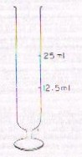
Fig.3-1 -Folln-Wu tube
4. Take 2 ml supernatant in a Folin-Wu tube. Add 2 ml alkaline copper reagent.
5. Introduce air bubbles into bulb of the tube with the help of a glass pipette. Shake to mix.
6. Put in boiling water for exact 10 minutes and cool.
7. Add 2 ml phosphomolybdate reagent. Wait till gas bubbles cease.
8. Add water upto 25 ml mark and mix by inversion.
9. After 45 minutes, read absorbance against water adjusted to zero with green filter (520-540 nm).
For standard, take 0.2 ml standard and for blank, take 0.2 ml water in place of blood.
Note :- (i) If the colour intensity in the final solution is expected to be poor, make the volume 12.5 ml in place of 25 ml and divide the result with 2.
(ii) If the blood sugar is beyond 200 mg/dI, the estimation should be performed after appropriate dilution.
(iii) The heating time must be exact, the colour intensity varies with time.
Calculation
Abs. test-Abs. blank
Glucose = ------------------------------- x 100 mg/dl
Abs. std.-Abs. blank
NELSON'S METHOD
This method is more specific for sugars than the preceding one. Blood is deproteinised with barium hydroxide-zinc sulphate mixture. Arsenomolybdate is used in place of phosphomolybdate. The principle is same as with Folin-Wu method.
Reagents
1. Zinc sulphate (ZnSO₄. 7 H₂0) 5% in water.
2. Barium hydroxide 3%. Dissolve 3 g barium hydroxide anhydrous or 5.6 g its octahydrate in about 80 ml boilng water and stopper. When cool, make to 100 ml with water and filter.
Keep the reagent stoppered to protect it from atmospheric carbon dioxide.
3. Alkaline copper tartarate. Dissolve 24 g sodium carbonate (Na₂CO₃) and 12 g sodium patassium tartarate in about 250 ml water. Slowly add, with constant stirring, 4 g copper sulphate (pentahydrate) dissolved in about 50 ml water. Shake to mix and add 16 g sodium bicarbonate. When it dissolves, add 500 ml sodium sulphate (anh.) 36%. Filter and store above 20ºC.
4. Arsenomolybdate reagent. Dissolve 25g ammonium molybdate in about 400 ml water. Add 2 litres conc. sulphuric acid, Mix and add 8 g disodium hydrogen arsenate (Na₂HAsO₄.7H₂O) dissolved in about 25 ml water. Mix, make to 500 ml with water and incubate at 37_{o}C for 24-48 hours. Keep the reagent in glass stoppered bottle.
5. Standard. Glucose 100 mg/dl in benzoic acid 0.1%.
Procedure
1. Mix 0.1 ml whole blood, with 3.5 ml water. Add 0 2 ml barium hydroxide and 0.2 ml zinc sulphate.
2. Shake to mix and centrifuge. Transfer clear supernatant into another tube.
3. Mix 1 ml supernatant with 1 ml water and 2 ml alkaline copper tartarate.
Table 2.5. Nelson's method
 | Test | Standard | Blank
Blood | 0.1 ml | - | -
Standard | - | 0.1 ml | -
Water | 3.5 ml | 3.5 ml | 3.6 ml
Barium hydroxide | 0.2 ml | 0.2 ml | 0.2 ml
Zinc sulphate | 0.2 ml | 0.2 ml | 0.2 ml
 | Centrifuge
Supernatant | 1 ml | 1 ml | 1 ml
Water | 1 ml | 1 ml | 1 ml
Alkaline copper | 2 ml | 2 ml | 2 ml
 | Place in boiling water for 10 minutes and cool.
Arsenomolybdate | 1 ml | 1 ml | 1 ml
Water to make | 10 ml | 10 ml | 10 ml
 | Read absorbance at 660 nm
4. put in boiling water for 10 minutes.
5. Cool rapidly and add 1 ml arsenomolybdate reagent.
6. Make upto 10 ml with water.
7. Read absorbance against water adjusted to zero with red filter (650-700 nm).
For standard, take 0.1 ml standard and for blank, take 0.1 ml water in place of blood.
Calculation
Abs. test-Abs. blank
Glucose = -------------------------------- x 100 mg/dl
Abs. std.-Abs. blank
COMMENT ON METHODS
Alkaline copper reduction methods for blood sugar estimation have been used for over six decades. Though Nelson's method is fairly specific for sugars, none is specific for blood glucose. With no other method available, the clinicians were aware of about 20% over-estimation with Folin-Wu method and thus the error was neutralized.
Folin-Wu method and Nelson's method are still used in several laboratories. The two factors contributing to their sustained use are :
1. The reagents can be conveniently prepared at the laboratory and are thus very economical in comparison with commercial kits using other methods.
2. Many technicians never had any institutional training. This methods have been propagated through successive teaching.
Use of alkaline copper reduction methods in modern age must be deplored. Such methods are no longer described in textbooks from more advanced countries. With the availability of o'toluidine (color-stabilized), o'toluidine reagent is both easier as well as more economical to make.
Of late, inclination to use enzymatic methods in biochemcial estimation has been increasing. The only plus factor with glucose oxidase method, however is absence of heating step. The reagent cannot be prepared at an average laboratory. Also a part of glucose, firmly bound to proteins, escapes the oxidase reation. Thus the results may be considerably lower. Poor stability of the reagent also makes it less suitable than o'toluidine reagent.
Apart from glucose, o'toluidine, gives colour reaction with xylose and galactose. The former is not present in normal blood and galactose level in the adult is too little to interfere. Because of galactose interference, o'toluidine method cannot be used with neonate blood.
INTERPRETATION
Fasting glucose concentration in serum or plasma is 70-110 mg/dl. Mainly because of difference in water level in cells and plasma, whole blood sugar is about 15% lower.
In diabetes mellitus glucose levels may rise upto 500 mg/dl. In pancreatic disease, levels upto 150 mg/dl may be found. Some increase may occur in infectious diseases, intracranial diseases and after anaesthesia.
Depressed glucose levels may be found in insulin overdosage, hypothyroidism, hypoadrenalism, hypopituitarism and glycogen srorage disease. Values as low as 20 mg/dl may be found in pituitary and adrenal deficiencies.
TOLERANCE TESTS
Factors affecting tolerance tests
1. Regular mixed diet, without carbohydrate restriction should be consumed during three days prior to the test. Excessive carbohydrates in the diet produce low curves; carbohydrate starvation produces high curves.
2. Physical activity. Bed rest may influence the test. If possible, the test should be performed on ambulatory patients.
3. Illness. Infections, surgery and injuries may influence tolerance tests. At least a week recovery period should be allowed before the test.
4. Drugs. Oral contraceptives, other hormones, salicylates, thiazide diuretics, insulin and oral hypoglycaemics affect the test outcome. Drugs should be stopped a week earlier. If hypoglycaemics must be administered, their effect upon the test should be kept in mind.
5. Pregnancy and endocrine disorders also influence the test. In endocrine deficiency, the test results may be suggestive
more of the endocrine disorder than of diabetes mellitus.
Oral glucose telerance test
The test is best performed around 7-9 AM after a fasting period of 8-16 hours. No alcohol should be consumed during the evening before. Water intake is not restricted during fasting period.
Glucose powder, calculated as 1 g per kg body weight, is dissolved in about 300 ml water with lemon juice or other fravouring substance. The glucose solution is consumed within 5 minutes and the time recorded. Blood samples and and urine samples are
drawn for sugar testing before consuming the the solution and ½, 1, 1½, 2, 3 hours thereafter. The test may at times be extended to 5 hours. Blood sugar in each sample is estimated with o'toluidine method or enzymatic method and urine sugar with Benedict's qualitative method described later in this chapter. A graph of glucose levels against time is plotted.
Interpretation
Diagnosis of diabetes mellitus is considered if any of the values exceeds the following limits :
1 hour level | 185
1½ hour level | 165
2 hour level | 140
3 hour level | 120
The oral glucose tolerance curves are suggestive also of some other disorders apart from diabetes mellitus. The expected values are given in the following figure.
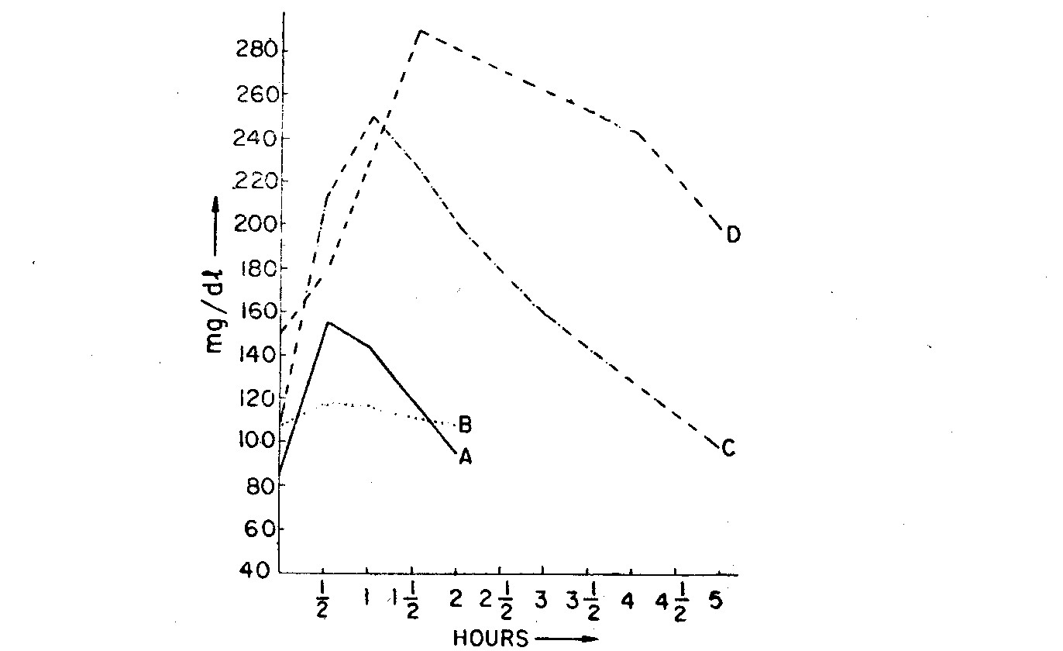
Fig. 3.2 Glucose tolerance curves
Intravenous glucose tolerance test
Oral glucose tolerance test for diabetes is not useful in sprue, coeliac disease, hypothyroidism, thyrotoxicosis and in patients with gastric resections.
Glucose, 0.5 gram per kilogram body weight up to a maximum of 35 grams, is administered intravenously in the form of glucose 25% solution within 1-2 minutes.
Glucose levels are drawn fasting and then 3 5 10 20 30 45 and 60 minutes after the infusion is complete. Occasionally plasma insulin levels are drawn at 2 3 and 5 minutes after the infusion is complete.
Interpretation
Shortly after the infusion transient glucose concentrations up to 250 mg/dl can be seen in normal individuals but fasting glucose levels will be achieved by 90 minutes with subfasting levels at 120 minutes and return to fasting levels at 180 minutes. Transient glucosuria can be seen right after the infusion since the renal threshold for glucose will be exceeded.
The rate in decrease in glucose levels is then determined. Blood glucose levels tend to decrease exponentially.
• normal adults under 50 years of age show a mean rate of glucose disappearance of 1.5% per minute
• normal adults over 50 years of age will show a mean rate of glucose disappearnce which declines with the age over 50 (about 0.09% per decade)
• diabetics show a mean rate of glucose disappearance of < 1% per minute.
The rate of decrease can be measured in several ways. Methods include:
• rate of disappearance of glucose expressed as a percent per minute of the 10 minute level (take 10 minute level as 100% and then the subsequent levels as percentages).
• semilogarithmic rate of decline of glucose from 10 to 30 minutes.
A commonly example of the first method is the equation:
rate of disappearance of glucose in % per minute =
= 70 / (number of minutes required for the blood glucose level to decrease to half of the 10 minute level)
Another variant of Intravenous glucose tolerance test (IGTT) is uncommonly used. Patients are given a known amount of glucose by vein for three minutes, and blood insulin levels are measured before glucose and at one and three minutes. Insulin is the hormone produced by the pancreas that moves glucose from the bloodstream into cells. Insulin levels below a standard threshold are predictive of Type 1 ("insulin-dependent") diabetes in some patients.
Cortisone stress test
The test is used to detect latent diabetes where both fasting as well as post prandial urine samples are sugar free. One obvious advantage is elimination of blood sugar estimation.
Three doses of prednisolone 25 mg (0.4 mg/kg for children) are given orally at 12 noon, 4 P.M. and 8 P.M. Bladder is emptied at 10 P.M. and urine discarded. Subsequently urine passed till 6 AM is pooled up, the bladder being again emptied into the pool at 6 AM. Urine is tested for sugar.
While larger doses reduce glucose tolerance and produce glycosuria in normal persons, the suggested dose induces glycosuria only in cases of diabetes mellitus.
Postprandial glucose estimation
This is used as abridged glucose tolerance test for screening purposes. Fasting glucose estimation may be omitted.
After taking a meal, blood sample is drawn at two hours. Levels beyond 140 mg/dl suggest the need for further investigation. At 50-60 year age, the acceptable level is upto 160 mg/dl and in older persons, 180 mg/dl
TESTS USED IN HYPOGLYCAEMIA
Tolbutamide test
The test is used for the diagnosis of insulin producing tumours. While negative test is almost conclusive, positive test may result also from other conditions. Intravenous tolbutamicle is used in the procedure.
After an overnight fast, tolbutamide 1 g or sodium tolbutamide 1.8 g in 20 ml is injected slowly over two minutes. Blood samples are drawn at 10, 20, 30, 45, 60, 90, 120, 180 minutes thereafter.
Interpretation
Blood glucose falls to about 50% of initial value in 30-45 minutes. It then returns to 75% of initial value in 2-3 hours.
The test is considered positive if after a normal fall, the blood glucose rises only slightly. Apart from insulin producing tumours, the test is positive also in idiopathic hypoglycaemia of childhood, alcohol-induced hypoglycemia, severe malnutrition and liver disease.
Plasma insulin may also be estimated on blood samples during first hour. Increased values indicate insulin producing tumours.
Glucagon test
In a overnight fasting patient, fasting blood sample is drawn. Glucagon 1 mg is injected intramuscularly in dose of 1 mg or 0.3 mg/kg body weight (whichever is less). Blood sample is drawn every 30 minutes for three hours.
In normal person, blood glucose rises by 30-90 mg/dl and 1alls to fasting level in 2-3 hours. A greater initial rise occurs in insulin-producing tumour when subsequent fall is normal. A smaller rise occurs in glycogen storage disease, liver disease, and endocrine disorders.
Leucine sensitivity test
In a overnight fasting patient, blood sample is drawn. Leucine 150 mg/kg body weight suspended in water is given by mouth. Further blood samples are drawn every 15 minutes during next hour. Plasma insulin may also be determined alongwith glucose.
In normal persons, blood glucose falls slightly. A fall exceeding 40% within half an hour in majority of insulin-producing tumours and idiopathic hypoglycaemia of childhood. Plasma insulin rises in these two conditions.
Insulin tolerance test
The patient is put on diet containing at least 300 g carbohydrate daily for 2-3 days. On the day of test, a fasting blood sample is drawn. Insulin 0.1 unit/kg body weight is administered intravenously. Blood samples are drawn 20, 30, 45, 60, 90, 120 minutes after the injection.
Interpretation
In normal persons, blood glucose falls to about half the lasting level in half an hour. It returns to fasting level at 90-120 minutes.
Abnormal response of two types may be observed :
1. A relatively slight or delayed fall (insulin resistance) in blood glucose may be obtained in diabetes mellitus, Cushings' syndrome, acromegaly and occasionally in rheumatiod arthritis. .
2. A normal or even higher fall with subsequent delayed or no rise occurs in Simmond's disease, Addison's disease and hyperinsulinism.
REDUCING SUBSTANCES IN URINE
Normal renal threshold for blood sugar is about 180 mg/dl,. which is almost the maximum normal postprandial blood glucose level in old age. Beyond this level, glucose appears in urine. Thus the diabetic control in elderly patients may rest solely on, urine examination.
The common Benedict's qualitative teit for urine sugar gives: colours also with substances other than glucose viz. fructose, pentose, lactose, glucuronic acid, salicyluric acid and homogentisic acid. The presence of these substances has to be excluded before Benedicts' test is relied upon.
Benedict's qualitative test
Reagent
Dissolve by heating 100 g sodium carbonate (anh.) and 173 g,, sodium citrate (trihydrate) in about 750 ml water. Add slowly, with constant shaking, 100ml copper sulphate solution containing17.3 g pentahydrate crystals. Make the volume to I L with water and filter.
Procedure
Mix 0.5 ml (8 drops) urine with 5 ml Benedict's solution in a boiling test tube. Heat to boil and continue heating further for two minutes. Cool and observe colour of precipitate formed, if any.
The reagent should be frequently checked by heating alone, when it should not change colour.
Interpretation
Colour | Sugar %
Green | 0.5%
Yellow | 1%
Orange | 1.5%
Red | 2% and above
Tablet and stick tests
Clinitest tablets (Ames), can ,be used in place of Benedict's qualitative test.
The tablets contain copper sulphate, sodium carbonate, citric acid and sodium hydroxide. In a test tube 5 drops each of urine and water are delivered with a standardised dropper. Then a tablet is dropped. The mixture evolves carbon dioxide which facilitates mixing. Heat is produced during reaction of sodium hydroxide with citric acid. -
Copper sulphate is reduced by sugars in urine to orange red cuprous oxide (Cu₂0). The colour produced is matched with the Chart.
Diastix and Uristix sticks are based upon enzymatic method. The stick is dipped into urine and the colour developed compared with a chart.
Tests for fructose
1. Selivanoff test. Fructose on boiling with concentrated hydrochloric acid is converted into oxymethyl furfurol which forms red colour with resorcinol.
Reagent. Dissolve 50 mg recorcinol in 33 ml conc. hydrochloric acid. Dilute to 100 ml with water.
Procedure. Mix about 0.5 ml urine with about 5 ml reagent in a test tube. Heat to boil.
In presence of fructose, red colur develops within 30 seconds. Glucose interferes in the test and higher levels may produce same colour.
2. Indole test. On heating with concentrated hydrochloric .acid, indole-3-acetic acid produces intense purple colour.
Reagent. Dissolve 500 mg indole-3-acetic acid in 100 ml 95% ethanol. The reagent is stable in refrigerator for about 2 weeks. Discard when coloured.
Procedure. Mix 0.1 ml urine with 0.5 ml reagent. Add about 4 ml conc. hydrochloric acid. Observe after half an hour.
Fructose gives purple colour. The test is specific for fructose.
Quantitative test
The same reagent may be used for quantitative estimation. Mix 0.1 ml urine with 0.5 ml reagent. Four over it 5 ml concen-
trated hydrochloric acid. Incubate at 60'C for 75 minutes. Cool rapidly and shake. Read absorbance against water adjusted to zero at 540 nm.
For standard use fructose 100 mg/dl in 0.1% benzoic acid and also take blank reading with the reagents treated similarly.
A stable reagent available as Semen Fructose Estimation kit may also be used.
Test for pentoses
Bial's test. Hydrochloric acid reacts with pentose to yield furfurol which gives green colour with orcinol.
Reagent. Dissolve 200 mg orcinol with 100 ml conc. hydrochloric acid. Add 5 drops of 10% ferric chloride.
Procedure. Heat 5 ml reagent to boiling point. Remove from flame and add 1 ml urine drop by drop. Pentoses give green colour whereas fructose gives red colour.
Tests for lactose
1. Woehlk's test. In highly alkaline solution, lactose reacts. with potassium hydroxide to form red colour.
Procedure. To 5 ml urine, add 2.5 ml liquid ammonia and 5 drops of 15% potassium hydroxide. Serum in hot water just below boiling point. Observe for red colour.
2. Fearon's test. The test is based upon the same principle as the preceding one. Methylamine is used in place of potassium hydroxide.
Procedure. To about 5 ml urine add 1 ml methylamine hydrochloride 0.2% followed by 0.2 ml sodium hydroxide 10%. Mix and incubate at 56ºC for 30 minutes. Then keep at room temperature.
In presence of excess lactose, red colour appears before incubation period ends, increases on standing and reaches peak in one hour. In presence of small quantities, colour develops only on standing for an hour.
The test is positive also with reducing disaccharides and maltose. Yellow colour produced by other constituents should be ignored.
Test for glucuronic acid
Mix 5 ml each of urine and concentrated hydrochloric acid.. Add 1 ml naphthoresorcinol reagent (1% in 95% ethanol). Boil with shaking for a minute and cool at room temperature. Add 10 ml ether. Mix by repeated inversions and allow ether layer to separate.
Glucuronic acid and pentoses give red-violet colour. Absence of pentoses can be confirmed with negative Bial test.
Test for salicyluric acid
Salicyluric acid is a metabolite of salicylates. Its presence can be detected by adding to urine, ferric chloride 10% drop by drop. A Precipitate may form first due to phosphates; on further addition of ferric chloride, reddish purple colour develops.
Tests for homogentisic acid (alcaptonuria)
Alcaptonuria results from a defect in metabolism of tyrosine due to congenital absence of an enzyme, homogentisate 1-2-dioxygenase. It is detected with following methods :
1. Urine darkens in colour, on standing, from surface downwards.
2. A greenish brown or black colour develops in Benedict's qualitative test for sugars. On keeping the mixture, yellow cuprous oxide precipitate settles down to the bottom.
3. When a few drops of liquid ammonia are added to a mixture of 0.5 ml urine and 5 ml silver nitrate 3%, a black colour develops. The test should be conducted without direct sunlight.
4. Ferric chloride test, performed as for salicyluric acid, gives a transient blue or green colour. Phenylketonuria also gives the same colour and can be differentiated on the basis of first two tests above.
SUGAR ESTIMATION IN URINE, CSF, SEMEN
Urine glucose
Urine glucose is estimated with o'toluidine method or with enzymatic method described for blood glucose estimation. Urine glucose should first be tested with Benedict's qualitative method and appropriately diluted to about 200 mg/dl before quantitative determination.
Normal values. Upto 30 mg/ dl.
C.S.F. glucose
Glucose in cerebrospinal fluid is also determined with blood glucose methods.
Interpretation
The glucose level in normal lumbar C S.F. is 45-70 mg/dl; in ventricular C.S.F. The normal level is about 80 mg/dl.
Raised in encephalitis, epilepsy, tetany, chorea, cerebral tumours, cerebral abscess, cerebral haemorrhage, apoplexy, febrile states, hypertension, diabetes mellitus, nephritis, uraemia, menstruation and pregnancy.
Depressed in pyogenic meningitis, tubercular meningitis, acute syphilis (stage 2), progressive paralysis and hypoglycemia.
Semen fructose
Fructose is secreted by seminal vesicle. Its estimation in semen is useful in assessment of male fertility and in operations on vas deferens.
Reagents
1. Trichloroacetic acid 10%.
2. Serum. Any serum sample with low bilirubin and glucose may be used. Serum facilitates coprecipitation of semen proteins.
3. Indole reagent. Dissolve 525 mg indole-3-acetic acid in 100 ml 95% ethanol. Store in refrigerator and discard on discoloration.
4. Hydrochloric acid, concentrated.
5. Fructose standard 200 mg/dI in benzoic acid 1%.
Procedure
1. Mix 0.1 ml semen, 0.1 ml serum and 1 ml trichloroacetic acid in a centrifuge tube. After 10 minutes, centrifuge to get a firm deposit. Transfer the supernatant into another tube.
2. Mix 0.25 ml supernatant with 0.25 ml indole reagent. Add 5 ml hydrochloric acid. Shake to mix.
3. Incubate at 37ºC for 75 minutes. Cool rapidly and shake.
4. Read absorbance against water adjusted to zero with green filter (520-550 nm).
For standard, take 0.1 ml standard and for blank, take 0.1 ml water in place of semen.
Calculation
Abs. test - Abs. blank
Fructose = -------------------------------- x 200mg/dl
Abs. std. - Abs. blank
Comment
The method is slightly cumbersome, particularly at infertility clinics where serum investigations may not be performed. Blank reading is high and increases during the short stability period of indole reagent.
A stable reagent without deproteinization step is available in kit form (Maa Vaishno Diagnostics).
Interpretation
When freshly passed, semen is viscid and takes time to liquefy. In order to maintain standard conditions, semen fructose is first determined at 30 minute sample. The normal values are 200 mg/dl and above.
Spermatozoa consume fructose as the source of energy. Fructose level thus falls over time and the drop is proportional to semen fertility. Semen fructose drop, at least 40% at four hours, is indicative of the adequate balance of total sperm count and sperm motility.
Absence of both spermatozoa and fructose in the semen indicates obstructive lesion distal to the ejaculatory duct. This may be used to assess the success rate in vasectomy as well as recanalization operation.

Links/Further reading
Methods for Measuring Insulin Sensitivity
Endocrinology & Metabolism
Glucose and Diabetes Mellitus
MonitoringGlycemic Control
Guthrie RA Guthrie DW et al. Standardization of the oral glucose tolerancetest and the criteria for diagnosis of chemical diabetes in children. Metabolism.1973;22:275-282.
Nelson RL. Oral glucose tolerance test: Indications and limitations.May Clin Proc. 1988;63:263-269.
O'Sullivan JB Mahan CM. Criteria for the oral glucose tolerance testin pregnancy. Diabetes. 1964;13:278-285.
Roche Biomedical Laboratories. The Comprehensive Clinical ReferenceInterpretive Guide. 1995. pages 464-465
Sacks DB. Chapter 22: Carbohydrates pages 928-1001 (951-952). IN: BurtisC Ashwood E. Tietz Textbook of Clinical Chemistry Second edition. W.B.Saunders Company. 1994.
Speicher C. The Right Test 2 edition. WB Saunders. 1993. page187
Tietz NW (editor). Clinical Guide to Laboratory Tests Third Edition.W.B. Saunders Co. 1995. pages 274-277

MonitoringGlycemic Control
Guthrie RA Guthrie DW et al. Standardization of the oral glucose tolerancetest and the criteria for diagnosis of chemical diabetes in children. Metabolism.1973;22:275-282.
Nelson RL. Oral glucose tolerance test: Indications and limitations.May Clin Proc. 1988;63:263-269.
O'Sullivan JB Mahan CM. Criteria for the oral glucose tolerance testin pregnancy. Diabetes. 1964;13:278-285.
Roche Biomedical Laboratories. The Comprehensive Clinical ReferenceInterpretive Guide. 1995. pages 464-465
Sacks DB. Chapter 22: Carbohydrates pages 928-1001 (951-952). IN: BurtisC Ashwood E. Tietz Textbook of Clinical Chemistry Second edition. W.B.Saunders Company. 1994.
Speicher C. The Right Test 2 edition. WB Saunders. 1993. page187
Tietz NW (editor). Clinical Guide to Laboratory Tests Third Edition.W.B. Saunders Co. 1995. pages 274-277

MonitoringGlycemic Control
Guthrie RA Guthrie DW et al. Standardization of the oral glucose tolerancetest and the criteria for diagnosis of chemical diabetes in children. Metabolism.1973;22:275-282.
Nelson RL. Oral glucose tolerance test: Indications and limitations.May Clin Proc. 1988;63:263-269.
O'Sullivan JB Mahan CM. Criteria for the oral glucose tolerance testin pregnancy. Diabetes. 1964;13:278-285.
Roche Biomedical Laboratories. The Comprehensive Clinical ReferenceInterpretive Guide. 1995. pages 464-465
Sacks DB. Chapter 22: Carbohydrates pages 928-1001 (951-952). IN: BurtisC Ashwood E. Tietz Textbook of Clinical Chemistry Second edition. W.B.Saunders Company. 1994.
Speicher C. The Right Test 2 edition. WB Saunders. 1993. page187
Tietz NW (editor). Clinical Guide to Laboratory Tests Third Edition.W.B. Saunders Co. 1995. pages 274-277

MonitoringGlycemic Control
Guthrie RA Guthrie DW et al. Standardization of the oral glucose tolerancetest and the criteria for diagnosis of chemical diabetes in children. Metabolism.1973;22:275-282.
Nelson RL. Oral glucose tolerance test: Indications and limitations.May Clin Proc. 1988;63:263-269.
O'Sullivan JB Mahan CM. Criteria for the oral glucose tolerance testin pregnancy. Diabetes. 1964;13:278-285.
Roche Biomedical Laboratories. The Comprehensive Clinical ReferenceInterpretive Guide. 1995. pages 464-465
Sacks DB. Chapter 22: Carbohydrates pages 928-1001 (951-952). IN: BurtisC Ashwood E. Tietz Textbook of Clinical Chemistry Second edition. W.B.Saunders Company. 1994.
Speicher C. The Right Test 2 edition. WB Saunders. 1993. page187
Tietz NW (editor). Clinical Guide to Laboratory Tests Third Edition.W.B. Saunders Co. 1995. pages 274-277

Chapter 4 : NON-PROTEIN NITROGEN
The term non-protein nitrogen includes all nitrogenous substances, other than protein. Urea is the main constituent of NPN, the others being uric acid, creatinine, creatine, amino acids, ammonia and some nitrogen of unknown constitution.
NON-PROTEIN NITROGEN
Reagents
1. Sodium tungstate dihydrate 10%.
2. Sulphuric acid 2/3 N
3. Sulphuric acid 2 N
4. Phenol reagent. Phenol 50 g and sodium nitroprusside 250 mg dissolved in 1 L water. Store in amber coloured bottle. Stable for about 2 months.
5. Alkaline hypochlorite. Dissolve 25 g sodium hydroxide in water and dilute to 960 ml. Add 40 ml sodium hypochlorite solution. Store in polythelene bottle. Stable for about 2 months.
6. Sodium hydroxide 1 N
7. Standard 200 mg/dl. Dissolve 944 mg ammonium sulphate, L.R. (dried at 100ºC) in some water. Add 1 ml sulphuric acid 1N. Dilute to 100 ml with water.
8. Working standard (2 mg/dl). Just before use dilute 0.1 ml standard with 9.9 ml water.
Procedure
1. Mix 0.1 ml serum with 1.7 ml water, 0.1 ml sodium tungstate 10% and 0.1 ml sulphuric acid 2/3 N. After 10 minutes, centrifuge to get firm deposit. Transfer clear supernatant into another tube.
2. Mix 0.1 ml supernatant with 0.5 ml sulphuric acid 2N. Add a glass bead to prevent bumping.
3. Heat carefully over a flame until dense white fumes fill up the tube. The liquid in the tube should be water-clear. If not, heat further,
Table 3.1. NPN estimation
 | Test | Standard | Blank
Serum | 0.1 ml | - | -
Standard | - | 0.1 ml | -
Water | 1.7 ml | 1.7 ml | 1.8 ml
Sodium tungstate | 0.1 ml | 0.1 ml | 0.1 ml
Sulphuric acid | 0.1 ml | 0.1 ml | 0.1 ml
 | Centrifuge for 10 minutes and take in fresh tubes
Supernatant | 0.1 ml | 0.1 ml | 0.1 ml
Sulphuric acid | 0.5 ml | 0.5 ml | 0.5 ml
 | Heat over flame
Phenol reagent | 1 ml | 1 ml | 1 ml
Sodium hydroxide | 1 ml | 1 ml | 1 ml
Alk hypochlorite | 1 ml | 1 ml | 1 ml
Water | 1.5 ml | 1.5 ml | 1.5 ml
 | Incubate at 37ºC for 15 minutes and read at 620 nm
4. Cool and add 1 ml phenol reagent followed by 1 ml sodium hydroxide 1 N.
5. Immediately add 1 ml alkaline hypochlorite and 1.5 ml water.
Mix and incubate at 37ºC for 15 minutes
6. Read absorbance against water adjusted to zero with orange-red filter (600-650 nm).
For standard, take 0.1 ml working standard and for blank, take 0.1 ml water in place of supernatant.
Calculation
Abs test-Abs blank .
Nitrogen = ------------------------------- x 40 mg/dl
Abs std-Abs blank
Interpretation
Normal values. 21-36 mg/dl
Raised in renal insufficiency, metabolic disorders, intestinal obstruction, hepatic coma, CNS disorders, collagen disease and burns.
NPN IN URINE AND CSF
Non-protein nitrogen in urine and CSF is also determined as in serum. Urine is appropriately diluted. In protein free urine, NPN is obviously called total nitrogen. Individual interpretation is described below.
Urine nitrogen
Normal values. 10-20 g/24 hours.
Raised in liver cirrhosis, myocardial infraction and wasting disorders.
CSF non-protein nitrogen
Normalvalues. 11-20 mg/dl
Raised in encephalitis, meningitis, cerebral sclerosis. cerebral tumours, cerebral syphilis, dementia paralytica and conditions associated with azotaemia.
UREA & UREA NITROGEN
Urease method (Berthelot reaction)
Reagents. Urease hydrolyses urea in the sample to liberate ammonia. Ammonia reacts with phenol in presence of hypochlorite to produce a blue coloured compound. The reaction is catalysed by nitroprusside.
1. Buffer. Dissolve 5 g EDTA disodium in 200 ml glycerine and 250 ml water. Adjust to pH 6.5 with about 10 ml sodium hydroxide 1 N. Dilute 500 ml with water.
2. Buffered urease. Dissolve 30 mg urease (SIGMA type 111) in 100 ml buffer.
OR
Take 5g red gram (arhar in Hindi vernacular) powder. Rub it up in a mortar with about 80 ml water Transfer into a stoppered cylinder and shake well. Add 3 ml decinormal HCl Shake well again and filter. Dissolve in it 1 g EDTA disodium. Adjust pH to 6.5 with sodium hydroxide 1 N. Dilute to 100 ml with water.
Buffered urease can be stored in refrigerator for about a month. Sediment at bottom should not be filtered.
3. Phenol reagent as in NPN
4. Alkaline hypochlorite as in NPN
5. Standard. Urea 40 mg/dl in benzoic acid 1% containing sulphuric acid N/10. Standardize against assayed control serum. Keep in tightly closed bottle or refrigerate. Procedure
1. Mix 0.5 ml buffered urease with 0.02 ml serum. Incubate at 37ºC for 15 minutes.
2. Add 1 ml each of phenol reagent and alkaline hypochlorite, mixing after each addition.
3. Incubate at 37ºC for 15 minutes. Add 10 ml water.
4. Read absorbance against water adjusted to zero with orange red filter (600-650 nm).
For standard, take 0.02 ml standard in place of serum and for blank, take reagents alone in the above procedure.
If colour development is too intense, quantity of water may be increased.
Calculation
Abs test-Abs blank .
Urea = -------------------------------- x 40 mg/dl
Abs std-Abs blank
Diacetylmonoxime method
Diacetylmonoxime in acidic medium hydrolyzes producing unstable diacetyl. Urea reacts with diacetyl to form a yellow
compound which becomes pink in presence of thiosemicarbazide.
Reagents
1. Diacetymonoxime (Fluka) 2% in water. In case of other brands, concentration should be adjusted to give acceptable colour development. The reagent is stable for about a year at room temperature.
2. Acid mixture. Dissolve 75 mg thiosemicarbazide in about 700 ml water. Add 30 ml phosphoric acid and then carefully, 160 ml concentrated sulphuric acid. Cool and dilute to 1 L with water. The reagent is infinitely stable at room temperature.
3. Standard. As in preceding method.
Procedure
1. Mix 0.02 ml serum with 0.1 ml diacetylmonoxime and 5 ml acid mixture. Shake vigorously.
2. Put in boiling water for 15 minutes and cool.
3. Read absorbance against water adjusted to zero with green filter (500-550 nm).
For standard, take 0.02 ml standard in place of serum and for blank, take reagents alone in the above procedure.
Calculation
Abs. test-Abs. blank
1. Urea = -------------------------------- x 40 mg/dl
Abs. Std.-Abs. blank
2. Urea nitrogen = urea x 7/15.
Urease method for urea estimation is regarded as reference method. Diacetylmonoxime method, as described herein, gives fairly comparable results with improved graph linearity upto 150 mg/dl. Stability of reagents is an added advantage.
Interpretation
Normal values. 20-40 mg urea/dl or
9.5-19.5 mg BUN/dl
Normal values vary with dietary intake. With daily protein intake of 0.5 g/kg body weight, the normal value is 13-23 mg/dl. This fact should be kept in mind while assessing patients on purely vegetarian diet.
Raised in renal insufficiency, adrenocortical insufficiency, acute intestinal obstruction, various poisonings, shock, urine, retention and protein breakdown states.
Depressed in acute liver failure and pregnancy.
URINE UREA
Urine urea is determined with same methods as blood urea. 24-hour sample is collected and diluted 1:100 before determination Normal values are 20-35 g/24 hours. Urine urea determination is mainly required in urea clearance test.
Urea Clearance Test
An hour after breakfast, give the patient a glass of water to drink. Ask him to empty the bladder completely and discard the urine. Note the exact time.
Exactly after an hour, ask the patient to empty the bladder completely and collect the entire urine passed. Measure its volume Also draw the blood sample. After one more hour repeat urin~ collection before for second hour estimation.
Determine urea content of the blood sample and two urine samples.
If the hourly urine output is,120 ml or above, calculate maximum urea clearance as follows :
U V
Maximum urea clearance ml/mt = ---- x -----
P 60
where U is urine urea concentration, P the blood urea concentration and V the urine output per hour.
If the hourly urine put is below 120 ml, then calculate the standard urea clearance. In the above equation, use square root of V/60 in place of the same expression.
Normal values Maximum urea clearance 64-99 ml/mt
Standard urea clearance 40-68 ml/mt
URIC ACID
Nitogen in the body is present in proteins and as nonprotein nitrogen.
Uric acid is a constituent of nonprotein nitrogen in the body, the other common constituents being urea, creatinine, and polypeptides. Urea constitutes 50% of nonprotein nitrogen.
An excess uric acid leads to the creation of tiny crystals of urate in the body tissues. Blood envelopes these uric acid crystals and results in the inflaming (arthritis) and pain & discomfort of the joints such as is present in a condition of gout.
Uric acid is the end result of catabolism of proteins
Uric acid in the body is of endogenous source and in addition, it is also formed from purine containing compounds present in the food, such as nucleoproteins of organic meats.
In plasma, uric acid is present as monosodium salt, sodium urate.
It is excreted in the urine as nonprotein nitrogenous waste product, daily excretion ranges from 0.5 to 1 gram
Autoanalyzer - Uricase method
The uricase enzyme catalyzes the oxidation of uric acid to produce allantoin and hydrogen peroxide. The hydrogen peroxide formed is quantitated by oxidative coupling of 4-aminoantipyrine with 3-5 dichloro-2-hydroxybenzene sulfonic acid (DHBS) in the presence of peroxidase. The intensity of the color produced is directly proportional to the concentration of the uric acid in the sample. The color complex formed is read at 500nm.
Phosphotungstate method (Folin's)
Original Folin's method developed about a century ago involved boiling in huge casseroles and parchment sacs for five days. With time, it was modified many times and presently the popular version, using sodium carbonate, is described here, followed by two more versions. Both the latter versons aim at colour boost and stabilization. Silicate version, developed in the presented form by Dr K Chaudhry, has been widely used in India and abroad.
Principle
Uric acid in the sample reduces phosphotungstic acid into phosphotungstous acid (tungsten blue). Uric acid is itself oxidized into allantoin. The colour intensity produced is proportional to concentation in the sample. Red filter (660-700 nm) is used to measure aborbance.
Carbonate version
Reagents
1. Sodium tungstate dihydrate 10%
2. Sulphuric acid 2/3 N
3. Phosphotungstic acid. Dissolve 50g sodium tungstate, (dihydrate) in about 400 ml water. Slowly with constant shaking add 40 ml phosphoric acid. Boil gently under reflex condenser for 2 hours. Cool and dilute to 500 ml with water. The reagent is stable at room temperature in amber coloured bottle for about two years. Just before use, dilute 1:10 with water.
4. Sodium carbonate (anh.) 10% in water.
5. Uric acid standard 20 mg/dl Disolve 2.3 gram anhydrous sodium phosphate in 300 ml water. Add 100 mg uric acid. Shake to dissolve and make to 500 ml with water.
5. Uric acid standard working solution 1 mg/dl. Just before use, dilute 5 ml stock standard to 100 ml with water.
Procedure
1. Prepare deproteinized supernatant (1:10) with 0.5 ml serum, 3.5 ml water, 0.5 ml sodium tungstate and 0.5 ml sulphuric acid.
2. To 3.8 ml supernatant, add 0.6 ml phosphotungstic acid followed by 0.6 ml sodium carbonate 10%. Keep for 30 minutes.
3. Read absorbance against water adjusted to zero at 660-700 nm.
For standard. take 0.5 ml standard and for blank, take 0.5 ml water in place of serum in the above procedure.In both, take 3.8 ml solution in place of supernatant.
 | Blank | Standard | Test
Water | 3.5 ml | - | -
Standard | - | 3.5 ml | -
Protein free filtrate |  | - | 3.5 ml
Sodium carbonate | 0.6 ml | 0.6 ml | 0.6 ml
Phosphotungstic acid reagent | 0.6 ml | 0.6 ml | 0.6 ml
Mix and keep at room temperature for 30 minutes
Read absorbance at 660 nm
Calculation
Abs test-Abs blank
Uric acid = ---------------------------- x 10 mg/dl
Abs Std-Abs blank
CUTE version (Jung and Parekh)
Phosphotungstic acid is used as protein precipitant too. Cute reagent comprising carbonate, urea and triethanolamine, is used as alkali and also as color booster deturbidant.
Reagents
1. Trisodium phosphate reagent. Trisodium phosphate Na₃PO₄.12H₂O 1% in water
2. Phosphotungstic acid. Dissolve 50 g sodium tungstate dihydrate (molybdate free) in 350 ml water. Add 20 ml phosphoric acid 85% (w/v). Reflux the solution for two hours. Add a drop of bromine. Cool to room temperature and dilute to a litre in water.
3. CUTE reagent (Carbonate - Urea - Triethanolamine). Dissolve 100 g sodium carbonate anhydrous, 200 g urea, 50 g triethanolamine in 800 ml of water and dilute to 1 litre with water.
4. Uric acid standard stock solution 100 mg/dl. Dissolve 100 mg lithium carbonate in 25 ml water at 60ºC and add exact 100 mg uric acid. Stir to dissolve, warming further if necessary. Add 4 ml formaldehyde 40% solution. Slowly and with shaking, add 1 ml glacial acetic acid. Dilute to 100 ml with water.
5. Uric acid standard working solution 5 mg/dl. Just before use, dilute 5 ml stock standard to 100 ml with water.
Procedure
In a centrifuge tube, add 0.2 ml serum or plasma (Test). In a tube, add 0.2 ml standard (Standard). In another tube, add 0.2 ml water (Blank). In all the three, add 0.2 ml trisodium phosphate reagent. Mix well and wait for 5 minutes. Add 0.6 ml phosphotungstic acid reagent. Mix and centrifuge (Test only) for 5 minutes. Into three cuvettes, transfer 0.5 ml supernatent, 0.5 ml from Standard tube, 0.5 ml from Blank tube. Into all the three add 0.2 phosphotungstic acid reagent and 1.5 ml CUTE reagent. Mix by inversion and read absorbance after 20-50 minutes at 660-700 nm.
 | Blank | Standard | Test
Water | 0.2 ml | - | -
Standard | - | 0.2 ml | -
Serum or plasma | - | - | 0.2 ml
Trisodium phosphate reagent | 0.2 ml | 0.2 ml | 0.2 ml
Phosphotungstic acid reagent | 0.6 ml | 0.6 ml | 0.6 ml
Mix and centrifuge Test only. In next step take 0.5 ml supernatant for test. Take 05 ml solution from above tubes for Standard and Blank
From above | 0.5 ml | 0.5 ml | 0.5 ml
Phosphotungstic acid reagent | 0.2 ml | 0.2 ml | 0.2 ml
CUTE reagent | 1.5 ml | 1.5 ml | 1.5 ml
Mix by inversion and read absorbance after 20-50 minutes at 660-700 nm
Calculation
Abs test-Abs blank
Uric acid = ---------------------------- x 5 mg/dl
Abs Std-Abs blank
Silicate version (Dr K Chaudhry)
Sodium silicate also eliminates turbidity. The method can be used on serum direct, without deproteinization. Commercial grade sodium silicate, with overage added, can be used to make reagent.
Reagents
1. Phosphotungstic acid. Dissolve 50g sodium tungstate, (dihydrate) in about 400 ml water. Slowly with constant shaking add 40 ml phosphoric acid. Boil gently under reflex condenser for 2 hours. Cool and dilute to 500 ml with water. The reagent is stable at room temperature in amber coloured bottle for about two years.
4. Silicate solution. Suspend 30g sodium silicate or 35g commercial sodium silicate in 1 litre water. Shake moderately and add 20 ml glycerol. Keep overnight and filter.
5. Uric acid standard stock solution 100 mg/dl. Dissolve 100 mg lithium carbonate in 25 ml water at 60ºC and add exact 100 mg uric acid. Stir to dissolve, warming further if necessary. Add 4 ml formaldehyde 40% solution. Slowly and with shaking, add 1 ml glacial acetic acid. Dilute to 100 ml with water.
6. Uric acid standard working solution 10 mg/dl. Just before use dilute stock standard 1:10 with water
OR
A substitute standard in the form of hydroxyl ammonium chloride can be used. Make about 1% solution. Standarize against assayed control serum or standard at hand and dilute to equivalent of 10 mg/dl.
Procedure
1. Take 0.01 ml sample in a test tube. Add 0.1 ml phosphotungstic acid and 1 ml water.
2. After 2 minutes add 2 ml silicate solution. Keep for exact 10 minutes.
3. Read absorbance against water adjusted to zero with, red-filter (660-700 nm).
For standard, take 0.01 ml standard and for blank, take 0.01 ml water in place of sample in the above procedure.
 | Blank | Standard | Test
Serum | - | - | 0.01 ml
Standard | - | 0.01 ml | -
Water | 0.01 ml | -
Phosphotungic acid | 0.1 ml | 0.1 ml | 0.1 ml
Water | 1 ml | 1 ml | 1 ml
Shake and wait for 2 minutes.
Silicate solution | 2 ml | 2 ml | 2 ml
Mix and keep at room temperature for exact 10 minutes Read absorbance at 660-700 nm
Calculation
Abs test-Abs blank
Uric acid = ---------------------------- x 10 mg/dl
Abs Std-Abs blank
Neocuproine method
Uric acid reduces cupric ions into cuprous ions which form yellow colour with neocuproine. In order to account for other reducing substances, a control reading is taken with uric acid in the sample hydrolyzed by the enzyme uricase.
Reagents
1. Stock borate buffer. Dissolve 15.5 g boric acid and 0.5 g lithium carbonate in water. Add 125 ml sodium hydroxide 1N and dilute to 500 ml with water.
2. Working borate buffer. On the day of use dilute stock buffer 1 : 10 with water.
3. Colour reagent. Dissolve 300 mg copper sulphate (pentahydrate) and 600 mg neocuproine in water. Add a drop of hydrochloric acid 1 N and then dilute to 100 ml with water.
4. Uricase reagent. On the day of use, mix 0.4 ml uricase solution 2 mg/ml, 0.1 ml catalase in glycerol (Boehringer Mannheim) and 0.3 ml water. Store in refrigerator during hours of nonuse.
Procedure
1. In two test tubes labelled Test (T) and Test Control (TC), mix 0.1 ml serum with 3 ml working borate buffer.
2. In tube TC, add 0.02 ml uricase reagent and mix.
3. After 10 minutes, add 0.1 ml colour reagent and 2ml water in each tube. Mix and wait for 5 minutes.
4. Read absorbance against water adjusted to zero with blue filter (460-500 nm).
For standard, take standard reading(s) and standard control (SC), using 0.1ml working standard in place of serum in the above procedure.
Calculation
Abs. T-Abs. TC
Uric acid = --------------------------- x 10 mg/dl
Abs. S-Abs. SC
Ion-Exchange Separation
Uric acid in the sample is isolated with Ion-Exchange Separation and then determined with any of the methods described.
Interpretation
Normal values
Men : 3.7-9.1 mg/dl
Women : 2.3-7.1 mg/dl
Raised in acute gout attacks, pregnancy, malnutrition, ketosis, pneumonia, sepsis, leukaemia, polycythaemia, anaemias, X-ray irradiation, renal insufficiency.
Depressed in acromegaly, acute yellow liver dystrophy and drugs e.g. cinchophen, colchicine, salicylates, piperazine derivatives.
Urine uric acid
Uric acid in the urine is determined with the same methods as serum uric acid. The sample has to be appropriately diluted (1+9) and deproteinization is not required. The 1+9 sample is furrher diluted 1+49 to replace the supernatant in silicate method or diluted 1+4 in case of carbonate method.
24 hour urine sample is collected over 5 ml sodium hydroxide 10% solution.
Urine uric acid rises in parallel with the serum uric acid, Normal range is 0.5-1.0 g in 24 hours.
CREATININE
Deproteinization method
Reagents
1. Sodium tungstate dihydrate 10%
2. Sulphuric acid 2/3 N
3. Picric acid saturated (about 1%). Dry picric acid is highly explosive; hence it is packed with water. Wash out the entire content of 500 g bottle into 2.5 L glass bottle with the aid of
funnel. Fill up the bottle with water. Take out the supernatant, when required and filter. Fill the bottle again with water. One pack yields about 50 L reagent.
4. Sodium hydroxide 3%
5. Creatinine standard 60 mg/dl. Dissolve 60 mg creatinine in 100 ml hydrochloric acid N/10. Standardize againgst assayed control serum or standard at hand.
Procedure
1. Mix 1 ml serum, 2.5 ml water, 0.5 ml sodium tungstate and 1 ml sulphuric acid, the last one drop by drop with constant shaking.
2. After 10 minutes, centrifuge to get firm deposit. Transfer supernatant into another tube.
3. Mix 3 ml supernatant, 1 ml picric acid and 1 ml sodium hydroxide. Keep for 15 minutes.
4. Read absorbance against water adjusted to zero with green filter (500-550 nm).
For standard, take 0.1 ml standard plus 0.9 ml water and for blank, take 1 ml water in place of serum in the above procedure.
Calculation
Abs Test-Abs. blank
Creatinine = ------------------------------- x 6 mg/dl
Abs std - Abs. blank
Adsorption method (True Creatinine)
Reagents
1-5. As in preceding method.
6. Oxalic acid dihydrate 15%. Store above 25ºC, or before use, keep at warm place to dissolve crystals.
7. Lloyd's reagent (a purified fuller's earth).
Procedure
1. Prepare deproteinized supernatant as in preceding method using 4.5 ml water in place of 2.5 ml.
2. Mix 5 ml supernatant, 0.5 ml oxalic acid and about 100 mg Lloyd's reagent.
3. Shake frequently for 15 minutes. Centrifuge at high speed for 15 minutes. Discard and drain off the supernatant.
4. Add 4 ml water, 1 ml picric acid and 1 ml sodium hydroxide.
5. Shake frequently for 15 minutes, centrifuge at high speed for 15 minutes and transfer supernatant into cuvette.
6. Read absorbance as in preceding method.
For standard and blank, substitute serum as in preceding method. Calculation is also identical.
Direct method
Sample is made to react with alkaline picrate at two different pH levels. At PH 11.5, both creatinine and other chromogens react whereas at pH 10.0, creatinine fails to react.
Reagents
1. Picric acid saturated.
2. Buffer, PH 10.0 - Mix 24.5 ml sodium dihydrogen phosphate (monohydrate) 13.3% with 255 ml sodium hydroxide 4%.
3. Buffer PH 11.5. Mix 192 ml sodium dihydrogen phosphate (monohydrate) 13.3% with 308 ml Sodium hydroxide 4%.
4. Standard 6 mg/dl. Prepare 60 mg/dI standard as in deproteinization method. Dilute 1+9 with water.
Procedure
1. Mix 0.6 ml picric acid with 2.4 ml buffer pH 11.5, and 2 ml water.
2. Add 0.3 ml serum, mix and incubate at 37ºC for 45 minutes.
3. Read absorbance (T) against water adjusted to zero with green filter (500-550 nm).
For test control (TC), use 2.4 ml buffer, pH 10 in place of buffer pH 11.5 in the above procedure.
Similarly take standard reading (S) and standard control reading (SC) using 0.3 ml standard in place of serum.
Calculation
Abs. T-Abs. TC
Creatinine = --------------------- x 6 mg/dI
Abs. S-Abs. SC
Interpretation
Normal values Men 0.7-1.2 mg/dI
Women 0.5-1.0 mg/dI
Raised in renal insufficiency, intestinal obstruction, heart failure.
Depressed in muscle dystrophy.
Urine Creatinine
Reagents
1. Picric acid saturated.
2. Sodium hydroxide 3%.
3. Creatinine 6 mg/dl as in serum creatinine.
Procedure
1. Dilute urine sample 1+199 with water.
2. To 3 ml diluted urine add 1 ml picric acid and 1 ml sodium hydroxide. Keep for 15 minutes.
3. Read absorbance against water adjusted to zero with green filter (500-550 nm).
Dilute standard 1+9 with water and proceed as in the test with 3 ml diluted standard in place of urine. For blank, take 3 ml water.
Calculation
Abs. Test-Abs. blank
Creatinine = ------------------------------- x 120 mg/dl
Abs. Std.-Abs. blank
Normal Values
Men 8.7-24.6 mg/kg body weight in 24 hours.
Women 7.3 -21.4 mg/kg body weight in 24 hours.
Raised in progressive muscle dystrophy and myasthenia.
Endogenous Creatinine Clearance Test
The patient should lie in the bed throughout the period of test. During beginning of the test, the patient is given 500 ml water to drink. He is then asked to drink water liberally during the test period.
A 24-hour urine specimen is collected. Alternatively, two consecutive periods of 2 hours each may be taken. Clearance rate of the two periods should be calculated separately and the average reported.
Blood sample is drawn at the beginning of the 24 hour period. For short period test, it may be drawn between the collection periods.
For urine collection, the periods may not be exact in time but the timings should be accurately recorded. Bladder is emptied at the beginning of the period and urine discarded (not applicable to second collection period). At the end of collection period, bladder is emptied again and urine sample collected for measurement and creatinine estimation.
Creatinine in blood sample and urine sample(s) is determined, preferably with adsorption method.
Calculation
U x V
1. C = --------
P
where C is the endogenous clearance in ml/mt
U is the creatinine concentration of urine in mg/dI
P is the creatinine concentration of plasma in mg/dI
V is the volume of urine in ml/mt
2. S = 167.2 x sqrt(W) x sqrt(H)
where S is the surface area in sq. metres
sqrt represents squareroot of the specified value
W is the weight of patient in kg
H is the height of patient in cms
C x S
3. C_{c} = --------
1.52
where C_{c} is the endogenous clearance corrected for body surface area.
In short period clearance test, if the two results deviate beyond 15% of the average, the test is unreliable and has to be repeated with 24-hour period. Deviation upto 10% indicates reliable test. Deviation between 10-15% permits the use of the report with caution.
Interpretation
Normal values. Men 98-156 ml/mt
Women 95-160 ml/mt
Endoganous creatinine level is estimated to monitor the course of renal disorders. In borderline cases, however, it is necessary to use more accurate insulin or PAH clearance test.
CREATINE
Creatine is hydrolyzed by heating with picric acid to form creatinine. Total creatinine and serum creatinine (without heating), are determined and the difference multiplied with 1.16 gives creatine concentration.
In the deproteinization method described under creatinine estimation 3 ml supernatant (or diluted urine) is mixed with 1 ml picric acid and put in briskly boiling water for 45 minutes. The solution level in the tube is marked before heating and made up after heating by adding water drop by drop. The solution is further processed as described.
Interpretation
Normal values in serum : Men 0. 2 - 0.6 mg/dI
Women 0.2-0.9 mg/dl
In whole blood the normal level is upto 3 mg/dI
Normal values in urine : Men 11-189 mg/24 hours
Women 19-270 mg/24 hours
Raised in starvation, diabetes mellitus, fevers, hyperthyroidism.
Depressed in muscle disorders.
Creatine tolerance test
The patient is given 1.32 g creatine hydrate by mouth and bladder emptied. 24 hour sample of urine is collected and tested for creatine content.
About 30% of ingested creatine in women and 25% in men is excreted during 24 hours.
Diminished tolerance (increased excretion) occurs in conditions enumerated under raised creatinine levels.
In order to put all clearance tests together, the other tests also are teing included in this chapter.
p-AMINOHIPPURATE (PAH)
PAH is not a constituent of blood, yet its determination in blood and urine is required in clearance studies.
Reagents
1. Acid cadmium sulphate. Dissolve 17 34 g cadmium sulphate (octahydrate) in 84.6 ml sulphuric acid 1 N and dilute to 500 ml with water.
2. Sodium hydroxide 4.4%
3. Hydrochloric acid 1.2 N
4. Sodium nitrite 0.1% Prepare fresh every week.
5. N-(1-naphthyl) ethylenediamine dihydrochloride 0.1% in ethanol. Keep in dark.
6. Ammonium sulphamate 0.5%. Stable for 2 weeks.
7. p-Aminohippuric acid standard 15 mgldl. Sodium aminohippurate injection 20% (MSD) is equivalent to 16.57 g/dl aminohippuric acid. Dilute the solution appropriately with water.
8. Working standard 0. 15 mg/dl. Just before use, dilute, the standard 1+99 with water.
Procedure
1. Mix 0.5 ml plasma, 1.5 ml water, 1.5 ml acid cadmium sulphate and 0.5 ml sodium hydroxide, shaking well after each addition.
2. After 5 minutes, centrifuge to get firm deposit and transfer supernatant into another tube.
3. Mix 2.5 ml supernatant with 1 ml HCI and 0-5 ml sodium nitrite and keep for 5 minutes.
4. Add 0.5 ml ammonium sulphamate and keep for 3 minutes.
5. Add 0.5 ml naphthylethylene diamine and keep for 10 minutes.
6. Read absorbance with water adjusted to zero with green filter (500-550 nm)
For standard, take 2.5 ml working standard and for blank, take 2.5 ml water in place of supernatant.
Calculation
Abs. Test-Abs. blank
p-Aminohippuric acid = --------------------------------- x 1.2 mg/dl
Abs. Std.-Abs- blank
Urine PAH
Dilute urine 1 +79 with water. Take 2.5 ml diluted urine in place of supernatant. Multiply the result with 10.
INUILIN
Inulin is also determined alongwith PAH in a combined clearance test.
Reagents
1. Acid cadmium sulphate. As in PAH estimation
2. Sodium hydroxide 4.4%.
3. Ferric chloride 0.75 mg/dI in conc. hydrochloric acid.
4. Resorcinol 150 mg/dl in absolute ethanol.
5. Standard 100 mg/dl in benzoic acid 1%.
6. Working standard 2 mg/dl. Before use, dilute the standard 1.50 with water.
Note: Since chemical composition of inulin and hence its molecular weight are variable, standard should be prepared only from the solution to be injected during the test.
Procedure
1. Mix 0.2 ml plasma, 1 ml water, 0.6 ml acid cadmium sulphate and 0.2 ml sodium hydroxide, shaking after each addition.
2. After 5 minutes, centrifuge to get firm deposit. Transfer Supernatant into another tube. Alternatively use 0 8 ml supernatant (PAH estimation) + 0.2 ml water in the next step.
3. Transfer 1 ml supernatant into a ground glass stoppered test tube. Add 2 ml resorcinol reagent and mix.
4. Add 2 ml ferric chloride, mix, stopper and incubate at 80"C for 40 minutes. Cool in water.
5. Within 20 minutes, read absorbance against water adjusted to zero with blue filter (480 nm).
For standard, take 1 ml working standard and for blank, take 1 ml water in place of 1 ml supernatant in the above procedure.
Calculation
Abs. Test -Abs. blank
lnulin = --------------------------------- x 20 mg/dl
Abs. Std -Abs. blank
Inulin in urine
Dilute urine 1499 with water and use 1 ml diluted urine in place of supernatant. Multiply the result obtained with 10.
Inulin determination with Indole Reagent
Inulin in plasma and urine can be determined with indole-3-acetic acid reagent (chapter 2) or with Semen Fructose Estimation Kit referred to therein. The procedure is also the same
vvith following amendments :-
1. The exact sample quantity requiredshould be determined to give acceptable standard absorbance.
2. Inulin standard should be prepared as in resorcinol method.
INULIN AND PAH CLEARANCE TEST
Solutions for injection
1. Inulin injection 16%. The solution may have crystalline deposit at the bottom. The same should be dissolved by briefly heating the solution.
2. Sodium aminohippurate 20%
3. Sodium chloride isotonic i.v. infusion bottle.
4. Priming solution. Mix 30 ml inulin 10% with 4 ml aminohippurate sodium 20%.
5. Maintenance solution. Remove and discard about 100 ml solution from isotonic saline infusion bottle. Introduce into the bottle, 70 ml inulin 10% and 20 ml sodium aminohippurate 20%.
6. Mixture for subcutaneous injection. in a sterile large svringe Mix 50-75 ml inulin 10% with 50-75 ml sodium aminohippurate 90% and 5 ml 2% lignocaine..
Notes : i. The above solutions should be made from material for i v. use and with all aseptic precautions required with intravenous injections.
2. Procaine interferes with the test and should not be used in place of lignocaine.
Procedure
1. The patient should be made to drink about a litre of water during an hour preceding the test. Breakfast may be taken as usual.
2. Catheterize the bladder to drain it continuously,
3. Solutions may be administered either intravenously or into loose subcutaneous tissue in the axilla. Either of the following techniques may be followed :-
a. Intravenous
(i) Inject priming solution through the i.v. canula over a few minutes. Connect the maintenance solution infusion bottle with the canula and start drip at 4 ml/minute.
(ii) After 20 minutes, begin collecting urine. Three accurately timed urine samples of 20 minutes each should be collected.
(iii) Collect blood samples at the beginning of first urine collection period and subsequently at the end of every collection period (4 samples in all). Alternatively single blood specimen can be drawn at the mid-time of second collection period.
b. Subcutaneous
(i) Introduce the solution (no. 6) subcutaneouslv into the axilla slowly over several minutes.
(ii) After an hour collect three urine samples as in intravenous technique.
(iii) Four blood samples have to be drawn; single sample will not do.
For children and patient with renal insufficiency, proportionately smaller volumes of solutions should be used based upon creatinine estimation.
Calculations are same as with endogenous creatinine clearance
AMINO ACID NITROGEN
Aminoacids in alkaline solution react with 5-naphthaquinone-4-sulphonate forming a brown colour.
Reagents
1. Sodium tungstate dihydrate 10%
2. Sulphuric acid 2/3 N
3. Sodium beta-naphthaquinone- 4-sulphonate 500 mg/dI in water. Prepare just before use.
4. Sodium hydroxide 0.4%.
5. Borax 2% in water
6. Phenolphthalein 250 mg/dI in alcohol.
7. Formaldehyde solution. Dilute 3 ml formaldehyde (40%) to a litre with 0.3 N HCI.
8. Sodium thiosulphate 0.05 N. Dilute 24.8% pentahydrate solution (1N) 1 : 20 with water.
9. Amino acid nitrogen standard 20 mg/dl. Dissolve 107 mg glycine in a solution containing sodium benzoate 0.2% in 0.7N HCI.
10. Working standard. 0.6 mg/dI. Just before use, dilute 0.3 ml standard to 10 ml with water.
Procedure
1. Mix 1 ml sample (whole blood, serum or plasma) with 8 ml water, 1 ml sodium tungstate and 1 ml sulphuric acid, shaking well after each addition. After 10 minutes, centrifuge to get firm
deposit and separate the supernatant.
2. To 5 ml supernatant, add a drop of phenolphthalein. Add sodium hydroxide drop by drop till pink colour.
3. Add 1 ml borax and 1 ml naphthaquinone solution. Mix and put in boiling water for 10 minutes. Cool.
4. Add 1 ml formaldehyde and 1 ml sodium thiosulphate. Keep for 30 minutes.
5. Read absorbance against water adjusted to zero with blue filter (480 nm).
For standard, take 5 ml working standard in place of Supernatant and for blank take 1 ml water in place of sample in the above procedure.
Calculation
Abs. Test-Abs. blank
Amino acid nitrogen = ------------------------------------- x 6 mg/dI
Abs. Std--Abs. blank
Interpretation
Normal values 3.4-7.0 mg/dI in plasma; about 30% higher in whole blood.
Raised in acute hepatic necrosis, renal fuilure and leukaemia.
Depressed after insulin injection.
PHENYLKETONURIA
Phenylketonuria, associated with phenylpyruvic acid mental deficiency, is caused by deficiency of phenylalanine hydroxylase so that conversion of phenylalanine into tyrosine is hampered. Phenylpyruvic acid in urine is detected with ferric chloride test.
Ferric chloride test
Take 3-4 ml urine in a test tube. Add 5-6 drops of ferric chloride 10%.
Phenylpyruvic acid gives a transitory blue or green colour which fades away in 1-2 minutes.
The test should be performed on fresh urine since phenylpyruvic acid is oxidized quickly. The negative test is almost conclusive. Positive test may also be given p-hydroxyphenylpyruvic acid.
p-HYDROXYPHENYLPYRUVIC ACID IN URINE
Reagents
1. Acetic acid 3%.
2. Lloyd's reagent.
3. Trichloroacetic acid 25%.
4. Potassium dihydrogen phosphate 4%.
5. Brigg's reagent. Sodium molybdate 2.5% in sulphuric acid 10 N.
Procedure
1. Acidify the urine, if necessary, with acetic acid 3%.
2. Add 100 mg Lloyd's reagent to 5 ml urine. Centrifuge strongly to remove creatinine in the sediment.
3. If protein is present, centrifuge 3 ml supernatant with 2 ml trichloroacetic acid. Transfer supernatant for subsequent testing.
4. To 2 ml supernatant, add 5 ml potassium dihydrogen phosphate and 5 ml Brigg's reagent. Immediately dilute to 50 ml with water
5. After 5 minutes and then after 3 hours, observe the colour with eyes or read absorbance with deep red filter (700 nm).
Blue colour produced by p-hydroxyphenylpyruvic acid reaches its peak in 3 hours.
CYSTINE IN URINE
Reagents
1. Acetate buffer. Mix 1 volume of acetic acid 2 M (L.R. diluted 2 to 7 with water) with 5 volumes sodium acetate 2 M (27.2% trihydrate).
2. Hydrochloric acid, L.R.
3. Sodium sulphite. Dissolve 126 g Na₂S0₃.7H₂O in 500 ml water. Add 25 ml sodium hydroxide 4%
4. Mercuric chloride 2.7%.
5. Phosphotungstate. Dissolve 210g sodium tungstate (dihydrate) in about 200 ml water. Add 16 ml phosphoric acid. Boil gently under reflux condenser for 2 hours. Cool and make to 500 ml with water. Add 16 g lithium sulphate (monohydrate).
6. Cystine standard 36 mg/100 ml in HCI 1N. Store in refrigerator.
Procedure
1. Centrifuge 10 ml from a well mixed 24-hour sample of urine. Transfer supernatant into another tube. Keep the deposit for further processing.
2. Transfer 1 ml supernatant into a tube marked "control".
3. Add I ml hydrochloric acid to the deposit. Put in water bath at 60ºC for 15 minutes.
4. Mix the content of this tube with the supernatant remaining from stop 2. Transfer I ml of the mixture into a tube marked 'test'.
5. Take 0.5 ml standard and 0.5 ml water in another tube marked 'standard'.
6. Take 1 ml water in a tube marked 'Blank'.
7. Into each of tubes (test, control, standard, blank), add 1.5 mi acetate buffer and 0.3 ml sodium sulphite.
8. To 'control' and 'blank' add 1.5 ml water and 0.2 mercuric chloride. To 'test' and 'standard', add 1.7 ml water. Wait for 2 minutes.
9. Add I ml phosphotungstate reagent. Shake to mix.
10. Read absorbance against water adjusted to zero with orange filter (600 nm) within 15 minutes.
If the colour is too intense in the test, repeat test and control with appropriately diluted supernatants.
Calculation
Abs test-Abs control
Cystine = ---------------------------------- x 20 mg/dI
Abs std-Abs blank
Interpretation
Normal values. upto 100 mg/24 hours
In cystinuria around 700 mg/24 hours
HYDROXYPROLINE IN URINE
Aeagents
1. Hydrochloric acid, L.R.
2. Lithium hydroxide saturated (about 22.5% monohydrate).
3. Buffer. Dissolve 57 g sodium acetate (trihydrate), 37.5 g trisodium citrate (dihydrate) and 5.5 g citric acid (monohydrate) in about 500 ml water. Add 385 ml isopropanol and make to 1 L with water.
4. Chloramine T 0.7% in water, must be prepared on the day of use.
5. Oxidant. Mix 4 Volumes of buffer with 1 Volume of chloramine T.
6. Dimethylaminobenzaldehyde (DMAB). Dissolve 17.6 g in 20.5 ml perchloric acid and make to 100 ml with isopropanol. Propare just before use.
7. Hydroxyproline standard 2 mg/dI in isopropanol.
Procedure
1. Hydrolysate preparation. Mix 5 ml urine with 5 ml hydrochloric acid and heat overnight in an oven at 150ºC. Nautralize with lithium hydroxide adding a drop of phenolphthalein. Acidify again with dilute hydrochloric acid and make the volume to 25 ml with water. Arrange three test tubes as follows :-
 | Sample+Std (TS) | Sample (T) | Control (C)
Hydrolysate | 1 ml | 1 ml | 1 ml
Standard | 2 ml | - | -
lsopropanol | - | 2 ml | 2 ml
Oxidant | 1 ml | 1 ml | -
 | Keep for 3-5 minutes
DMAB | 2 ml | 2 ml | 2 ml
Oxidant | - | - | 1 ml
Heat the tubes for 21 minutes in a water bath at 60ºC. Cool and after I hour, read absorbance against water adjusted to zero with yellowish green filler (562 nm)
Calculation
Abs. T-Abs. C
Hydroxyproline = --------------------- x 20 mg/dI
Abs. TS-Abs. T
Note :-
1. For 24 hours before and during urine collection, a low collagen diet should be taken ; nonvegetarian food should be avoided.
2. Hydroxyproline excretion is maximum after midnight. Hence first morning sample should be drawn for qualitative tests. 24-hour sample is essential for quantitative determination.
Interpretation
Normal values (per 24 hours)
Infants | 9-61 mg
1-10 years | 15-200 mg
11-16 years | 45-700 mg
young adults | 31-120 mg
Older ages | 9-70 mg
Raised in pregnancy. paget's disease, bone tumours, multiple myeloma, osteomalacia, endocrine disorders, hyperthyroidism, hyperpathyroidism, acromegaly, disseminated lupus erythematosus, polyarteritis nodosa, rheumatoid arthritis.
Depressed in growth retardation during age.

5-HYDROXYINDOLE IN URINE
Reagents
1. 1-Nitro-2-naphthol 0.1% in ethanol.
2. Nitrous acid. Just before use mix 0.2 ml sodium nitrite 2.5% with 5 ml sulphuric acid 2 N.
3. Ethyl acetate.
4. Hydroxytryptamine standard 100 mg/dl. Dissolve 230 mg 5-hydroxytryptamine creatinine sulphate in 100 ml hydrochloric acid 1 N.
5. Working standard. Before use dilute the standard 1+99 with water.
Procedure
Arrange 3 Test tubes as follows :-
 | Sample+ Std (TS) | Sample (T) | Control (C)
Urine sample | 1 ml | 1 ml | 1 ml
Water | 1 ml | 2 ml | 2 ml
Working standard | 1 ml | - | -
Nitrosonaphthol | 1 ml | 1 ml | 1 ml
Nitrous acid | 1 ml | 1 ml | -
Sulphuric acid 2 N | - | - | 1 ml
 | Keep for 10 minutes
Ethyl acetate | 5 ml | 5 ml | 5 ml
 | Shake vigorously and discard ethyl acetate layer.
Ethyl acetate | 5 ml | 5 ml | 5 ml
 | Shake and discard as before.
Read absorbance against water adjusted to zero with yellowish green filter (540 nm).
Calculation
Abs. T-Abs. C
5-Hydroxyindole = -------------------------- x mg/dI
Abs. TS-Abs. T
(as hydroxytrytamine)
Note :- The results are generally reported as mg/g creatinine in the urine. Either single specimen or 24-hour sample may be used.
5-HI (mg/dl)
5-HI (mg/g creatinine)= ---------------------------
Creatinine (g/dl)
Interpretation
Normal values. Upto 10mg/g creatinine
Highly raised in metastasising carcinoid tumours. Normal results may be obtained in cases of tumours without metastasis.
5-HYDROXYINDOLE-3-ACETIC ACID IN URINE
Collect 24-hour urine sample over 25 ml glacial acetic acid.
1. Solid sodium chloride.
2. Ether. To make it peroxide free, wash with saturated ferrous sulphate (about 40% hexahydrate), then with water and distill twice.
3. 1 - Nitroso- 2- naphthol 0.1 % in ethanol.
4. Nitrous acid. As in preceding estimation.
5. Ethyl acetate.
6. Phosphate buffer pH 7.0 Mix 61.1 ml solution of Na₂HPO₄.2H₂O 8.91% with 38.9 ml of KH2PO4 6.81%
7. Standard 25 mg/dl in glacial acetic acid.
8. Working standard 1 mg/dl. Before use, dilute 1+24 with water.
Procedure
1. Mix 5 ml urine with 49 sodium chloride in a glass stoppered tube. Add 25 ml ether. Shake for 5 minutes.
2. Transfer 20 ml ether layer into another glass-stoppered tube. Add 3 ml buffer. Shake for 5 minutes and discard ether layer.
3. Transfer 2 ml aqueous layer into another tube. Add 1 ml water.
4. proceed further as in preceding estimation, adding nitrosonaphthol onwards (sample only).
For standard, take 5 ml working standard and for blank, take5 ml water in place of urine in the above procedure.
Calculation
Abs test-Abs. blank
5-HIAA = ------------------------------ mg/dI
Abs. std.-Abs. blank
Interpretation
Normal values. Upto 10 mg/24 hours.
Raised in carcinoid tumours with metastases.

Links/Further reading
Hallynck T Soep HH et al. Prediction of creatinine clearance from serum creatinine concentration based on lean body mass. Clin Pharmacol Therap. 1981; 30: 414-421.
Mulvenna, P.F. and Savidge, G. (1992) A modified manual method for the determination of urea in seawater using diacetylmonoxime reagent. Estuarine, Coastal and Shelf Science 34, 429-438.

Chapter 5 : Protein & haemoglobin
PROTEIN
WITH MICRO-KJELDAHL METHOD
Reagents
1. Digestion mixture. Carefully with constant cooling, add 30 ml concentrated sulphuric acid to about 50 ml water. Cool and add 30 g sodium sulphate (anh.). Dilute to 100 ml with water. When sulphate has fully dissolved. add 500 mg mercuric chloride and shake to dissolve.
2. Sodium hydroxide 10%.
3. Alkaline hypochlorite. Dissolve 25 g sodium hydroxide in water and dilute to 960 ml. Add 40 ml sodium hypochlorite solution. Store in polythelene bottle. Stable for about 2 months.
4. Phenol reagent. Dissolve 25 g phenol and 50 mg. sodium nitroprusside in 500 ml water. Stable in amber coloured bottle for about 2 months.
5. Nitrogen standard 200mg/dl. Dissolve 944 mg ammonium sulphate in some water. Add 1 ml sulphuric acid 1 N. Dilute to 100 ml with water.
6. Working standard 10 mg/dl Dilute the standard 1+19 with water.
Procedure
1. Dilute the serum 1+99 with isotonic saline.
2. Transfer 1 ml diluted serum into a digestion tube marked at 50 ml. Add 1 ml digestion mixture. and two glass beads to provent bumping.
3. Digest the mixture over flame until sulphur trioxide fumes begin coming out.
4. Loosely cap the tube with glass bulb and continue digestion for 30 minutes after it begins to boil. Allow to cool spontaneously.
5. When the solution is still warm, add about 10 ml water to dissolve sodium sulphate crystals.
6. Add 4 ml sodium hydroxide and make volume to 50 ml with water.
7. Read absorbance against water adjusted to zero at 650 nm.
For standard take 1 ml working standard and for blank, take 1 ml water in place of diluted serum.
Calculation
Abs. test-Abs. blank
Protein nitrogen = ------------------------------ x 1 g/dl
Abs std - Abs blank
protein == protein nitrogen x 6.54
Total Protein with Biuret Method
Biuret is named neither after the principal chemical used in it nor it is after the name of a scientist as either one would appear. In stead, biuret is a chemical substance which gives violet colour with the reagent, just as the proteins.
Caution
I specialise in producing substitute standards. I could not succeed in producing biuret solution or such other solution mimicking 6g/dl serum protein but, while attempting that I made strange observation which would put a question mark on the authenticity of biuret method in routine serum protein estimation.
Biuret reagent produces a variety of colours with ampicillin, amoxycillin, cephalosporins, tetracyclines, fenfluramine and too many other drugs frequently prescribed in day to day medical practice. These drugs may be present in the test sample and alter the results significantly. That also suggests possible use of biuret reagent in spectrophotometric assay of drugs.
Reagents
1. Biuret reagent concentrate. Dissolve 15 g copper sulphate (pentahydrate) in about 400 ml water. Add 45 g sodium potassium tartarate and 25 g potassium iodide. When completely dissolved, add 500 ml sodium hydroxide 2N (8%). Make to 1 L with water. Filter the reagent frequently.
2. Standard. Assayed control serum, pooled serum or solution of albumin flakes, standardised against a sample of known concentration. The latter two should be preserved with sodium azide 50 mg/dl and stored in refrigerator.
Procedure
1. Mix 1ml biuret reagent concentrate with 4 ml water.
2. Read (blank) absorbance against water adjusted to zero with yellowish green filter (530-560 nm).
3. Add 0.1 ml serum. Shake to mix and keep for 30 minutes at 23-27ºC. Shake again.
4. Read (test) absorbance.
For standard, apply the same procedure to assayed control serum.
 | Blank | Standard | Test
Reagent | 1 ml | 1 ml | 1 ml
Water | 4 ml | 4 ml | 4 ml
Serum | - | - | 0.1 ml
Standard | - | 0.1 ml | -
After 30 minutes, read at 540 nm
Protein and A:G Ratio
Reagents
1. Biuret concentrate as in preceding estimation
2. Sulphate-sulphite mixture. Containing sodium sulphate (anh.) 20.8%, sodium sulphite (anh.) 7% and sulphuric acid 0.2%. (v/v). Store above 25ºC.
6. Assayed control serum or other standards stated preceding estimation.
Procedure
1. Mix 0.5 ml serum with 9.5 ml sulphate sulphite mixture. Immediately after mixing, transfer 2 ml into another tube for total protein estimation. Keep the remaining mixture for 10 minutes.
2. Filter the remaining mixture. In case the filtrate it not clear pour it back over the filter. Transfer 2 ml clear filtrate into test tube for albumin estimation.
3. Into the two tubes containing 2 ml mixture and 2 ml filtrate add 2 ml water and 1 ml biuret concentrate.
4. Keep for 30 minutes and read absorbance against water adjusted to zero with green filter (520-550 nm).
Take blank and standard readings as described in preceding estimation. Only one total protein standard reading would suffice.
Calculation
The calculation described in preceding estimation may be applied to protein and albumin. Multiplication factor in both is the total protein content of the standard. Albumin content of the standard may be ignored.
Globulin = Protein - Albumin
Albumin with Dye-binding
Bromocresol green in solution has two forms-monovalent yellow form with phenol group undissociated and the divalent blue ion. Slightly below the pK value (4.7), only a minor part of the dye is in blue form and the solution has yellow colour. Albumin binds with monovalent yellow form, upsetting the balance, and blue colour produced is proportional to the albumin concentration in the sample. Apart from albumin, some other substances, also give the same reaction. However such substances produce the colour rather slowly and don't interfere with immediate readings.
Reagents
1. B.C.G. reagent concentrate. Dissolve 280 mg bromocresol green in 125 ml sodium hydroxide 4%.. Add about 500 ml water, 28 succinic acid and 500 mg sodium azide. Shake to dissolve anddilute to 1 litre with water..In case the blank reading exceeds 0.15 (with 1-+ 4 dilution), bring it down by adding HCI. 1N drop by drop.
2 Standard. Any of the following preparations may be used :-
(i) Assayed control serum
(ii) Pooled human serum preserved with sodium azide 50m/dl and standardized against assayed control serum.
(iii) Bovine albumin standardized the same way.
(iv) Sodium hydroxide sodium (about 1.2%) producing the same colour intensity as serum albumin 4g/dl
Procedure
1. Mix 4 ml water with 1 ml BCG reagent concentrate. Read absorbance (blank) against water adjusted to zero with orange
red filter (610-630 nrn).
2 Add 0.1 diluted serum (1 +3). Mix and immediately read absorbance again.
For standard, proceed similarly with 0.1 ml assayed control serum (1+3) or undiluted sodium hydroxide standard.
Calculation
Abs. test-Abs blank
Albumin = ------------------------------- x conc. of std.
Abs. Std.-Abs. blank
Total Globulin Estimation
Globulin contains tryotophan which gives colour reaction with glyoxylic acid (CHO. COOH. H₂0)
Reagents
1. Glyoxylic acid reagent. Dissolve 1g copper sulphate pentahydrate in 90 ml water. Add about 400 ml glacial acetic acid and 1 g glyoxylic acid monohydrate. Shake at once to mix. Slowly and carefully add 60 ml conc. sulphuric acid. Cool to room temperature, mix again and dilute to 1 L with glacial acetic acid. The reagent is stable in refrigerator for over a year.
2. Standard 3g/dl. Dissolve 1.75 g N-acetyl-DL-tryptophan in 10 ml sodium hydroxide 3% and dilute to a litre with water. Check against control serum assayed for globulin and adust the concentration, if necessary.
Procedure
1. Mix. 0.025 ml serum with 5 ml glyoxylic acid reagent.
2. put in boiling water for exact four minutes and then cool in running water.
3. Read absorbance against water adjusted to zero with yellowish green filter (540-570 nm).
For standard, take 0.025 ml standard for blank, take reagent alone.
Calculation
Abs test-Abs blank
Globulin = ------------------------------- x 3 g/dl
Abs std-Abs blank
Differential Globulin Estimation with Biuret Reagent
α-Globulin
α-globulin is determined with bluret reagent in the same way as albumin. The reagents are same as for protein and A:G ratio. The diluted sulphate-sulphite (3.5 ml reagent with 1 ml water) precipitates β- and γ-globulins leaving α-globulin and albumin in solution.
Procedure
1. Mix 0.3 ml serum with 1 ml water and 3.5 ml sulphate-sulphite mixture. Keep for 10 minutes and filter.
2. Mix 1.6 ml clear filtrate with 2.4 ml water and 1 ml biuret reagent concentrate.
3. After 30 minutes read absorbance against water adjusted to zero with green filter (520-550 nm).
Use blank and standard readings obtained in protein estimation.
Calculation
Abs. test-Abs, blank
Albumin+α-globulins= --------------------------------- x 6 g/dI
Abs. std-Abs. blank
α-globulins= (Albumin+ α-globulins)-Albumin
β-globulins and γ-globulins
Aminonium sulphate reagent
Dissolve 96.5 g ammonum sulphate and 20 g sodium chloride in water and dilute to 500 ml.
Procedure
Proceed as in α-globulin, taking 4.5 ml ammonium sulphate in place of 1 ml water and 3.5 ml sulphate-sulphite mixture.
Calculation
Abs. test-Abs. blank
Albumin+ α-globulin + β-globulins = ------------------------------- x 6 g/dl
Abs. std.-Abs. blank
Calculate the concentrations of β-globulin and γ-globulin from equations under last two estimations.
Fibrinogen Estimation
Plasma fibrinogen is precipitated with ammonium sulphate reagent. The resultant turbidity is measured with red filter 680 nm).
Reagents
1. Isotonic saline. Dissolve 4.5 g sodium chloride in water and make to 500 ml.
2. Ammonium sulphate reagent. Dissolve 80 g ammonium sulphate and 6 g sodium chloride in water. Make the volume to 600 ml. Adjust pH to 7.0 by adding sodium hydroxide 40%.
3. Standard. Fibrinogen 500 ml/100 ml. Barium chloride solution may also be used after standardization against fibrinogen standard.
Procedure
1. Dilute plasma and standard with equal volume of isotonic saline.
2. To 0.5 ml diluted plasma (test), 0.5 ml diluted standard (standard) and 0.5 ml water (blank) in separate test tubes, add 4.5 ml ammonium sulphate reagent.
3. Read absorbance against water adjusted to zero with red filter (650-700 nm).
Calculation
Abs. test-Abs. blank
Fibrogen= --------------------------------- x 500 mg/dI
Abs. std-Abs. blank
Interpretation
Normal Values
Adults | 6.7-8.7 g/dl
Children | 5.4-8.7 g/dl
Neonates | 5.2-9.1 g/dl
Causes of Hypoproteinaemia
Kidney disorders | Massive proteinuria, nephrotic syndrome
Intestinal disorders | Idiopathic exudative enteropathy, enteritis, colitis, fistulae, amyloidosis, polyadenomatosis, Whipple's disease, lymph node metastases
Skin conditions | Burns, Exudative dermatosis
Malnutrition
Causes of Hyperproteinaemia
Dehydration
Hyperglobulinaemias
Albumin
Normal values. 4.4-5.5 g/dl.
Depressed in conditions of hypoproteinaernia already enumerated.
Raised in dehydration.
Globulins
Normal values. 1.5-3.6 g/dI
Albumin/Globulin ratio 1.5-2.5
α-globulins 300+500 mg/dl
β-globulins 600-1200 mg/dI
γ-globulins 900-1500 mg/dI
Raised in (A : G ratio depressed in) severe liver disease, infectious diseases, multiple myeloma.
Fibrinogen
Normal values. 200-400 mg/dI
Depressed in congenital fibrinogenopenia, typhoid, disseminated coagulation syndrome, acute hepatic insufficiency.
Raised in acute inflammations (rheumatic fever, pueumomia, tuberculosis), nephrotic syndrome and pregnancy.

Lability Reactions
Stability of serum colloids is affected by pathological changes in serum proteins. Such alterations in colloidal states are demonstrated by lability reactions. Since serum proteins are anabolized as well as catalyzed mainly in the liver, the lability reactions are used as screening tests for liver disorders. However, lability reactions are nonspecific and may be positive in conditions unconnected with liver. Thus lability reactions are interpretted alongwith other findings in assessment of liver function.
Erythrocyte sedimentation rate (E.S.R.)
Erythrocyte sedimentation rate is the most commonly performed lability reaction. However, by convention it is included in haematology and described in haematology books.
Takata reaction
Reagents
1. Sodium carbonate. Dissolve 20g sodium carbonate (anh.) and 7.2 g sodium chloride in water and dilute to 1 litre.
2. Mercuric Chloride 0.25%
3. Standard, producing turbidity equivalent to 100 mg/dI HgCl₂. A pooled up normal serum may be used.
Procedure
1. Mix 0.1 ml serum with 2 ml sodium carbonate reagent.
2. Add 0.5 ml mercuric chloride solution. Shake to mix and incubate at 25ºC for 15 minutes.
3. Shake and read absorbance against water adjusted to zero with yellowish green filter (540-560 nm).
For standard, take 0.1 ml standard in place of serum in the above procedure,
For turbid or jaundiced sample, take control reading with 0.1 ml serum and 2.5 ml sodium carbonate reagent. Subtract control reading from test reading.
Calculation
Abs test (-Abs. control)
TR turbidity = ----------------------------------- x 100 mg/dl HgCl₂
Abs. Std
Interpretation
Normal values. 75-125 mg/dI HgCl₂
A positive Takata reaction means values below 50 mg/dI HgCl₂.
A positive reaction in a febrile patient occurs in liver damage, chronic liver disease, neoplasia and plasmacytoma.
A positive reaction during and after a febrile state occurs inr, pneumonia, polyarthritis, endocarditis, pyelonephritis, syphilis, tuberculosis and leprosy.
Thymol Turbidity Test
Reagents
1. Thymol buffer. Add 500 ml water to 1.38 g barbitone, 1.03 g barbitone sodium and about 8 g thymol. Heat to boil, shake well and cool to room temperature. Add a pinch of thymol, shake, and keep overnight at 20-25ºC. Shake vigorously and filter. Store above 20ºC.
2. Serum diluted with water, to contain 1.5 g/dI proteins.
3. sulphosalicylic acid 25%.
Procedure
Mix 0.1 ml serum with 5 ml thymol buffer. After 30 minutes, shake and read absorbance against water adjusted to zero with red filter (650-700 nm).
Read the result from Callibration graph prepared by mixing 1 ml of the following solutions with 4 ml sulphosalicylic acid :-
Diluted serum | 0 | 0.1 ml | 0.2 ml | 0.3 ml | 1.0 ml
Water | 1.0 ml | 0.9 ml | 0.8 ml | 0.7 ml | 0
Thymol turbidity units | 0 | 1 | 2 | 3 | 10
Normal values. 0-4 units.
Zinc Sulphate Turbidity Test
The test is performed in the same way as thymol turbidity test. In stead of 1hymol buffer, zinc sulphate buffer is used, which is prepared as follows.
Dissolve 12 mg zinc sulphate (heptahydrate), 140 mg barbitone and 105 mg barbitone sodium in 500 ml water. Adjust pH to 7.5 with barbitone or barbitone sodium.

Urine Proteins
Qualitative tests
1. Boiling test. Check the pH of urine. If alkaline, adjust to weakly acid with acetic acid 10%. Fill a test tube 2/3 with urine. Heat the upper portion of urine over a flame. A turbidity indicates proteins in urine.

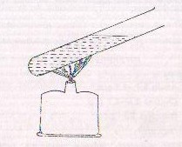
Fig 5-1 Boiling Test

2. Sulphosalicylic acid test. Mix 0.5 ml sulphosalicylic acid 20% with 5 ml acidic (or acidified) urine. If turbidity appears, heat the mixture.
Turbidity at room temperature indicates Proteins, albumoses or Pentones. Turbidity that persists on heating, indicates protein only.
3. Nitric acid test. Take about 3 ml conc. nitric acid in a test tube. Pour slowly over wall of the tube about 2 ml urine. A white ring at the junction indicates proteins.
4. Protein differentiation. Mix equal volumes of urine and sulphate-sulphite mixture. A precipitate indicates globulins. Apply any of the preceding three tests to the filtrate. A positive test indicates albumin.
5. Bence-Jone's proteins. Add 5 drops acetic acid 10% to about 10 ml urine. Put the tube in water bath with thermometer. Switch the water bath on. Observe the rise of temperature and precipitation in urine tube.
A precipitate appearing at 45-60ºC and disappearing on subsequent heating, indicates Bence-Jone's proteins.
If the precipitate persists till boiling point, filter while hot and allow the filtrate to cool. Reappearance of precipitate at 4560ºC indicates Bence-Jone's proteins.
1. Bence-Jone's proteins are excreted in multiple myeloma, sarcomatosis, hypernephroma, leukaemia and bronchlial carcinoma.
Quantitative test
1. Turbidimetric method with trichloroacetic acid as in C.S.F. protein estimation described later in this chapter. Sensitivity can be increased by mixing 4 ml urine with 1 ml trichloroacetic acid 20%. Divide the result by 4.
2. Biuret method. Mix 5 ml urine with 5 ml ice-cold perchloric acid. After 10 minutes, centrifuge at high speed to get clear supernatant. Discard the supernatant. To the deposit add 1 ml biuret reagent concentrate and make the volume to 5 ml with water. After 30 minutes, read absorbance and calculate the result as in serum protein estimation, using the same standard reading. Divide the result obtained by 50.
Interpretation
The normal glomeruli are almost impermeable to proteins. Proteins in normal urine comes from prostatic secretions and from seminal vesicles. Normal excretion is upto 150 mg per 24 hours.
Increased excretion occurs in nephrotic syndrome, increased muscle cell destruction (myoglobin) and haemoglobinuria (haemoglobin).

CSF Protein
Reagents
1. Trichloroacetic acid 5%
2. Protein standard, 50 mg/dl. Determine protein content of a serum sample and dilute appropriately with isotonic saline.
Procedure
Mix 1 ml sample/standard with 4 ml trichloroacetic acid. After 5 minutes, shake and read absorbance against water adjusted to zero with red filter (650-700 nm).
Calculation
Abs. test
Protein = -------------------- x 50 mg/dI
Abs. std
Interpretation
Normal values
Lumbar CSF 15-45 mg/dI
Lumbar CSF (neonates) Upto 90 mg/dI
Ventricular CSF 5-20 mg/dI
Cisternal CSF 15-25 mg/dI
Raised in
Tubercular meningitis 60-300 mg/dI
Meningococcal meningitis 180-3,000 mg/dI
Pneumococcal meningitis 150-2,000 mg/dI
Abacterial serous meningitis 60-300 mg/dI
Encephalitis 50-300 mg/dI
Gullain-Barre Syndrome over 300 mg/dI

Hemoglobin
Hemoglobin estimation overlaps the fields of hematology and biochemistry. In hematology, hemoglobin is measured with Sahli's hemoglobinometer using hydrochloric acid N/10 as diluting solution. The blood is diluted to match a standard shade of acid hematin.
Colorimetric methods are more convenient and with better precision. However, the problem of callibration is amongst the most intricate ones in biochemistry.
Oxyhemoglobin method has advantage of a stable nonpoisonous reagent. A comparison prepared with coloured substances, can be used as lasting standard. The colour development is, however, poor and the final solution is not absolutely clear.
Cynmethhemoglobin method has an edge over oxyhemoglobin method in colour development. However, the method has to be standardised first with a sample of known concentration. Also the reagent deteriorates with time thus requiring fresh callibration. A practical solution is to use cynmethemoglobin formed with the last test during the preceding day as the standard for the day. Of course, this cannot be done at places with just 2-3 samples in a day.
In order to make any callibration applicable to all laboratories, Sahli's pipette must deliver exact 0.02 ml sample. With commercial pipettes, delivering upto 50% extra quantity, overwhelming the market, any standard performing well at all laboratories is practically ruled out. Thus standard reading has to be deduced in the laboratory itself. The pipettes used in a laboratory have to be uniformly callibrated, if not accurately.
Reagents
1. Cynmethemoglobin reagent concentrate. Dissolve 2 g potassium ferricyanide and 1.4 g potassium dihydrogen phosphate in about 500 ml water. Add to it 50 ml potassium cyanide 1% solution. Make the volume to 1L with water. Filter and add 10 ml nonidet-P 40.
For working reagent, dilute 100 ml concentrate with 900 ml water.
2. Standard : Comparison solutions for direct reading in colorimateter are used as standard.
(i) Take blood sample of known haemoglobin concentration. Dilute 0.5 ml sample with 12 ml haemoglobin reagent concentrate. Dilute it further, with water, to the volume calculated as follows :-
Volume = 125xC/15
Where C is the haemoglobin concentration of the sample. The comparison solution is equivalent to 15 g/dI haernoglobin in the procedure and should be stored in refrigerator till turbidity, makes it unfit for use.
(ii) Permanent standard. Dissolve 50g ferric nitrate (9 H₂O), 1g cobalt nitrate and 165 mg potassium chromium sulphate (24 H₂O) in 100 ml water. Dilute further with water till the absorbance matches with the natural standard.
Procedure
Dilute 0.02 ml whole blood (fresh or anticoagulated) with 5 ml haernoglobin reagent (0.5 ml concentrate plus 4.5 ml water). Shake to mix and after 2 minutes, read absorbance against water adjusted to zero with green filter (510-550 nm).
For standard, take 5 ml standard direct into a cuvette. Read absorbance.
Calculation
Abs. test
Haemoglobin = ------------------ x 15 g/dI
Abs. std
Normal values (g/dl)
Men 14-18 ; Women 12-16 ; Neonates 16-25 ; Infants
10-15 ; Small children 11- 14 ; Older children 12-16.
FOETAL HAEMOGLOBIN (Hb-F)
Total haernoglobin in the sample is converted into cynmethaemoglobin. Cynmethaemoglobin derived from the normal haemoglobin is precipitated and removed. Percentage of haernoglobin-F is calculated from absorbance of the filtrate and absorbance of total cynmethaemoglobin.
Reagents
1. Cynmethaemoglobin reagent concentrate as in haemoglobin estimation.
2. Sodium hydroxide 1.2 M in carbon dioxide free water.
3. Ammonium sulphate 50%.
Procedure
Fresh blood or blood anticoagulated with EDTA may be used.
1. Mix 0.5 mI blood with 9 ml water and keep for at least two minutes.
2. Add 1 ml concentrate to obtain cynmethaemoglobim solution.
3. Mix 5.6 ml cynmethaemoglobin solution with 0.4 ml sodium hydroxide. Start the stop watch immediately on addition Mix and after exact 120 seconds, add 4 ml ammonium sulphate.
4. After 15 minutes, filter through Whatman no. 6 filter paper. If the initial filtrate is turbid, pour it back over the filter paper.
5. Read absorbance of the filtrate against water adjusted to zero at 540 nm. (Abs T)
6. Mix 1.4 ml cynmethaemoglobin solution (from step 2) with 1.6 ml water and 2 ml ammonium sulphate.
7. Dilute I ml of the mixture with 4 ml water, and read absorbance as before. (Abs C).
Calculation
Abs. T
Hb-F% = ------------------ x10
Abs. C
If the absorbance of the filtrate is too high, dilute the filtrate with water and multiply the result with the dilution factor.
Interpretation
Normal values
Adults | At birth | 1 month | 2 months | 3 months | 6 months | 1 year
0.9% | 70-90% | 50-75% | 25-60% | 10-35% | 8% | 2%
Raised in : Anaemia (myelofibrosis, aplastic anaernia, paroxysmal nocturnal haemoglobinuria), homozygous thalassaemia, hereditary sickle cell anaernia, leukaemia, thyrotoxicosis.
Depressed in : Heterozygous thalassaernia, Down's syndrome.
SICKLE-CELL HAEMOGLOBIN (Hb-S)
Sodium dithionite reduces the total haemoglobin present in the blood. Whereas reduced haemoglobin (adult) is soluble and forms a clear solution, the reduced Hb-S is insoluble and forms turbidity. The turbidity produced can be assessed by reading a printed script through it. Alternatively, the solution can be filtered and treated with cynmethaemoglobin reagent concentrate. The absorbance produced is expressed as percentage of the absorbance produced without dithionite treatment (i.e. total haemoglobin).
Reagents
1. Buffer. Dissolve 80 g potassium dihydrogen phosphate (anh.) and 140 g dipotassiurn hydrogen phosphate in distilled water and make the volume to 500 ml.
2. Dithionite reagent. Dissolve 2 g sodium dithionite (Na₂S₂O₄) and 100 mg saponin in 80 ml buffer and make the volume to 100 ml with distilled water. The reagent is stable in refrigerator for a month.
3. Cynmethaemoglobin reagent concentrate.
Procedure
1. Dilute the whole blood with twice its volume of water. Shake and keep for at least two minutes.
2. Mix 0.5 ml diluted blood with 2 ml dithionite reagent. Invert repeatedly to mix. Visual method ends with reading a printed script through this mixture in a 12 mm x 75 mm test tube. For colorimetric method, proceed to next step.
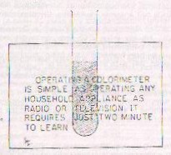
Fig.5-2 Visual method for Hb-S estimationation
3. Filter the mixture. If the supernatant is not clear, pour it back over the filter paper.
4. Mix 0.5 ml clear supernatant with 0.5 ml cynamethaemoglobin reagent concentrate and 4 ml water. Keep for 2 minutes.
5. Read absorbance against water adjusted to zero with green filter (510-550 nm).
For control, apply the same procedure taking 1.6 ml buffer and 0.4 ml water in place of 2 ml dithionite reagent.
Calculation
Abs. Control-Abs. test
Hb-S (%) = ------------------------------------- x 100
Abs. Control
Interpretation
Hb-S content of the normal blood is undetectable with this method. In the visual method, the mixture is clear and printed script can be read through this. Upto 60% Hb-S may be present
in sickle-cell trait. Levels beyond 60% are found in sickle-cell disease.
HEAT DENATURATION TEST
Unstable haemoglobins are denatured by heating. The remaining stable haernoglobin is determined with cynmethaemoglobin method.
Reagents
1. Isotonic saline
2. Phosphate buffer. Dissolve 15.6 g sodium dihydrogen phosphate (dihydrate) and 14.2 g disodium hydrogen phosphate in water and make the volume to I litre.
3. Cynamethaemoglobin reagent concentrate
Procedure
1. Mix I ml whole blood with 10 ml isotonic saline and centrifuge at moderate speed for 10 minutes. Discard the supernatant. Repeat similar washing with 10 ml more isotonic
saline.
2. To the packed cells (deposit), add 5 ml water and 5 ml buffer. Mix and centrifuge for 10 minutes.
3. Transfer 2 ml supernatant (haemolysate) into a test tube and put in a water bath at 50ºC for 3 hours. In presence of unstable haemoglobins, a flocculent precipitate forms within an hour and increases on heating further.
4. Centrifuge at moderate speed for 10 minutes.
5. Mix 0.2 ml supernatant with 5 ml cynamethaernoglobin reagent (1 + 9 concentrate) and read absorbance against water adjusted to zero with green fitter (510-550 nm).
For control, repeat the procedure, step 3 onwards, without heating.
Calculation
Abs. control-Abs. test
Unstable haemoglobins (%) = --------------------------------------- x 100
Abs. control
Interpretation
With normal blood no precipitate forms in one hour. At 3 hours, the unstable haemoglobin is below 1% i.e. not detectable.
The unstable haemoglobins lose haem more readily releasing free globin and leading to anaernia.
CARBOXYHAEMOGLOBIN
(Qualitative tests)
1. Dilution test. Mix 0.1 ml blood with 5 ml water. Normal blood gives yellowish red colour whereas blood containing carboxyhaemoglobin gives pink or bluish-red.
2. Alkali test. Add a few drops of sodium hydroxide 10 N to 2 ml blood. Normal blood gives black-brown colour whereas blood containing carboxyhaernoglobin gives a reddish tinge.
3. Tannic acid test. Dilute 0.5 ml blood with 2 ml water. Add 1.5 ml tannic acid 1%. Normal blood gives grayish brown precipitate whereas blood with carboxyhaemoglobin gives red precipitate.
Interpretation
Normal values are 0.5-1% for nonsmokers and upto 6% for smokers. The levels are increased in heavy smokers, garage, workers, drivers and traffic policemen.
METHAEMOGLOBIN (HEMIGLOBIN)
Methaernoglobin with absorbance at 630 nm is converted into cynmethaemoglobin with nil absorbance at 630 nm. The difference is proportional to methaernoglobin content in the sample.
Total haernoglobin is converted into methemoglobin by adding potassium ferricyanide and subsequently converted into cynamethaemoglobin. Percentage methaemoglobin is thus calculated.
Reagents
1. Buffer. Dissolve 950 mg disodium hydrogen phosphate (anh.), 1.36 g potassium dihydrogen phosphate (anh.) and 2 g, saponin in water and make the vohime to 1 litre.
2. Potassium ferricyanide 5%.
3. Neutral sodium cyanide. Mix equal volumes of sodium cyanide 10% and acetic acid 12% (v/v) prepare fresh before use.
Procedure
Dilute 0.5 ml whole blood with 25 ml buffer. Arrange 2 cuvettes as follows :
1. Test. Take 5 ml diluted blood in a cuvette. Read absorbance (A) against water adjusted to zero with orange red filter (630 nm). Add 0.1 ml neutral sodium cyanide, mix and read absorbance (B) again.
2. Total. Mix 5 ml diluted blood with 0.1 ml potassium, ferricyanide. Read absorbance (C) and, after adding 0.1 ml neutral sodium cyanide, read absorbance (D) again.
Calculation
A-B
Methaemoglobin (%) = ---------- x 100
C-D
Interpretation
Normal values. Upto 0.3%
Raised in congenital methaemoglobinaemia, and poisonings (nitrite, chlorates, quinones, nitrobenzol, aniline, acetanilide).
HAEMOGLOBIN IN URINE
Reagents
1. Benzidine saturated in glacial acetic acid.
2. Hydrogen peroxide.
3. Working reagent. Just before use mix equal volumes of above solutions.
Procedure
Mix equal volumes of urine and working reagent. A blue colour indicates blood.
Interpretation
Haemoglobin may be excreted in free form (haemoglobinuria) or as constituent of erythrocytes (haematuria). On centrifuging the urine, the former produces red supernatant and the latter, red deposit.

Chapter 6 : Lipids
TOTAL CHOLESTEROL ESTIMATION
Cholesterol in presence of acetic acid and sulphuric acid is sequentially dehydrated, oxidized and finally sulphonated with sulphuric acid to produce green coloured compounds. The reaction, called Liebermann-Burchard reaction, is the basis of most nonenzymatic colorimetric methods of cholesterol estimation. Esterified cholesrerol is hydrolyzed by acidic solvents so that total cholesterol is determined.
The Lieberman- Burchard reaction is catalyzed by ferric ions (Fe⁺³) and and the colour produced is red. However, the ions also catalyze the reaction of glyoxylic acid (impurity in acetic acid) with tryptophan in the serum proteins which also produces intense red cojour. Such interference is not appreciable without ferric ions so that acetic acid, L.R. grade may be used. With Ferric chloride in acetic acid, the proteins must be removed before addition of sulphuric acid. Ferric chloride reagent without deprotenization step is a useless entity because not even half the colour intensity produced is attributable to cholesterol.
Efforts have been made to substitute acetic acid. One such reagent is ferric chloride in ethyl acetate. With sulphuric acid, the combination is used as monostep reagent.
Provided sufficient sulphuric acid is added, proteins don't produce turbidity. Dimethyl benzene sulphonic acid may be added as further safeguard against turbidity.
LIEBERMANN-BURCHARD REACTION
Reagents
1. Acetic anhydride.
2. Sulphuric acid reagent. Cool 300 ml glacial acetic acid by immersion in ice-cold water. Very slowly and carefully, with constant shaking, add 100 ml sulphuric acid.
3. Stock standard. Add 1 g cholesterol crystals in 100 ml isopropyl alcohol (or glacial acetic acid). Determine cholesterol content against assayed control serum or standard (for same method) at hand and label appropriately.
4. Working standard 200 mg/dl. Dilute the stock standard with the same solvent to make 200 mg/dl. The standard is infinitely stable. Standard in isopropyl alcohol should be stored in refrigerator to prevent vaporization.
Procedure
1. Mix 2.5 ml acetic anhydride with 2.5 ml sulphuric acid reagent in a test tube immersed in cold water. Shake and put the tube back into water.
2. Add 0.1 ml serum/standard. Remove the tube from water and shake vigorously to mix.
3. After 10 minutes, read absorbance against water adjusted to zero with orange red filter (610-630 nm).
The reagents give nil blank against water. However it should be checked frequently and, if necessary, blank reading should be subtracted,
Calculation
Abs. test
Cholesterol = ------------- x 200 mg/dl
Abs. std.
Note : Sulphuric acid absorbs moisture from the atmosphere. Since moisture affects cholesterol estimation, sulphuric acid should be drawn from bottles which have been continuously stored in tightly closed bottle. This applies to subsequent methods also.
FERRIC PERCHLORATE METHOD
Reagents
1. Cholesterol reagent. Dissolve 520 mg ferric perchlorate (non-yellow grade) in 600 ml ethyl acetate. Chill by placing in ice-bath and pour 400 ml sulphuric acid drop by drop either through separating funnel or from a burette. The flask should be continuously placed in ice-bath with constant shaking. More ice may be added as desired. The temperature in the flask should at no time exceed 40ºC. The reagent is stable at room temperature for at least a year.
2. Cholesterol standard 200 mg/dl. As in preceding method. Standardize for ferric perchlorate method.
Procedure
1. Mix 0.05 ml serum with 5 ml reagent.
2. Put in boiling water for exact 90 seconds.
3. Cool and read absorbance against water adjusted to zero with yellow filter (575-600 nm).
For standard, take 0.05 ml standard in place of serum and for blank, take reagent alone.
Calculation
Abs. test-Abs. blank
Cholesterol = ------------------------------- x 200 mg/dl
Abs. std-Abs. blank
Note : If micropipette is not available, dilute serum with equal volume of water and standard with equal volume of its solvent (not with water); 0.1 ml diluted sample/standard is required.
DIOXANE METHOD
1. A-D solution. Under a fume hood, mix 400 ml dioxane with 600 ml acetic anhydride.
2. Concentrated sulphuric acid.
3. Standard 200 mg/dl. As in L. B reaction.
Procedure
1. In a centrifuge tube marked at 10 ml, add 0.5 ml serum.
2. Add A-D solution at a fast speed upto 10 ml mark.
3. Stopper the tube and place in boiling water for 30 minutes. Cool to room temperature.
4. If necessary, add more A-D solution upto 10 ml mark. Mix by inversion.
5. Centrifuge at high speed for 10 minutes.
6. Add 0.25 ml sulphuric acid to 5 ml supernatant, shake vigorously and keep at room temperature for exact 5 minutes.
7. Incubate at 30-32ºC for exact 13 minutes.
8. Read absorbance against water adjusted to zero with orange red filter (610-630 nm).
For standard, take 0.5 ml standard and for blank, take 0.5 ml water in place of serum in the above procedure.
Calculation
Abs. test-Abs. blank
Cholesterol = ------------------------------ x 200 mg/dl
Abs. std-Abs. blank
DMBS METHOD
Reagents
1. Cholesterol reagent. Mix 700 ml acetic anhydride with 330 ml acetic acid. Add 10 g 2,5-dimethyl benzene sulphonate ammonium (p-xylene sulphonate ammonium). Shake to dissolve. The reagent is stable in refrigerator for a year.
2. Concentrated sulphuric acid in bottle kept tightly closed.
3. Cholesterol standard 200 mg/dl.
Procedure
1. Mix 0.1 ml serum with 4 ml cholesterol reagent. Keep for 10 minutes.
2. With the tube immersed in cold water, add 1 ml concentrated sulphuric acid drop by drop over tube wall. Shake the tube mildly in water and take out.
3. After exact 5 minutes, read absorbance against water adjusted to zero with yellow filter (560-580 nm).
For standard, take 0.1 ml standard in place of serum and for. blnnk take reagents only in the above procedure.
Calculation
Abs. test-Abs. blank
Cholesterol = -------------------------------- x 200 mg/dl
Abs. std-Abs. blank
PAREKH-JUNG METHOD
Serum proteins are precipitated with urany! acetate and bilirubin interference is arso eliminated. ,
Reagents
1. Ferric uranyl acetate. Mix 10 ml ferric chloride 5% (hexahydrate) with 3 ml liquid ammonia, Centrifuge and discard supernatant. Wash the precipitate twice with warm water. Wash out the precipitate with glacial acetic acid into a flask and make to 1 litre with acid. - Add 100 mg uranyl acetate (dihydrate). Keep overnight. The solution is stable for six months in amber-coloured bottle.
2. Sulphuric acid reagent. Dissolve 100 mg ferrous sulphate (anh.) in 100ml glacial acetic acid. Add very slowly and carefully, with the receiving flask in cold water, 100ml conc. sulphuric acid.
3. Cholesterol 200 mg/dl
Procedure
1. Mix 0.025 ml serum with 5 ml ferric uranyl acetate. After 5 minutes, centrifuge at moderate speed for 5 minutes.
2. Add slowly and carefully 2 ml sulphuric acid reagent to 3 ml supernatant Shake vigorously to mix and keep for 20 minutes.
3. Read absorbance against water adjusted to zero with yellow filter (560-580 nm).
For standard, take 0.025 ml standard in place of serum and for blank, take 3 ml ferric uranyl acetate in place of supernatant.
Calculation
Abs. test-Abs. blank
Cholesterol = -------------------------------- x 200 mg/dl
Abs. std-Abs. blank
FERRIC CHLORIDE METHOD
Reagents
1. Ferric chloride (hexahydrate) 0.05% in glacial acetic acid.
2. Concentrated sulphuric acid.
3. Cholesterol standard 200 mg/dl
Procedure
1. Mix 0.1 ml serum with 10 ml ferric chloride in a centrifuge tube. Keep for at least 10 minutes (preferably several hours).
2. Centrifuge to get clear supernatant.
3. Very slowly and carefully, with test tube immersed in water, add 3 ml concentrated sulphuric acid to 5 ml supernatant.
4. After 20 minutes, read absorbance against water adjusted to zero with yellowish green filter (540-580 nm).
For standard, take 0.1 ml standard in place of serum and 5 ml ferric chloride in place of supernatant.
Calculation
Abs. test-Abs. blank
Cholesterol = ------------------------------- x 200 mg/dl
Abs. std-Abs. blank
ENZYMATIC METHOD
Reagents
1. Buffer. Dissolve 1.4 g sodium cholate, 180 g 4-aminoantipyrine, 7.5 g disodium hydrogen phosphate (anhydrous), 7.3 g sodium dihydrogen phosphate (monohydrate) and 1 g polyethylene glycol-6000 in water and make to a litre. Store in refrigerator.
2. Phenol 7% in 50% ethanol.
3. Peroxidase reagent. Make an aqueous suspension of cholesterol ester hydrolase 180 units/dl and peroxidase 350,000
units/dl. Store in refrigerator and shake well before use.
4. Oxidase reagent. Make an aqueous suspension of cholesterol oxidase 1.30 units/10 ml. Store in refrigerator and
shake well before use.
5. Working reagent. Add 1 ml phenol reagent, 1 ml peroxidase reagent and 0.5 ml oxidase reagent to 50 ml buffer.
Procedure
Mix 0.1 ml serum/standard with 5 ml working reagent. Incubate at 37ºC for 10 minutes. Read absorbance against reagent
blank adjusted to zero with bluish green filter (480-520 nm).
Calculation
Abs. test-Abs. blank
Cholesterol = ------------------------------ x 200 mg/dl
Abs. std-Abs. blank
FREE AND ESTERIFIED CHOLESTEROL
Digitonin method
Free cholesterol forms an insoluble digitonide with digitonin.The resultant precipitate is isolated and cholesterol subsequently, extracted. Esterified cholesterol is calculated by difference.
Alternatively, esterified cholesterol may be determined in the supernatant. While free cholesterol may be determined with any method for total cholesterol, determination of esterified cholesterol in the supernatant is selective to methods.
Reagents
1. Digitonin 1% in 50% ethanol. Warm to about 56ºC witho gentle shaking. Stable for about 6 weeks.
2. Isopropanol.
Procedure
1. Mix 0.2 ml serum with 1.8 ml isopropanol. Mix well on vortex mixer.
2. After 5 minutes, centrifuge at moderate speed for 10 minutes.
3. To 1 ml supernatant, add 0.5 ml digitonin reagent. Mix and refrigerate for 30 minutes.
4. Centrifuge at moderate speed for 10 minutes. Transfer the supernatant into a boiling tube. Discard it for free cholesterol determination
5. Wash the precipitate twice with 5 ml isopropanol. Mix the washings with the supernatant (or discard).
6. To the precipitate add reagents and proceed as for total cholesterol estimation (free cholesterol).
7. Evaporate the super natant-washings mixture to dryness. To the residue, add reagents and proceed as for total cholesterol estimation (esterified cholesterol).
Calculation
In case 0.1 ml serum is used in the procedure used in the procedure used for cholesterol estimation, no adjustment in calculation is required. In case the quantity used in cholesterol estimation is different, corresponding adjustment may be made either in the quantity of supernatant (step 3) or in the calculation.
Tomatine Method
Tomatine reagent. Dissolve 200 mg tomatine in 30 ml absolute ethanol by heating to about 48ºC. Make to 100 ml with ethyl acetate. Keep for 8 days and filter. The reagent is stable at room temperature for one year.
1. Mix 0.2 ml serum with 0.8 ml tomatine reagent.
2. After 30 minutes, centrifuge at moderate speed for 10 minutes.
3. Evaporate 0.5 ml. supernatant to dryness.
4. To the residue add reagents and proceed as for total cholesterol estimation.
Calculation
As with digitonin method. The result obtained is esterified cholesterol.
HDL-CHOLESTEROL ESTIMATION
All the fractions of lipoprotein viz chylomicron, very low density lipoprotein (VLDL), low density lipoprotein (LDL) and high density lipoprotein (HDL) are associated with certain amount of cholesterol. The utility of HDL-cholesterol estimation lies as a measure of high density lipoprotein which is inversely related to the tendency of heart disease.
The VLDL-cholesterol and LDL-cholesterol are removed by polyanionic preceipitation. Cholesterol content of the supernatant, as determined with usual methods (preferably enzymatic) gives the concentration of HDL-cholesterol in the sample.
Magnesium phosphotungstate method
Reagents
1. Magnesium chloride 2M (40.6 % hexahydrate) in water.
2. Sodium phosphotungstate reagent. Dissolve 4.5 g phosphotungstic acid in water. Add 16 ml sodium hydroxide 4% and make to 100 ml with water.
Procedure
1. Recentrifuge the serum sample to remove any traces of red blood cells.
2. Mix on vortex mixer 1 ml serum with 0.1 ml sodium phosphotungstate reagent.
3. Add 0.025 ml magnesium chloride. Mix and keep for 30 minutes.
4. Centrifuge at high speed for 30 minutes. Immediately after centrifugation, remove supernatant for analysis.
5. Determine the cholesterol content of the supernatant and multiply the result with 1.125.
Manganese-Heparin method
.Reagents
1. Heparin 7,500 units/ml in isotonic saline.
2. Manganous chloride 40.1 % quadrihydrate in water.
Procedure
As in magnesium phosphotungstate method, using 0.1 ml heparin and 0.025 ml manganous chloride. Before centrifugation, incubate (for 30 minutes) in ice bath and centrifuge at 4ºC.
CHOLESTEROL EQUATIONS
When chylomicrons are absent and triglycerides below 400 mg/dl,
Triglycerldes
VLDL Cholesterol = ---------------
5
Total cholesterol = VLDL cholesterol + LDL cholesterol + HDL cholesterol
INTERPRETATION
Normal values
Total cholesterol
Age in Years | Men | Women
20 | 110-250 | 110-250
30 | 120-290 | 120-290
40 | 135-315 | 135-290
50 | 150-340 | 145-330
60 | 140-320 | 156-356
70 | 140-310 | 140-310
Esterified cholesterol
68-78% of total cholesterol
HDL-Cholesterol (over 50 years)
Men 29-61 mg/dI
Women 38-75 mg/dl
Total cholesterol raised in
1. Essential hypercholestraemia.
2. Essential hyperlipidaemia.
3. Nephrotic syndrome.
4. Diabetes mellitus.
5. Hypothyroidism.
6. Obstructive jaundice.
7. Pregnancy. -
Total cholesterol depressed in
1. Severe hepatic damage.
2. Hyperthyroidism.
3. Malnutrition.
Esterified cholesterol depressed in
- Severe hepatic damage.
HDL-Cholesterol
Serum levels lower than 45 mg/dl in men and 55 mg/dl in women carry increased risk of heart disease. Higher levels are associated with lesser risk and increased longevity.
PHOSPHOLIPIDS (PHOSPHATIDES)
Phospholipids are determined either with extraction methods or with precipitation methods. In either case, phosphorus is libertated from phospholipids by process of digestion and determined with molybdate method.
Extraction Method
Phospholipids (alongwith some more lipids) are extracted into organic solvents leaving behind proteins and inorganic phosphates. An aliquot of supernatant is digested to liberate phosphorus.
Reagents
1. Extraction mixture. Mix 75 ml absolute ethanol with 25 ml ether.
2. Digestion mixture. Add 30 mg calcium carbonate to 1 L concentrated nitric acid.
3. Ascorbic acid 2% in 10% trichloroacetic acid.
4. Ammonium molybdate quadrihydrate 1%
5. Arsenite-citrate reagent. Dissolve 20 g trisodium citrate (dihydrate) and 20 g sodium arsenite (anh.) in water. Add 20 ml glacial acetic acid and make the volume to 100 ml with water.
6. Phosphorus standard 100 mg/dl. Dissolve 438 mg potassium dihydrogen phosphate (dried) in 100 ml benzoic acid 1%
7. Working standard 10 mg/dI. Dilute 0.1 ml standard with 0.9 ml distilled water.
Caution
All the reagents should be prepared with double-distilied water or deionized water. Glassware including the glass beads used in testing should be rendered phosphorus free by thoroughly rinsing with distilled water. This applies to both the methods.
Procedure
1. Mix 0.1 ml serum with 4 ml extraction mixture by repeated inversion or on a vortex mixer.
2. After 5 minutes, centrifuge at moderate speed for 5 minutes.
3. Mix 2 ml supernatant with 4 ml digestion mixture in a boiling tube. Add 2 glass beads to prevent bumping.
4. Heat over a flame until yellow fumes of nitrous oxide cease and solution is colourless. Cool.
5. Add 2 ml ascorbic acid reagent. Agitate to dissolve any precipitate.
6. Add 1 ml ammonium molybdate and 2 ml arsenite citrate. Keep for 20 minutes.
7. Read absorbance against water adjusted to zero with deep red fiIter (700 nm).
For standard, take 0.1 ml working standard and for blank, 0.1 mI water in place of serum in the above procedure.
Calculation
Abs Test-Abs. blank
Phospholipids = -------------------------------- x 250 mg/dI
Abs. Std.-Abs. blank
Precipitation method
Reagents
1. Trichloroacetic acid 10%.
2. Perchloric acid.
3. Nitric acid.
4. Ammonium molybdate 1.5% (quadrihydrate)
5. Reducing solution. Dissolve 11 g metol, 33 g sodium metabisulphite and 2.75 g thiourea in 500 ml distilled water.
6. Phosphorus working standard 10 mgldl. As in preceding method.
Procedure
1. Mix 0.2 ml serum with 3 ml distilled water. Add 3 ml trichloroacetic acid.
2 After 10 minutes, centrifuge at moderate speed for 5 minutes. Discard the clear supernatant.
3. Add 3 ml trichloroacetic acid and 3 ml distilled water. Centrifuge and discard the supernatant.
4. Stand the tube inverted for about 5 minutes. Wipe off' the wall of the tube with filter paper.
5. Add 0.5 ml perchloric acid, 2 glass beads and 0.2 ml concentrated nitric acid.
6. Heat the mixture over a flame till brown fumes of nitrous oxide cease. Cool.
7. Add 5 ml distilled water, 0.1 ml ammonium molybdate, and 0.1 ml reducing solution. Keep for 10 minutes.
8. Read absorbance against water adjusted to zero with deep red filter (700 nm).
For standard, take 0.2 ml standard and for blank take 0.2 ml distilled water in place of serum. Heating step has to be performed as in the test.
Calculation
Abs. Test-Abs. blank
Phosphollpids = ---------------------------------- x 250 mg/di
Abs. Std-Abs. blank
For lipid phosphorus, multiply with 10 in place of 250.
TRIGLYCERIDES (NEUTRAL FATS)
TrIglycerides may be determined approximately by calculations. Colorimetric method involves separation of phospholipids and triglycerldes into two organic layers viz isopropanol and n-nonane respectively. Triglycerides are then hydrolyzed to liberate glycerol. Glycerol is oxidized with metaperiodate into formaldehyde. With acetylacetone and ammonia, formaldehyde gives yellow compound, diacetyl hydrolutidine (Hantzsch condensation).
Calculation Methods
1. Triglycerides = Total lipids-(free cholesterol + I.7 x cholesterol esters + phospholipids).
2. Triglycerides = Total lipids-(1.5 X Total cholesterol + phospholipids).
3. Phospholipids=0.73 x total cholesterol + 90
Hence TrigIycerides = 2.25 x total cholesteroI + 90.
4. Triglycerides = Esterified fatty acids-(0.764 x estrified cholesterol + 14.2 x lipld phosphorus)
Llpid phosphorus= Phospholipids/10
Note : All the values are expressed as mg/dI.
Colorimetric Methods
Reagents
1. n-Nonane.
2. Isopropanol
3. Sulphuric acid 0.04 M. Dilute 10 ml sulphuric acid 1 M (or 2 N) with 240 ml water.
4. Alkali reagent. Dissolve 50 g Potassium hydroxide in 600 ml water. Add 40 ml isopropanol.
5. Sodium metaperiodate. Dissolve 38.5 g ammonium antato (anh.) in 400 ml water. Add 30 ml glacial acetic acid and 325g sodium metaperiodate. Shake to dissolve and make to 500 ml with water.
6. Acetylacetone reagent. Mix 4 ml acetylacetone, 100ml isopropanol and 800 ml water.
7. Triolein standard 200mg/dl in isopropanol. The standard is stable in refrigerator for about 6 months. Alternatively aqueous solutlon of glycerol 20.8 mg/dI (w/v) or formaldehyde 11.76 mg/dI may be used.
Procedure
1. Mix 0.5 ml serum, 2 ml n-nonane, 3.5 ml isopropanol and, 1 ml sulphuric acid 0.04 M. Shake well on a vortex mixer and keep still for 10 minutes. Take aliquot from upper n-nonane layer for analysis.
2. To 0.2 ml from aliquot, add 2 ml isopropanol and 0.6 ml alkali reagent. Incubate at 60-70ºC for 15 minutes. Cool.
3. Add 1 ml metaperiodate and 1 ml acetyl acetone Mix and incubate at 50ºC for 15 minutes. Cool.
4. Read absorbance against water adjusted to zero with violet filter (410 nm).
For standard, take 0.5 ml standard and for blank, take 0.5 ml water in place of serum in the above procedure.
If glycerol or formaldehyde standard is used, dilute 0.5 ml with 2 ml water. Take 0.2 ml diluted standard in step 2 above.
Calculation
Abs. test-Abs. blank
Triglycerides = ----------------------------- x 200 mg/dI
Abs. std.-Abs. blank
Though triglycerides are a mixture of several neutral fats, the results are expressed as weight equivalent of triolein (molecular weight 884, each molecule yielding one molecule of glycerol and subsquently two molecules of formaldehyde).
Interpretation
Normal values. 10-104 mg/dI
An increased concentration of triglycerides in serum is termed hyperlipaemia (cf. hyperlipidaemia i.e. total fat increase). Lipaemia is a condition of serum turbidity due to excessive hyperlipaemia.
Raised in : Essential hyperlipaemia, glycogen storage disease, diabetes mellitus, nephrotic syndrome and liver cirrhosis.
Depressed in : Hyperthyroidism.
ESTERIFIED FATTY ACIDS
Esterified fatty acids are extracted into isopropanol. Subsequently the same react with hydroxylamine to from hydroxamic acids which form reddish brown compound with ferric ions.
Reagents
1. Hydroxylamine reagent. Shake 13.9 g hydroxylamonium chloride with 5 ml distilled water. Make the volume to 100 ml with methanol.
2. Alkali reagent. Shake 13.52 g sodium hydroxide with 1 distilled water. Make the volume to 100 ml with methanol.
3. Alkaline hydroxylamine. Mix equal volumes of the above rangents and centrifuge. The supernatant is stable for about a week.
4. Hydrochloric acid 3.8 N. Add 50 ml concentrated hydrochloric acid to 100 ml water.
5. Ferric chloride 10%. Dissolve 16.7 g hexahydrate in water and make the volume to 100 ml. The anhydrous salt poses problems in weighing and dissolving. It should thus be avoided.
6. Tributyrin standard 25 mg/dI in isopropanol.
Procedure
1. In a centrifuge tube, take 0.2 ml serum and 3.8 ml isopropanol. Stopper and shake vigorously for a minute. Keep for 10 minutes and centrifuge.
2. Mix 2 ml supernatant with I ml alkaline hydroxylamine. Keep for 30 minutes.
3. Add 0.5 ml hydrochloric acid 3.8 N and 0.5 ml ferric chloride 10%. Mix and keep for 30 minutes.
4. Read absorbance against water adjusted to zero with bluish green filter (500-530 nm).
For standard, take 2 ml standard and for blank, take 2 ml isopropanol in place of supernatant in the above procedure.
Calculation
Abs. test-Abs. blank
E.F. acids = -------------------------------------- x 500 mg/dl
Abs. std-Abs. blank
Interpretation
Normal values. 265-380 mg/dI at 20-25 years, increases with age.
Raised in : Postprandial and essential hyperlipidaemia, nephrotic syndrome, hypothyroidism, xanthomatosis and storage diseases.
Depressed in : Malnutrition, fat malabsorption, carcinoma.
NON-ESTERIFIED FATTY ACIDS
The non-esterified fatty acids in the serum are extracted into an organic solvent and converted into copper soap. The copper content of the soap formed is determined with diphenyl carbazide reagent.
1. Extraction mixture. Mix 250 ml chloroform, 250 ml heptane and 100 ml methanol.
2. Phosphate buffer, pH 6.4. Dissolve 3.026 g potassium dihyrogen phosphate and 1.979 g dipotassium hydrogen phosphate (dihydrate) in water and make the volume to 1 L.
3. Copper reagent. Mix 10 ml copper nitrate, 12% (trihydrate) 10 ml triethanolamine 10% (aqueous) and 6 ml sodium hydroxide 4%. Dilute to 100 ml with water. Add 33 g sodium chloride. Adjust to pH 8.1. The reagent has to prepared on day of use.
4. Diphenylcarbazide reagent. Dissolve 400 mg 1.5-diphenylcarbazide in 100 ml ethanol. Just before use, mix 10 ml solution 0.1 ml triethanolamine 10%.
5. Palmitic acid standard 25 mg/dl. Dissolve 25 mg paimitic acid in extraction solvent and make the volume to 100 ml.
Sample Collection
Take a sample of fasting venous blood and prepare serum as quickly as possible. Analyse immediately or store at -20ºC.
Procedure
1. Mix 0.1 ml serum with 1 ml phosphate buffer and 8 ml extraction mixture.
2. Shake vigorously for 90 seconds and keep for 15 minutes.
3. Centrifuge at high speed for 10 minutes.
4. Transfer 6 ml extract into a centrifuge tube and add 2 ml copper reagent. Shake vigorously for 5 minutes.
5. Centrifuge at high speed for 5 minutes and transfer 4.5 ml of Ihe upper solvent layer into a test tube.
6. Add 0.5 ml diphenylcarbazide reagent and mix carefully. Keep for 15 minutes.
7. Read absorbance against water adjusted to zero with green filter (550 nm).
For standard, take 0.1 ml standard and for blank, take 0.1 ml water in place of serum.
Calculation
Abs. test-Abs blank
N.E.F. acids = --------------------------------- x 25 mg/dl
Abs. std.-Abs. blank
Interpretation
Raised in diabetes mellitus, starvation, exercise, emotional, stress, hyperthyroidism, oral contraceptive therapy (after 3 cycles) and several other drugs.
Depressed in therapy with aspirin, clofibrate, nicotinic acid and propropanalol.
TOTAL LIPIDS
Lipids, on heating with concentrated sulphuric acid are oxidized into ketones. The latter form pink colour with phosphoric acid and vanillin.
Reagents
1. Vanillin 0.6% in benzoic acid 1%. The reagent is stable at room temperature for several years.
2. Phosphoric acid.
3. Concentrated sulphuric acid.
4. Standard 1000 mg/dl. Dissolve 1 g of pure olive oil in absolute ethanol and make the volume to 100 ml.
Procedure
1. Mix 0.1 ml serum with 1 ml sulphuric acid. Place in boiling water for 10 minutes and cool.
2. Mix 1 ml vanillin 0.6% with 4 ml phosphoric acid. Add, 0.1 ml sulphated serum from step 1.
3. Shake vigorously and incubate at 37ºC for 15 minutes at room temperature.
4. Read absorbance against water adjusted to zero with green filter (530-550 nm).
For standard, take 0.1 ml standard and for blank, take 0.1 ml water In place of serum in the above procedure.
Calculation
Abs. test-Abs. blank
Total lipids = ----------------------------------- x 1000 mg/dI
Abs. std.-Abs blank
Interpretation
Normal values 450-1000 mg/dI
Raised in. Essential hyperiplidaemia, nephrotic syndrome, diabetes mellitus, hypothyroidism, chronic pancreatitis, primary biliary cirrhosis, after fatty meal.
Depressed in. Malnutrition, fat malabsorption, hyperthyroidism.
FAT IN FAECES
Preparation of patient
1. The Patient should be on a known fat intake of at least 50 g per day.
2. Faeces marker. The patient is given orally one capsule containing 750 mg carmine red dye at the beginning and again at the end of a 72-hour period.
3. The collection of faeces should begin with the first sample containing the dye after initial dose. Pool all the stool samples passed till the dye first appears after the second dose. This sample with dye, should be discarded and not included in the collection. Obviously the actual collection period will be different than 72 hours, depending upon intestinal motility.
4. The collected faeces should be stored in refrigerator.
Reagents
1. Potassium hydroxide 33%.
2. Amyl alcohol-ethanol mixture. Dilute 0.4 ml amyl alcohol to 100 ml with ethanol 96%.
3. Concentrated hydrochloric acid.
4. Petroleum benzene (BP 40-60ºC)
5. Ethanol 96%.
6. Sodium hydroxide N/10.
7. Thymol blue indicator. Dissolve 1 g thymol blue in 26 ml ethanol 96%. Add distilled water to make 50 ml.
Procedure
1. Weigh the jar before and after faeces collection, Calculate the total weight of faeces by difference.
2. If the faeces are formed (i.e. not watery), add water equal to total weight of faeces. In step 4, take 10 g blended faeces in place of 5 g faeces.
3. Attach the jar to a mixer. Blend the contents till homogenous.
4. Weigh out 5 g blended faeces into a flask with glass stopper and return flow cooling arrangement (ErIenmeyer flask).
5. Add 10 ml potassium hydroxide and 40 ml amyl alcohol-ethanol mixture.
6. Boil the mixture for 20 minutes with return flow cooling. Cool quickly under running water.
7. Add 17 ml concentrated hydrochloric acid and, after cooling, 50 ml petroleum benzene.
8. Shake the stoppered flask vigorously for a minute. Withdraw 25 ml petroleum benzene layer into a flask attached with suction pump. Add a few strips of filter paper.
9. Concentrate under vacuum till dry.
10. Dissolve the residue in 10 ml ethanol 96%. Add a few drops of thymol blue indicator.
11. Titrate with sodium hydroxide N/10 till persistent faint blue colour. Note the titre in ml as 't'.
Calculation
5.907 x t
Fatty acids = ------------------------- g/100 g faeces.
5
Interpretation
Normal values. 2-5% of the total fat intake during collection

Lipid Estimation with Autoanalyzer
(Courtesy: https://www.cdc.gov/nchs/data/nhanes/nhanes_03_04/l13_c_met_lipids.pdf)

Analyte:
Total Cholesterol, HDL-Cholesterol,
Triglycerides, and LDL-Cholesterol

Matrix:
Serum

Method:
Hitachi 704 Analyzer which is serviced by Roche Diagnostics (formerly Boehringer-Mannheim Diagnostics), Indianapolis

Lab Protocol for NHANES 2003-2004 data
Analytes
Analyte | SAS Label (and SI units)
LBXTC | Total cholesterol (mg/dL)
LBDTCSI | Total cholesterol (mmol/L)
LBXHDD | HDL-Cholesterol (mg/dL)
LBDHDDSI | HDL-Cholesterol (mmol)
LBXTR | Triglycerides(mg/dL)
LBDTRSI | Triglycerides(mmol/L)

1. Summary of test principles and clinical relevance
A. Total Cholesterol
Cholesterol is measured enzymatically in serum or plasma in a series of coupled reactions that
hydrolyze cholesteryl esters and oxidize the 3-OH group of cholesterol. One of the reaction
byproducts, H₂O₂ is measured quantitatively in a peroxidase catalyzed reaction that produces a
color. Absorbance is measured at 500 nm. The color intensity is proportional to cholesterol
concentration. The reaction sequence is as follows:
cholesteryl ester hydrolase
Cholesteryl ester + H₂O ------------------------------------->cholesterol + fatty acid

cholesterol oxidase
Cholesterol + O₂ ----------------------------> cholest-4-en-3-one + H₂O₂

peroxidase
2H₂O₂ + 4-aminophenazone + phenol ---------------------> 4-(p-benzoquinonemonoimino)-phenazone + 4 H₂O

B. Triglycerides
Triglycerides are measured enzymatically in serum or plasma using a series of coupled reactions
in which triglycerides are hydrolyzed to produce glycerol. Glycerol is then oxidized using glycerol
oxidase, and H₂O₂, one of the reaction products, is measured as described above for cholesterol.
Absorbance is measured at 500 nm. The reaction sequence is as follows:
lipase
Triglycerides + 3H₂O ------------> glycerol + fatty acids

glycerokinase
Glycerol + ATP ----------------------> glycerol-3-phosphate + ADP

glycerophosphate oxidase
Glycerol-3-phosphate + O2 ------------------------------> dihydroxyacetone phosphate + H2O2

peroxidase
H2O2 + 4-aminophenazone + 4-chlorophenol -------------> 4-(p-benzoquinone-monoimino)-phenazone + 2H2O + HCl.

C. High density lipoprotein (HDL) cholesterol
Direct HDL method
HDL is measured directly in serum. The basic principle of the method is as follows. The apoB containing lipoproteins in the specimen are reacted with a blocking reagent that renders them non-reactive with the enzymatic cholesterol reagent under conditions of the assay. The apoB containing lipoproteins are thus effectively excluded from the assay and only HDL-chol is detected under the assay conditions.
The method uses sulfated alpha-cyclodextrin in the presence of Mg+2, which forms complexes with apoB containing lipoproteins, and polyethylene glycol-coupled cholesteryl esterase and cholesterol oxidase for the HDL-cholesterol measurement. The reactions are as follows:
(1) ApoB containing lipoproteins + α-cyclodextrin + Mg⁺² + dextran SO4 ---> soluble non-reactive
complexes with apoB-containing lipoproteins
(2) HDL-cholesteryl esters PEG-cholesteryl esterase > HDL-unesterified cholesterol + fatty acid
(3) Unesterified chol + O2 PEG-cholesterol oxidase > cholestenone + H2O2
(4) H2O2 + 5-aminophenazone + N-ethyl-N-(3-methylphenyl)-N’_succinyl ethylene diamine
+ H2O + H+peroxidase > qunoneimine dye + H2O
Absorbance is measured at 600 nm.
D. LDL-cholesterol
Most of the circulating cholesterol is found in three major lipoprotein fractions: very low density
lipoproteins (VLDL), LDL and HDL.

[Total chol] = [VLDL-chol] + [LDL-chol] + [HDL-chol]

LDL-cholesterol is calculated from measured values of total cholesterol, triglycerides and HDLcholesterol according to the relationship:
[LDL-chol] = [total chol] - [HDL-chol] - [TG]/5
where [TG]/5 is an estimate of VLDL-cholesterol and all values are expressed in mg/dL.

EQUIPMENT AND INSTRUMENTATION, MATERIALS, REAGENT PREPARATION, CALIBRATORS
(STANDARDS), AND CONTROLS

Cholesterol, triglyceride and HDL-cholesterol analyses are performed on a Hitachi 704 Analyzer
which is serviced by Roche Diagnostics (formerly Boehringer-Mannheim Diagnostics), Indianapolis,
IN. Cholesterol is measured enzymatically using the Cholesterol High Performance reagent (cat.no.
704036), Roche Diagnostics). Triglycerides are analyzed enzymatically simultaneously with
cholesterol using reagents from the same manufacturer (Triglycerides/GPO, cat. no. 1488872).
Triglyceride blanks are measured in CDC surveillance materials using the same reagent, but without lipase. Direct HDL-cholesterol reagent is obtained from Roche Diagnostics (Direct HDL, cat. no. 1661442), and analyzed simultaneously with cholesterol and triglycerides. If for some reason,
analyses must be delayed, the specimens should be kept frozen at -80° C until they are analyzed.
Specimens to be analyzed for cholesterol, triglyceride and HDL-cholesterol can be stored for up to 1
year at -80° C.

A. Reagents required to operate instrument.
(1) Cell Clean 90, cat no. 1224310, Roche Diagnostics. (This is a solution of NaOH, concentration
not specified, used to keep reaction cells free of protein deposits). Store at room temperature
until expiration date indicated for the lot.
(2) Hitergent, cat no. 409149, Roche Diagnostics. pH 12.5, solution contains 5% ethanolamine, an
unidentified antibacterial agent and an unidentified non-ionic detergent. Store at 10-35 o
C until
expiration date indicated for the lot.
(3) Working solution, 2% Hitergent. Add 20 mL Hitergent to deionized water and bring to 1,000
mL. Store at room temperature for up to 4 months.

B. Test specific reagents
(1) Cholesterol Reagent: The components of Cholesterol High Performance System Pack
Reagents (Roche Diagnostics, Indianapolis, IN) include (taken from package insert):
Cholesterol Reagent (16 x 50 mL)
75 mmol/L PIPES buffer, pH 6.8
10 mmol/L Mg2+
0.2 mmol/L Sodium cholate
0.15 mmol/L 4-Aminophenazone
> 4.2 mmol/L Phenol
> 0.5 U/mL Cholesterol esterase (EC 3.1.1.13; pseudomonas species; 25° C)
> 0.15 U/mL Cholesterol oxidase (EC 1.1.3.6; E. coli; 25° C)
> 0.25 U/mL Peroxidase (EC 1.11.1.7; horseradish; 25° C)
1% Fatty alcohol-polyglycol ether
Buffer, unspecified stabilizers, unspecified preservative

The reagent is supplied as a solution and is ready to use. After being opened, the reagent is
stable for 28 days at 2-12 °C, or 7 days at room temperature. Protect reagent from light.

(2) Triglyceride Reagents: The components of the Triglycerides (GPO) System Pack include (from
package insert):

50 mmol/L PIPES buffer, pH 6.8
40 mmol/L Mg++ 0.20 mmol/L Sodium cholate
> 1.4 mmol/L ATP
> 0.13 mmol/L 4-Aminophenazone
4.7 mmol/L 4-Chlorophenol
1 μmol/L Potassium hexacyanoferrate (II)
0.65% Fatty alcohol polyglycolether
> 5.0 U/mL lipoprotein lipase (EC 3.1.1.13; Pseudomonas species, 25˚C)
> 0.19 U/mL glycerolkinase (EC 2.7.1.30; Bacillus stearotheromophilus; 25˚C)
> 2.5 U/mL glycerophosphate oxidase (EC 1.1.3.21; E. coli; 25˚C)
> 0.10 U/mL Peroxidase (EC 1.11.1.7; horseradish; 25°C)
unspecified preservative

The reagent is supplied as a solution and is ready for use. When opened, the solution is stable
for 14 days at 2-12° C, or 7 days at room temperature (15-25° C).

(3) Direct HDL-cholesterol method
(a) The Direct HDL-cholesterol reagents, R1 and R2 contain the following components (from
package insert):
R1 Cyclodextrin/Buffer, supplied as a solution, ready to use.
0.5 mmol/l α-cyclodextrin
0.5 g/l dextran sulfate
7.0 mg/ml magnesium sulfate (MgSO4)
0.3 g/l EMSE
10 mmol/l MOPS (3-morpholino-propane sulfonic acid) buffer, pH 7.0)
unspecified preservative
(b) R2 Buffer/PEG-enzyme/4-Aminophenazone, is supplied as a lyophilized mixture and is
reconstituted with diluent supplied in the reagent kit. R2 contains the following approximate
concentrations after reconstitution:
> 1 kU/l PEG cholesterol esterase (EC 3.1.1.13; Pseudomonas species; 25˚C)
> 5.6 kU/l PEG cholesterol oxidase (EC 1.1.3.6; Pseudomonas species; 25˚C)
> 30 kU/l peroxidase (EC 1.11.1.7; horseradish; 25˚C)
0.5 g/l 4-aminophenazone
10 mmol/l MOPS (3-morpholino-propane sulfonic acid) buffer, pH 7.0
Detergent and preservative (unspecified)

(c) Preparation:
The R1 Reagent solution is ready for use. The R2 Reagent (bottle 2a) requires
reconstitution using the pre-measured contents of the diluent vial (bottle 2). The procedure
is as follows: Carefully pour about 1/2 of the diluent solution (bottle 2) into bottle 2a. Mix
gently until the lyophilized material is fully dissolved. Carefully pour the reagent solution
back into bottle 2, allowing bottle 2a to drain completely. This transfer should be done as
quantitatively as possible, but without rinsing bottle 2a after the transfer. Mix the solution
gently for a couple of minutes. The solution is now ready for use. R1 after opening, and
R2 after reconstitution are stable for 28 days at 2-12° C.

C. Storage and Stability:
(1) Cholesterol reagent. Store the open cholesterol System Pack Reagent on the analyzer at 2-
12° C. The solution is stable for 4 weeks at 2-12° C or 7 days at 20-25° C when protected
from light and contamination by microorganisms.

(2) Triglyceride reagent. Store triglyceride reagent on the analyzer at 2-12 o
C. The reagent is
stable for 14 days at 2-12° C or 7 days at room temperature.

(3) Heparin. Store unopened heparin at 20-25° C. Stable until the expiration date printed on the
bottle label.

(4) Direct HDL-cholesterol. R1 Reagent is stable unopened up to the stated expiration date.
When open, R1 reagent is stable up to 28 days on the analyzer at 2-12° C. R2 Reagent is
stable up to the expiration date prior to reconstitution. After reconstitution, the R2 is stable up
to 28 days on the analyzer at 2-12° C.
D. Equipment
500 ul positive displacement pipettes (SMI, Inc.)
250 ul positive displacement pipettes (SMI, Inc.)
50 ul pipettes, (Absoluter)
1.4 mL microcentrifuge tubes
Wheaton Step-Pette TM
7. CALIBRATION AND CALIBRATION VERIFICATION PROCEDURES
The Hitachi analyzer is calibrated at the beginning of the week and as necessary thereafter. A one
point calibration procedure is used for total cholesterol, triglyceride and Direct HDL-cholesterol.
Frozen serum calibration pools (Soloman Park Laboratories, Kirkland, WA) are used to calibrate total
cholesterol and direct method HDL-cholesterol assays. Triglycerides are calibrated using calibration
sera (Precical, cat no 620213) obtained from the Roche Diagnostics.

A. Daily Check
The following procedures are performed at the beginning of each work day before the first
analytical run.
(1) Check water supply.
(2). Check 2% Hitergent supply**.
(3) Check Cell Clean 90 supply**.
(4) Prepare reagents, controls and calibrators as needed.
(5) Exchange incubation bath water: Press MAINTENANCE, then press 1 ENTER.
(6) Perform Photometer Check.
(7) Air purge: "Start Conditions" display.
(8) Wipe sample and reagent probes.
(9) Probe adjust.
** Refer to Section 6. Reagents, above

B. Full Calibration:
If the CRT display shown is in the Routine Job Menu, press NEXT or BACK to move to the
Calibrator & Control Test Selection display. If the CRT display shown is not in the Routine Job
Menu, press ROUTINE, then press 3 ENTER.

(1) PHASE: The Instrument stores operating parameters and calibration data for two sets of
twenty chemistries each. These two sets of chemistries are referred to as PHASE 1 and PHASE
2. The two phases are defined in the Channel Assignment display. To indicate which set of
chemistries is being used, type the phase number (1 or 2), the press ENTER. For NHANES
2001-2002, all tests are in the PHASE 1 set.

(2) CALIBRATION TYPE: Press 1 ENTER to specify "Start-Up" Calibration.
(3) STANDARD TYPE: Press 1 ENTER to select tests for the blank (saline). If test selection for
the blank is stored in memory, the tests in memory appear at the right margin of the display.
(4) TESTS: Activate the appropriate test or profile keys for those tests which require a Blank
Calibrator, then press ENTER. (Each test key is activated when its LED is illuminated). The tests
assigned appear at the right margin of the display, and the STANDARD TYPE entry field
displays: "STD 2-6."
(5) TESTS: Press the appropriate test keys for those tests which require a standard or
standards, then press ENTER. The tests assigned appear at the right margin of the display and
the STANDARD TYPE entry field displays: "ISE 1,2." Advance the cursor to the CALIB LOAD
LIST entry field. Press 1 ENTER.
(6) If you do not want to run controls, update the System Disk with calibrator test selection as
follows:
Advance the cursor to FD READ/WRITE.
Press 2 ENTER.
The CRT displays: "WRITE OK?"
Press 1 ENTER (YES).
Note: It is not absolutely necessary to write calibrator test selection data on the System Disk.
However, if the laboratory experiences a power failure, this step prevents permanent loss of test
selection information.
Wait while the System Disk is updated, then proceed to ROUTINE PATIENT TEST SELECTION.

C. Blank Calibration Only:
If the CRT display shown is in the Routine Job Menu, press NEXT or BACK to move to the
Calibrator & Control Test Selection display. If the CRT display shown is not in the Routine Job
Menu, press ROUTINE, then press 3 ENTER.
(1) PHASE: The instrument stores operating parameters and calibration data for two (2) sets of
twenty chemistries each. These two sets of chemistries are referred to as PHASE 1 and PHASE
2. The two phases are defined in the Channel Assignment display. For NHANES 2001-2002, all
tests are in the PHASE 1 set.

To indicate which set of chemistries is being used, type the phase number (1 or 2), then press
ENTER.

(2) CALIBRATION TYPE: Press 1 ENTER to specify "Start-Up" Calibration.
(3) STANDARD TYPE: Press 1 ENTER to select tests for the blank (saline) update. If previous
test selections for blanks are stored in memory, the tests in memory will appear at the right
margin of the display.
(4) TESTS: Activate the appropriate test or profile keys for those tests requiring a blank update,
then press ENTER. (Each test key is activated when its LED is illuminated.) The tests assigned
appear at the right margin of the display, and the STANDARD TYPE entry field displays: "STD 2-
6".
(5) TESTS: Deselect all previously selected tests so that no tests are selected for "STD 2-6",
then press ENTER. No tests should appear at the right margin of the display, and the
STANDARD TYPE entry field now displays: "ISE 1,2".
(6) Press ROUTINE, then press 4 ENTER and the Start Conditions screen will appear on the
display.
(7) Enter the START SAMPLE NO. and request START UP CALIBRATION. Verify that a control
interval of 1 or greater has been selected. All runs of 15 samples or more require 3 sets of
control pools per run. (Tests requiring controls were selected in Routine Job No. 3)

(8) Press START to begin the calibration.
D. Reagent/calibrator changes
The primary means of following any manufacturer initiated changes in reagent or calibrator
formulations is the laboratory quality control system. Such reagent or calibrator changes are
generally minor, if visible at all. However, they have the potential for introducing minor abrupt
shifts in the laboratory mean, which are normally detected through the QC system.
When the laboratory is informed of an impending change, the Laboratory Operations Coordinator
will take steps to procure the new reagent or calibrator in sufficient time to perform analyses in
parallel with the old and new reagent or calibrator. Such parallel analyses will be conducted over
a period of 3-4 weeks in 10 runs, each of which is performed on a different day. Each parallel run
will be performed on the same day, and will include the appropriate QC pools and at least 20
specimens, for a total of 200 specimens over the 10 runs. This is accomplished by setting up
additional instrument channels with the new reagent or calibrator and analyzing the sample
simultaneously in both the normal and new channels.
At the end of the 10 runs, descriptive statistics (mean (SD), %CV) will be determined for each
analyte in each QC pool and a paired t-test will be used to assess the significance of the
differences between like analytes in each pool. Descriptive statistics (mean (SD), paired t-tests,
and linear regression analyses relating the two arms of the parallel analyses will also be
conducted for the affected analytes in the 200 split specimens analyzed with the old and new
reagents or calibrators. These data will serve to characterize the effect of new reagent or
calibrator formulations on NHANES 2001-2002 analyses.
Note that the laboratory has no control over reagent or calibrator formulations, and will have to
use the new reagent if it replaces the current formulation. The data collected above, however,
will be useful during the data analysis phase when the desirability of adjusting NHANES 2001-
2002 data to account for such systematic bias changes can be considered. Based on past
experience, such systematic biases are expected to be minimal and would probably be
considered acceptable without adjustment. Nonetheless, the data will be available for such
adjustment should this not be the case.

8. PROCEDURE OPERATING INSTRUCTIONS; CALCULATIONS; INTERPRETATION OF
RESULTS
The assay conditions for each test are defined by the Instrument Settings for that test. The
instrument settings are provided by the manufacturer. They define the time, temperature, reagent
and sample volumes, calibration parameters and other information required for the instrument to
analyze the specimens and calculate the results. The instrument settings for NHANES 2003-
2004 measurements are as follows.
A. Instrument Settings:
(1) Cholesterol

Temperature: 37°C
Test [CHOL]
Assay Code [1POINT ]:[15]-[0]
Sample Volume [4]
R1 Volume [350][50][NO]
R2 Volume [ 0][20][NO]
Wavelength [700][505]
Calib. method [LINEAR][0][0]
Std. (1) Conc.-Pos. [ 0]-[1]
Std. (2) Conc.-Pos. [325]-[5]
Std. (3) Conc.-Pos. [ 0]-[0]
Std. (4) Conc.-Pos. [ 0]-[0]
Std. (5) Conc.-Pos. [ 0]-[0]
Std. (6) Conc.-Pos. [ 0]-[0]
Unit [MG/DL]
SD Limit [0.1]
Duplicate Limit [200]
Sensitivity Limit [1500]
ABS. Limit (INC/DEC) [0][INC.]
Prozone Limit [0][LOWER]
Expected Value [0]-[250]
Instrument Factor [1.00]
(2) Triglyceride

Temperature: 37°C
Test [TRIG]
Assay Code [1POINT ]:[32]-[0]
Sample Volume [3]
R1 Volume [350][50][NO]
R2 Volume [ 0][20][NO]
Wavelength [700][505]
Calib. Method [LINEAR][0]
Std. (1) Conc.-Pos. [ 0]-[1]
Std. (2) Conc.-Pos. [137]-[2]
Std. (3) Conc.-Pos. [ 0]-[0]
Std. (4) Conc.-Pos. [ 0]-[0]
Std. (5) Conc.-Pos. [ 0]-[0]
Std. (6) Conc.-Pos. [ 0]-[0]
Unit [MG/DL]
SD Limit [ 0.1]
Duplicate Limit [200]
Sensitivity Limit [1100]
ABS. Limit (INC/DEC) [0][INC.]
Prozone Limit [0][LOWER]
Expected Value [0]-[200]
Instrument Factor [1.00]

(3) Direct HDL-cholesterol
Temperature: 37oC
Test [DHDL]
Assay Code [2POINT ]:[15]-[32]
Sample volume [4]
R1 Volume [300][ 50][NO]
R2 Volume [100][ 20][NO]
Wavelength [700][600]
Calib. Method [LINEAR ][0][0]
Std. (1) Conc.-Pos. [ 0]-[1]
Std. (2) Conc.-Pos. [51.4]-[2]
Std. (3) Conc.-Pos. [ 0]-[0]
Std. (4) Conc.-Pos. [ 0]-[0]
Std. (5) Conc.-Pos. [ 0]-[0]
Std. (6) Conc.-Pos. [ 0]-[0]
Unit [MG/DL]
SD Limit [ 0.1]
Duplicate Limit [100]
Sensitivity Limit [700]
ABS. Limit (INC/DEC) [32000][INC.]
Prozone Limit [32000][UPPER]
Expected Value [35]-[ 65]
Instrument Factor [1.00]

B. Calculation
The Hitachi 704 microcomputer uses absorbance measurements to calculate cholesterol,
triglyceride, and HDL concentrations as follows:
Cx = [K(Ax - Ab) + Cb ] x IF
Where:
Cx = Concentration of Sample.
K = Concentration factor (determined during calibration).
Ax = Mean of absorbances of Sample + R1 read during cycles indicated in Assay Code
field for the respective test.
Ab = Mean of absorbances of Blank +R1 read during cycles indicated in the Assay Code field for
the respective test.
Cb = Concentration of Blank (STD).
IF = Instrument Factor (dilution correction. IF = 1.00 for cholesterol, triglyceride, and direct
method HDL-cholesterol.
C. Sample Analysis Procedures
(1) Receipt of samples in laboratory. When the samples arrive in the laboratory, they are logged
into the laboratory by batch according to the shipping transmittal that accompanies the
samples. The laboratory records the date the samples were received and their condition
(O.K., thawed, sample missing, etc.) using the appropriate sample condition code (Appendix
A). The samples are transferred to a -80°C freezer until they are analyzed.
(2) Inadequate specimens. Inadequate specimens can result from factors such as cracked vials,
inadequately sealed vials, empty vials, gross hemolysis, and thawed samples. When they
occur occasionally, such inadequate specimens are noted on the transmittal using the
sample condition codes. If the problem involves an entire shipment, or reflects a continuing
problem, the originating MEC will be alerted by fax as soon as the Laboratory becomes
aware of the problem.
(3) Preparation of samples for analyses. The vials are removed from the freezer, placed upright
and allowed to thaw at room temperature. The sealed vials are placed on a blood mixer and
rotated for 30 min at room temperature to ensure complete mixing. The samples are then
unsealed and aliquots are removed for the appropriate tests. After thawing, specimens are
stored at 4°C. The schedule sample receipt, analysis, data checks and preparation of
transmittal files is indicated above in section 6. Analyses should be performed within the first
2 days after thawing and repeat analysis should be performed within 6 days.

(4) Interferences. Hemolysis can interfere with absorbance readings. Lipemia can affect the
triglyceride measurements by interfering with absorbance measurement. Grossly turbid
samples are diluted before analysis. An aliquot of the specimen is diluted with normal saline
to an extent sufficient so that the value measured in the diluted specimen remains within the
range 1 – 1,000 mg/dL. Depending on the triglyceride concentration, sample dilutions will
generally be within the range from 1:2 (i.e., 1 part specimen + 1 part saline, v/v) to 1:20 (i.e.,
1 part specimen + 19 parts saline, v/v). In addition, samples with triglyceride values
exceeding 400 mg/dL and cholesterol values exceeding 400 mg/dL are reanalyzed to confirm
the high values.
D. Sample analysis. The Hitachi analyzer is programmed by downloading the specimen ID numbers
and test codes (for total cholesterol, triglyceride, HDL-cholesterol and direct HDL-cholesterol, as
appropriate) in machine readable form. The download file is a database prepared from the
electronic sample shipment log. Cholesterol, triglycerides and direct HDL-cholesterol are
analyzed simultaneously. Heparin-Mn+2 supernates are analyzed in a separate run. For each
sample, the Instrument performs the analyses indicated by the test codes for that sample.

E. Analysis of lipids and lipoprotein cholesterol. The reaction conditions are established by the
Instrument Settings (see Section 8. Procedures, above). Place a 100 ul aliquot of sample into the
disposable sample cups on the instrument carousel using a disposable polyethylene transfer
pipet. Arrange the samples on the carousel in the order in which they are to be analyzed, as
determined from the download file (see Section 10 e, above). Place the quality control samples
into their assigned positions on the instrument and begin the analysis. The results are printed on
the Hitachi printout and also sent in real time to computer text files on a dedicated computer. A
separate file is created for each sample. These are assembled into a single database at the end
of the day.

F. Quality control. The quality control results are copied from the Hitachi run printout onto the Run
cover sheet, and examined by the technician. If the results exceed control limits, the source of
the difficulty is identified and corrected, and the run is repeated. Specimen results falling outside
of expected ranges defined for each analyte (see section 9), are confirmed. When it is necessary
to confirm a high triglyceride value, the specimen is diluted as appropriate for the repeat analysis.
When a sample is very turbid and it is expected that the value will be off scale, the sample is
diluted for the initial analysis. In extremely turbid samples (milky in appearance), it may be
necessary to use a dilution of 1:4 or higher.
G. Analysis review. After analysis and review of the quality control measurements, the results from
‘in-control’ runs are downloaded to the NHANES working database (NHRDR database). When all
analyses are complete, they are reviewed by the Laboratory Technician (Preliminary Review) to
ensure that all necessary repeat analyses have been performed. The results are then reviewed
by the Laboratory/Study Coordinator (Final Review), using a series of visual and computer
checks for completeness, consistency of the measurement, and quality control status.
H. Repeat ranges. The results are reviewed using ranges based on the normal population
distribution determined in NHANES III. The purpose is to help detect analytical errors, and when
values fall outside defined ranges, they are considered to be unlikely values and are confirmed.
The ranges we use for total cholesterol, triglyceride and HDL-cholesterol are as shown below.
Age < 12 y Age >12 y

Cholesterol 100-300 mg/dL 140-400 mg/dL

Triglyceride 25-400* mg/dL 25-400* mg/dL
HDL-Cholesterol 20-85 mg/dL 20-85 mg/dL
* If the sample is turbid, it will generally have a high triglyceride. In this case the upper limit for
Triglyceride is 600 mg/dl; Values above this level are confirmed by repeating the analysis after
appropriately diluting the sample.
9. REPORTABLE RANGE OF RESULTS
The expected values for cholesterol, triglyceride and HDL-cholesterol are as follows:
Cholesterol Conc (mg/dL) Interpretation
< 200 Desirable
200-239 Borderline-High
> 240 High
Triglyceride Conc (mg/dL) Interpretation
< 200 Desirable
200-400 Borderline
400-1,000 High
>1,000 Very High
HDL-cholesterol (mg/dL) Interpretation
< 35 Low
>60 High
10. QUALITY CONTROL (QC) PROCEDURES
The Central Laboratory monitors its performance by analyzing quality control sera for which the
values have been assigned by the Centers for Disease Control (CDC) Lipid Standardization
Laboratory using CDC reference methods. The estimates of analytical error obtained from the
analysis of quality control materials are assumed to represent the error of the measurements in
survey samples. The control pools are therefore subjected to the same analytical manipulations as
the survey samples.
The precision of lipid and lipoprotein analyses is determined from replicate analyses of the control
sera in each run. Two control pools, one with normal and one with elevated lipid concentration, are
used to monitor the analysis of total plasma cholesterol and triglyceride. Similarly, two levels of
control sera are used for HDL-cholesterol, one at the level of about 35 mg/dL and the other at about
50 mg/dL.
A. Control limits
The control limits for each pool are calculated from the overall mean and standard deviation of the
run means, and ranges for the pool. Temporary control limits for each pool are calculated from the
first 20 run days. Permanent control limits are determined after 50 run days and remain in effect
until the pool is exhausted. Continuity between the current and replacement pool is maintained
from at least 20 overlapping runs in which both pools are analyzed in parallel. It is from this period
of overlap that the 20 run temporary limits are established for the replacement pool. During this
period the acceptability of the measurements is based on the current pool. Furthermore, the
analyses must be "in control" before the data are accepted for use to establish control limits for the
replacement pool. Two types of control charts are prepared for each level of each analyte. The
mean chart monitors the deviation of individual run means X from the overall laboratory mean, X.
Any shift, drift, or among day variability is assessed from the mean chart. The range, or R chart,
monitors within-run variability.
B. Quality Control Pools
Two quality control pools are used to monitor the analysis of total cholesterol and triglyceride. Two
other pools are used for HDL-chol. In each case, one pool has normal, and the other elevated
concentrations of the respective analytes. An aliquot from each pool is analyzed three times in
each run.
C. Introduction of Replacement Control Pools
Before a control pool is depleted, a replacement pool is purchased from Solomon Park
Laboratories, Kirkland, WA. These pools have CDC-assigned reference values. Each is analyzed
on a minimum of 20 run days (temporary limits) concurrently with the current pool. The mean,
standard deviation, and range for the replacement pool are established. During this overlap period,
quality control is maintained with the current pool.
Limits for the replacement pool are calculated and evaluated, and control charts are prepared as
described in the following sections. Care is taken to assure that data used in the calculations are
only from runs that are "in control" i.e. that meet established quality control criteria. As soon as
acceptable temporary limits are reestablished, control is transferred to the replacement pool, and
the original pool is retired. Permanent control limits are established after 50 run days.
D. Calculation of Control Limits
The Lipid Laboratory uses statistical control charts to evaluate performance and make quality
control decisions. Control limits are calculated from the means, standard deviations and ranges as
described in this section. It is important that the data used to calculate control limits be collected
during a stable analytical period when they are representative of overall laboratory performance.
The daily mean, X, for a control pool is calculated for each run by averaging the replicate values for
the pool:
X = sum of control values/number of replicates = x/n
The overall mean for the pool, X, is calculated by summing the individual run means and dividing by
the number of runs, N:
X = sum of run means/number of runs = X/N

The overall mean is rounded to the nearest whole number.
N = 20 run days for temporary limits
N = 50 run days for permanent limits
The standard deviation of the run means, Sx, is also calculated for the control pool. The basic
equation for calculating standard deviation is as follows:
Sx = (x - x)2 /(N - 1)
The range, R, for each run is the difference between the highest and the lowest value obtained for
the pool in that run:
R = Xhigh - Xlow
The average range, R, for a series of runs is calculated by dividing the sum of the ranges for the
series by the number of runs:
R = R/N
N = 20 for temporary limits
N = 50 for permanent limits.
The control limits (99%) for the X chart are calculated as follows:
Upper control limit = X + 3Sx
Lower control limit = X - 3Sx
Control limits are rounded to the nearest whole number.
The warning (95%) limits for the X chart are calculated as follows:
Upper warning limit = X + 2Sx
Lower warning limit = X - 2Sx
Warning limits are rounded to nearest whole number.
The limits on X are evaluated as described below.
The limits used for the R chart are calculated in a similar fashion.
Range control limit = R + 3 Sr
Range warning limit = R + 2 Sr
where Sr is the standard deviation of R.
The lower limit for the range chart is zero since there is no negative range.
E. Evaluation of Control Limits
Before the control chart can be used for quality control, it is reviewed to determine that the data have
been collected during a stable analytical period. The chart is examined for outliers, for periods of
questionable or unstable performance, and for evidence of excessive bias. An outlier will distort the
control limits if incorporated into the final calculations. An outlier is considered to be any value of X
which falls outside the control limits (X + 3Sx) or any value of R which exceeds the control limit for R.
These values are eliminated as are values from any questionable period of performance. The values
of X, Sx, and the control limits are recalculated and the charts are evaluated again.
When values from at least 20 acceptable runs are used for the final calculations, the control charts
are constructed according to the criteria listed below. If there are not 20 acceptable runs after
eliminating unacceptable data, continue analyzing the pool until at least 20 acceptable runs have
been completed.
The criteria used in the Lipid Laboratory were those that served as guidelines for the Lipid Research
Clinics Program and are designed to minimize both bias and variability. As used in this manual, the
bias of the cholesterol, triglyceride or HDL-cholesterol measurement is calculated as the algebraic
difference between the X and the CDC reference value (RV) for the pool.
F. Construction of Control Charts
A separate control chart is constructed for each analyte in each control pool. Construct each chart so
that plots for X and R are arranged one above the other on the same sheet of graph paper. Draw the
X line across the entire sheet; draw the warning- and control limits parallel to the X line. At the top of
the chart, indicate the CDC reference value. Draw the R line and R limits on the R plot.
Plot the run mean and range values. The chart should be kept current; the values should be plotted
after each run. Make liberal use of annotations indicating events that might affect the analyses
(personnel changes, reagent problems, changes in instrument components, etc.).
G. Use and Interpretation of Control Charts
Values for X which exceed the 3Sx limit or values of R that exceed the range control limit indicate the
run is ‘out-of-control’. The run must be repeated. Statistically, one in 100 runs can be expected to be
‘out-of-control during normal stable operation. A value exceeding the warning limit, but not the control
limit, is interpreted as an indication of possible trouble, but does not necessarily require action.
Statistically, about one in 20 values will exceed the warning limits.
H. Standardization and External Surveillance
The Laboratory is directly standardized for cholesterol, triglyceride and HDL-cholesterol
measurements through the CDC-NHLBI Lipid Standardization Program. As part of this program, the
laboratory undergoes continuous external surveillance by CDC to maintain standardization. CDC
Standardization samples are normally received quarterly. Each shipment contains 36 specimens,
identified for analysis in four analytical runs of 9 samples each. Each sample is analyzed in duplicate.
Thus, the four standardization runs are analyzed over a 12 week period, or one run each three
weeks.

Standardization is assessed for each quarter by CDC. This assessment is based on the results from
all four runs, which must be completed before the assessment can be made. Our primary aim is that
the Lipid Standardization measurements are distributed more or less equally throughout the entire
year, rather than each quarter’s samples being analyzed during one short period during the quarter.
In this way, the data more nearly reflects continuous, rather than periodic laboratory performance.
For this reason, one CDC standardization run will be made every three weeks (+ 1 week to account
for unforeseen delays). The data will be transmitted to CDC and evaluated upon completion of all
four runs.
11. REMEDIAL ACTION IF CALIBRATION OR QC SYSTEMS FAIL TO MEET ACCEPTABLE CRITERIA
In cases where a single control pool falls outside specified ranges, but calibration is acceptable and the
other control pool is acceptable, a decision may be made to repeat 10% of the samples from the
technically out of Control run, and if these values are confirmed in an in control run, the run may be
accepted. This decision is made by either the Lab Director or the Laboratory/Study Coordinator.
When runs are consistently out of control, the calibrators, reagents and other material are checked to
make sure they are not out of date. The Hitachi 704 troubleshooting guide is consulted and calibration is
repeated.
Replacement control pools are analyzed to obtain temporary limits (20 run days). Final limits are
calculated after 50 run days. A new QC graph is prepared each time a pool lot changes and is recreated
when limited are created, temporary or permanent.
12. LIMITATIONS OF METHOD; INTERFERING SUBSTANCES AND CONDITIONS
A. Cholesterol and Triglyceride Limitations.
The following information applies to both cholesterol and triglyceride.
Hemolysis: No interference up to 200 mg/dL hemoglobin.
Lipemia: No interference unless lipemia is marked, generally over 1,000 mg/dL. Turbid
specimens are automatically flagged by the analyzer, and are reanalyzed after dilution with 0.15
M NaCl. Note that in NHANES 2001-2002, specimens with TG > 600 mg/dL are diluted with
0.15 M NaCl and reanalyzed.
Bilirubin: No interference up to 12 mg/dL.
The color reactions used to measure cholesterol and triglyceride (Section 1 a. and b., above) are
unaffected by common interfering substances such as uric acid, creatinine, and glutathione.

Drug Interference.
The following information was taken from package insert. No further details were provided by the
manufacturer.
Therapeutic amounts of 38 drugs showed no interference with this procedure.
A two-fold toxic dose of a-methyldopa lowered recovery by 50%.
Noramidopyrine showed a 20% lowered recovery.
A ten-fold therapeutic concentration of ascorbic acid led to 5% lower recovery of cholesterol.
B. Direct HDL-cholesterol limitations (from package insert):
Icterus: No significant*
interference from unconjugated bilirubin up to an icteric index of 65 or
from conjugated bilirubin up to an I index of 18.
Hemolysis: No significant interference from hemoglobin up to a hemoglobin index of 1000.
Lipemia: No significant interference from triglycerides up to 1,200 mg/dl.
Ascorbic Acid: No significant interference from ascorbic acid up to 15 mg/dl.
* The term 'significant' was not defined by the manufacturer.
13. REFERENCE RANGES

The reference ranges are the population distributions for cholesterol, triglyceride and HDLcholesterol,
as determined in NHANES III.
14. CRITICAL CALL RESULTS (“PANIC VALUES”)
The Critical Call Results ('Panic Values') as established by NCHS are as follows:
Triglyceride > 1,000 mg/dL
Cholesterol > 400 mg/dL
There is no critical call range for HDL-cholesterol.
Very high triglyceride values can lead to a medical emergency. Therefore, whenever Critical Call
Results are obtained for triglyceride, the sample is repeated immediately. Upon confirmation of the
results, the information is given to NCHS by telephone or fax. Faxes are generally used because the
fax and its confirmation message serve as documentation for the laboratory and NCHS.
No immediate medical emergency is associated with a cholesterol value above 400 mg/dL. NCHS
has requested similar notification of cholesterol values > 400 mg/dL, however, and the notification
procedures used for triglyceride are also used for cholesterol.

Chapter 7 : Enzymes
AMYLASE
Serum amylase is made to react with starch solution. Reduction in starch concentration or increase in reducing sugar concentration in the serum-starch mixture is indicative of amylase concentration in the sample. Thus the methods may be classified as amyloclastic and saccharogenic. - A quick visual method is also described.
International enzyme unit (U) is universally applied to all the enzymes. One unit may be defined as the quantity of enzyme
which utilizes 1 micromole of the substrate in 1 minute under standardized conditions. The conversion amongst different amylase units is as follows :
I U = 1.64 Street Close units = 5.4 Somogi units.
Stability
In sterile uncontaminated sample, amylase is stable for a week at room temperature.
Amyloclastic Method - I
Starch solution is used as substrate-cum-standard. Starch gives blue colour with iodine. Drop in colour intensity in starch solution mixed with serum, is the measure of amylase concentration in serum. The enzyme quantity which would theoretically utilize the entire substrate in the procedure is taken as standard in calculation.
This is an example of reverse colorimetry where the substance to be determined reduces the colour developed with nil concentration of the substance. The other examples are chloride estimation (mercuric nitrate method), sodium estimation and potassium estimation. In case the reagents don't deteriorate with time, use of standard solution is not necessary.
Reagents
1. Substrate. Dissolve 4.196 g dipotassium hydrogen phosphate (dihydrate), 2.721 g potassium dihydrogen phosphate, 0.877 g sodium chloride, 200 mg soluble starch and 1 g benzoic acid in 900 ml boiling water and boil for 3 minutes. Cool and adjust to pH 7.0 with sodium hydroxide 4% or hydrochloric acid I N. Add 10 ml chloroform and make the volume to 1 litre with previously boiled and cooled water. The amylase substrate described in this and subsequent methods is expected to. be infinitely stable in a refrigerator.
2. Lugol's iodine. Dissolve 5 g iodine in 100 ml potassium iodide 10%. Store in amber-coloured bottle in dark.
Procedure
1. Incubate 1 ml substrate at 37ºC for 5 minutes.
2. Add 0.01 ml serum and incubate further for exact 15 minutes.
3. Add 10 ml water and 0.1 ml lugol's iodine. Mix thoroughly and keep for 5 minutes.
4. Read absorbance against water adjusted to zero with light red filter (620-650 nm)
For control, mix 1 ml substrate, 10 ml water and 0.1 ml Lugol's iodine and read absorbance.
The quantity of water may be adjusted to give a control reading of around 0.6 in the colorimeter.
Calculation
Abs. control-Abs. test
Amylase = --------------------------- x 100 S.C.U/100 ml
Abs. control
Other amyloclastic methods
Several methods are described with varying stapch concentrations, incubation time and buffer composition.. Every method has its own unit system. For the sake of simplicity, all the unit systems herein have been converted into Street-Close Unit.
Amylase substrate in general is poorly stable. The substrate composition in every method has been modified by the author in table 6.2 outlining different methods. With the quantities and reaction time substituted as in the table, the process of reagent making and procedure are same. In case blue (or green) colour fail& to develop in the test, repeat the test with serum diluted I : 10, in isotonic saline.
 | Method 1 | Method 2 | Method 3
K₂HPO₄.2H₂O | 4.196 g | 39.338 | 1.283
K₂HPO₄ | 2.721 g | - | 1.009 g
Benzoic acid | 1 g | 4.3 g | 1 g
Starch | 0.2 g | 0.4 g | 2 g
Substrate volume made | 1 L | 4.3 L | 1 L
Substrate volume used | 1 ml | 1 ml | 1 ml
Reaction time | 15 min | 7.5 min | 60 min
Multiplication factor | 100 | 200 | 125
Visual method
In the absence of colorimeter, amylase may be assessed visually as follows.
Reagents
Same as in amyloclastic method 1.
Procedure
1, Incubate 1 ml substrate at 25ºC for 5 minutes. Alternatively, the bottle may be incubated for some time before use.
2. Add 0.1 ml serum. Incubate for four minutes.
3. Add 0.1 ml Lugol's iodine and 0.5 ml water. Keep for 5 minutes.
Observation
Colour | Street-Close units/100 ml | Assessment
Blue | <50 | Normal
Red-violet | 50-70 | Marginal
Yellow | >70 | Pathological
Saccharogenic method
Reagents
1. Substrate. As in amyloclastic method 1, taking 13.827 g dipotassium hydrogen phosphate (dihydrate), 4.55 g potassium dihydrogen phosphate and 11.4 g soluble starch in place of stated quantities.
2-6. Reagents 1-5 in Folin-Wu method for sugar estimation (chapter 2).
Procedure
1. Incubate 2.1 ml substrate at 37ºC (or 40ºC) for 5 minutes.
2. Add 0.3 ml serum and incubate further at 37ºC for exact 34 minutes, or at 40ºC for exact 30 minutes.
3. Add 0.15 ml sodium tungstate 10%, 3 ml water and 0.45 ml sulphuric acid 2/3 N.
4. Centrifuge and proceed further with 2 ml supernatant as in Folin-Wu method.
For control, mix 0.3 ml serum with sulphuric acid and sodium tungstate. Add 2.1 ml substrate and centrifuge,
Calculate sugar content of test (ST) and control (SC).
Calculation
Amylase=(ST-SC) x 1.5 U/L.
Interpretation
Normal values 9-50 Street-Close units/100 ml (54-308 mμ/ml).
Raised in pancreatitis, acute renal insufficiency, mumps, ulcer, gall bladder perforations.
Urine amylase
Amylase in urine is determined as in serum, after 1+9 dilution with water. In visual method the dilution used is 1+5 Red violet colour in visual method indicates 360-600 SC units/100 ml. Blue colour is normal and yellow colour pathological.
Normal values. 370-3000 SC units/24 hours (230-1860 U/24 hours).
Raised in Pancreatic disorders.
Depressed in renal disorders.
CHOLINESTERASE
Acetylcholine is hydrolyzed by cholinesterase into choline and acetic acid. The quantity of acetic acid is determined by change in indicator colour by titration or by hydroxylamine method.
Nitrophenol method
Reagents
1. m-nitrophenol reagent. Dissolve 9.835 g dipotassium hydrogen phosphate (dihydrate) and 0.43 g potassium dihydrogen phosphate in about 200 ml water. Dissolve separately, by heating 300 mg metanitrophenol in about 200 ml water. Mix the two solutions and adjust to pH 7.8 with sodium hydroxide. Dijute to a litre with water.
2. Acetylcholine 15% in water. Store in refrigerator.
3. Isotonic saline. Sodium chloride 0,9 g/dI.
4. Acetic acid 0.15 M. Dilute 8.7 ml glacial acetic acid to a litre with water. Check by alkali titration.
Procedure
1. Mix 0.2 ml serum, 0.2 ml isotonic saline, 5 ml m-nitrophenol and 0.2 ml acetylcholine.
2. Incubate at 25ºC for exact 30 minutes.
3. Read absorbance against water adjusted to zero with violet filter (420 nm).
For control heat serum-saline mixture to 60ºC for three minutes. Add m-nitrophenol, acetylcholine and proceed as with the test.
For standard, take 0.2 ml standard in place of acetylcholine and 0.2 ml normal serum inactivated by heating as in control.
For blank, proceed as with standard taking 0.2 ml water in place of standard.
Calculation
Abs control-Abs test
Cholinesterase = ----------------------------- x 5 U/ml
Abs blank-Abs std
Bromothymol blue method
Reagents
1. Buffer. Dissolve 486 mg potassium dihydrogen phosphate. 4.41 g sodium barbitone and 62.6 g sodium chloride in water and make the volume 500 ml with water.
2. Indicator. Dissolve 47.6 mg bromothymol blue in 1 ml sodium hydroxide 8%. Add 100 ml buffer and 800 ml water. Adjust to pH 8.0 with sodium hydroxide 2% and make the volume to a litre with water.
3. Acetylcholine bromide 15% in water.
4. Acetic acid 0.075 M.
Procedure
1. Mix 5 ml indicator with 0.1 ml serum and 3.2 ml acetylcholine.
2. Read absorbance against water adjusted to zero with orange-red filter (600-650 nm). Record it as control reading.
3. Incubate at 37ºC for exact 30 minutes and read again (test reading).
For standard, take 0.2 ml acetic acid in place of acetylcholine and 0.1 ml pooled normal serum in place of serum in the procedure above. Only final reading is necessary.
For blank, proceed as in standard, taking 0.2 ml water in place of acetic acid.
Calculation
Abs. test-Abs. blank
Cholinesterase = ------------------------------- x 5 U/mI
Abs. std-Abs. blank
Hydroxylamine Method
Reagents
1. Barbitone buffer. Dissolve 20.6 g sodium barbitone irr about 600 ml water. Add slowly, with constant shaking 120 mt hydrochloric acid IN. Barbitone crystals settle to the bottom Add 100 ml sodium carbonate 1 M and warm gently to dissolv& crystals. Cool and make the volume to a litre.
2. Salt mixture. Magnesium chloride 42 g (anhydrous) and potassium chloride 2 g per litre.
3. Acetylcholine bromide: 11.3 % in water.
4. Substrate. Just before use, mix 8 ml barbitone buffer, 1 ml acetycholine bromide and 1 ml salt mixture.
5. Hydroxyl ammonium hydrochloride 14 % in water. Stable in refrigerator for a week.
6. Alkaline hydroxylamine. Before use mix equal volumes of hydroxyl ammonium hydrochloride 14% and sodium hydroxide 14%.
7. Hydrochloric acid 0.5 M.
8. Ferric chloride 10% (hexahydrate) in 0.2 M hydrochloric acid
9. Acetic acid 0.15M
Procedure
1. Mix 0.2 ml serum with 2 ml substrate and incubate at 37ºC for 60 minutes.
2. Add 2 ml alkaline hydroxylamine, wait for at least a minute and add 6 ml hydrochloric acid 0.5 N. Stopper and invert the tube thrice.
3. Take 0.5 ml in another tube. Add 9 ml water and 1 ml ferric chloride. Again invert thrice and centrifuge.
4. Read absorbance of the supernatant againt water adjust to zero with green filter (540 nm).
For standard, take 0.2 ml acetic acid 0.15 M in place of serum and 3 ml water in place of substrate in the above procedure.
For blank mix 0.5 ml hydrochloric acid 0.5 N, 9 ml water and 1 ml ferric chloride.
Calculation
Abs. test-Abs. blank
Cholinesterase = ------------------------------- x 5 U/mI
Abs. std-Abs. blank
Interpretation
Normal values 2.15-5.15 U/ml.
Depressed in liver disorders and insecticides (organophosphorus compounds) poisoning. Estimation is indicated prior to administration of suxamethonium during anaesthesia.
GLUTAMIC OXALOACETIC TRANSAMINASE (G.O.T.)
Reagents
1. Phosphate buffer, pH 7.4. Add 17.64 g dipotassium hydrogen phosphate (dihydrate), 2.177 g potassium dihydrogen phophate and 1 g benzoic acid in about 900 ml water. Heat to boil, cool and adjust to pH 7.4. Add 10 ml chloroform. Shake to mix and make the volume to a litre with water. Filter and store in refrigerator.
2. G.O.T. substrate. Dissolve 146 mg a-oxoglutaric acid and 13.3 g /-aspartic acid in 20 ml sodium hydroxide 4%. Adju to pH 7.4 by adding more alkali dropwise. Dilute to 500 ml with phosphate buffer. Stable in refrigerator for about 3 months.
3. Dinitrophenyl hydrazine. Dissolve 200 mg 2,4-dinitrophenyl hydrazine in a litre hydrochloric acid 1N. Store in Polythelene bottle in a refrigerator.
4. Sodium hydroxide 1.6%.
5. Pyruvate standard 2 mM. Dissolve 22 mg sodium pyruvate in 100 ml phosphate buffer.
Procedure
1. Incubate 1 ml G.O.T. substrate at 37ºC for 45 minutes.
2. Add 0.2 ml serum and incubate further for exact 60 minutes.
3. And 1 ml dinitrophenylhydrazine. Keep for 20 minutes.
4. Add 10 ml sodium hydroxide 1.6%. Stopper and mix by inversion. Keep for 5 minutes.
5. Read absorbance against water adjusted to zero with bluish green filter (500-520 nm).
For control reading, mix 1 ml substrate, 1 ml dinitrophenylhydrazine and 0.2 ml serum. Keep for 20 minutes and add 10 ml sodium hydroxide.
Calibration curve
Calibration is best done with abnormal control serum. Dilute control serum to get different enzyme concentrations. Proceed bove and plot a graph of absorbance (minus control) against. enzyme concentrations.
Alternatively arrange five test tubes as follows
Tube no. | Pyruvate | Substrate | Water | Karmen units
 |  |  |  | SGOT | SGPT
1 | 0 | 1.0 | 0.2 | 0 | 0
2 | 0.1 | 0.9 | 0.2 | 24 | 25
3 | 0.2 | 0.8 | 0.2 | 61 | 51
4 | 0.3 | 0.7 | 0.2 | 114 | 87
5 | 0.4 | 0.6 | 0.2 | 190 | -
Add 1 ml dinitrophenyl hydrazine and proceed further as in the test. Plot a graph of absorbance against enzyme concentration.
Interpretation
Normal values 10-40 Karmen units
Raised in :-
1. Liver disorders. G.O.T. level is more reliable in chronic disorders while GPT level more so in acute disorders.
2. Myocardial intarction. G.O.T. level begins to rise at 6 hours, reaches peak in 12-36 hours and returns to normal in about a week.
3. Muscle disorders. G.O.T. and G.P.T. are raised particularly in progressive muscular dystrophy. G.O.T. is raised after muscle trauma.
GLUTAMIC PYRUVIC TRANSAMINASE (G.P.T.)
Reagents
1. Phosphate buffer, pH 7.4. As in G.O.T. estimation.
2. G.P.T. substrate. Dissolve 146 mg α-oxoglutaric acid and 8.9 g dl-alanine in 100 ml water. Adjust to pH 7.4 by adding sodium hydroxide 4% dropwise (about 2.5 ml), Dilute to 500 ml wlth phosphate buffer. Store in refrigerator.
3-5. As in G.O.T. estimation.
Procedure
Proceed as in G.O.T. estimation, taking appropriate substrate. Incubate for 30 minutes in place of 60 minutes.
Calibration curve is the same. Plot the corresponding G.P.T. concentration from the table in place of G.O.T concentrations
Interpretation
Normal values. 4-30 karmen units.
Raised in liver disorders and muscle disorders.
ALKALINE PHOSPHATASE
Disodium Phenylphosphate method-I
Alkaline phosphatase liberates inorganic phosphate and phenol from disodium phenylphosphate. Phenol is measured with aminophenazone reagent.
Reagents
1. Buffer. Dissolve 3.18 g sodium carbonate (anh.) an 1.68 g sodium bicarbonate in water and make the volume to 500 ml.
2. Disodium phenylphosphate. Dissolve 254 mg disodium phenylphoshate dihydrate and 1 g benzoic acid in 100 ml water and heat to boil. Cool and add 1 ml chloroform. Store in refrigerator.
3. Substrate. Before use mix equal volumes of buffer and disodium phenylphosphate. Adjust to pH 10.
4. Phenol reagent. Dissolve 25 g sodium tungstate (dihydrate) and 6.25 g sodium molybdate (dihydrate) in about 500 ml water. Add 12.5 ml orthophosphoric acid and 25 ml concentrated hydrochloric acid. Reflux (i.e. boil with condenser) for 10 hours. Add 37.5 g lithium sulphate and 0.2 ml bromine. Boil for about 15 minutes to remove excess bromine. Cool and make to 750 ml with water.
5. Sodium carbonate 15% (anh.) in water.
6. Phenol standard 100 mg/dl in N/10 hydrochloric acid.
Procedure
1. Incubate 4 ml substrate at 37ºC for 5 minutes. Add 0.2 ml serum and incubate further for exact 15 minutes.
2. Add 1.8 ml phenol reagent. Mix thoroughly and centrifuge.
3. To 4 ml supernatant, add 2 ml sodium carbonate. Incubate at 37ºC for exact 15 minutes.
4. Read absorbance against water adjusted to zero with dark red filter (700 nm).
For control, perform as above adding phenol reagent at once with serum without incubating in step 1.
For standard, mix 0.2 ml standard, 2.6 ml water, 1.2 ml phenol reagent and proceed further as with 4 ml supernatant.
For blank, take 0.2 ml water in place of standard.
Calculation
Abs. test-Abs. control
Alkaline phosphatase = ------------------------------------ x 30 K.A.
Abs. std.-Abs. blank
1 K.A. unit/100 ml=7.1 U/L.
Disodium phenylphosphate method-II
In presence of alkaline potassium ferricyanide, 4-aminophenazone (amino-antipyrine) gives purple colour with phenol.
Reagents
1 . Buffer. As in preceding method.
2. Substrate. As in the preceding method.
3. Sodium hydroxide 3.2%.
4. Sodium bicarbonate 5%.
5. 4-Aminophenazone 0.6%.
6. Potassium ferricyanide 2.4%.
7. Stock standard. Phenol 100 mg/dI in N/10 hydrochloric acid
8. Working standard. Before use dilute stock standard 1+9 with water.
Procedure
1. Incubate 2 ml substrate at 37ºC for 5 minutes, add 0.1 ml serum and incubate further for exact 15 minutes.
2. Add 1 ml each of reagents 3-6 in that order mixing after addition.
3. Read absorbance against water adjusted to zero with bluish green filter (520 nm).
For control, mix all the reagents as above, adding 0.1 ml serum after sodium bicarbonate.
For standard, take 1 ml buffer, 1 ml water and 0.1 ml working standard. Proceed further with step 2 above.
For blank, proceed as in standard without adding working standard.
Calculation
Abs. test-Abs. control
Alkaline phosphatase = ---------------------------------- x 10 K.A. unitsIdt
Abs. std.-Abs. blank
Nitrophenyl phosphate method
Alkaline phosphatase hydrolyzes nitrophenyl phosphate liberating p-nitrophenol which is yellow in alkaline medium.
Reagents
1. Glycine buffer. Dissolve 3.7 g glycine and 48 mg magnesium chloride (anh.) in water. Add 42.5 ml sodium hydroxide 4%. Dilute to a litre with water.
2. p-nitrophenylphosphate (disodium) 16 mg vials.
3. p-nitroohenol standard 3 mM. Dissolve 41.7 mg p-nirophenol in 0.02 N sodium hydroxide.
Procedure
1. Add 5 ml buffer into one NPP vial and incubate at 37ºC for 5 minutes.
2. Add 0.1 ml serum, shake to mix and read control absorbance with water adiusted to zero with violet filter (400 nm)
3. Incubate further for exact 30 minutes. Read absorbance again.
For standard, take 5 ml standard in a cuvette and read absorbance.
Phenolphthalein monophosphate method
Alkaline phosphatase hydrolyzes phenolphthalein monophosphate liberating phenolphthalein which gives red colour with alkali.
Reagents
1. Buffer. As in nitrophenyl phosphate method. Dilute to a litre in place of 950 ml.
2. Substrate. Dissolve 160 mg phenolphthalein monophosphate dicyclohexamine in 100 ml buffer. Stable in refrigerator for several months.
3. Phosphate buffer. Dissolve 9.3 g trisodium phosphat (12 H₂O) and 12.8 g disodium hydrogen phosphate (2 H₂O) in water and make the volume to 1L.
4. Phenolphthalein standard 2 mM/L. Phenolphthalein 637 mg/L in ethanol. Store in refrigerator.
Procedure
1. Warm 0.1 ml substrate to room temperature and add 0.9 ml water. Incubate at 37ºC for 5 minutes.
2. Add 0.1 ml serum and incubate further for exact 20 minutes.
3. Add 5 ml phosphate buffer and shake to mix.
4. Read absorbance against water adjusted to zero with green filter (530-560 nm).
For control, mix substrate, water, phosphate buffer and serum in that order.
For standard, take 0.1 ml standard in place of serum and 1 ml water alone in step 1.
For blank, take 0.1 ml water in place of standard.
Calculation
Abs. test-Abs. control
Alkaline Phosphatase = ---------------------------------- x 100 U/L
Abs. std.-Abs. control
Procedure modifications
The serum volume and reaction time in enzyme estimations, described in this book, is adjusted to give acceptable range of absorbance with most colorimeters. Depending upon the type of
equipment used, both these can be modified to give optimum speed and precision.
With manually operated equipments, timings cannot be very accurately maintained - variation of a minute or so is most likely. In order to absorb this variation, a reaction time nearing on hour
should be chosen. Serum volume should be correspondingly reduced with any increase in suggested reaction time.
With autounalyzer where the reaction need not be stopped by manual addition of reagents, the reaction time may be reduced to 5 minues or even lesser.
With change in serum volume and reaction time the calculation should be modified as follows
fst
F = ---------
ST
Where F is the multiplication factor in modified calculation, f the multiplication factor originally suggested, S and s respectively the sample volumes, T and t respectively the reaction time.
Interpretation
Normal values. 3-13 KA units/ 100 ml
22-92 U/L
In growing children, the normal range is upto 2¹/₂ times higher.
Raised in. Obstructive jaundice, cholestasis, billary cirrhosis, liver carcinoma, osteogenesis imperfecta, dysplasia fibrosa polyostotica, osteopetrosis, Paget's disease, rickets, osteomalacia, hypervitaminosis D, bone tumours, acromegaly, hyperparathyroidism, hyperthyroidism, ectopic ossification, bone tuberculosis, sarcoidosis and fractures.
Depressed in. Familial hypophosphatasia, hypothyroidism, pituitary nanism, malnutrition, scurvy, bone irradiation.
ACID PHOSPHATASE
Some reagents in acid phosphase estimation are common with alkaline Phosphatase estimation. In order to avoid duplicity, such reagents are only named in the description. The exact compositionhas already been narrated.
Disodium Phenylphosphate Method
Reagents
1. Citrate buffer. Dissolve by heating 500 mg benzoic acid in about 400 ml water. Cool and add 29.41 g trisodium citrate dihydrate followed by 50 ml hydrochloric acid 1 N. Adjust to pH 5.0 and make the volume to 500 ml. Add a few drops of chloroform.
2. Disodium phenylphosphate 254 mg/dI.
3. Substrate. Before use mix equal volumes of buffer and disodium phenylphosphate.
4. Sodium hydroxide 3.2%
5. Sodium bicarbonate 5%
6. 4-Aminophenazone 0.6%
7. Potassium ferricyanide 2.4%
8. Phenol standard 10 mg/dl
Procedure
1. Incubate 2 ml substrate at 37ºC for 5 minutes. Add 0.1 ml serum and incubate further for exact 60 minutes.
2. Add 1 ml each of reagents 4-7 in that order, mixing after each addition.
3. Read absorbance against water adjusted to zero with bluish green filter (520 nm).
For control, mix all the reagents as above, adding 0.1 ml serum after sodium bicarbonate.
For standard, take 1 ml buffer, 1 ml water and 0.1 mi standard. Proceed further with step 2 above.
For blank proceed as in standard without adding standard.
Calculation
Abs. test-Abs. control
Acid phosphatase = ----------------------------- x 2.5 K.A. units/dl
Abs. std-Abs. blank
Nitrophenyl phosphate method
Reagents
1. Citrate buffer. As in preceding method diluting to a litre in place of 500 ml.
2. Substrate. On the day of use, dissolve 20 mg p-nitrophenyl phosphate (disodium) hexahydrate in 10 ml buffer.
3. Sodium hydroxide 0.02 N.
4. p-nitrophenol 3 mM
Procedure
1. Incubate 1 ml substrate at 37ºC for 5 minutes. Add 0.2 ml serum and incubate further for exact 60 minutes.
2. Immediately add 3.8 ml sodium hydroxide.
3. Read absorbance against water adjusted to zero with violet filler (410 nm).
For control, add serum after sodium hydroxide and don't incubate.
For standard, take 5 ml standard in a cuvette and read absorbance,
Calculaton
Abs. test-Abs control
Acid phosphase = -------------------------------- x 25 U/L
Abs std
Thymolphthalein monophosphate method
Reagents
1. Citrate buffer. Dissolve 18.907 g citric acid monohydrate in about 600 ml water. Add 180 ml sodium hydroxide 1N and 100 ml 0.1 N hydrochloric acid. Add 17 ml 30% Brij-35 and dilute to 1 L with water. Store in refrigerator.
2. Substrate. Dissolve 74.7 mg disodium thymolphthalein rnonophosphate in 100 ml buffer. Stable in refrigerator for 2 months.
3. Alkali reagent. Dissolve 2 g sodium hydroxide and 5.3 g sodium carbonate (anh.) in water and make the volume to a litre.
4. Thymolphthalein stock standard 22.5mM/L. Dissolve 69 mg thymolphthalein in ethanol to make the volume 100 ml.
5. Working standard. Before use, dilute stock standard 1+49 with ethanol.
Procedure
1. Incubate 1 ml substrate at 37ºC for 5 minutes. Add 0.2 mI serum and incubate further for exact 30 minutes.
2. Add 5 ml alkali reagent and mix by inversion.
3. Read absorbance against water adjusted to zero with yellow filter (590 nm).
For control mix 1 ml substrate with 5 ml alkali reagent. Then add 0.2 ml serum.
For standard, mix 1 ml buffer with 0.2 ml working standard. Add 5 ml alkali reagent and read absorbance.
For blank, take 0.2 ml water in place of standard.
Calculation
Abs.test-Abs.-control
Acid phosphatase = ------------------------------ x 15U/L
Abs.std-Abs.blank
Prostatic acid phosphatase
Total acid phosphatase rneasured with methods described includes acid phosphatase derived from prostate as well as extraprostatic sources. Since acid phosphatase determination is performed in prostate disorders, specific determination of prostatic component of acid phosphatase may be required.
Prostatic acid phosphates activity is inhibited by tartarate. In a procedure for acid phosphatase determination, 0.1 ml sodium tartarate 0.2 M is added between substrate and serum. The drop in the result obtained is prostatic acid phosphatase.
Obviously prostatic acid phosphatase determination becomes redundant, if total acid phosphatase is normal. Thus the clinician should advise "prostatic acid phosphatase also if necessary".
Interpretation
Normal Values
Children : 10-20 U/L (total)
Adults : 4.8-13.5 U/L (total)
Up to 3.7 U/L (prostatic)
Raised in. Prostatic carcinoma, after prostate palpation, breast carcinoma, liver disease, Paget's disease, leukaemia, pancreatic and skin carcinoma.
5'-NUCLEOTIDASE
Molybdate Method
5'-Nucleotidase hydrolyzes AMP to liberate phosphorus which is determined with acid molybdate method. The enzyme is inactivated by nickel. The difference in phosphorus content of the final solution is the measure of 5'-nucleotidase activity.
Reagents
1. Barbitone buffer. Dissolve 2.4 g diethyl barbituric acid and 1.45 g sodium diethylbarbiturate in water to make 500 ml. Store in refrigerator.
2. AMP reagent. Dissolve 174 mg adenosine-5-phosphate in barbitone buffer to make 50 ml. Stable in refrigerator for a week.
3. Nickel chloride 4.754 g/dl in distilled water.
4. Manganous sulphate 466 mg/dl in distilled water.
5. Trichloroacetic acid 10%
6. Acetate buffer. Dissolve 23 g sodium acetate trihydrate and 1.25 g copper sulphate pentahydrate in 11.5% acetic acid to make 500 ml.
7. Ammonium molybdate 5 %
8. Reducing reagent. Dissolve 2 g metol, 6 g sodium metabisulphite and 0.6 g thiourea in water to make 100 ml.
9. Phosphorus standard 6 mM/L. Dissolve 204 mg potassium dihydrogen phosphate in benzoic acid 0.1% to make 250 ml. Add 1 ml chloroform.
10. Working standard. Before use dilute the standard 1+99 with distilled water.
Caution
All the reogents should be prepared with distilled or deionized water. The glassware should also be rinsed well to remove all traces of phosphorus.
Procedure
1. Mix 0.2 ml serum, 0.1 ml manganous sulphate and 1.4 ml barbitone buffer. Incubate at 37ºC for 5 minutes.
2. Add 0.2 ml AMP reagent and incubate further for exact 30 minutes.
3. Add 2 ml trichloroacetic acid, mix well and centrifuge.
4. To 2 ml supernatant, add 3 ml acetate buffer, 0.5 ml ammonium molydbate and 0.5 ml reducing reagent. Shake to mix and keep for 10 minutes.
5. Read absorbance against water adjusted to zero with dark red filter (700 nm).
For control, take 0 1 ml nickel chloride in place of manganous sulphate.
For standard, take 1 ml working standard and I ml trichloroacetic acid in place of supernatant.
For blank, take 1 ml distilled water and 1 ml trichloroacetic acid in place of supernatant.
Calculation
Abs.test-Abs.-control
5'nucleotidase = ------------------------- x 20U/L
Abs.std-Abs.blank
Direct molybdate method
Reagents
1. Barbitone buffer. Dissolve 2.4 g diethyl barbituric acid and 1.45 g sodium diethylbarbiturate in water to make 400 ml. Store in refrigerator.
2. AMP reagent. Dissolve 36 mg adenosine-5-phosphate 50 ml buffer.
3. Nickel chloride 4.754 g/dl
4. Manganous sulphate 466 mg/dl
5. Ascorbic acid 8% in 2/3N sulphuric acid. Prepare fresh on the day of use.
6. Teepol-610. Dilute with equal volume of distilled water.
7. Ammonium molybdate 2%
8. ACD solution. Dissolve 10.9 sodium arsenite (anh.) and 10 g sodium citrate dihydrate in distilled water. Add 10 glacial acetic acid and 200 ml dimethyl sulphoxide. Dilute to 500 ml with distilled water.
9. Phosphorus standard 6 mM/L. Dissolve 204 mg potassium dihydrogen phosphate in benzoic acid 0.1% to make 250 ml. Add 1 ml chloroform.
10. Working standard. Before use dilute the standard 1+9 with distilled water.
Procedure
1. Mix 1 ml AMP reagent with 0.1 ml manganous sulphate. Incubate at 37ºC for 5 minutes.
2. Add 0.05 ml serum and incubate further for exact 30 minutes.
3. Add, with mixing after each addition, 0.5 ml ascorbic acid, 0.25 ml Teepol, 0.5 ml ammonium molybdate and 2 ml ACD reagent. Keep for 10 minutes.
4. Read absorbance against water adjusted to zero with dark red filter (700 nm).
For control, take 0.1 ml nickel chloride in place of manganous sulphate.
For standard, take 0.05 ml working standard and for blank, take 0.05 ml distilled water in place of serum.
Calculation
Abs.test-Abs.-control
5'nucleotidase = ------------------------------ x 20U/L
Abs.std-Abs.blank
Hypochlorite method
AMP is hydrolyzed by 5'-nucieotidase to liberate adenosine. The latter is deaminated enzymatically. Ammonia thus formed is determined with hypochlorite method.
Interference due to nonspecific alkaline phosphatase is eliminated by adding its preferential substrate, disodium phenylphosphate.
Reagents
1. Adenosine deaminase 5 mg/ml in 50% glycerol.
2. Buffer. Dissolve 2.1 g sodium barbitone and 3.15 g magnessium sulphate heptahydrate in about 450 ml water. Adjust to pH 7.5 with 1M hydrochloric acid and make to 500 ml.
3. ADA Buffer Solution. Dilute 0. 1 ml adenosine deaminase with 150 ml buffer. Stable in refrigerator for two weeks.
4. Substrate. Before use, dissolve 25 mg adenosine-5-phosphate and 21.5 mg disodium phenylphosphate in 10 ml ADA buffer solution.
5. EDTA dipotassium dihydrate 11.2% in water
6. Phenol reagent. Dissolve 25 g phenol and 125 mg sodium nitroprusside in water in make 500 ml. Store in dark bottle in refrigerator.
7. Phenol-EDTA reagent. Dilute 20 ml phenol reagent with 80 ml water and add 2 ml EDTA solution. Prepare fresh before use.
8. Alkaline hypochlorite. Add 36 ml sodium hypochlorite solution to 125 ml sodium hydroxide 10%. Dilute to 500 ml with water. Store in refrigerator in a dark bottle. Dilute 1+4 with water before use.
9. Adenosine standard 1.2 mM/L. Dissolve 32.1 mg adenosine in 100 ml benzoic acid 0.1%.
Procedure
1. Incubate 1 ml substrate at 37ºC for 5 minutes. Add 0.1 ml serum and incubate further for exact 60 minutes.
2. Add 5 ml phenol-EDTA reagent and quickly 5 ml diluted alkaline hypochlorite reagent. Incubate at 37ºC for 30 minutes.
3. Read absorbance against water adjusted to zero with orange red filter (610-640 nm).
For standard, take 0.1 ml standard and for blank, take 0.1 ml water in place of serum.
Calculation
Abs.test-Abs.-control
5'nucleotidase = ------------------------------ x 20U/L
Abs.std-Abs.blank
Interpretation
Normal values. 2-15 U/L.
Raiscd in. Liver disease but not in bone disorders. Thus it is further investination when alkaline phosphatase is raised.
CAERULOPLASMIN
(Ferroxidase 1)
Caeruloplasmin is a protein, earlier known for its copper oxidase activity and later for iron oxidase activity. It catalyses oxidation of cuprous and ferrous ions into cupric and ferric ions respectively. It is, however, determined by its catalytic action on oxidation of some aromatic amines.
p-Phenylenediamine and o'dianisidine are the commonly used substrates. Both give coloured products on oxidation. However, in absence of standard solution, generally semi-quantitative assessment is made visually. Quantitative estimation can be made either with spectrophotometer with standard multiplication factors or with colorimeter using assayed control serum standard.
o'Dianisidine method
Reagents
1. Acetate buffer. Dissolve 13.61 g sodium acetate trihydrate in about 900 ml water. Add 2.6 ml glacial acetic acid. Adjust to pH 5.0 with sodium hydroxide or hydrochloric acid N/10 and make to one litre.
2. Sulphuric acid 50%
3. o'Dianisidine hydrochloride. Dissolve 253 mg in water to make 100 ml. Store in refrigerator in amber-coloured bottle.
Procedure
Perform the test simultaneously either with pooled normal serum for visual comparison or with assayed control serum for calculation.
1. In two test tubes (test and control), mix 0.1 ml serum with 1.5 ml buffer. Incubate at 30ºC for 5 minutes.
2. Add 0.4 ml dianisidine and incubate further for exact 5 minutes (control) and 15 minutes (test).
3. Immediately after incubation, add 4 ml sulphuric acid mix well.
4. Read absorbance of the test against control adjusted zero at 540 nm in cuvettes with 1 cm light path (for spectrophotometer).
Calculation (spectrophotometer)
Ferroxidase-I = IA x 625 U/L (33ºC)
where IA is the increase in absorbance per minute.
Phenylenediamine method
Reagents
1. p-Phenylenediamine hydrochloride 0.5% in water.
2. Acetate buffer. Mix 20 ml sodium acetate trihydrate 13.6% with 1.2 ml acetic acid 6%. Adjust to pH 5.5 and dilute to 50 ml with water. Store in refrigerator.
3. Sodium azide 0.5% (or sodium fluoride 2%)
Procedure
1. Mix 0.05 ml serum with 4 ml acetate buffer and 0.5 ml p-phenylenediamine.
2. Incubate at 37ºC for 60 minutes.
3. Add 0.5 ml sodium azide.
Shake to mix and keep at 4-10ºC for 30 minutes.
5. Read absorbance against water adjusted to zero with green filter (520-550 nm).
For control, add sodium azide in step 1 in place of step 3. Deduct control absorbance from test.
Interpretation
Normal values. The normal values are 64-140 U/L. With normal pooled serum, both the methods give deep violet colour. A lighter colour indicates deficiency of the enzyme.
Raised in. Pregnancy, infections, myocardial infarction, liver cirrhosis, oestrogen therapy, carcinoma, leukaemia, schizophrenia.
Depressed in. Wilson's disease, nephrotic syndrome, malabsorption syndrome, kwashiorkor.
ORNITHINE CARBAMYL TRANSFERASE
The enzyme catalyzes condensation of carbamoyl phosphate and ornithine into citrulline, a step in urea synthesis. Citrulline thus formed is determined with diacetylmonoxime.
Reagents
1. Triethanolamine buffer. Dissolve 37.1 g triethanolamine hydrochloride in about 450 ml water. Adjust to pH 7.7 with sodium hydroxide 4% and dilute to 500 ml with water.
2. Ornithine reagent 0.05 M. Dissolve 660 mg ornithine in 100 ml buffer.
3. Carhamyl phosphate (dilithium salt) 0.05M. Dissolve 750 mg in 100 ml buffer.
4. Buffered urease. Dissolve 100 mg urease (500 unit) in 100 ml buffer.
5. Diacetylmonoxime 1%.
6. Antipyrine reagent. Add 12.2 g antipyrine and 3.2 g ferric chloride hexahydrate into 375 ml water. Then add 625 ml orthophosphoric acid. Shake to dissolve.
7. Trichloroacetic and 25%
8. Citrulline standard 15 mM. 263 mg/dl in water.
9. Working standard. Dilute the standard 1+49 water.
Procedure
1. Mix 0.4 ml ornithine, 0.4 ml carbamoyl phosphate, 0.4 ml buffered urease and incubate at 37ºC for 5 minutes.
2. Add 0.1 ml serum and incubate further for exact 30 minutes.
3. Add 1 ml trichloroacetic acid, mix well and centrifuge.
4. To 1 ml supernatant, add 4 ml antipyrine reagent and 1 ml diacetylmonoxime.
5. Place in boiling water for 20 minutes and cool.
6. Read against water adjusted to zero with blue filter (460 nm).
For control, take 0.8 ml buffer in place of ornithine carbamoyl phosphate.
For standard, take 0.1 ml working standard in place of serum. Don't incubate. Also take a reagent blank without serum or standard.
Calculation
Abs.test-Abs.-control
OC transferase = ------------------------------ x 10U/L
Abs.std-Abs.control
Interpretation
Normal values. 0-5 U/L.
Elevated in. Hepatocellular jaundice.
Slight rise in obstructive jaundice, metastatic carcinoma, myocardial infarction.
LIPASE
Titration Method
Serum sample is incubated with olive oil. The enzyme lipase converts olive oil into fatty acids which are measured by titrating against sodium hydroxide.
Reagents
1. Olive oil 50%. Dissolve 5g gum acacia (babool/kikar in Hindi vernacular) and 400 mg sodium benzoate in 100 ml water. Add 100 ml olive oil and blend for 10 minutes. Store in refrigerator and shake vigorously before use.
2. Stock Tris buffer. Dissolve 48.55 g tris (hydroxymethyl) aminomethane in water and make to a litre.
3. Working buffer. Dilute 50 ml stock buffer and 21 ml hydrochloric acid 1N to about 190 ml with water. Adjust to pH 8.0 and make to 200 ml.
4. Sodium hydroxide N/20
5. Thymolphthalein indicator 1 % in 95% ethanol
6. 95% ethanol.
Procedure
1. Mix 2.5 ml water, 10 ml olive oil 50%, 1 ml working buffer and incubate at 37ºC for 5 minutes.
2. Add 1 ml serum and incubate further for 3 hours.
3. Transfer the contents into a titration flask washing out residue with 3 ml ethanol.
4. Mix the contents of the flask by rotation and add 4 drops of thymolphthalein indicator.
5. Titrate against sodium hydroxide N/20 to light blue colour and note the quantity used.
For control, incubate a test tube containing water, buffer, olive oil at 37ºC and 1 ml serum in refrigerator. At the end of 3 hours, mix the two and proceed as in the test.
Calculation
Lipase = ml alkali in test - ml alkali in control (lipase units/3 hours).
1 lipase unit/3 hours = 280 U/L.
Colorimetric method
Serum sample in incubated with olive oil. The fally acids thus formed impart red colour to methyl red reagent.
Reagents
1. Purified olive oil. Mix olive oil with equal volume of alumina (chromatography grade). After 10-15 minutes, filter through glass wool. Repeat purification, if blank reading is high.
2. Tris buffer. Dissolve 2.42 g tris (hydroxymethyl) aminomethane, 3.5 g deoxycholic acid and 0.2 g sorbic acid in water and litre.
3. Substrate. Mix 5 ml olive oil (purified) with 100 ml buffer in a blender. Several blendings, upto 1 minute each, should be made to get homogenous suspension. Adjust to pH 8.5 with sodium hydroxide or hydrochloric acid 1N. The Suspension is stable for 2 months in a refrigerator.
4. Absolute ethanol
5. Ethanol 95%
6. Sulphuric acid 0.14 M. Very slowly and carefully, add 4 ml concentrated sulphuric acid in water to make 500 ml.
7. Petroleum ether
8. Acid-alcohol mixture. Before use, mix 6 ml absolute ethanol with 4 ml sulphuric acid 0.14 M.
9. Methyl red 0.2%. Add 200 mg methyl red (and not its sodium salt) to 100 ml ethanol 95%. Keep for a day or more to mix.
10. Methyl red reagent. Add 10 ml hydrochloric acid 1M to a litre ethanol 95%. Add sufficient methyl red 0.2% (10-13 ml) to bring absorbance around 0.1 at 500 nm. Then add 1 ml sodium acetate 13.6% (trihydrate). Shake to mix. Add hydrochloric 1M drop by drop till absorbance is around 0.2. Stable in refrigerator for about a month.
11. Stearic acid standard 0.5 μM. Dissolve 14.3 mg in 100 ml hexane.
Procedure
1. Keep serum and substrate at 37ºC for some time.
2. Mix 1 ml substrate with 0.05 ml serum and incubate at 37ºC for exact 30 minutes.
3. Add 3.3 ml acid-alcohol and 4 ml petroleum ether.
4. Shake Vigorously for two minutes and centrifuge at moderate speed for 5 minutes.
5. Transfer 2 ml from upper petroleum ether layer into another tube and evaporate at 50ºC to dryness.
6. Add 5 ml methyl red reagent and shake vigorously for a minute. Coot in refrigerator (to counter the heat produced in centrifuge) and centrifuge to remove suspended oil.
7. Read absorbance against water adjusted to zero with bluish green filter (500 nm).
For control, add serum after incubation instead of before incubation.
For standard, evaporate 0.75 ml standard to dryness and proceed with step 6.
For blank, take methyl red reagent alone.
Calculation
Abs.test-Abs.-control
lipase = ------------------------------ x 15 Lipase Units/hour/ml
Abs.std-Abs.control
3 Lipase units = 50 U/L
Interpretation
Normal values with titration method are 0-0.85 Lipase units/3 hours (0-240 U/L) and with colorimetric method are 2.0-7.5 Lipase units/hour/ml (30-125 U/L). The difference is due to diminishing lipase activity over time.
Elevated in. Acute pancreatitis, carcinoma pancreas, kidney diseases, high intestinal obstruction, duodenal ulcer penetrating into pancreas.
LEUCINE ARYLAMIDASE
(Lucine aminopeptidase)
The enzyme hydrolyzes aminoacyl - peptide into aminoacids and peptide.
Serum sample is incubated with leucine-p-nitroanilide. The yellow product, p-nitroaniline, formed on hydrolysis is measured with colorimeter.
Reagents
1. Phosphate buffer. Dissolve 1.508 dipotassium hydrogen phosphate (dihydrate) and 0.385 g potassium dihydrogen phosphate in about 450 ml water. Adjust to pH 7.2 with sodium hydroxide or hydrochloric acid 1N and make to a litre.
2. Leucine-p-nitroanilide 630 mg/dl in methanol. Stable in refrigerator in amber-coloured bottle for six months.
3. Nitroaniline standard 1.5 mM. Dissolve 20.7 mg p-nitroaniline in 100 ml methanol.
Procedure
1. Mix 5 ml buffer with 0.1 ml leucine-p-nitroanilide and 0.1 ml serum.
2. Incubate at 37ºC for 5 minutes. Read absorbance (control) against water adjusted to zero with violet filter (405 nm).
3. Incubate further for exact 30 minutes. Read absorbance again.
For standard, take 0.1 ml standard in place of serum and for blank, take reagents only. Don't incubate.
Calculation
Abs.test-Abs.-control
Leucine-p-arylamidase = ------------------------------ x 50U/L
Abs.std-Abs.blank
Interpretation
Normal values
Serum :-11-30 U/L
Urine :-0.2-6.9 U/L
Elevated in. Carcinoma of pancreas, stomach, lungs and liver; viral hepatitis, billary obstruction, infectious mononucleosis, acute pancreatitis, contraceptive therapy.
TRYPSIN
Trypsin estimation is usually required in the duodenal aspirate. Simplest method is to mix a standard solution of casein with serial quantities of duodenal aspirate and thus determine quantity required for complete digestion. Another method depends upon fall in pH due to aminoacids produced. Trypsin activity is determined from time required for a standard pH drop. A substrate yielding coloured p-nitroaniline can be used in colorimetric method.
Casein digestion method
Enzyme trypsin digests casein which forms turbidity with acetic acid. Thus absence of turbidity with acetic acid is used as indication of complete digestion in a standard solution.
Reagents
1. Casein solution 0.1% in sodium carbonate 0.1%. Add 1 ml/L chloroform.
2. Acetic acid 1%
Procedure
1. Incubate casein solution at 40ºC for sometime.
2. Set up 10 marked test tubes, each with 10 ml casein solution.
3. Centrifuge duodenal aspirate and add 0.1 ml, 0.2 ml,, 0.3 ml, 0.4 ml, 0.5 ml, 0.6 ml, 0.7 ml, 0.8 ml, 0.9 ml, 1.0 ml clear fluid into the respective tubes.
4. Mix and incubate at 37ºC for exact 15 minutes.
5. Add 0.2 ml acetic acid into each tube noting any increase
dity with the acid. Record the first tube which shows no increase in turbidity and use its duodenal aspirate content in calculation.
Calculation
Trypsin activity = 1/x units.
where x is the quantity (in m1) of the aspirate added into the tube.
pH drop method
The substrate used is N-α-benzoyl-L-arginine ethyl ester (BAEE). Time required for a standard pH drop is the measure of trypsin activity.
Reagents
1. Sodium hydroxide 0.16%.
2. Substrate. Dissolve 100 mg sodium barbitone in 100 ml water. Add 500 mg BAEE and adjust to pH 9.0.
3. Acetate buffer. Dissolve 3.4 g sodium acetate trihydrate and 250 mg calcium chloride in about 450 ml water. Adjust to 5.8 with acetic acid 10% and make to 500 ml.
Procedure
1. Dilute the aspirate 1+9 with acetate buffer and bring to 25ºC.
2. Mount a glass vial on the plate of a magnetic stirrer with a small magnet in the vial in water bath at 25ºC.
3. Add 5 ml substrate into the vial and insert pH meter electrode.
4 Start the stirrer and add 1 ml diluted aspirate. pH begins dropping from about 8.5.
5. When pH is 8.0, add 0.1 ml sodium hydroxide and start a stop watch. The pH rises to about 8.4 and begins to drop again.
6. Stop timing when pH drops to 8.0 again and note time elapsed (usually upto 4 minutes).
Calculation
Trypsin = 40000/t U/L
where t is the time elapsed in minutes.
Note : - If the time taken exceeds 10 minutes, repeat the test with 1+4 dilution of aspirate. If still the time exceeds 10 minutes, report as less then 2,000 U/L.
Colorimetric method
The enzyme trypsin hydrolyzes N-α-benzoyl-D,L-arginine p-nitroanilide (BAPNA), liberating yellow coloured p-nitroaniline. Trypsinogen in the aspirate is activated by incubating with a small quantity of trypsin.
Reagents
1. Tris solution. Dissolve 60.6 g tris (hydroxymethyl) aminomethane in water to make a litre.
2. Calcium chloride 0.1 M. Dissolve 14.7 g calcium chloride dihydrate water to make a litre.
3. Buffer, pH 7.6. Mix 100 ml tris solution, 100 ml calcium chloride 0.1 M and about 250 ml water. Adjust to pH 7.6 by adding hydrochloric acid 1N (about 39 ml) and dilute to 500 ml.
4. Buffer pH 8.2. Mix 50 ml tris solution, 100 ml calcium chloride 0.1 M and about 300 ml water. Adjust to pH 8.2 by adding hydrochloric acid 1N (about 11 .5 ml) and dilute to 500 ml.
5. Activating solution. Dilute trypsin standard (reagent 7) with buffer, pH 7.6 to a concentration of 0.001 mg/dl.
6. Substrate. Dissolve 43.5 mg BAPNA in 1 ml dimethylsulphoxide and dilute to 100 ml with buffer, pH 8.2.
7. Trypsin standard 0.1 mg/ml. Just before use, dissolve 10 mg crystalline trypsin in 10 ml hydrochloric acid N/1000. Dilute 1 ml of the solution to 10 ml with buffer pH 7.6.
Procedure
1. Dilute clear duodenal aspirate with equal volume of activating solution and incubate at 37ºC for 20 minutes.
2. Incubate 5 ml substrate at 37ºC for 5 minutes.
3. Add 0.2 ml diluted aspirate and incubate further for 5 minutes.
4. Read absorbance (control) against water adjusted to zero with violet filter (405 nm) and replace in water bath.
5. Exactly 20 minutes after control reading, repeat absorbance reading (test).
For standard, take 0.2 ml standard in place of diluted aspirate.
Calculation
Abs.test-Abs.-test control
Trypsin = ------------------------------ x 0.2 mg/ml
Abs.std-Abs.std control
Interpretation
Normal values vary so greatly with the method used and population that a normal range cannot be generalized. The range may be around 1-4 units in casein digestion method, 10,000-40,000 U/L in pH drop method and 0.15-0.60 mg/ml in colorimetric method. Exact range has to be established by testing normal aspirates.
α₁-ANTITRYPSIN
The principle of estimation is same as for colorimetric estimation. Trypsin solution is incubated with serum and the substrate in parallel with control without serum. Drop in trypsin activity is the measure of α₁-antitrypsin.
Reagents
1. Tris solution. Dissolve 60.6 g tris (hydroxymethyl) aminomethane in water to make a litre.
2. Buffer pH 8.2. Mix 100 ml tris solution, 100 ml calcium chloride 0.1M and about 250 ml water.
3. Substrate. Dissolve 43.5 mg BAPNA in 1 ml dimethylsulphoxide The solution is stable in refrigerator for a week. Before use, dilute 1+99 with buffer.
4. Trypsin solution. Dissolve 25 mg trypsin in 25 ml hydrochloric acid N/1000. Before use, dilute 1+24 with buffer.
5. Albumin solution 4% in buffer. Before use, dilute 1+99 with buffer.
6. Acetic acid 30%
Procedure
1. Dilute serum sample 1+99 with buffer.
2. Take 5 ml substrate each in tubes marked 'test', 'test blank', 'control' and 'control blank'. Incubate at 37ºC for about 10 minutes.
3. Mix diluted serum with equal volume of trypsin solution. Separately mix albumin solution with equal volume of trypsin solution. Incubate serum-trypsin mixture and albumin-trypsin mixture at 37ºC for about 10 minutes.
4. Add 1 ml serum-trypsin mixture to substrate in test and 1 ml albumin -trypsin mixture to substrate in 'control'. Incubate for exact 10 minutes.
5. Add 1 ml acetic acid 30% into all the four tubes.
6. Add 1 ml serum-trypsin mixture to 'test blank' and 1 ml albumin-trypsin mixture to 'control-blank'.
7. Shake all the tubes to mix. Read absorbance of test and control against respective blank adjusted to zero with violet filter (400 nm).
Calculation
Abs. control -Abs. test
α₁-antitrypsin = ------------------------------ x 1 trypsin unit/ml
Abs. control
(1 trysin unit completely inhibits 4 mg trypsin).
Interpretation
Normal values. 0.15-0.25 trypsin unit/mi.
Depressed in congenital a,-antitrypsin deficiency.
LACTATE DEHYDROGENASE
Lactate dehydrogenase, in the presence of coenzyme n amide adenine dinucleotide (NAD), converts lactic ael Pyruvic acid. The latter is measured with 2, 4-dinitrophee drazine as in GOT/GPT estimation.
Reagents
1. Glycine buffer. Dissolve 750 mg glycine and 585 mg sodium chloride in water to make 100 ml.
2. Substrate. Mix 25 ml glycine buffer with 15 ml sodium hydroxide 0.4%. Add 800 mg lithium lactate. Shake to dissolve.
3. NAD solution. Dissolve 25 mg NAD in 5 ml nicotinamide 2 mM (2.44%). Stable at 0.4ºC for about 6 months.
4. DNPH reagent. Dissolve 100mg 2,4-dinitrophenylhydrazine in 500 ml hydrochloric acid 1N.
5. Sodium hydroxide 2N
6. Pyruvate standard 1 mM. Dissolve 11 mg sodium pyruvate in 100 ml substrate.
7. Reduced NAD (NADH₂) 1mM in buffred substrate. Determine concentration reouired from stated assay.
Procedure
1. Mix 1 ml substrate with 0.02 ml serum and incubate at 37ºC for about 5 minutes.
2. Add 0.2 ml NAD solution, shake to mix and incubate further for exact 15 minutes.
3. Add 1 ml DNPH reagent, shake to mix and incubate for 15 minutes.
4. Add 8 ml water and 2 ml sodium hydroxide 2N. Shake to mix.
5. Within 5 minutes, read absorbance against water adjusted to zero with bluish violet filter (440 nm).
For control, take 0.2 ml water in place of NAD solution.
Standard
NADH formed in the reaction also gives coloured complex in the procedure. Therefore NADH₂ is included in the standard. The addition of NADH₂ can be eliminated by using pyruvate solution of slightly higher concentration matched to give the same absorbance as the original standard.
Mix 0.1 ml NADH₂, 0.1 ml pyruvate standard, 0.8 rnl substrate and 2.0 ml NAD. Proceed further with step 3 above.
For blank, take 0.3 ml water in place of NADH₂ and pyruvate standard.
For CSF, take 0.1 ml sample in place of 0.02 ml and divide the result by 5.
Calculation
Abs.test-Abs.control
LDH = ------------------------ x 333 U/L
Abs.std-Abs.blank
Interpretation
Normal values. Serum > 70-240 U/L
CSF: 10-25 U/L
Elevated in. Myocardial infarction, progressive muscular dystrophy, myoglobinuria, leukaemia, pernicious anaemia, renal diseases, carcinomatosis, liver disease.
CSF level elevated in. CNS tumours.
Heat Stability index
Out of five isoenzymes (LD₁ to LD₅), only LD₁ is specific for heart. Thus if lactate dehydrogenase is increased, the proportionate LD₁ is determined as heat stability index.
Serum is incubated with NADH₂ (1+4) at 60ºC for an hour. LDH is then determined as before, using 0.1 ml mixture in place of 0.02 ml serum.
Heat stability index over 0.5 (i.e. 50% of preheated value) indicates myocardial infarction.
A heat stability index below 0.5 indicates LDH increas LDH increrase due to other causes.
ISOCITRATE DEHYDROGENASE (ICD)
Reagents
1. Tris buffer 0.1 M pH 7.5. Dissolve 6.07 g tris (hydroxymethyl) amino methane in 40 ml hydrochloric acid 1N . Add 400 ml water. Adjust to pH 7.5 and dilute to 500 ml with water.
2. Substrate. Trisodium dl-isocitrate 1.845% in tris buffer. Store in deep freezer.
3. NAD phosphate. 1% in isotonic saline. Prepare fresh before use.
4. NADPH 1% in isotonic saline.
5. Manganous chloride 0.03 M . Dissolve 594 mg manganous chloride quadrihydrate in 100 ml isotonic saline.
6. Oxoglutarate standard 4.8 mM. Dissolve 70 mg α-oxoglutaric acid in 100 ml water. Before use, dilute 1+9 to make it 0.48mM.
7. EDTA 5.6%
8. DNPH reagent. Dissolve 20 mg 2,4-dinitrophenylhydrazine in 100 ml hydrochloric acid 1N.
9. Sodium hydroxide 0.4N
Procedure
1. Mix 0.5 ml substrate, 0.1 ml NADP, 0.1 ml manganous chloride and 0.3 ml isotonic saline. Incubate at 37ºC for 5 minutes.
2. Add 0.2 ml serum and incubate further for exact 60 minutes.
3. Add 1 ml EDTA and 1 ml DNPH reagent. Keep for 20 minutes.
4. Add 10 ml sodium hydroxide. Keep for 15 minutes.
5. Read absorbance against water adjusted to zero with violet filter (400 nm).
For control, take 0.1 ml more isotonic saline in place of NADP.
For standard, mix 0.5 ml oxoglutarate standard, 0.1 ml manganous chloride 0.083 ml NADP, 0.017 ml NADPH, and 0.5 ml isotonic saline. Proceed further with step 3 above.
For blank, mix 0.1 ml manganous chloride, 0.1 ml NADP ml isotonic saline. Proceed further with step 3.
Calculation
Abs.test-Abs.control
ICD = ----------------------------- x 20 U/L
Abs.std-Abs.blank
Interpretation
Normal Values. 2-9 U/L
Elevated in. Infective hepatits, carcinoma liver, toxic h tOsis, Pre-eclamptic toxaemia.

Chapter 8 : Inorganic constituents
CALCIUM
Cacium is determined by complexing either with o'cresolphthalein complexone (CPC) or with methyl thymol blue complexone (MTBC). In either case, magnesium also gives identical reaction. Magnesium interference is inhibited by chelation with 8-hydroxyquinoline. For all practical purposes this step can be eliminated by deducting 2.2 mg/dl, the average normal for magnesium, from the results without 8-hydroxyquinoline.
Cyanide-diethylamine is used in the former method as base reagent.
C.P.C. Method
Reagents
1. CPC reagent. Dissolve 40 mg o'cresolphthulein complexone in 1 ml concentrated hydrochloric acid and carefully add 1 ml distilled water. Then add 350 ml dimethylsulphoxide and 2.5 g 8-hydroxyquinoline. Shake to dissolve and dilute to 500 ml with distilled water.
2. Base reagent. Dilute 10 ml diethylamine to 600 ml with distilled water.
3. Calcium standard 10 mg/dl. Dissolve by boiling, 100 mg benzoic acid in 90 ml distilled water. Cool and add 25 mg calcium carbonate. Slowly add 0.7 ml hydrochloric acid 10% (v/v). Shake to dissolve and adjust to pH 6.0 with ammonium acetate 50%. Dilute to 100 ml with distilled water
Procedure
The method is very sensitive to contaminations. The glassware used should be of highest quality and preferably plastic tubes and cuvettes should be used.
The test should be performed at least in duplicate. If blank reading varies, giassaware is not fit for use by virtue of material or contamination. If test readings are not congruent, fault lies in pipetting. In either case the fault should be detected and corrected before attempting calcium estimation further.
1. Mix 2.5 ml CPC reagent with 2.5 ml base reagent.
2. Read absorbance (blank) against water adjusted to zero with yellow filter (575 nm).
3. Add 0.1 ml serum and shake to mix.
4. Read absorbance again.
For standard, take 0.1 ml standard in place of serum
Calculation
Abs Test - Abs Blank
Calcium = ------------------------------ x 10 mg/dl
Abs Std - Abs Blank
MTBC method
Reagents
1. MTBC reagent. Dissolve 90 mg MTB complexone (methyl thymol blue monosodium), 3 g polyvinylpyrrolidone and 3.6 g 8-hydroxyquinoline in about 400 ml distilled water. Add 5 ml concentrated hydrochloric acid and dilute to 500 ml with distilled water.
2. Base reagent. Dissolve 6 g sodium sulphite (anh.) in about 200 ml distilled water. Add 110 ml ethanolamine and dilute 500 ml with distilled water.
3. Calcium Standard as in preceding method.
Procedure
1. Mix 2.5 ml MTBC reagent with 2.5 ml base reagent.
2. Read absorbance (blank) against water adiusted to zero with orange red filter (600-630 nm).
3. Add 0.1 ml serum, shake to mix and read absorbance again.
For standard, take 0.1 ml standard in place of serum.
Calculation
Abs test-Abs blank
Calcium = ----------------------------------- x 10 mg/dl
Abs std-Abs blank
Ionized Calcium
A part of serum calcium is present in free ionized form. The remaining calcium is bound to proteins or complexed with bicarbonates, citrates and other ions. Since ionized calcium is physiologically active form, its determination may be of more help than total calcium. Ionized calcium is usually calculated as follows :-
11.8 x TC
Ionized Calcium = --------------------- x 1 mg/dl
11.8 + TP
where TC is total calcium in mg/dl and TP is total protein in g/dl
MAGNESIUM
CaImagite Method
Reagents
1. CaImagite reagent. Dissolve 30 mg calmagite, 14 g potassium chloride, 540 mg p-nonyl phenol 9-ethylene oxide, 5 g polyvinylpyrollidone in distilled water to make 500 ml.
2. Base reagent. Dissolve I g potassium cyanide, 7.9 g potassium hydroxide and 225 mg EGTA [ethylene glycol bis (2-amidoethyl ether) tetraacetic acid] in distilled water to 500 ml.
3. Magnesium standard 5 mg/dl. Dissolve 50.7 mg magnesium sulphate heptahydrate in 100 ml benzoic acid 1%.
Procedure
1. Mix 4.5 ml calmagite reagent with 0.5 ml base reagent.
2. Read absorbance (blank) against water adjusted to with green filter (520-540 nm).
3. Add 0.1 ml serum, shake to mix and keep for 20 minutes.
4. Read absorbance again.
For standard, take 0.1 ml standard in place of serum.
Calculation
Abs test-Abs blank
Magnesium = ----------------------------------- x 5 mg/dl
Abs std-Abs blank
Titan Yellow Method
1. Trichloroacetic acid 5%.
2. Polyvinyl alcohol 0.1 %. Mix 500 mg polyvinyl alcohol, 20 ml absolute ethanol and 300 ml distilled water. Warm to dissolve and dilute to 500 ml with distilled water.
3. Titan yellow solution. Dissolve 75 mg titan yellow in 100 ml polyvinyl alcohol 0.1%. This stock solution is stable at room temperature for 2 months. On the day of use, dilute 1+4 with polyvinyl alcohol.
4. Sodium hydroxide 10%.
5. Magnesium standard 5 mg/dl, as in preceding method.
Procedure
1. Mix 1 ml serum with 4 ml trichloroacetic acid. After 10 minutes, centrifuge to get a firm deposit.
2. To 3 ml supernatant, add 1 ml titan yellow solution. Shake to mix.
3. Add 1 ml sodium hydroxide.
4. Shake and rmmediately read absorbance against water adjusted to zero with green filter (540 nm).
For standard, take 1 ml standard and for blank, take 1 ml water in place of serum.
Calculation
Abs test-Abs blank
Magnesium = ---------------------------- x 5 mg/dl
Abs std-Abs blank
Interpretation
Normal values. 1.8-2.6 mg/dI.
Elevated in. Magnesium poisoning, renal insufficiency, familial periodic paralysis, hypothyroidism.
Depressed in. Malabsorption, primary hyperparathyroidism, alcoholism, acidosis, diabetes mgllitus, pancreatitis, necrosis of pancreas, primary hyperaldosteronism, liver cirrhosis, pregnancy.
INORGANIC PHOSPHORUS
Phosphorus in the blood is divided into acid soluble phosphorus and lipid phosphorus. Acid soluble phosphorus is present as inorganic phosphorus and as organic or ester phosphorus.
Of these, lipid phosphorus estimation has already be described (chapter 5). Acid soluble phosphorus can be determined with the same method (precipitation) by digesting 3.1 ml supernatant in place of precipitate and multiplying the result with 20 in place of 10. Inorganic phosphorus estimation is being described below. Thus ester phosphorus can be calculated.
Deproteinization method
Reagents
1. Acid molybdate. Very slowly and carefully, add 200 ml distilled water to 100 ml concentrated sulphuric acid. Add 11 g ammonium molybdate and shake to dissolve. Add 600 ml trichloroacetic acid 10% and dilute to a litre with distilled water.
2. Reducing reagent. Dissolve 500 mg p-paraphenylenediamine and 5 g sodium bisulphite in distilled water to make 100 ml.
3. Phosphorus standard 100 mg/dl. Dissolve 4 potassium dihydrogen phosphate in benzoic acid 1% to 100 ml.
4. Working standard. Before use, dilute 1+19 with water.
Procedure
1. Mix 0.2 ml with 1.8 ml acid molybdate. Centrifuge after 5 minutes.
2. Mix 1 ml supernatant with 4 ml reducing reagent. Keep for 20 minutes.
3. Read absorbance against water adjusted to zero with red filter (700 nm).
For standard, take 0.2 ml working standard and for blank, take 0.2 ml distilled water in place of serum.
Calculation
Abs test-Abs blank
Phosphorus = ------------------------------ x 5 mg/dl
Abs std-Abs blank
Direct Method
Reagents
1. Borax reagent. Dissolve 20 g borax and 20 a sodium bisulphite in distilled water to make a litre.
2. Ammonium molybdate 1.75% in sulphuric acid 15%.
3. Reducing reagent. Dissolve 1 g metol and 3 g sodium bisulphie in distilled water to make 100 ml.
4. Deturbidant. Dissolve 7 g sodium sulphite and 40 g sodium carbonate anhydrous in distilled water to make a litre.
5. Phosphorus working standard 5 mg/dl, as in preceding method.
Procedure
1. Mix 0.1 ml serum, 1 ml borax reagent, 0.2 ml ammonium molybdate and 0.2 ml reducing reagent. Keep for 20 minutes.
2. Add 2 ml deturbidant and 2.5 ml distilled water. Shake thoroughly to mix and keep for 15 minutes.
3. Read absorbance against water adjusted to zero with red filter (700 nm).
For standard, take 0.1 ml standard and for blank, take 0.1 ml distilled water in place of serum.
Calculation
Abs test-Abs blank
Phosphorus = ------------------------------ x 5 mg/dl
Abs std-Abs blank
Interpretation
Normalvalues.
Children : 4-7 mg/dl
Adults : 2.5-4.8 mg/dl
Elevated in. Hypoparathyroidism, renal insufficiency, rickets (recovery phase).
Depressed in. Primary hyperparathyroidism, malabsorption, Vitamin D deficiency, Fanconi syndrome, phosphodiabetes, osteomalacia.
CHLORIDE
Chloride is estimated with mercuric thiocyanate reagent. The thiocyanate ions are liberated from the undissociated compound and give red colour with ferric ions present in the reagent.
Reagents
1. Colour reagent. Dissolve, by boiling, 1 g mercuric thiocyanate in a litre distilled water. Cool and add 24 g ferric ammonium sulphate. Add mercuric nitrate 10% (in 2% nitric acid) till blank reading is around 0.05. About 2 ml mercuric nitrate is necessary. Add 5 ml concentrated nitric acid.
2. Chloride standard 1mM. Dissolve 584.5 mg dried sodium chloride in 100 ml benzoic acid 0.1%.
Procedure
Mix 0.1 ml serum/standard with 5 ml colour reagent. Shake to mix and read absorbance against colour reagent adjusted to zero with bluish green filter (520 nm).
Calculation
Abs test-Abs blank
Chloride = ------------------------------ x 100 mM/L
Abs std-Abs blank
Interpretation
Normal values. 94-111 mM/L
Elevated in. Increased intake, renal hyperchloraemic acidosis, hyperelectrolytaemia, ammonium chloride therapy.
Depressed in. Persistent vomiting, severe burns, diarrhoea, Addison's disease, severe oedema, pneumonia, emphyma, mercury poisoning. salt withdrawal.
POTASSIUM
Potassium in the sample is precipitated with sodium cobaltinitrite. Loss of cobalt ions due to precipitation is measured by reaction with ammonium thiocyanate in acetone medium.
Reagents
1. Sodium cobaltinitrite 3% in distilled water. Stable in refrigerator for about a week. Adjust concantration to give control reading around 0.6.
2. Ammonium thiocyanate 20%
3. Acetone
4. Assayed control serum. A serum sample with known concentration may also be used instead.
Procedure
1. Mix 0.1 ml sodium cobaltinitrite with 0.1 ml serum to mix and keep for exact five minutes.
2. Add 1 ml acetone. Shake to dislodge the deposit and add 5 ml more acetone. Shake mildly to mix.
3. Contrifuge at moderare speed for 10 minutes. Transfer supernatant into a test tube. Measurement is not necessary but it should be minimum 5 ml (3 ml for 3 ml cuvette colorimeter).
4. Add 0.1 ml ammonium thiocyanate to the supernatant. Shuffle between two tubes to mix.
5. Read absorbance against water adjusted to zero with orange red filter (620 nm).
For control, take 0.1 ml distilled water and for standard, take 0.1 ml assayed control serum in place of serum sample.
Calculation
C
F = ------------ x R
C - S
where C is control reading, S the standard reading with assayed control serum and R the potassium concentration in the assayed control serum report.
C - T
Potassium = ------------ x F
C
where T is the reading with test sample and F the multiplication factor just deduced above.
Interpretation
Normal value. 3.6-5.4 mM/L
Elevated in. Addison's disease, severe cardiac insufficiency, uraemia, anuria, haemolytic anaemia, severe burns.
Depressed in. Severe vomiting, diarrhoea, primary aldosteronism, glucocorticoid therapy, stress situations.
SODIUM
Sodium estimation is best performed with flame photometer. Inherent variation in colorimetry is not condusive to sodium estimation with a very narrow normal range, about 7% of normal value. Reproducibility of individual performance is a prerequisite to sodium estimation. Each estimation must be performed in quadruplicate. Only the mode (at least two congruent readings) should be relied upon.
The centrifuge tubes used in sodium estimation must be rendered sodium free. Since any contamination interferes during first estimation alone, the tubes should better be reserved for sodium estimation.
Reagents
1. Precipitant. Dissolve by boiling 25 g uranyl acetate dihydrate in 100 ml acetic acid 33%. Cool and add 100 g magnesium acetate followed by 400 ml ethanol. Shake vigorously and keep overnight. Filter and add 1 ml sodium chloride 0.9% (not necessary if water used in acetic acid is undistilled). Use after at least a day with fresh filtration. The performance of reagent improves with age. Dilute it further with ethanol to give a control reading around 0.6
2. Potassium ferrocyanide trihydrate 20% in water.
3. Assayed control serum. A sample with known concentration may be used instead.
Procedure
1. Mix 0.1 ml serum with 0.5 ml precipitant in a centrifuge tube and keep in ice-cold water for 10 minutes.
2. Centrifuge at moderate speed for 10 minutes and transfer clear supernatant into another tube.
3. Mix 0.1 ml supernatant with 5 ml water and then 0.1 ml potassium ferrocyanide.
4. Add 10 ml more water and mix thoroughly by shuffling between two tubes.
5. Read absorbance against water adjusted to zero with blue filter (480 nm).
For control, take 0.1 ml distilled water and for standard, take 0.1 ml assayed control serum in place of serum sample.
Calculation
C
F = ------------ x R
C - S
where C is control reading, S the standard reading with assayed control serum and R the sodium concentration in the assayed control serum report.
C - T
Sodium = ------------ x F
C
where T is the reading with test sample and F the multiplication factor just deduced above.
Interpretation
Normal values. 136-145 mM/L.
IRON
The serum iron concentration is very small and thus its determination is grossly interfered by traces of iron in water and chemicals used in reagent making. For example nitric and, L.R. contains upto 5 mg/dl iron and sulphuric acid, L.R. upto 2 mg/dl iron compared with average serum iron values around 0.1 mg/dl. Thus iron cannot be estimated unless water and chemicals used in estimation are iron-free.
Iron is determined in reduced state by reaction with dipyridyl, bathphenanthroline and ferrozine reagents. Need to eliminate iron contamination in laboratory is obvious. The glassware must be well rinsed and, preferably, disposable plastic tubes should be used.
Ferrozine method
Reagents
1. Acetate buffer. Dissolve 21.45 g sodium acetate trihydrate in about 450 ml distilled water. Add 14.2 ml glacial acetic acid. Adjust to pH 4.5 with sodium acetate or acetic acid and dilute to 500 ml with distilled water.
2. Reducing reagent. Just before use, dissolve 50 mg ascorbic acid in 10 ml buffer.
3. Ferrozine 0.5% in distilled water.
4. Iron standard 100 mg/dl. Dissolve 392 mg ferrous ammonium sulphate in distilled water, add 0.5 ml conc. hydrochloric acid and make to 500 ml.
5. Working standard 200μg/100 ml. Dilute the standard 1+49 with water.
Procedure
1. Mix 0.5 ml serum with 4 ml reducing reagent.
2. Add 0.5 ml ferrozine. Keep for 10 minutes.
3. Read absorbance againt water adjusted to zero with yellowish green filter (560 nm).
For standard, take 0.5 ml standard and for blank, take 0.5 ml distilled water in place of serum.
Calculation
Abs test-Abs blank
Iron = ------------------------------ x 200 μg/dl
Abs std-Abs blank
Bathophenanthroline method
Reagents
1. Protein precipitant. Dissolve 50 g trichloroacetic acid in distilled water. Add 15 ml thioglycollic acid and 90 ml concentrated hydrochoric acid. Dilute to 500 ml with distilled water. Stable for 2 months in amber-coloured bottle.
2. Colour reagent. Dissolve 125 mg bathophenanthroline syulphonate and 136 g sodium acetate trihydrate in distilled water to make 500 ml.
3. Iron standard 100 mg/dl. Dissolve 392 mg ferrous ammonium sulphate in distilled water, add 0.5 ml conc. hydrochloric acid and make to 500 ml.
4. Working standard 200μg/100 ml. Dilute the standard 1+49 with water.
Procedure
1. Mix 2 ml serum with 2 5 ml protein precipitant. Keep for 5 minutes.
2. Centrifuge at moderate speed to get a firm deposit.
3. Mix 2.5 ml supernatant with 2.5 ml colour reagent. Keep for 5 minutes.
4. Read absorbance against water adjusted to zero with green filter (530-550 nm).
For standard, take 2 ml standard and for blank, 2 ml distilled water in place of serum.
Calculation
Abs test-Abs blank
Iron = ------------------------------ x 200 μg/dl
Abs std-Abs blank
Dipyridyl method - I
Ferric iron is reduced by sodium sulphite into ferrous iron which gives pink colour with 2,2'-dipyridyl. Proteins are precipitated by heating.
Reagents
1. Dipyridyl reagent. Add 500 ml 2,2'-dipyridyl to 450 ml distilled water. Add 15 ml glacial acetic acid and shake to dissolve. Dilute to 500 ml with distilled water.
2. Sodium sulphite 1.26% (anh.) in distilled water. Prepare fresh before use.
3. Chloroform.
4. Iron standard 100 mg/dl. Dissolve 392 mg ferrous ammonium sulphate in distilled water, add 0.5 ml conc. hydrochloric acid and make to 500 ml.
5. Working standard 200μg/100 ml. Dilute the standard 1+49 with water.
Procedure
1. Mix 2 ml each of serum, dipyridyl reagent and sodium sulphite.
2. Put in boiling water for 5 minutes.
3. Add I ml chloroform and shake vigorously for 30 seconds.
4. Centrifuge at moderate speed for 5 minutes. Transfer clear supernatant into cuvette.
5. Read absorbance against water adjusted to zero with bluish green filter (520 nm).
For standard, take 2 ml standard and for blank, take 2 1 distilled water in place of serum.
Calculation
Abs test-Abs blank
Iron = ------------------------------ x 200 μg/dl
Abs std-Abs blank
Dipyridyl method - II
Reagents
1. Hydrochloric acid 2N
2. Trichloroacetic acid 20%
3. Ascorbic acid, crystalline
4. Dipyridyl reagent. Dissolve 400 mg dipyridyl in 5 ml glacial acetic acid. Dilute to 100 ml with distilled water.
5. Sodium acetate saturated. Shake 130 g sodium acetate trihydrate with 100 ml distilled water. Keep overnight and filter.
6. Iron standard 100 mg/dl. Dissolve 392 mg ferrous ammonium sulphate in distilled water, add 0.5 ml conc. hydrochloric acid and make to 500 ml.
7. Working standard 200μg/100 ml. Dilute the standard 1+49 with water.
Procedure
1. Mix 2 ml serum with 2 ml hydrochloric acid 2N. Keep for 15 minutes.
2. Add 1 ml trichloroacetic acid 20%, mix thoroughly ot keep for 15 minutes.
3. Centrifuge at moderate speed for 20 minutes.
4. To 3 ml supernatant, add 15 mg ascorbic acid, 0. 5 mg dipyridyl reagent and 1.5 ml sodium acetate.
5. After 5 minutes, read absorbance against water adjusted to zero with bluish green filter (520 nm).
For standard, take 2 ml standard and for blank, take 2 ml distilled water in place of serum.
Calculation
Abs test-Abs blank
Iron = ------------------------------ x 200 μg/dl
Abs std-Abs blank
Interpretation
Normal values.
Men 90-140 μg/dl
Women 80-120 μg/dl
Depressed in. Insufficient dietary intake, malabsorption, essential hypochromic anaemia, chronic bleeding, pregnancy, infectious diseases, polyarthritis, malignancy.
Raised in. Haemolytic anaemia, haemochromotosis, hepatitis
Iron load test
After withdrawing initial blood sample for analysis, patient given orally an iron preparation containing about 200 mg elemental ferrous iron (3 tablets of ferrous sulphate or ferrous fumarate 200 mg each). Blood samples are drawn at 2 hours, 4 hours, 6 hours after administration, for serum iron determination.
Interpretation
An increase from subnormal serum level to about 200 μg/dl suggests iron deficiency anaemia with normal absorption. No increase or only a marginal increase suggests malabsorption due to infections, tumours, etc.
IRON BINDING CAPACITY
Plasma iron is bound to transferrin and forms about a third of the total iron binding capacity of the latter. Thus transferrin in plasma has capacity to take up additional iron. This spare capacity is termed unsaturated iron-binding capacity (UIBC) and this added to the actual plasma level, makes total iron-binding capacity (TIBC). The iron binding capacity can be measured in two ways :-
1. Excess of iron is added to the sample. After the sample saturated to its capacity, surplus iron is removed by adsorption onto light magnesium carbonate. Iron content of the sample thus saturated is TIBC. UIBC is then calculated by deducting plasma concentration.
2. Sample is saturated by adding a known quantity of iron. The surplus iron is measured at alkaline pH when the transferrin bound iron fails to produce a reaction with ferrozine. The quantity of iron thus utilized is UIBC. This added to plasma iron is TIBC.
Determination of TIBC
Reagents
1. Ferric chloride solution 500 μg/dl. Dissolve 240 mg ferric chloride hexahydrate in 100 ml hydrochloric acid N/2. Before use, dilute 1+99 with distilled water.
2. Light magnesium carbonate
Procedure
1. Mix 1 ml serum with 2 ml ferric chloride solution. Keep for 5 minutes.
2. Add about 200 mg light magnesium carbonate. Shake vigorously 4-5 times during next 15 minutes.
3. Centrifuge at high speed for 10 minutes.
4. Determine iron content of the supernatant with any method for serum iron estimation. Multiply the result with 3.
Determination of UIBC
Reagents
1. Tris buffer. Dissolve 12.1 tris (hyroxymethyl aminomethane) in about 4.00 ml distilled water. Add 50 ml hydrochloric acid 1N. Add more acid (about 5 ml) to make pH 7.8. Dilute to 500 ml with distilled water.
2. Reducing reagent. Ascorbic acid 500 mg/dl in tris buffer. Prepare just before use.
3. Ferrozine 0.5% in distilled water.
4. Iron standard 100 mg/dl. Dissolve 392 mg ferrous ammonium sulphate in distilled water, add 0.5 ml conc. hydrochloric acid and make to 500 ml.
5. Working standard 400μg/100 ml. Dilute the standard 1+24 with water.
Procedure
1. Mix 0.2 ml serum, 0.4 ml standard and 4 ml reducing reagent. Incubate at 42ºC for 10 minutes.
2. Add 0.5 ml ferrozine, shake to mix and keep for 10 minutes.
3. Read absorbance against water adjusted to zero with yellowish green filter (560 nm).
For control, take 0.2 ml distilled water in place of serum and for blank, take 0.6 ml distilled water in place of serum and standard.
Calculation
Abs test-Abs blank
UIBC = ------------------------------ x 800 μg/dl
Abs std-Abs blank
TIBC = UIBC + serum iron concentration
Interpretation
Normal values
TIBC :
Men : 300-400 μg/dl Women : 250-350 μg/dl
UIBC=
Men : 200-300 μg/dl Women : 150-250 μg/dl
UIBC alone depressed in. Pernicous anaemia, aplastic anaemia, haemolytic anemia, acute hepatitis.
TIBC alone depressed (with low serum iron) in. Liver cirrhosis, infections, neoplasia, chronic nephritis.
Both depressed (with high serum iron) in. Haemosiderosis, severe liver cirrhosis.
Both elevated (with low serum iron) in. Iron deficiency anaemia, haemorrhagic anaemia, idiopathic pulmonary siderosis.
COPPER
Bathocuproine Method
Reagents
1. Hydroquinone 1% in hydrochloric acid 1N.
2. Trichloroacetic acid 20%
3. Colour reagent. Dissolve 250 mg bathocuproine disulphonic acid (disodium) in 500 ml sodium acetate 40% (trihydrate).
4. Copper standard 10 mg/dl. Dissolve 394 mg copper sulphate pentahydrate in distilled water. Add 0.5 ml sulphuric acid 2% and dilute to a litre.
5. Working standard 200 μg/100 ml. Dilute the standard 1+49 with distilled water.
Procedure
1. Mix 2 ml serum with 2 ml hydroquinone and keep for 10 minutes.
2. Add 2 ml trichloroacatic acid, mix and centrifuge.
3. Mix 4 ml supernatant with 1 ml colour reagent.
4. Read absorbance against water adjusted to zero with blue filter (480 nm).
For standard, take 2 ml working standard and for blank, take 2 ml distilled water in place of 2 ml serum.
Dicyclopentamethylenethiuram method
Reagents
1. Hydrochloric acid 2N
2. Trichloroacetic acid 10%
3. Colour reagent. Dicyclopentamethylenethiuram disulphide 8 mg/dl in glacial acetic acid
4. Copper standard 10 mg/dl. Dissolve 394 mg copper sulphate pentahydrate in distilled water. Add 0.5 ml sulphuric acid 2% and dilute to a litre.
5. Working standard 200 μg/dl. Dilute the standard 1+49 with distilled water.
Procedure
1. Mix 1.5 ml serum with 1.5 ml hydrochloric acid 2 N and keep for 10 minutes.
2. Add 1 ml trichloroacetic acid, mix and centrifuge.
3. Mix 3 ml supernatant with 2 ml colour reagent.
4. Read absorbance against water adjusted to zero with violet filter (420 nm). For standard, take 1.5 ml standard and blank, take 1.5 ml distilled water in place of serum.
Dithiocarbamate method
Reagents
1. Hydrochloric acid N/10
2. Hydrochloric acid 6N
3. Trichloroacetic acid 20%
4. Sodium pyrophosphate 20%
5. Ammonia
6. Colour reagent. Sodium diethyldithiocarbamate 0.4%.
7. Amyl alcohol 50% in ether
8. Sodium sulphate, anhydrous
9. Copper standard 10 mg/dl. Dissolve 394 mg copper sulphate pentahydrate in distilled water. Add 0.5 ml sulphuric acid 2% and dilute to a litre.
10. Working standard 200 μg/dl. Dilute the standard 1+49 with distilled water.
Procedure
1. Mix. 3 ml serum with 1ml hydrochloric acid N/10. Place in boiling water with continuous shaking till the mixture begins to cloud.
2. Add 1.5 ml hydrochloric acid 6 N and keep for 10 minutes.
3. Add 3 ml trichloroacetic 20%, mix well and centrifuge. Transfer supernatant into a test tube.
4. To the precipitate add 3 ml distilled water and 1 ml trichloroacetic acid 20%. Centrifuge again and mix the two supernatants.
5. To the combined supernatants, add 1 ml sodium pyrophosphate, 2 ml ammonia and 1 ml colour reagent.
6. Add 6 ml amyl alcohol 50%. Shake vigorously for 2 minutes.
7. Pipette out amyl alcohol layer and dry by shaking with sodium sulphate powder.
8. Read absorbance against water adjusted to zero with violet filter (440 nm).
For standard, take 3 ml standard and for blank, take 3 ml distilled water in place of serum.
Calculation
Abs test-Abs blank
Copper = --------------------------- x 200 μg/dl
Abs std-Abs blank
Interpretation
Normal values
Men : 70-140 μg/dl
Women : 85-155 μg/dl
Depressed in. Insufficient dietary intake, nephrotic syndrome, Wilson's disease.
Elevated in. Obstructive jaundice, liver cirrhosis, pregnancy, oral contraception, infectious diseases, neoplasia.
ZINC
Reagents
1. Guanidine reagent. Dissolve 286 g guanidine hydrochloride and 12.1 g tris (hydroxymethyl) aminomethane in distilled wator to make 500 ml.
2. GCA reagent. Just before use dissolove 30 mg sodium cyanide and 100 mg ascorbic acid in 20 ml guanidine solution.
3. Colour reagent. Dissolve 100 ml 4-(2-pyridylazo) resorcinol 100 ml distilled water. Store in refrigerator in an amber-coloured bottle.
4. Chloral hydrate 60% in distilled water.
5. Zinc stock standard 100 mg/dl. Dissolve 1.245 g zinc oxide in distilled water. Add 1 ml conc. nitric acid and dilute to a litre.
6. Working standard. Just before use, dilute stock standard 1+19 and the diluted standard further 1+24 with distilled water.
Procedure
1. In a test tube mix 1 ml serum, 3.5 ml GCA reagent, 0.4 ml colour reagent and 0.2 ml chloral hydrate.
2. After 5 minutes, read absorbance against water adjusted to zero with bluish green filter (500 nm).
For standard, take 1 ml standard and for blank, take 1 ml water in place of serum.
Calculation
Abs test-Abs blank
Zinc = -------------------------------- x 200 μg/dl
Abs std-Abs blank
Interpretation
Normal values
Men 74-130 μg/dl
Women 76-110 μg/dl
Depressed in. Corticosteroid therapy, oestrogen therapy, alcoholic cirrhosis, chronic infections, malabsorption, nephrotic syndrome, chronic renal failure, pregnancy.
Deficiency is associated with delayed wound healing.
Elevated in : Chronic haemodialysis.

Most Poorly stable reagents deteriorate either by oxidation or because of fungal growth. Unless either chemical is found to interfere, such reagents may be stabilized with benzoic acid and thiourea.
AUTHOR

Chapter 9 : Liver function tests
CLASSIFICATION
Indications
(i) To determine the type of jaundice
(ii) To confirm the suspected liver disease
(iii) To estimate hepatic function as a guide to progress and prognosis
(iv) To detect the occult hepatic damage prior to surgery.
Shortcomings
(i) Due to great functional reserve of liver, slight damage may fail to give positive result.
(ii) Some tests may be positive in extra hepa tic lesions.
(iii) Tests indicate the nature and extent of the disease but not the cause.
(iv) Results have no relation with the extent of anatomical damage.
(v) Certain tests are based on functions occurring m other organs also, e.g., conversion of glucose into glycogen in muscles.
Classification
I. Tests based on bile pigment metabolism:
1. Serum bilirubin estimation:
Normal liver 0.14.0 mg%
Latent jaundice 1.0-3.0 mg%
Manifest jaundice above 4 mg%
Bilirubin may be present in conjugated or unconjugated form. The two types of bilirubin can be distinguished by van den Bergh's test. Ehrlich's diazoreagent is added to serum of the patient. Red colour indicates directpositive test (conjugated). If this red colour deepens on addition of alcohol, the test is biphasic (mixed). If the colour appears only on addition of alcohol the test is indirect positive (unconjugated).
Direct positive Post-hepatic jaundice.
Indirect positive Pre-hepatic jaundice.
Biphasic Hepatic jaundice.
Bile pigment and saft in utine:
Appear in post-hepatic (obstructive) jaundice.
3. Estimation of urobilinogen in urine:
Normal 0.5 - 3.0 mg/day
Increased in Pre-hepatic jaundice
Hepaticjaundice
Absent in Post hepatic jaundice
II. Test based on excretory functions of liver:
Bromsulphthalein retention test:
The dye is injected intravenously (5 mg/kg. body weight). It is taken up by liver and excreted in bile. After 45 minutes the retained dye is estimated. The normal value is 0.5 per cent. It is raised in hepatic (b) 7hymol turbidity test: and post-hepatic jaundice.
III. Test based on detoxication:
Benzoic acid conjugation test.
Benzoic acid, taken orally, is conjugated in the liver by lysine forming hippuric acid. The latter is excreted in urine. If liver is damaged, hippuric acid in the urine remains low.
IV. Tests based on metabolism:
1. Carbohydrate metabolism:
The test is based upon values in serial blood sugar determinations following the oral or intravenous administration of glucose or galactose, normally converted into glycogen. While this test is used in the detection of galactosaemia, rare inborn error of metabolism in infants, it has been superseded by other methods which are more sensitive for liver functions.
2. Protein metabolism:
(i) Estimation of total proteins:
All the serum proteins are manufactured in the liver. Liver damage results in lowered level of serum proteins. Other causes of hypoproteinaemia, however, should be excluded.
(ii) Detection of relatively raised globulin
(Seroflocculation tests):
The tests are based upon the precipitation of globulin by certain chemical agents. Albumin prevents this precipitation. The positive tests indicate hepatoceflular damage in which globulin is relatively raised in comparison with albumin.
(a) Cephalin cholesterol flocculation test.
Reagents
Cephalin, partially oxidized 100 mg.
Cholestérol (Wilson) 300 mg.
(Thèse are supplied in one tube ready for use.)
Ether
Procédure
Prépare a stock ether solution by placing 8 ml of ether in the vial containing the Cephalin and Cholestérol. Stopper and shake well. This stock ether solution is stable if kept in an ice box.
Prépare an emulsion by adding (with stirring) 1 ml of the stock ether solution to 35 ml of freshly distilled water which has been warmed to 65-70°C. Heat the mixture slowly
to boiling and allow to simmer until the final volume reaches 30 ml. Cool to room température. This emulsion may be used only on the day prepared.
Place 1 ml of this emulsion in a centrifuge tube containing 0.2 ml of the patient's serum diluted with ml of normal saline (sodium chloride 0.85%). Shake the mixture thoroughly. Stopper with cotton and allow to stand undisturbed at room température. Readings are taken after twenty-four hours and the reactions are graded in terms of :-
0
plus-minus
1 plus
2 plus
3 plus
4 plus

A 4 plus reaction indicates complete flocculation leaving the supernatant liquid water clear. A plus-minus reaction designates only slight flocculation. A control tube containing 4 ml of saline solution and 1 ml of emulsion, without sérum, should be made to test the stability of the emulsion. New emulsion must be prepared freshly on the day of the test. It is essential that clean glassware be used. Serum which has been refrigerated for one day or longer may yield false positive tests.
Interpretation
The result is expressed as:
Normal :
0
plus-minus
Positive :
1 plus
2 plus
3 plus
4 plus
(b) Thymol turbidity test
1-4 units normal
above 4 units positive.
(c) Zinc sulphate turbidity test:
2-12 units normal
above 12units Hepatic jaundice
Caution. These tests may also be positive in other conditions with hyperglobulinaemia, e.g., kalaazar, malaria, multiple myelosis, sarcoidosis and collagen diseases.
(iii) Estimation of serum prothrombin level. A low serum prothrombin level, not improving after administration of vitamin K, shows liver damage.
3. Serum Cholesterol
Normal 150 - 250 mg/100 ml.
Raised in obstructive jaundice (exclude other causes):
Lowered in Haemolytic jaundice.
V. Tests based on enzyme synthesis:
1. Serum alkaline phosphatase:
Produced by liver osteoblasts.
Normal 3-13 King Armstrong units.
Raised in
(i) Obstructive jaundice. (ii) Space occupying lesions of the liver.
Lowered in Severe liver damage.
2. Serum glutamic oxaloacetic transaminase
(S. G.P. T)
Normal 5-40 units.
Raised in
(i) Liver damage,
(ii) Myocardial damage.
The level is raised in proportion to the extent of damage. However, myocardial damage should be .excluded.
3. Serum glutamic pyruvic transaminase (S. G. P. T).
Normal 120-500 units
Importance of Enzyme Tests:
(i) Early detection of infective hepatitis
(ii) Detection of mild damages due to drugs.
VI. Test based on hormonal regulation:
Urine Ketosteroid Estimation:
Sex hormones are metabolised in the liver and excreted in the urine as 17-ketosteroids. In liver damage, ketosteroids are diminished in urine.
VII. Test based on a absorption and storage of iron.
Estimation of Serum Iron:
Normal 80-140 mg. per 100 ml.
Raised in
(i) Acute hepatic injury (ii) Haemolysis (iii) Abnormal absorption.
Selections of Tests
Jaundice:
Serum bilirubin estimation with van den Bergh reaction Serum alkaline phosphatase Sero-flocculation test (iv) Serum cholesterol (v) Urinary and faecal urobifinogen (vi) Bile salts and pigment in urine.
Hepatitis
(a) Pre-icteric:
(b) Icteric:
(i) Bile pigment in urine
(ii) S.G.O.T. and other enzymes.
(i) Bile pigment and urobilinogen in
urine
(ii) Enzymes
(ifi) Sero-flocculation tests.
(c) Chronic:
(i) Serum proteins (ii) Bromsulphthalein test.
Liver Cirrhosis.,
(i) Seroflocculation
(ii) Serum proteins
(iii) Bromsulphthalein.
Neoplasms and space occupying lesions:
- Serum enzymes.

ORAL GALACTOSE TOLERANCE TEST
Procedure
1. Take fasting blood sample in the morning.
2. Give the patient 40 g galactose, dissolved in about 250 ml water, to drink.
3. Take blood samples at 30 minutes, 90 minutes, and 120 minutes after galactose drink.
4. Determine galactose content in all the four samples.
Galactose determination with o'toluidine
Glucose in the sample is removed by incubating with glucose oxidase. Galactose is then measured with o'toluidine reagent.
Reagents
1. Glucose oxidase. Mix 0.5 ml (500 units) glucose oxidase with 2 ml potassium dihydrogen phosphate 3.4%.
2. Trichloroacetic acid 10%.
3. o' Toluldine reagent. Dissolve 60 ml o' toluidine in glacial acetic acid to make 500 ml. Add 500 of 2, 3-butandiol followed by 1.5 g thiourea. Keep overnight before use.
4. Galactose standard 100 mg/dl in benzoic acid 0.1%.
Procedure
1. Mix 0.1 ml serum with 0.9 ml water and 0.2 ml glucose oxidase.
2. Incubate at 37ºC for 90 minutes, shaking frequently to aireate the solution.
3. Add 0.8 ml trichloroacetic acid. Mix and centrifuge.
4. Mix 1 ml supernatant with 4 ml o'toliudine reagent.
5. Put in boiling water for 10 minutes and cool.
6. Read absorbance against water adjusted to zero with red filter (620-650 nm).
For standard, mix 0.1 ml standard with 1.1 ml water and 0.8 ml trichloroacetic acid. Take I ml of this solution in place of supernatant.
For blank, take 0.6 ml water and 0.4 ml trichloroacetic acid in place of supernatant.
Calculation
Abs. test-Abs. blank
Galactose = ------------------------------ x 100 mg/dl
Abs. std-Abs. blank
Enzymatic galactose determination
Galactose is enzymatically oxidized to form galactohexodialdose and hydrogen peroxide. The latter, in presence of peroxidase, forms coloured complex with o'dianisidine.
Reagents
1. Phosphate buffer, pH 7.0. Dissolve 1.06 potassiuni dihydrogen phosphate and 2.573 g dipotassium hydrogen phosphate (dihydrate) in about 950 ml water. Adjust to pH 7.0 with sodium hydroxide or hydrochloric acid N/10 and make to a litre.
2. Galactose oxidase. Triturate 1 mg (30 units) dry powdered galactose oxidase in a morter with 50 ml phosphate buffer and filter.
3. Chromogen solution. Dissolve 10 mg peroxidase in 500 ml phosphate buffer. Add 50 mg o'dianisidine dissolved in 5 ml methanol.
4. Sulphuric acid 30%
5. Zinc sulphate (7 H₂O) 5% in water.
6. Barium hydroxide (8 H₂O) 4.7% in water.
7. Galactose standard 100 mg/dl in benzoic acid 0.1%.
Procedure
1. Somogi filtrate. Mix 0.2 ml serum with 1 ml water, 0.4 ml barium hydroxide and 0.4 ml zinc sulphate. Centrifuge or filter.
2. Mix 1 ml chromogen, 1 ml galactose oxidase and 1 ml Somogi filtrate.
3. Incubate at 37ºC for 30 minutes.
4. Add 2.5 ml sulphuric acid 30%.
5. Read absorbance against water adjusted to zero with green filter (500-540 nm).
For standard, take 0.2 ml standard and for blank, take 0.2 ml water in place of serum.
Calculation
Abs. test-Abs. blank
Galactose = ------------------------------- x 100 mg/dl
Abs. std-Abs. blank
Substract fasting concentration from each of the other results.
Interpretation
Normalvalues. Upto 80 mg/dl (anyone sample).
Upto 160 mg/dl (total of three).
Raised in Infective hepatitis, toxic hepatitis, liver cirrhosis.
INTRAVENOUS GALACTOSE TOLERANCE TEST
Procedure
1. Take fasting blood sample in the morning.
2. Inject galactose 50% i.v. solution, 1 ml/kg body weight.
3. Take blood samples at 5 minutes, 30 minutes, 90 minutes, and 120 minutes after injection.
4. Determine galactose content in all the five blood samples. Subtract fasting value from each of the other four.
Interpretation
The normal curve begins with about 200 mg/dl and drops steeply to below 10 mg/dl at the end of two hours. In liver damage, the curve drops slowly. In obstructive jaundice, the curve is normal.
VAN DEN BERGH REACTION
Reagents
1. Diazo reagent A. Sulphanilic acid 100 mg/dl in hydrochloric acid 1.5% (v/v)
2. Diazo reagent B. Sodium nitrite 0.5% in water. Prepare fresh every week.
3. Diazo reagent. Just before use mix 0.3 ml diazo reagent B with 10 ml reagent A.
Procedure
1. Direct reaction
Mix 0.3 ml serum with 0.3 ml diazo reagent. If any colour change occurs, note the time elapsed since mixing.
The reaction may give response of three types :-
a. Immediate direct reaction. A pink colour appears immediately and reaches the peak intensity rapidly. There is no change after 3-4 minutes.
b. Colour begins to appear after 5-30 minutes and the develops slowly.
c. No direct reaction
2. Indirect reaction
After performing the indirect reaction, add 2 ml methanol.
The reaction is indirect positive, if colour appears only on addition of methanol. It is biphasic, if colour intensity enhances on addition of methanol.
BILIRUBIN ESTIMATION
Jendrassik-Grof method
Reagents
1. ABC reagent. Dissolve 62.5 g sodium acetate trihydrate 37.5 g sodium benzoate and 25 g caffeine in warm water to make 500 ml.
2. Diazo reagent A. Add 2.5 g sulphanilic acid and 7.5 ml concentrated hydrochloric acid to about 450 ml water. Shake to dissolve and make to 500 ml.
3. Diazo reagent B. Sodium nitrite 0.5% in water. Stable in regrigerator for a week.
4. Diazo mixture. Mix 0.25 ml diazo reagent B with 10 ml diazo reagent A. Stable in refrigerator for 3 days.
5. Hydrochloric acid 0.05 M. Dilute 0.9 ml concentrated hydrochloric acid to 200 ml with water.
6. Ascorbic acid 4%. On the day of use, mix 2 ml Redoxon injectable solution (Roche) with 3 ml water.
7. Alkaline tartarate. Dissolve 50 g sodium hydroxide and potassium sodium tartarate in distilled water to make 500 ml. Store in polythelene bottle.
8. Assayed control serum or Iyophilized bilirubin standard.
Procedure for total bilirubin
1. Mix 0.2 ml serum with 0.8 ml isotonic saline, 2 ml ABC reagent and 0.5 ml diazo mixture. Keep for exact 10 minutes.
2. Add 1.5 ml alkaline tartarate.
3. After 5-10 minutes, read absorbance against water adjusted to zero with orange red filter (600-650 nm).
For control, take 0.5 ml diazo reagent A in place of diazo mixture. For standard, take 0.2 ml assayed control serum in place of serum. For blank, take 0.2 ml water in place of serum.
Procedure for conjugated bilirubin
1. Mix 0.2 ml serum with 0.8 ml isotonic saline, 2 ml hydrochloric acid 0.05 M, and 0.5 ml diazo mixture. Keep for 10 minutes.
2. Add 0.1 ml ascorbic acid ard 1.5 rnl alkaline tartarate.
3. After 5-10 minutes, read absorbance against water adjusted to zero with orange red filter (620 nm).
For control, take 0.5 ml diazo reagent A in place of diazo mixture. The blank and standard readings observed in total estimation may be used here also.
Calculation
Abs. test-Abs. control
Bilirubin = ------------------------------- x C
Abs. std-Abs. blank
where C is concentration of the standard.
Malloy-Evelvyn method
Reagents
1. Diazo mixture. As in preceding method.
2. Methanol
3. Assayed control serum or lyophilized standard
Procedure
1. Mix 0.4 ml serum with 3.6 ml isotonic saline.
2. Add 1 ml diazo mixture.
3. Read absorbance (conjugated) against water adjusted zero with green filter (540 nm). Take corresponding control reading, taking 1 ml diazo reagent A in place of diazo mixture.
4. Add 5 ml methanol to both test and control. Keep for 30 minutes.
5. Read absorbance (Total) again.
For standard, take 0.4 ml assayed control serum and for blank, take 0.4 ml water in place of serum. Read absorbance only in point 5 .
Calculation
Abs. test-Abs. control C
Conjugated Bilirubin = --------------------------- x ----
Abs. std-Abs. blank 2
Abs. test-Abs. control
Total Bilirubin = --------------------------- x C
Abs. std-Abs. blank
where C is bilirubin concentration of standard.
Interpretation
Normal values. Total bilirubin : Upto 1 mg/dl
Conjugated bilirubin : Upto 0.5 mg/dl
Conjugated (direct) bilirubin elevated in. Obstructive jaundice, intrahepatic cholestasis, acute hepatitis, liver dystrophy, liver cirrhosis.
Unconjugated (indirect) bilirubin elevated in. Haemolytic jaundice, neonatal jaundice, erythroblastosis, pernicious anaernia, haemorrhagic exudates.
UROBILINOGEN IN URINE
Reagents
1. Ehrlich's reagent. Dissolve 700 mg p-dimethylaminobenzaldehyde in 150 ml concentrated hydrochloric acid. Add 100 ml water.
2. Ferrous sulphate 20% (heptahydrate). Prepare fresh on the day of use.
3. Sodium hydroxide 10%
4. Sodium acetate staurated. Add 100 g sodium acetate trihydrate to 60 ml water. Warm to dissolve and cool. Some crystals shall settle to the bottom.
5. Light Petroleurn, BP 40-60ºC.
6. Glacial acetic acid
7. Alkaline phenolphthalein standard. Mix 1 ml phenol solution (50 mg/dl in ethanol) with 5 g sodium carbonate (anh.). Make to 100 ml with water. This comparison solution is equivalent to 0.387 mg/dl urobilinogen.
Procedure
1. Collect a 24 hour urine specimen, over 5 ml sodium carbonate and 100 ml light petroleum in an amber-coloured glass bottle. Measure urine volume.
2. Mix 50 ml urine with 25 ml ferrous sulphate solution followed by 25 ml sodium hydroxide with continuous shaking.
3. Filter after at least 30 minutes.
4. To 50 ml filtrate, add 5 ml glacial acetic acid.
5. Extract thrice with about 30 ml light petroleum, shaking vigorously every time.
6. Wash the combined extract with water.
7. Extract urobilinogen into 2 ml Ehrlich's reagent.
8. Add 4 ml sodium acetate and shake well.
9. Repeat steps 7 and 8 again and again till the final solution is colourless.
10. Discard the last colourless final solution. Combine the other final solutions. Make the volume 25 ml with water.
11. Read absorbance against water adjusted to zero with green filter (540 nm).
For blank, mix 2 ml Ehrlich's reagent with 4 ml sodium acetate. For standard, take 5 ml standard direct into the cuvette.
Calculation
Abs. test-Abs. blank
Urobilinogen = ------------------------------- x 0.387 mg/dl
Abs. std
Note :-If the test reading exceeds standard reading, dilute the combined final solution (25 ml) appropriately and multiply the result with dilution factor. Dilute blank solution also proportionately.
Interpretation
Normal values. Infants 0-4 mg/24 hours
Children 4-8 mg/24 hours
Adults 0-4 mg/24 hours.
Raised in Haemoglobinuria, haemolytic jaundice, Pernicious anaamia, Polycythaemia, constipation, colitis.
Qualitative test
1. Mix 5 ml urine with 0.5 ml Ehrlich's reagent. Keep for 5-10 minutes. If a red colour is produced, proceed further. No colour or pale pink colour indicates normal urobilinogen.
2. Shake the solution with 5 ml chloroform. If red colour is transferred to chloroform, proceed with the step 3. Colourless chloroform layer indicates normal urobilinogen.
3. Mix 10 ml urine with 10 ml petroleum benzene. Repeat the test as above on 5 ml aqueous phase. Sulphonamides and other chromogens are extracted into petroleum benzene layer. A red colour in chloroform layer confirms raised urobilinogen.
UROBILINOGEN IN FAECES
Reagents
As in estimation of urobilinogen in urine.
Procedure
1. Weigh out 1.5 g fresh stools into a large test tube.
2. Emulsify with 9 ml water. Add 10 ml ferrous sulphate and 10 ml sodium hydroxide.
3. Keep for 3/4 hours in a dark place and filter.
4. Mix 2 ml filtrate with 2 ml Ehrlich's reagent. Keep for 10 minutes.
5. Add 6 ml sodium acetate.
6. Read absorbance against water adjusted to zero with green filter (540 nm).
For blank, take 2 ml filtrate, 2 ml hydrochloric acid 60% (v/v) and 6% sodium acetate. For standard, take 5 ml standard direct into the cuvette.
Calculation
Abs. test-Abs. blank
Urobilinogen = ------------------------------- x 38.7 mg/100 g
Abs. std
Interpretation
Normal values. 40-280 mg/100 g
Elevated in. Haemolytic jaundice, pernicious anaemia, haemolytic anaernia.
Depressed in. Microcytic anaemia, bile duct obstruction, infective hepatitis (marginally depressed).
BILE PIGMENTS IN URINE
Foam test
Shake 5 ml urine in a test tube. Note the colour of the foam. If the foam has a persistent yellow colour, bile pigments may present.
Nitric acid test
1. Mix the urine by swirling or inverting the container.
2. Filter about 20 ml and allow filter paper to slightly dry out in air.
3. Place a few drops of concentrated nitric acid on filter paper.
A display of colours - yellow, green, blue - indicates presence of bile pigments.
Gmelin test
Pour about 1 ml urine by the side of an inclined test tube containing 3-5 ml concentrated nitric acid.
A band of coloured rings indicates presence of bile pigments.
Harrison test
Reagents
1. Barium chloride 10%
2. Fouchet's reagent. Mix 10 ml ferric chloride 10% with 100 ml trichloroacetic acid 25%.
Procedure
1. Mix 10 ml barium chloride with 20 ml urine.
2. Filter and dry out the filter paper slightly in air.
3. Place a few drops of Fouchet's reagent on the filter paper.
A blue or green colour indicates presence of bile pigments.
Smith test
Alcoholic iodine. Add 5 ml water over 0.7 g iodine and 0.5 g potassium iodide. Shake to mix and add 95 ml ethanol 95%.
Procedure
By the side of an inclined test tube containing 5 ml clear urine, add 1 ml alcoholic iodine.
A green colour at the junction indicates presence of bile pigments.
Interpretation
Present in Infective hepatitis, obstructive jaurtdice.
BILE SALTS (BILE ACIDS) IN URINE
Hay's Test
Bile salts lower the surface tension of urine - thus sulphur particles sink down.
Place fresh clear urine in a cylinder. Sprinkle a little dry, finely powdered sulphur on to the surface. The sulphur particles float over normal urine surface while the same sink down, if urine contains bile salts.
Pettenkofer's Test
Add 5 drops of 5% sucrose to about 5 ml urine. With the tube inclined, pour 2-3 ml concentrated sulphuric acid down the side.
If bile salts are present, a ring forms at the junction.
Holding the tube under water, shake the tube gently. Red colour spreads through out the liquid.
Interpretation
Detectable in obstructive jaundice.
BROMSULPHALEIN TEST
Bromsulphthalein, when injected into the blood stream, is taken up by liver and excreted in bile. From the intestine, it is partly reabsorbed and then re-excreted by the liver.
Bromsulphthalein determination
Reagents
1. Alkali reagent. Sodium p-toluene sulphonate 640 mg/dl
2. Acid reagent. Sodium dihydrogen phosphate monohydrate 27.6 g/dl.
3. Bromsulphthalein standard 2 mg/dl. Prepare by appropriately diluting the injectable solution.
Procedure
1. Mix 0.5 ml serum with 4.5 ml alkali reagent.
2. Read absorbance (test) against water adjusted to zero with yellow filter (580 nm).
3. Add 0.1 ml acid reagent, shake to mix and read absorbance (control) again.
Take corresponding standard and blank readings using 0.5 ml standard in place of serum in the above procedure.
Calculation
Abs. test-Abs. control
Bromsulphthalein = -------------------------- x 2 mg/dl
Abs. std-Abs. blank
Test procedure
1. With the patient fasting, inject intravenously over one minute, bromsulphthalein 5 mg/kg body weight as 5% injectable solution.
2. Withdraw blood sample from opposite arm at 25 minutes and 45 minutes after the injection. Prepare serum and determine BSP concentration.
Maximum concentration reached is usually assumed as 10 mg/dl Alternatively, draw a blood sample at 4 minutes also and determine BSP content with 1+4 dilution of serum.
Interpretation
In normal samples, BSP concentration at 25 minutes is less than 15% and, at 45 minutes, less than 3% of the maximum concentration.
Excretion is delayed in cases of liver damage. Due to interference from bilitubin, the test is not useful in jaundiced patients.
PROTHROMBIN TIME
Quick's Method
Reagents
1. Thromboplastin. Prepare rabbit's brains by completely removing all the blood vessels and stripping off the pia mater. Macerate the brain under acetone replacing acetone several times. Dry the nonadhesive, granular powder on a suction filter and place them in small ampoules, kept at vacuum for three minutes. Store in refrigerator. For use, suspend 300 mg material in 5 ml isotonic saline. Incubate at 50ºC for 10-15 minutes. Centrifuge and use supernatant.
2. Sodium oxalate M/10. Dissolve 1.34 g sodium oxalate anhydrous in 100 ml distilled water.
3. Calcium chloride M/40. Dissolve 1.11 g calcium chloride anhydrous in 400 ml distilled water.
Procedure
1. Take 0.5 ml sodium oxalate in a test tube marked at 5 ml.
2. Draw fresh blood sample and pour into the tube upto 5 ml mark. Mix thoroughly by inversion.
3. Centrifuge at moderate speed to get clear plasma.
4. Transfer 0.1 ml clear plasma into a small serological tube. Add 0.1 ml thromboplastin.
5. Heat to 37ºC and add quickly 0.1 ml calcium chloride. Start the stop watch.
6. Note the time elapsed for clot formation as shown by tilting the tube to horizontal position.
Interpretation
With this method, the normal coagulation time is likely to be 12-14 minutes. A normal blood sample should be tested simultaneously for comparison.
Prothrombin time is elevated in liver cell damage.

Chapter 10 : Kidney function tests
KIDNEY FUNCTION TESTS
I. Tests based on observing the response to a load:
1. By naturally occurring substances
(i) Diurnal variations
(ii) Water clearance test
(iii) Urea concentration test.
By foreign substances:
(i) Phenylsulphonephthalic acid (PSP) test
(ii) Congo red test.
II. Clearance tests
- Urea clearance test
- Creatinine clearance test (iii) Inulin clearance test.
III. Based on composition of blood:
1. Non-protein nitrogen (NPN).
(i) Urea
(ii) Creatinine
(iii) Uric acid.
2. Plasma protein
3. Cholesterol.
Diurnal Variations
The patient should not take water after 6 P.M. Urine is collected between 10 P.M. and 6 A.M. and specific gravity measured. In normal persons, the specific gravity is 1023 or above. In kidney diseases, specific gravity is lowered and the amount of urine passed during night may approximate to that during the day. Other conditions to be differentiated are:
(i) Diabetes insipidus
(ii) Enlarged prostate
(iii) Urinary tract infections
(iv) Addison's disease
(v) Excessive intake of tea, coffee, etc.
Water Clearance Test
First, take a sample of urine emptying the bladder completely. After one hour ask the patient to take one pint of water. Collect the urine hourly for 3 hours. Measure the amount and specific gravity of every sample. In normal persons, there is quick diuresis; within 4 hours, most of the water passes out. Damaged kidneys cannot remove the extra load of water.
Urea Concentration Test
The patient is not given water for 10 hours. Then he is given 15 G of urea dissolved in 150 nil. of water and flavoured with suitable agent. Urea is estimated in the urine every hour for 3 hours. In normal persons at least one sample should contain minimum 2.5 G of urea per 100 ml.
PSP Test
The advantage is that inefficiency of single kidney can be tested. The substance is harmless, non-irritant, excreted freely by the kidneys, and easily detected in urine. 300 ml. water is given and bladder emptied. One mi. of dye solution containing 6 mg. of PSP is injected intramuscularly. Urine is collected in a test tube containing some alkali. If two separate catheters are used, the function of individual kidneys can be tested. Appearance of dye in the urine manifests by red colour. In normal persons, the dye appears within 10 minutes; 40-60 per cent of the dye is excreted in first hour, and 20-25 per cent in second hour. Total excretion of less than 50 per cent indicates renal damage.
Congo Red Test
In normal persons, only 40 per cent of the dye disappears from the blood in an hour. In renal amyloidosis, the dye disappears very quickly.
Urea Clearance Test
Urine is collected and measured for a period of 2 hours, with or without loading the urine. Sample of blood is taken at the mid-point of collection period. Amount of urine passed per minute is calculated. Urea clearance is calculated as follows:.
UxV
C_{m} = --------
B
U x ,/V
C₈ = ----------
B
Where C_{m}. or C₈ is the urea clearance, U the amount of urea in the urine, V the volumeof urine passed per minute, and B the blood urea. If the volume per minute is more than 2 nil. maximum urea clearance (Cm) is calculated the normal value being 65.85. If the volume per minute is less than 2 ml., standard urea clearance (C₈) is calculated; the normal value being 44.64.
The urea clearance is lowered in impaired renal function. Fall in urea clearance is gradual in chronic nephritis.
Creatinine Clearance Test
The excretion of urea is the resultant of glomerular filtration and tubular reabsorption. Creatinine, however, is not reabsorbed by tubules and thus has an advantage in the clearance studies. Normal value is 90-100 per cent.
Inulin Clearance Test
Inulin is completely filtered off and completely unchanged by the tubules. Normal value is 100 per cent.
Blood Urea Estimation
Normal blood urea level is 20-40 mg per 100 ml. It is unaltered in the early stages of chronic nephritis but later, there is a marked rise. In terminal stages, it frequently exceeds 500 ing. per 100 ml. The extrarenal conditions to be differentiated are:
(i) Heavy metal poisoning
(ii) Prostatic obstruction
(iii) Eclampsia of pregnancy
(iv) Cardiac failure
(v) Oligovolaemia.
Blood Creatine Estimation
4. Bacteriology.
5. Special investigations: (i) Colloidal gold test (ii) Pandy's test.
Normal 0.8-1.0 mg per ml. Not affected by protein Physical Examination intake.
Blood Uric Acid Estimation
Normal - 2.4 ing per 100 nil
Raised in
(i) Renal insufficiency
(ii) Chronic myeloid leukaemia (iii) Gout.
Plasma Proteins
Normal scrum protein 6-7.5 G/100 nil. (Albumin 33-5.5 G; globulin 23-3.0 G).
Serum albumin below 2.5 G1100 ml. leads to oedma; Albumin: globulin ratio is reversed.
Serum Cholesterol
Normal - 150-250 mg/100 ml.
Raised in
(i) Renal failure
(ii) Nephrotic syndrome
(iii) Diabetes mellitus
(iv) Myxoedema.

Chapter 11 : Gastric function tests
GASTRIC JUICE ANALYSIS
Physical Examination
1. Volume. Fasting volume is upto 50 ml. A volume exceeding 250 ml in a fasting patient suggests delayed emptying of stomach.
2. Odour. Normal gastric juice has a mild pungent odour Abnormal odour suggests the conditions as follows :-
i. | Foul and acrid | Pyloric stenosis
ii | Offensive faecal | Intestinal obstruction  Gastrocolic fistula
iii | Ammoniacal | Uraemia
3. Bile. Some bile is present in normal stomach. It is recognized by its yellowish-green colour. Larger amount suggests intestinal obstruction.
4. Blood. Trauma during intubation may produce streaks of fresh blood. Brown and granular (coffee ground) blood occurs in gastritis, peptic ulcer and carcinoma. It may also come from mouth, oesophagus or lungs.
Gastric acidity
Acidity is titrated with sodium hydroxide N/100. Two successive indicators are used to measure free acid at lower pH end point and total acid at higher pH end point.
Reagents
1. Sodium hydroxide N/100.
2. Topfer's reagent, pH range 2.9-4 4. Dimethyl-aminoazobenzene 0.5% in absolute ethanol.
3. Methyl orange indicator, pH range 3.1-4.4. Methyl orange 0.1 % in water.
4. Phenolphthalein indicator, pH range 8.8-10.0. Phenolphthalein 0.1 % in 60% ethanol.
5. Thymol blue indicator, pH range 1.2-2.8 and 8.0-9.5. Thymol blue 0.1% in 20% ethanol.
Procedure
1. Mix 2-3 drops of Topfer's reagent or methyl orange indicator with 1 ml filtered gastric juice.
2. Titrate with sodium hydroxide N/100 until yellowish orange end point. Note the volume used for calculation of free acid.
3. Add 2-3 drops of phenolphthalein indicator.
4. Titrate further till persistent red tinge. Note the total volume used for calculation of total acid.
Multiply the volume of N/100 sodium hydroxide used in ml with 10 to get free or total acid in meq/L.
Thymol blue indicator may be used in step 1. Then addition of indicator in step 3 is eliminated. End-point in step 4 is persistent blue tinge in place of red.
Gunzberg's test for hydrochloric acid
Resting gastric juice, even in the absence of free hydrochloric acid may show free acid in the above procedure due to excess of lactic acid and other organic acids. The first end point in such cases is not conspicuous and the results show a high total acid. Presence of free hydrochloric acid is ascertained with Gunzberg's test.
Reagents
1. Phloroglucinol 4% in ethanoI 95%.
2. Vanillin 2% in ethanol 95%.
3. Gunzherg's reagent. Just before use, mix equal volume of phloroglucinol 4% and vanillin 2%.
Procedure
Mix 2 drops each of reagent and gastric juice. Slowly evaporate to dryness. Appearance of rose red colour indicates presence of free hydrochloric acid.
Test for lactic acid
Reagents
1. Diethyl ether.
2. Uffelmann's reagent. Just before use mix 0.2 ml ferric chlorlde 10% (anh.) with 25 ml phenol 1%
Procedure
Shake about 10 ml filtered gastric juice with about 10 diethyl ether. Separate the ether extract and mix it with about equal volume of Uffelmann's reagent.
In presence of lactic acid, the blue colour of Uffelmann's reagent changes to yellowish green.
Interpretation
Free acid in normal fasting gastric juice amounts to 0-30 meq/L. Concentrations over 5 meq/L suggest hyperacidity. Lactic acid is found in gastric carcinoma.
FRACTIONAL TEST MEAL
Sample collection
The Patient should have fasted for at least 12 hours. In casc of pylorlc or antral stenosis, the stomach should be washed out on the evening before the test. Drugs affecting gastric secretion should be stopped at least 24 hours before the test.
With the patient sitting up, insert a Ryle's tube through the nose, down to the deepest point in the stomach. The position the tube should preferably be confirmed by radiological control.
A saliva ejector (dentist's pump) should be placed in mouth to prevent swallowing of saliva. Aspirate the gastric secretion completely with a syringe. Place a portion in flask A.
Basal Secretion
Aspirate the stomach secretion every 15 minutes. Collect 4 samples and place in flasks B, C, D, E.
Test Aspirations
600 ml oat meal gruel or 200 ml 5% ethanol is administered Ryle's tube. 10 ml sample is aspirated every 15 minutes. Ten such samples are placed in flasks 1, 2, 3, 4, 5, 6, 7, 8, 9, 10.
All the 15 flasks thus at hand should be sent for gastric juice analysis.
Interpretation
Normal Findings
1. Free acid at resting stage for 15-45 minutes. Maximum free acid (15-45 meq) in 75-90 minutes. Total acid about 10 meq/L higher.
2. Stomach may yield no aspirate at any time after 90 minutes. Otherwise upto 30 ml residue may be obtained at the end of test period.
3. There should be no blood. Bile should not be present in appreciable amount.
4. Starch absent in later samples.
Hyperchlorhydria
1. Maximum free acid exceeds 45 meq/L
2. Total acid almost normal.
3. An initial rise may be followed by normal or even increased rate of fall.
4. After initial fall from high fasting level, the level may rise rapidly (duodenal ulcer).
5. Volume of resting as well as residual contents may be very high (pyloric stenosis).
6. Residual content may show starch
7. Both blood and bile together indicate duodenal ulcer,
Achlorhydria
1. No free acid.
2. Pepsin may or may not be present. Absence of both free acid and pepsin is termed achylia gastrica.
HISTAMINE TEST MEAL
1. Pass Ryle's tube and withdraw the fasting content.
2. Inject 0.25 mg histamine hydrochloride subcutaneously.
3. Aspirate 10 ml juice every 10 minutes for one hour or lesser till no aspirate is obtained.
4. Filter the sample and titrate as before.
Interpretation
1. Some patients with achlorhydria in fractional test meal may respond to histamine with acid secretion.
2. Patients with achylia gastrica are histamine resistant.
The test is used to confirm achylia gastrica.
AUGMENTED HISTAMINE TEST MEAL
A combination of histamine and an antihistaminic is used. Thus much higher dose can be administered without unpleasant side effects. A stronger stimulus further confirms achlorhydria. Also the maximum acid secreting capacity is more correctly estimated.
Procedure
1. After an overnight fast, pass a Ryle's tube. Aspirate the resting contents.
2. Aspirate the secretions during the next hour either through continuous pump or with intermittent suction.
3. Half an hour after initial aspiration (step 1), inject 100 mg mepyramine maleate (Anthisan, 2 ampoules) intramuscularly.
4. At the end of step 2, inject subcutaneously histamine acid phosphate 0.04 mg/kg body weight.
5. Aspirate 10 ml sample every 20 minutes for maximum three samples.
6. Titrate with sodium hydroxide as before.
7. Measure pH of resting aspirate, prehistamine aspirate and post-histamine samples.
Interpretation
1. In pernicious anaemia, pH of resting content is 7.0 or above; after histamine, it is never less than 8.5
2. In hypochlorhydria, pH is over 8.5 but subsequent fall exceeds 1.0.
3. In normal persons, free acid secretion in combined posthistamine aspirate is 10-25 meq with prehistamine values upto 10 meq per hour.
4. In duodenal ulcer, higher values upto 100 meq are found.
INSULIN TEST MEAL
This is performed to confirm vagotomy operation for duodenal ulcer. Effect of insulin on secretion is mediated though action of hypoglycemia on vagus nerve. Blood sugar levels below 45 mg/dl for a reliable test. Emergency measures to combat hypoglycaemic shock must be at hand while performing the test.
Procedure
1. After an overnight fast, pass Ryle's tube and empty the stomach.
2. Inject 15 units of insulin intravenously.
3. Aspirate 10 ml sample every 15 minutes for a maximum 10 samples.
4. Filter the samples and analyze.
5. Determine blood sugar 30 minutes after insulin administration. If it exceeds 50 mg/dl, repeat at 60 minutes or perferably earlier, if possible.
Interpretation
In patients before vagotomy operation, the maximum acid after insulin administration may reach 100 meq/L. After successful vagotomy operation, there is no response to insulin administration.
ALCOHOL TEST MEAL
The test is similar to fractional test meal with oat gruel. The response to alcohol is more rapid. Thus the duration of sample collection is reduced to 90 minutes. Higher levels of free acid are obtained. The samples obtained are more homogeneous than with oat gruel.
100 ml of 7% alochol is given orally in place of oat gruel.
DIGESTIVE ENZYMES
Renin
Add 5 drops of gastric juice to 5 ml fresh milk in a test tube. Incubate at 40ºC for 15 minutes. Coagulation of milk indicates presence of rennin.
Pepsinogen in gastric juice
Reagents
1. Trichloroacetic acid 6%.
2. Sodium hydroxide N/4.
3. Hydrochloric acid, pH 2.1.
4. Phenol reagent. Dissolve 25 g sodium tungstate (dihydrate) and 6.25 g sodium molybdate (dihydrate) in about 500 ml water. Add 12.5 ml orthophosphoric acid and 25 ml concentrated hydrochloric acid. Reflux (i.e. boil with condenser) for 10 hours. Add 37.5 g lithium sulphate, 12.5 ml water and a few drops of bromine. Boil for 15 minutes (without condenser). Cool and dilute to 500 ml.
5. Substrate. Dissolve 5.6 g dried serum or dried citrated plasma in 100 ml hydrochloric acid, pH 2.1. Filter though cotton wool.
6. Phenol standard 100 mg/dl in benzoic acid I%.
Procedure
1. Dilute gastric juice with an equal volume of hydrochloric acid, pH 2.1 and incubate at 37ºC for use later in the procedure. Also incubate trichloroacetic acid separately.
2. Incubate 5 ml substrate at 37ºC for about 5 minute.
3. Add 1 ml diluted gastric juice (step 1) and incubate further for exact 15 minutes.
4. Add 10 ml incubated trichloroacetic acid. Incubate further for 4 minutes.
5. Filter and keep for 20 minutes.
6. Add 2 ml filtrate to 20 ml sodium hydroxide. Mix by gentle rotation.
7. Add 1 ml phenol reagent and shake to mix.
8. Read absorbance against water adiusted to zero with red filter (680 nm).
For control, add 1 ml diluted gastric juice after trichloroacetic acid in place of position above.
For standard, mix 0.1 ml standard with 1.9 ml water and for blank, take 2 ml water. Proceed further as with 2 ml filtrate.
Calculation
Abs. test - Abs. control
Pepsinogen = ---------------------------- x 50 units/ml
Abs. std - Abs. blank
OCCULT BLOOD IN FAECES
Benzidine Test
Reagents
1. Benzidine saturated. In an amber-coloured bottle, mix 4 g benzidine (for blood test) and 50 ml glacial acetic acid. Shake vigorously to dissolve. A few crystals remain at the bottom. The reagent is stable for one month.
2. Hydrogen peroxide 3%
Procedure
Take a pea-sized lump of faeces on a spot plate. Add a few drops of benzidine saturated. Mix with an applicator stick. Add a few drops of hydrogen peroxide 3% and mix.
A blue or green colour indicates occult blood. Any other colour should be ignored.
Guaiac test
Reagents
1. Guaiac reagent. Just before use mix 2 ml ethanol 95% and 0.2 g powdered guaiac. Add 2 ml hydrogen peroxide and mix.
2. Acetic acid glacial.
Procedure
Mix 2 drops of acetic acid glacial with a pea sized lump of faeces on a spot plate. Add a few drops of gualac and mix.
A blue or green colour indicates occult blood. Any other colour should be ignored.
o'Tolidine test
Reagents
1. o'Tolidine reagent. Dissolve 1 g o'tolidine (not o'toluidine) in 25 ml acetic acid glacial. Stable in amber-coloure bottle for a month.
2. Hydrogen poroxide 3%
Procedure
Mix a few drops of hydrogen peroxide 3% with a pea sized lump of faeces. Add a few drops of o'tolidine and mix.
A blue or green colour indicates occult blood. Any other colour should be ignored.

Chapter 12 : Vitamins
CAROTENE AND RETINOL (Vitamin A)
Reagents
1. Absolute ethanol
2. Light petroleum
3. Chloroform
4. Carr-Price reagent - Antimony trichloride 25% in chloroform. Filter before use, if necessary. Alternatively, use freshly prepared TFA reagent comprising 5 ml trifluoroacetic acid, 10 ml chloroform and 0.1 ml acetic anhydride.
5. beta-Carotene standard 50 mg/dl in light petroleum or hexane.
6. Working standard 1 mg/dl. Before use, dilute the standard 1+49 with the same solvent.
Procedure
Mix 3 ml serum with 3 ml absolute ethanol in a stoppared centrifuge tube.
2. Add 6 ml light petroleum (or hexane) and shake vigorously for 10 minutes.
3. Centrifuge at a low speed for a minute.
4. Pipette out upper solvent layer into a cuvette and read absorbance aaainst solvent (light petroleum or hexane) adjusted to zero with violet filter (440 nm).
For standard, dilute the working standard further to give concentrations of 50µg, 100 µg, 200 µg, 400 µg and 600 µg/dl. Read against the solvent and plot a curve. Read carotene concentration from the curve.
5. Take 4 ml solvent layer in a cuvette and evaporate by placing in hot water Evaporation can be hastened by passing over the surface, a stream of carbon dioxide (from house-hold soda making machine).
6. Dissolve the residue in 0.5 ml chloroform.
7. Adjust chloroform to zero with orange- red filter ( 620 nm) With. residue in chloroform in cuvette placed in colorimeter, add 4.5 ml Carr-Price reagent (or TFA reagent) quickly. Note the maximum reading in the colorimeter. The colour fades very quickly.
For standard cirve, evoparate 4 ml each of serially diluted carotene as above and proceed further as in the test. Read retinol concentration from the curve.
Interpretation
Carotenes
Normal values. 50-200 µg/dl.
Elevated in. High intake, myxoedema, diabetes mallitus, chronic nephritis.
Depressed in. Low intake, malabsorption.
Retinol
Normal values. 20-50 µg/dl.
Depressed in. Liver disease, myxoedema (carotene level elevated) and malabsorption.
PYRUVIC ACID
Pyruvate in the blood is decarboxylated by the enzyme cocarboxylase. This process is retarded in deficiency of thiame (vitamin B). Thus pyruvate level is elevated in thiamine deficiency and is determined for this purpose.
Pyruvic acid and lactic acid are very closely related in metabolism. Thus the two are being described together in this chapter.
Pyruvate and lactate are very unstable. Over 25% pyruvate from citrated blood and 75% pyruvate from oxalated blood is lost in 30 minutes. This is due to conversion of pyruvate into lactate.
Later pyruvate concentration in the blood begins to rise because of synthesis from material other than lactic acid Thus eventually both pyruvate and lactate rise on keeping after an initial fall in pyruvate.
The following precautions should be observed in addition to quickly the sample with trichoroacetic acid :-
1. Release the pressure immediately on inserting the needle into vein.
2. The patient should not clinch and open his hand.
3. Do not warm syringe.
4. Use wide bore needle. Keep 6 ml refrigerated trichloroacetic acid 10% at hand in a centrifuge tube. Before clotting begins, pipette out 1.5 ml blood into it. Keep in refrigerator till next step. The mixture may be kept for two days.
5. If the patient has ketosis, keep the mixture overnight to eliminate the effect of acetoacetic acid.
AQlternatively Long's anticoagulant tube may be used to stabilise both pyruvate and lactate. Dissolve 168 mg citric acid monohydrate in about 0.5 ml distilled water. Add sodium hydroxide 10N drop by drop to make pH 4 0. Pipette out half the volume of this solution into a test tube. Dry out under vacuum in boiling water bath. Add 21 mg sodium fluoride and 20 mg cetavlon (75% content). Put rubber stopper. The anticoagulant is stable for several weeks.
Reagents
1. Trichloroacetic acid 10%. Prepare trash or store in refrigerator. Older solution stored at room temperature may give high blank.
2. DNPH Reagent. Dissolve 100 mg 2,4-dinitrophenylhydrazine in 100 ml hydrochloric acid 2N. Store in refrigerator.
3. Xylene (or toluene or benzene)
4. Sodium carbonate 10%
5. Sodium hydroxide 10%
6. Pyruvate Standard 100 mg/dl. Dissolve 125 mg sodium pyruvate in 100 ml sulphuric acid N/10. Stable for several months in refrigerator.
7. Working standard. Dilute the standard 1+19 with water.
Procedure
1. Mix 1.5 ml blood with 6 ml trichloroacetic acid in a centrifuge tube.
2. Centrifuge and incubate 4.5 ml supernatant at 25ºC 10 minutes.
3. Add 1.5 ml DNPH reagent and incubate further for exact 5 minutes.
4. Add 4.5 ml xylene and pass a rapid stream of air for 2 minutes.
5. Pipette out 3 ml supernatant into another tube. Add 6 ml sodium carbonate. Again pass a rapid stream of air for 2 minutes.
6. Insert a 5 ml pipette to the bottom of the tube. Blow some air into it to push out xylene. Allow the layers to separate again.
7. Remove 5 ml carbonate into a tube.
8. Add 1 ml sodium hydroxide. Shake to mix and keep for 5 minutes.
9. Read absorbance against water adjusted to zero with bluish green filter (520 nm).
For blank, take 1.5 ml water in place of blood. For standard curve, dilute the working standard with water to give concentrations of 0, 0.5, 1.0, 1.5, 2.0, 2.5 and 3.0 mg pyruvic acid per 100 ml. Proceed with 1.5 ml each solution as in test and plot a curve.
Interpretation
Normal range. 0.5 -1.0 mg/dl.
Elevated in. Vitamin B deficiency, diabetes mellitus, congestive heart failure, diarrhoea, liver disease and acute infections.
Glucose tolerance test
An increase in blood pyruvic acid occurs on glucose intake. In normal persons, there is small rise in an hour and the level returns to normal limits within 3 hours. In thiamine deficiency the rise is greater and return to normal limits is also slow. The technique is same as for corresponding test in diabetes mellitus. Since trichloroacetic acid may be used in both estimations, two tests can be carried out simultaneously.
A maximum pyruvic acid level exceeding 1.2 mg/dl indicates thiamine deficiency.
LACTIC ACID
Due to poor stability of lactic acid, precautions stated in pyruvic acid estimation are also required in lactic acid estimation.
Reagents
1. Trichoroacetic acid 10%
2. Copper sulphate pentahydrate 20%
3. Copper sulphate pentahydrate 4%
4. Calcium hydroxide powder
5. Concentrated sulphuric acid
6. p-hydroxydiphenyl 1.5% in sodium hydroxide 0.5%
7. Lactic acid standard 20 mg/dl. Dissolve 213 mg dry lithium lactate in water. Add 1 ml conc. sulphuric acid. Dilute to a litre.
Procedure
1. Mix 0.4 mI blood with 1.6 ml trichloroacetic acid. Centrifuge and take 1 ml supernatant in a centrifuge tube.
2. Add 1 ml copper sulphate 20% and 8 ml water.
3. Add 1g calcium hydroxide powder and shake vigorously. Keep for at least 30 minutes, shaking occasionally, and centrifuge.
4. Mix 1 ml supernatant with 0.05 ml copper sulphate 4%.
5. Add 6 ml concentrated sulphuric acid with continuous shaking.
6. Place in boiling water bath for 5 minutes. Cool.
7. Add 0.1 ml p-hydroxydiphenyl. Shake quickly to disperse the precipitate formed.
8. Incubate at 30ºC for 30 minutes shaking at least once midway.
9. Place in boiling water for 90 seconds and cool.
10. Read absorbance against water adjusted to zero with yellow-green filter (560 nm).
For standard, take 0.4 ml standard and for blank, take 0.4 ml water in place of serum.
Calculation
Abs Test - Abs Blank
Lactic acid = ------------------------------ x 20 mg/dl
Abs Std - Abs Blank
Interpretation
Normal values. 6-18 mg/dl
Elevated in. Liver disease, after exercise.
Depressed in. Hypoxia.
ASCORBIC ACID
Ascorbic acid in urine is oxidized with 2,6-dichloro phenolindophenol to form dehydroascorbic acid.
The latter reacts with 2,4-dinitrophenylhydrazone to form osazone which produces red colour with sulphuric acid.
Reagents
1. Trichloroacetic acid 2%.
2. DCPIP reagent. Dissolve 20 mg 2,6-dichloro-phenolindophenol (sodium salt) in 100 ml water. Store in dark bottle.
3. Amyl acetate
4. Thiourea 10% in ethanol 50%
5. DNPH reagent. Dissolve 2 g 2,4-dinitrophenyl-hydrazine in sulphuric acid 25%. Keep in amber-coloured bottle in refrigerator.
6. Sulphuric acid 85%. Add very slowly and carefully, 85 ml sulphuric acid concentrated into 15 ml water.
7. Ascorbic acid standard 50 mg/dl in trichloroacetic acid 4%.
Procedure
1. Mix 12 ml trichloracetic acid with 5 ml urine and add 3 ml DCPIP reagent.
2. Add slowly by the side, 10 ml amyl acetate. Shake and discard amyl acetate layer. Repeat the same step with more amyl acetate.
3. Pipette out 2 ml aqueous phase into a test tube. Add 0.1 ml thiourea and 0.5 ml DNPH reagent.
4. Incubate at 37ºC for 2 hours or at 50ºC for 75 minute.
5. Place in ice bath. Add drop by drop 2.5 ml sulphuric acid 85%.
6. Keep at room temperature for 30 minutes. Read absorbance against water adjusted to zero with bluish green filter (520 nm).
For control, add DNPH reagent just before measuring absorbance in place of position above. Step 4 is not required.
For calibration curve dilute the standard with water to give ascorbic acid concentrations of 0, 0.5, 1.0, 2.0, 3 0 and 4 0 mg/dl. Proceed as in the test and plot absorbance graph.
Interpretation
Normal values. 20-30 mg/24 hours.
Depressed In. Scurvy.
Ascorbic acid in blood
Reagents
1. Trichloroacetic acid 6%
2. DNPH reagent. Dissolve 2 g 2,4-dinitrophenyl-hydrazine in 100 ml sulphuric acid 25%. Add 4 g thiourea. Shake to dissolve and store in refrigerator.
3. Acid washed activated charcoal. Add 500 ml hydrochloric acid 10% (v/v) to 100 g activated charcoal. Heat to boil and filter. Transfer charcoal cake into a beaker. Add 500 ml distilled and filter. Repeat washings till the filtrate gives negative test for ferric ions. Dry overnight at 110-120ºC.
4. Sulphuric acid 85%.
5. Ascorbic acid standard 50 mg/dl in trichloracetic acid 4%
Procedure
1. Mix 2 ml whole blood (or plasma) with 6 ml trichloroacetic acid 6% in a centrifuge tube. Centrifuge after 5 minutes.
2. Add 300 mg acid washed activated charcoal to the supernatant. Cork, shake vigorously and filter.
3. Mix 2 ml filtrate with 0.5 ml DNPH reagent and proceed further as with urine estimation.
Prepare calibration curve also with the same dilutions.
Interpretation
Normal values. 0.4-2.0 mg/dl.
Depressed in. Scurvy

Chapter 13 : Hormones
17-KETOSTEROIDS (17-Oxosteroids)
17-Ketosteroids in urine are extracted into 1,4-dichioroethane. After evaporarating the solvent, the free 17-ketosteroids react with m-nitrobenzene to give a purple colour extractable in ether (Zimmermann reaction).
Reagents
1. Concentrated hydrochloric acid.
2. 1,2-Dichloroethane.
3. Sodium hydroxide 10%.
4. Absolute ethanol.
5. m-Dinitrobenzene 2% in ethanol. Prepare fresh on the day of use and keep in dark.
6. Potassium hydroxide 3 N.
7. Ethanol 30%.
8. Diethyl ether.
9. Androsterone standard 75 mg/dl in ethanol.
Store in amber-coloured bottle in refrigerator.
Procedure
1. Mix 2 ml concentrated hydrochloric acid with 10 ml filtered urine. Place in boiling water bath for 10 minutes and cool.
2. Add 10 ml dichloroethane and shake on a vortex mixer for 15 minutes. Centrifuge.
3. Remove upper aqueous layer. Add 2.5 ml water, shake to mix, centrifuge and remove aqueous layer, Similarly wash with 2.5 ml sodium hydroxide.
4. Filter dichloroethane layer and transfer 6 ml into a test tube.
5. Evaporate in boiling water bath to dryness. Cool and add 0.2 ml ethanol. Shake to dissolve the residue.
6. Add 0.2 ml dinitrobenzene and 0.2 ml potassium hydroxide. Keep in dark at warm place (over 25ºC) for an hour.
7. Add 2 ml ethanol 30% followed by 5 ml diethyl ether. Shuffle between two tubes to mix.
8. Allow ether layer to separate and transfer it into a cuvette. Read absorbance against water adjusted to zero with bluish green filter (520 nm).
For standard, take 0.2 ml standard and for blank, take 0.2 ml ethanol. Proceed further with step 6 above.
Calculation
Abs. test-Abs. blank
17-Ketosterolds = ------------------------ x 2.5 mg/dl
Abs. std-Abs. blank
Interpretation
Normal values (in mg per 24 hours)
 | Males | Females
3-15 years | 0-13 | 0-10
15-35 years | 8-25 | 3-17
35-55 years | 7-20 | 2-14
55-75 years | 4-17 | 1-8
Depressed in. Testicular dysgenesis, cryptorchidism, Klinefelter's syndrome, panhypopituitarism, eunuchoidism, Addison's disease, anorexia nervosa, hypothyroidism.
Elevated in. Cushing's syndrome, adrenogenital syndrome, Krunenberg's tumour. Leydig's cell tumour.
17-HYDROXOCORTICOIDS
(17-ketogenic steroids, Total corticoids)
17-hydroxcorticoids are oxidized with metaperiodate to form 17-oxosteroids which are measured with Zimmermann reaction. The colour developed is relatively lower. Thus a correction factor of 1.33 is used in calculation
Reagents
1. Potassium borohydride 10% in sodium hydroxide 0.4%. Prepare fresh before use.
2. Acetic acid 25%.
3. Sodium metaperiodate 10%.
4. Sodium hydroxide 10%.
5. Sodium hydroxide 4%.
6. 1, 2-dichloroethane.
7. Alkaline dithlonite. Dissolve 5 g sodium dithinite in sodium hydroxide 5%.
8. 17-KS reagent set already described.
Procedure
1. Adjust pH of 5 ml urine sample to 7.0 with acetic acid or sodium hydroxide.
2. Add 0.5 ml potassium borohydride. Keep for at least 2 hours, preferably overnight.
3. Add slowly by the side, 0.25 ml acetic acid 25%.
4. After 15 minutes. add 2 ml sodium metaperiodate and 0.5 ml sodium hydroxide 4%. Adjust to pH 6.5-7.0.
5. Incubate at 37ºC for an hour. Add 0.5 ml sodium hydroxide 10%. Incubate further for 15 minutes.
6. Add 10 ml dichloroethane and proceed further with step 2 in 17-ketosteroid estimation. Wash the extract with 2.5 ml alkaline dithionite in place of sodium hydroxide.
Calculation
Abs. test-Abs. blank 20
17-Oxogenic steroids = ------------------------ x ---- mg/dl
Abs. std-Abs. blank 3
Normal values.
Male 3-15 mg/24 hours
Females 2-13 mg/24 hours.
11-DEOXY-17-OXOGENIC STEROIDS
Reagents
As in 17-Oxogenic steroids, taking hexane in place of dichloroethane.
Procedure
1. Perform as in 17-oxogenic steroid estimation, taking double quantity of sample and reagents.
2. Extract with 20 ml hexane in place of 10 ml dichloroetane.
3. Evaporate 15 ml hexane layer in place of 6 ml dichloroethane layer.
Calculation
Abs. test-Abs. blank
11-Deoxy-17-Oxogenic steroids = ------------------------------ x 2 mg/dl
Abs. std-Abs. blank
3-β-HYDROXY-17-KETOSTEROIDS
Reagents
1. Hyderochloric acid, concentrated
2. Diethy ether
3. Sodium hydroxide 10%
4. Ethanol absolute, 95% and 90%
5. Sulphuric acid reagent. Add 120 ml concentrated sulphuric acid to 30 ml ethanol 90% in an ice bath.
6. Sulphuric acid concentrated
7. Methanol absolute
8. DHA standard 100 mg/dl in methanol absolute.
9. Working standard. Dilute the standard 1+4 with methanol absolute.
Procedure
1. Mix 10 ml filtered urine with 3 ml concentrated hydrochloric acid. Incubate at 80-85ºC for 12 minutes and cool.
2. Add 20 ml diethyl ether. Shake for a minute. Discard aqueous layer.
3. Add 10 ml sodium hydroxide 10%. Shake and again discard aqueous (sodium hydroxide) layer.
4. Add 10 ml distilled water and shake. Centrifuge at low speed for 5 minutes.
5. Evaporate 10 ml ether extract to dryness in a water bath at 40-45ºC under a stream of air. Wash down the sides of the tube with 0.5 ml ethanol absolute. Evaporate again to dryness.
6. Add 2 ml sulphuric acid reagent. Incubate at 55ºC for 12 minutes. Cool.
7. Add 3 ml ethanol 95%. Shake to mix.
8. Read absorbance against water adjusted to zero with orange filter (620 nm).
For standard, take residue of 0.1 ml working standard and for blank, take empty test tube. Proceed with step 6 above.
Calculation
Abs. test-Abs. blank
HKS = -------------------------- x 0.4 mg/dl
Abs. std-Abs. blank
Intepretation
Normal values. Upto 16% of total 17-KS.
Elevated in Adrenal carcinoma.
4-HYDROXY-3-METHOXYMANDELIC ACID (HMMA)
Oxidation method
HMMA is extracted with ethyl acetate and oxidized to vanillin with metaperiodate. The extracted vanillin is measured direct in spectrophotometer. Alternatively, vanillin is converted into nitrophenylhydrazone which is purple in alkaline medium.
Reagents
1. Activated magnesium silicate
2. Sodium metaperiodate 2%. Stable for a week.
3. Sodium metabisulphite 10%
4. Hydrochloric acid 50% (v/v)
5. Hydrochloric acid 1N
6. Hydrochloric acid N/100
7. Potassium carbonate 1 M
8. Acetic acid 5 N
9. Dipotassium hydrogen phosphate 3 M
10. Ethyl acetate
11. Toluene
12. Sodium chloride Power
13. Dinitrophenyl hydrazine. Dissolve 200 mg 2,4-dinitrophenyl hydrazine in a litre hydrochloric acid 1N. Store in Polythelene bottle in a refrigerator.
14. Sodium hydroxide 2 N
15. HMMA standard 100 mg/100 ml in hydrochloric acid N/100. Stable for 3 months in refrigerator (upper half).
16. Working standard. Dilute the standard 1+99 with water.
Procedure
1. Decolorize about 20 ml urine with about 1 g activated magnesium silicate and filter.
2. Mix 4 ml urine with 2 ml water and 0.5 ml hydrochloric acid 50%.
3. Add 3 g sodium chloride powder. Shake.
4. Add 30 ml ethyl acetate. Shake on vortex mixer for minute. Cetrifuge at low speed for 5 minutes.
5. Mix 20 ml ethylacetate layer with 3 ml potassium carbonate 1 M. Shake on vortex mixer for 30 seconds. Centrifuge at low speed for 5 minutes.
6. Discard ethyl acetate layer.
7. Mix 1 ml from aqueous layer with 0.1 ml sodium metaperiodate. Incubate at 50ºC for 30 minutes.
8. Add 0.1 ml sodium metabisulphite, 0.3 ml acetic acid 5N, 0.6 ml dipotassium hydrogen phosphate and 15 ml toluene.
9. Centrifuge at low speed for 5 minutes.
10. Mix 10 ml toluene layer with 1.5 ml potassium carbonate. Shake on vortex mixer for 30 seconds and centrifuge. Discard toluene layer.
11. Read absorbance of aqueous layer against water adjusted to zero at 360 nm. Alternatively proceed with alternative step below
11A. Mix 0.5 ml aqueous. layer with 0.1 ml hydrochloric acid 50%. Wait till effervescence ceases.
12. Add 0.5 ml DNPH reagent. Keep at 37ºC for 20 minutes.
13. Add 1 ml sodium hydroxide 2 N and 4 ml water.
14. Read absorbance against water adjusted to zero with bluish green filter (520 nm).
For standard (+test), take 2 ml working standard in place of water (step 2). For control, reverse the positions of sodium metaperiodate and sodium metabisulphite.
In case the absorbance in colorimetric procedure is too high, repeat last four steps with smaller quantity of aqueous layer. Dilute the quantity chosen to 0.5 ml with potassium carbonate 1 M
Calculation
Abs. test-Abs. control
HMMA = -------------------------- x 0.5 mg/dl
Abs. std-Abs. test
Diazo Method
Phosphates in urine are precipitated. HMMA is the supernatant reacts with diazotized p-nitroaniline to form bluish violet dyestuff.
Reagents
1. Phosphorous acid 30%
2. Zinc acetate reagent. Dissolve 20 g zinc acetate in acetic acid N/10.
3. Phenolphthalein indicator
4. Hydroxide buffer. Dissolve 100 g sodium hydroxide and 7.5 g sodium carbonate (anh) in water to make 500 ml.
5. Carbonate buffer. Dissolve 100 g sodium carbonate anhydrous and 2.5 g sodium hydroxide in water to make 500 ml.
6. p-Nitroaniline 5% in methanol.
7. p-Nitroaniline acidic. Dilute 2 ml p-nitroaniline to 100 ml wilh hydrochloric acid 5% (v/v). Stable in refrigerator for a week.
8. Diazo reagent. Just before use mix 1 ml sodium nitrite 5% with 5 ml p-nitroaniline acidic.
9. Extraction solvent. Mix 483 ml chloroform with 352 ml n-butanol
10. HMMA standard. Dissolve 10 mg HMMA in 114 methanol.
Procedure
1. Mix 5 ml filtered urine with 0.1 ml phosphorous acid, 0.5 ml zinc acetate and 0.1 ml phenolphthalein indicator.
2. Add drop by drop hydroxide buffer till pink colour persists. Centrifuge.
3. Mix 1 ml clear supernatant with 0.1 ml carbonate buffer. Add 0.2 ml diazo reagent. Keep for exact 60 seconds.
4. Add 7 ml extraction solvent and 1 ml hydroxide buffer. Shake vigorously to mix and centrifuge at low speed for 5 minutes
5. Discard upper aqueous phase. Add 2ml hydroxide buffer, shake, centrifuge and discard aqueous phase. Repeat till the discarded phase is colourless.
6. Read absorbance against water adjusted to zero with green filter (540 nm) as well as violet filter (420 nm). Deduct the latter reading from the former for purpose of calculation.
For standard, take 5 ml water in place of urine. Add 0.1 standard before 0.1 ml carbonate buffer in step 3.
Calculation
Abs. test
HMMA = ---------------- x 1 mg/dl
Abs. std
Interpretation
Normal values. Upto 10 mg/24 hours.
Elevated in. Phaeochromocytoma.
OESTRIOL IN PREGNANCY URINE
Oestriol is liberated by hydrolyzing the oestrogen conjugates and extracted with ether. It is then isolated from oestrone and oestradiol by solvent partition. It is finally measured with Kober reagent.
Reagents
1. Alundum, 60 mesh
2. Hydrochloric acid concentrated
3. Sodium chloride powder
4. Diethylether
5. Sodium Dicarbonate reagent pH 10.5. Just before use, mix 15 ml sodium hydroxide 20 % with 100 ml sodium bicarbonate saturated.
6. Sodium hydroxide 20%
7. Sodium hydroxide 8%
8. Sodium bicarbonate saturated. Prepare fresh before use
9. Ethanol 95%
10. n-Heptane, saturated with water
11. Toluene, saturated with water.
12. Kober reagent. Very slowly and carefully, add 750 ml concentrated sulphuric acid to 250 ml water in an ice bath. Add 10 mg sodium nitrate and 20 mg p-quinone. Shake to dissolve. Place in boiling water bath until a light green colour just appears. Add 20 g hydroquinone. Place in boiling water bath again for 45 minutes shaking occasionally to dissolve. After a week in dark, filter through glass filtration funnel and store in amber-coloured bottle.
13. Oestriol standard 10 mg/dl in ethanol 95%
Procedure
The procedure described is for glucose-free urine. In case urine contains glucose, mix 20 ml filtered urine with 4 ml phosphate buffer (pH 6.5) containing 1200 units β-glucuronidase. Adjust to pH 6.5. Incubate at 37ºC for a day. Dilute to 100 ml with water. Use 20 ml of this solution in place of 20 ml hydrolysate in procedure below (step 3).
1. Mix 20 ml urine (third trimester only) with 60 ml water. Add about 2 g alundum and heat to boil under a reflex condenser.
2. Add 16 ml concentrated hydrochloric acid and boil for 30 minutes. Cool and dilute to 100 ml.
3. Add 1 g sodium chloride to 20 ml acid hydrolysate (from step 2). Shake and add 40 ml diethylether. Shake for a minute and discard aqueous layer.
4. Wash the ether extract with 8 ml sodium bicarbonate reagent.
5. Add 2 ml sodium hydroxide and 8 ml sodium bicarbonate saturated. Shake for 30 seconds and discard aqueous layer.
6. Wash the extract with 2 ml sodium bicarbonate saturated and then twice with 1 ml water. The last washing should be neutral. Else continue washing with water.
7. Evaporate 30 ml ether extract in a water bath at 40-45ºC with a stream of air. Wash down the sides with 1 ml ethanol 95%. After 15 minutes, evaporate to dryness at 50ºC.
8. Dissolve the residue in 0.8 ml hot ethanol 95%. Add 5 ml n-heptane, 5 ml toluene and 20 ml water. Shake for a minute.
9. Centrifuge for 5 minutes and discard the organic solvent layer.
10. Mix 10 ml from aqueous layer with 1 g sodium chloride and 20 ml diethyl ether. Shake for a minute.
11. Evaporate 15 ml ether extract to dryness in a water bath at 40-45ºC under a stream of air.
12. Dissolve the residue in 3 ml Kober reagent. Place in boiling water bath for 20 minutes shaking frequently inbetween.
13. Cool in ice bath and add 1 ml water. Place again boiling water for 10 minutes and then cool rapidly in ice bath.
14. Read absorbance against water adjusted to zero with bluish green blue filter (500 nm).
For standard, mix 1 ml standard with 15.8 ml water. Add 3.2 ml concentrated hydrochloric acid. For blank, mix 16.8 ml water with 3.2 ml concentrated hydrochloric acid. Proceed further as with 20 ml acid hydrolysate
Calculation
Abs. test-Abs. blank
Oestriol = ------------------------ x 2.5 mg/dl
Abs. std-Abs. blank
Interpretation
Urine oestriol level rises rapidly during last trimester to 22-35 mg/24 hours, a week befure delivery.
Diminished excretion may be observed in foetal distress resulting from diabetes mellitus, toxaemia, pre-eclampsia or placental insufficiency. Persistently low or dimishing levels after 32nd week suggest need for premature delivery.
A single estimation carries little diagnostic value. Assessment must be based upon serial estimations.
5-HYDROXYINDOLE ACETIC ACID
Reagents
1. Sodium chloride powder
2. Chloroform
3. Diethylether
4. Phosphate buffer 0.067 M, pH 8.0. Mix 26.5 ml potassium dihydrogen phosphate 0.067M with 473.5 ml dipotassium hydrogen phosphate 0.067M.
5. Nitrosonaphthol 0.1% in ethanol 95%
6. Sulphuric acid 3N
7. Nitrous acid. Mix 0.5 ml sodium nitrite 2.5% with 12.5 ml sulphuric acid 3N.
8. Ethyl acetate
9. 5-Hydroxyindole acetic acid 20 mg/dl in sulphuric acid N/5. Stable in frozen state.
Procedure
Collect 24-hour urine specimen over 15 ml hydrochloric acid 6N.
1. Adjust 20 ml filtered urine to pH 2.0 by adding hydrochloric acid N/10 or sodium hydroxide N/10.
2. Add 7 g sodium chloride and 50 ml chloroform. Shake on vortex mixer for a minute and centrifuge. Discard chloroform layer.
3. Repeat washing with chloroform. Add 7 g sodium chloride and 40 ml diethylether. Shake for a minute and centrifuge.
4. Mix 30 ml ether layer with 4 ml phosphate buffer. Shake for a minute, centrifuge and discard ether layer.
5. Add 1 ml nitrosonaphthol reagent and 1 ml nitrous acid. Shake to mix. Incubate at 37ºC for 10 minutes.
6. Add 6.5 ml ethyl acetate. Shake, centrifuge, and discard ethyl acetate layer. Repeat washing the same way.
7. Read absorbance of aqueous layer against water to zero with green filter (540 nm).
For control, take 0.5 ml sulphuric acid 3 N in place of nitrous acid in step 5.
For standard, take 0.25 ml standard and 9.75 ml isotonic saline in place of urine. For blank, take 10 ml isotonic saline in place of urine.
Calculation
Abs. test-Abs. control
5-HIAA = -------------------------- x 0.5 mg/dl
Abs. std-Abs. blank
Interpretation
Normal values. 1-25 mg/24 hours.
Elevated in. Carcinoid tumours.
PROTEIN BOUND IODINE
Because of too high risk of iodine contamination, PBI estimation area must be isolated from general laboratory. Tincture iodine must not have been applied to patient's skin recently. The radio-contrast dyes may affect the results several months after administration. Some drugs, such as iodochlorohydroxyquinoline, may interfere
PBI is determined by catalytic action of iodine on the redution of yellow cerric ammonium sulphate (Ce⁴⁺) into colourless Ce3⁺ with arsenious acid
PBI may be converted into inorganic iodide with dry digestion method or wet digestion method. Calibration graph from previous day should not be used. It should be prepared daily.
Dry digestion method
Reagents
1. Zinc sulphate 10% (heptahydrate)
2. Sodium hydroxide 2%
3. Potassium hydroxide 2 N
4. Sodium arsenite 650 mg/dl
5. Acid mixture. Very slowly, carefully, and with continuous shaking, add 98 ml concentrated sulphuric acid to about 400 ml distilled water. Add 27 ml concentrated hydrochloric acid. Make to 500 ml with distilled water.
6. Caric ammonium sulphate 1.25%. Concentration should be adjusted to give control reading around 0.8.
7. Iodine stock standard 10 mg/dl. Dissolve 130.8 mg dessicated potassium iodide in a litre distilled water.
8. Dilute standard 20 μg/dl. Dilute 1 ml stock standard to 500 ml with distilled water.
9. Working standard 4 μg/dl. Dilute the dilute standard 1+4 with distilled water. Store all standards in refrigerator.
10. pH adjusting solution. Add 4 ml sulphuric acid 7N to 4 ml hydrochloric acid 2 N. Then add 4 ml distilled water and shake to mix. Add 2 ml sodium carbonate 2M. Wait till effervescence ceases.
Procedure
1. Mix 1 ml serum with 7 ml distilled water and 1 ml zinc sulphate. Shake on vortex mixer for 10 seconds.
2. Add 1 ml sodium hydroxide. Shake again and keep for 15 minutes.
3. Centrifuge at moderate speed for 10 minutes. Discard supernatant. Wash precipitate thrice with 10 ml distilled water at a time. Wipe off supernatant with filter paper. Mix each time thoroughly with glass rod.
4. Add 1 ml potassium hydroxide. Mix with the same rod. Wash down the rod with 1 ml distilled water.
5. Place the tube in an oven at 100-150ºC to drive off water. Ash in a muffle furnance. Keen in oven at 600ºC for three hours. Wrap the tube in aluminium foil to prevent escape of vapours while in furnance. Cool to room temperature.
6. Add 10 ml distilled water. Mix well with glass rod, removing any material from tube wall. Centrifuge.
7. Mix 4 ml clear supernatant with 0.5 ml sodium arsenite. Then slowly add 1 ml acid mixture. Keep at 37ºC for 10 minutes.
8. Add 1 ml pre-incubated ceric ammonium sulphate. Mix quickly and incubate further for exact 20 minutes.
9. Read absorbance against water adjusted to zero with violet filter (420 nm).
For calibration graph, mix 0, 0.5, 1.0, 1.5 and 2.0 ml working standard with 5.0, 4.5, 4.0, 3.5 and 3.0 ml distilled water respectively. Add 3 ml pH adjusting solution to each and proceed with step 2. The standards correspond to 0, 2 μg/dl, 4 μg/dl, 6 μg/dl, 8 μg/dl PBI in the serum sample.
Wet digestion method
Reagents
1. Perchloric acid 10%. Dilute 70% perchloric acid 1+6 with distilled water. Store in amber coloured bottle.
2. Chloric acid reagent. Add 450 ml distilled water to 250 g potassium chlorate. Heat upon hot plate (no naked flame). Slowly add 200 ml perchoric acid 70% with continuous stirring to dissolve. While hot, cool and keep in freezer for a day. Filter through glass-wool. Store in amber-coloured bottle in a refrigerator. Flush out precipitated salts with plenty of water.
3. Chromic acid. Dissolve 3.03 g chromium trioxide in distilled water to make a litre. Store in amber-coloured bottle.
4. Arsenious acid 2.0 N. Dissolve 4.945 g arsenic trioxide and 3.5 g sodium hydroxide in 200 ml distilled water. Add 0 1 phenolphthalein indicator. Add concentrated sulphuric acid dropwise till red colour vanishes. Add 21 ml concentrated sulphuric acid and dilute to 500 ml with distilled water.
5. Ceric ammonium sulphate 0.04 N. Dissolve 12.655 g ceric ammonium sulphate dihydrate in 300 ml distilled water 51.5 ml concentrated sulphuric acid. Cool and dilute to 500 ml with distilled water. Store in polythelene bottle.
6. Acidic sodium chloride. Dissolve 50 g sodium chloride in 300 ml distilled water. Very slowly, with continuous shaking, add 139 ml concentrated sulphuric acid. Cool and dilute to 500 ml with distilled water.
7. Iodine stock standard 10 mg/dl. Dissolve 168.5 mg dessicated potassium iodate in distilled water to make a litre.
8. Working standard. Dilute 1.2 ml stock standard to a litre with distilled water. Stable for a week.
Procedure
1. Add, with continuous shaking, 25ml perchloric acid 10% to 3 ml serum. Centrifuge at moderate speed for 30 minutes. Discard supernatant.
2. Wash the precipitate with 25 ml perchloric acid 10%.
3. Transfer the precipitated protein into a beaker containing 15 glass beads. Add 15 ml chloric acid washing down the side of tube containing the remaining precipitate. Transfer the precipitate with chloric acid into the beaker. Transfer twice more with 10 ml chloric acid and 5 ml chloric acid. The tube and stirring rod at the end should be clear of precipitate.
4. Add 1 ml chromic acid. Evaporate on a hot plate with surface temperature about 150ºC
5. When cracking ceases and white fumes appear, add 0.5 ml chloric acid. During evaporation the residue must be kept wet by frequently adding a few drops of chloric acid. The colour should be orange with no green tinge. Evaporate further till the volume falls short of 0.5 ml as compared with a beaker containing 15 glass beads and 0.5 ml water and tilted to make the volume visible.
6. Cool the beaker slightly and add immediately 10 ml distilled water. Shake to mix.
7. Take 4 ml from the beaker into a tube. Add 2 ml arsenious acid 0.2N and 0.5 ml acidic sodium chloride. Shake to mix.
8. Incubate at 30ºC for 30 minutes. Add 0.5 ml ceric amsulphate. Shake vigorously.
9. Read % transmission with water adjusted to 100% with violet filter (400 nm). Transmission rises contiunously. Note the time elapsed between 30% and 60% transmission.
For calibration graph, take 5 beakers containing 15 glass beads, 25 ml chloric acid and 1 ml chromic acid. Into each marked beaker add respectively 0, 0.5 ml, 1.0 ml, 1.5 ml, 2 ml working standard. These correspond to 0, 2 μg/dl, 4 μg/dl, 6 μg/dl, 8 μg/dl PBI concentration in serum sample. Proceed further with step 4, without adding more chromic acid. Calculate the transmission rise per minute and plot a graph of it against serum PBI concentration.
Interpretation
Normal values. 3.2 - 7.6 μg/dl
Elevated in. Hyperthyrthroidism, pregnancy, oestrogen therapy, hydatiform mole, acute hepatitis.
Depressed in. Hypothyrodism.

Chapter 14 : Toxicology
ETHANOL
Specimen Collection
Collect 10 ml venous blood over 150 mg sodium fluoride and 100 mg sodium citrate. Alcoholic solution should not used for cleansing the skin for venepuncture.
Obtain first urine sample passed at the time of blood taking and second sample passed 30 minutes later. The second sample should correlate with blood level.
The samples may be stored in refrigerator for 2 days or may be kept frozen for longer periods.
Reagents
1. Picric acid saturated
2. Dichromate reagent. Dissolve 3.333 g potassium dichromate in about 300 ml water. Keep in ice bath and add slowly, 521 ml concentrated sulphuric acid. Cool to room temperature a dilute to a litre with water. Store in glass stoppered bottle.
3. Antifoam emulsion
4. Ethanol standard 160 mg/dl
Procedure
1. Into a distillation flask, pipette 10 ml sample (blood or urine). Rinse out the pipette with water into the flask.
2. Add 10 rnl picric acid saturated and 5-10 drops of antifoam emulsion.
3. Connect the distillation equipment with delivery into a graduated tube. Heat gently so that exact 10 ml distiliate is delivered in 10-12 minutes. Shake the distillate to mix.
4. Mix 4 ml dichromite reaoent with 1 ml distillate. Place in boiling water for 15 minutes. Read absorbance against water adjusted to zero with orange filter (620 nm).
For calibration graph, take 10.0 ml, 7.5 ml, 5 ml, 2.5 ml and 0 ml solution. Mix with 10 ml each of normal alcohol-free blood and proceed as with sample. The standard readings correspond to 160 mg/dl, 120 mg/dl, 80 mg/dl, 40 mg/dl and nil in the blood sample.
In case the alcohol level in the sample exceeds 160 mg/dl, repeat with diluted distillate.
Interpretation
Intoxication is apparent in persons with levels over 80 mg/dl. The exact figure, however, varies with the alcohol -consuming habit. Confusion appears at 200 mg/dl, stupor at 300 mg/dl and coma at 400 mg/dl. Concentration in urine is about a third higher. A positive test may also be given by methanol, formaldehyde or paraldehyde. The three must be excluded if the test is positive.

METHANOL/FOFMALDEHYDE/PARALDEHYDE
Test for these are conducted on the distillate prepared for ethanol estimation.
Methanol and Formaldehyde
Reagents
1. Sulphuric acid 10%
2. Potassium permanganate 5%
3. Sodium metabisulphite 0.15M
4. Chromotropic acid 0.5%. Store in amber-coloured bottle.
5. Sulphuric acid concentrated
Procedure
Mix 1 ml distillate with 1 ml suIpuric acid 10% and 0.5 ml potassium permanganate. Keep for 15 minutes.
2. Add sodium metabisulphite dropwise until purple colour disappears. Place in ice-bath.
3. Add 0.2 ml chromotropic acid and 4 ml concentrated. sulphuric acid. Place in boiling water for 15 minutes.
A purple colour indicates methanol and/or formaldehyde. Perform step 3 with 1 ml distillate in ice bath. A purple colour indicates formaldehyde.
Paraldehyde
Reagents
1. Copper sulphate 4%
2. Sulphuric acid concentrated
3. p-hydroxydiphenyl 1% in sodium hydroxide 2%
Procedure
1. Mix 1 ml distillate with a drop of copper sulphate and 6 ml sulphuric acid concentrated.
2. With constant shaking, add 0.2 ml p-hydroxydiphenyl.
3. Place in boiling water for 3 minutes and cool.
A pink colour indicates paraldehyde or formaldehyde. The former is distinguished by its characteristic odour.

BARBITURATES
The sample is placed on a cellulose disc and extracted with dichloromethane. Barbiturate is complexed with mercury and measured with diphenylcarbazone.
Reagents
1. Cellulose paper discs, Whatman No. 3 MM, 30 mm diameter
2. Dichloromethane
3. Mercuric nitrate stock solution. Dissolve 2 g mercuric nitrate in 0.1 nitric acid to make 100 ml.
4. Phosphate buffer 0.1 M, pH 7.0. Dissolve 13.6 g potassium dihydrogen phosphate in about 800 ml water. Adjust to pH 7.0 with sodium hydroxide 20%. (about 165 ml) and dilute to a litre with water.
5. Mercuric reagent. Add 15 ml mercuric nitrate stock solution dropwise with constant shaking, to 85 ml phosphate buffer
6. Diphenylcarbazone 200 mg/100 ml in isopropanol
7. Isopropanol 85% containing 15% water
8. Phenobarbitone stock standard 10 mg/dl in isopropanol 85%. May be prepared from phenobarbitone 200 mg ampoule.
9. Working standard. Dilute the standard 1+9 with isopropanol 85%.
Procedure
1. Apply 0.1 ml serum or plasma to the centre of one cellulose disc. After 10 seconds, partially fold using forceps and drop into test tube containing 8 ml dichloromethane.
2. Shake on vortex mixer for a minute and remove cellulose disk with forceps.
3. Add 0.5 ml mercuric reagent. Shake again and allow layers to separate. Discard aqueous layer.
4. Filter dichloromethane extract. Mix 5 ml extract with 0.1 ml diphenylcarbazone.
S. Read absorbance against water adjusted to zero with green filter (555 nm).
For standard, take 0.1 ml working standard and for blank, 0.1 ml water in place of serum.
Calculation
Abs. test-Abs. blank
Barbiturate= --------------------------------- x 10 mg/dl
Abs. std-Abs. blank
Interpretation
Blood levels over 7 mg/dl for long acting barbiturates, 3 mg/dl for amylo or butobarbitone and 1.7 mg for cyclo or pento barbitone pose a serious threat to life.

CARBROMAL
Screening test
Reagents
1. Hydrochloric acid 1N
2. Diethyl ether
3. Sodium hydroxide 5%
4. Fluorescein solution 1%
5. Glacial acetic acid
6. Hydrogen peroxide
Procedure
1. Take 10 ml gastric aspirate, adjust to pH 3.0 with hydrochloric acid 1N and extract twice with 30 ml ether. Pool ether extract and filter.
2. Wash the extract with 5 ml water.
3. Evaporate to dryness. Dissolve the residue in 2 drops of sodium hydroxide 5%. Transfer to a white tile and dry it with gentle heating. Cool.
4. Add 2 drops Of flurescein solution 1%, 4 drops of hydrogen peroxide.
5. Evaporate to dryness on boiling water bath.
A red residue indicates carbromal.
Interpretation
Carbromal is administered in usual therapeutic dose of 250 mg with 100 mg pentobarbitone. The probable fatal dose is10 g
If the the test is positive the blood should be examined for pentobarbitone and bromide.

CHLORAL HYDRATE
Fujiwara's test
The test is given also by other chlorinated hydrocarbons such as chloroform, trichloroethylene and trichloroethane.
Reagents
1. Hydrochloric acid 1N
2. Ether
3. Sodium hydroxide 10%
4. Pyridine
Procedure
1. Prepare ether exctract residue from 10 ml blood or gastric aspirate as in carbromal estimation. Dissolve in 1 ml water For urine, take I ml clear sample.
2. Add 1 ml sodium hydroxide and 1 ml pyridine.
3. Place in boiling water bath for 2 minutes
A pink or red colour in pyridine layer indicates chloral hydrate.
Todd-Sanfold method
Reagents
1. Hydrochloric acid concentrated
2. Ether
3. Benedict's qualitative reagent
Procedure
1. Concentrate 100 ml clear urine, by boiling. to 25 ml volume.
2. Add 5 ml concentrated hydrochloric acid and 15 ml ether. Shake to mix well.
3. Separate the ether layer and evaporate just to dryness. Cool.
4. Add 5 ml water and mix.
5. Mix 0.5 ml of this solution with 5 ml Benedict's reagent. Boil for two minutes.
A positive test for glucose indicates chloral hydrate.
Interpretation
The therapeutic dose of chloral hydrate is 1-2 g. Lethal dose is 10-30 g.

ETHCHLORVYNOL
Reagents
1. Hydrochloric acid 1N
2. Ether
3. Sodium sulphate anydrous
4. Phloroglucinol 100 mg/dl in ethanol. Prepare fresh before use.
5. Hydrochloric acid concentrated
Procedure
1. Take 1 ml sample (blood, gastric aspirate or urine) and adjust to pH 3.0 with hydrochloric acid N/10.
2. Extract with 3 ml ether and wash the extract with 1-2 water
3. Mix 2 ml ether extract with 0.4 ml phloroglucinol solution.
4. Add 3.6 ml concentrated hydrochloric acid. Place in boiling water for 30 minutes.
A greenish colour slowly becoming orange, indicates ethclovynol.
Interpretation
The usual dose is 0.5-1.0 g. Lethal dose is about 15 g.

BROMIDES
Gold chloride is converted into brown coloured gold bromide and measured with bluish violet filter.
Reagents
1. Gold chloride 0.5% in water. Store in refrigerator.
2. Trichloroacetic acid 10%.
3. Bromide stock standard 200 mg/dl. Dissolve 257.5 sodium bromide in 100 ml water.
Procedure
1. Mix 2 ml serum with 8 ml trichloroacetic acid. Keep for 10 minutes and centrifuge.
2. Mix 5 ml supernatant with 1 ml gold chloride. Keep for 5 minutes.
3. Read absorbance against water adjusted to zero with bluish violet filter (440 nm).
For standard, dilute 0.1 ml standard to 5 ml with trichloroacetic acid. For blank, take 5 ml acid. Proceed further as with supernatant.
Calculation
Abs. test-Abs. blank
Bromide = --------------------------- x 20 mg/dl
Abs. std-Abs. blank
Interpretation
Normal values. 0-1.5 mg/dl
Toxic symptoms appear beyond 136 mg/dl.

BENZODIAZEPINES
The commonly used benzodiazepines are diazepam, nitrazepam, lorazepam and chlordiazepoxide. All these give colour reaction with direct diazotization method. Nitrazepam can be distinguished by its colour reaction with reduction diazotization method.
Direct Diazotization Method
Reagents
1. Ammonia solution.
2. Chloroform.
3. Hydrochloric acid 50% (v/v)
4. Sodium nitrite 100 mg/dl. Prepare fresh before use.
5. Ammonium sulphamate. 500 mg/dl
6. Coupling reagent. n-(1-naphthyl)ethylenediamine dihydrochloride 500 mg/dl
Procedure
1. Adjust 5-10 ml sample (urine or plasma) to pH 10 with ammonia solution.
2. Extract twice with 10 ml chloroform. Wash the combined extract with 2 ml water.
3. Add 5 ml hydrochloric acid and shake for 5 minutes. Remove chloroform layer completely.
4. Place in oil bath at 125ºC for 30 minutes. Cool and make the volume to 5 ml with water.
5. Add 0.5 ml sodium nitrite. Keep in ice bath for 2 minutes.
6. Add 0.5 ml amonium sulphamate. Keep for 2 minutes.
7. Add 0.2 ml coupling reagent.
A purple mauve colour indicates benzodiazepines. Lorazepam gives pink colour.
Reduction diazotization method
Reagents
1. Ammonia solution
2. Sodium dithionite powder
3. Dichloromethane
4. Ethyl acetate
5. Borax 5%.
6. Hydrochloric acid 2 N
7. Sodium nitrite 400 mg/dl
8. Ammonium sulphamate 2%
9- Coupling reagent. NNED 500mg/dl
1. Adjust 5 ml urine to pH 10.0 with ammonia solution. Shake for 30 seconds.
2. Add 250 mg sodium dithionite. Shake for 10 minutes and incubate at 50ºC for an hour. Cool.
3. Add 5 ml dichloromethane and 5 ml ethylacetate. Shake for 10 minutes.
4. Wash the organic solvent layer with 10 ml borax. Extract with 5 ml hydrochloric acid 2N.
5. Place 4 ml acid extract in ice bath and add 0.2 ml sodium nitrite. Keep for 2 minutes.
6. Add 0.2 ml ammonium sulphamate. Shake to mix and keep for 2 Minutes.
7. Add 0.2 ml coupling reagent.
A Pinkish mauve colour indicates a benzodiazepine with nitro-group.
Interpretation
The therapeutic dose and lethal dose vary with the individual drug. The tests are positive even with therapeutic doses. In overdosage, the tests may be positive even after several days.
The therapeutic dose of diazepam is 5-60 mg a day. Lethal may be 100-500 mg/kg body weight.

PHENOTHIAZINES
FPN Test
Reagents
1. Ferric chloride 5% (anh.)
2. Dilute perchloric acid 70% 1+4 with water.
3. Nitric acid 5%
4. Working reagent. Mix 1 ml ferric chloride, 9 ml dilute perchloric acid and 10 ml nitric acid.
Procedure
Mix urine with equal volume of working reagent.
The different phenothiazines give purple, orange, pink, and blue colours. Crush a tablet of respective drug and mix with reagent to develop colour for matching.
Ferric chloride test
Reagent
Add 10 ml sulphuric acid 30% to 2 ml ferric chloride 5% (anh.).
Procedure
Mix the reagent with equal volurne of urine. Colour development is almost identical with the preceding test.
Forrest Test
Reagent
Mix equal volumes of potassium dichromate 0.2%, sulphuric acid 30%, perchlorIc acid 25% (v/v), and nitric acid 50%.
Procedure
Mix the reagent with equal volume of urine. The test is positive with promazine (orange), chlorpromazine (pink-orange), promethazine (pink-orange), ethopropazine (pink-orange), and thioridazine (green).
Ceric sulphate test
Reagent
Suspend 3.162 g ceric ammonium sulphate in 50 ml water. Add 450 ml orthophosphoric acid. Shake to dissolve.
Procedure
1. Dichloroethane extraction. Mix 100 ml urine or gastric aspirate, 25 ml sodium hydroxide 10N and 100 ml dichloroethane. Shake for 2 minutes and allow to layer out. If an emulsion forms, centrifuge. Discard upper aqueous layer and emulsion layer, if any. Dry dichloroethane extract with anhydrous sodium sulphate.
2. Mix 10 ml extract with 3 ml reagent. Shake. Pink, purple, blue or orange colour in lower acid layer indicates phenothiazine.
Formaldehyde test
Reagents
1. Concentrated sulphuric acid
2. Formaldehyde solution.
Procedure
1. Evaporate 10 ml dichloroethane extract to dryness. Add 3 ml sulphuric acid and then 1 ml formaldehyde. Different phenothiazines give varying colours first with sulphuric acid and then in final solution. A colour reaction occurs also with some benzodiazepines and tricyclic antidepressants.
Phosphoric acid test
To dried residue of 10 ml extract, add 2 ml reagent. Shake to dissolve.
A colour reaction indicates phenothiazines.

MORPHINE
Reagents
1. Ammonia solution
2. Diethyl ether.
3. Formaldehyde reagent. Just before use add a drop of formaldehyde to 1 ml sulphuric acid concentrated.
4. Frohde's reagent. Dissolve 50 mg sodium molybdate in 10 ml sulphuric acid concentrated. Stable for two days.
Procedure
1. Mix about 20 ml urine with 10 ml ammonia solution.
2. Extract with 15 ml diethyl ether. Divide the extract into 2 parts. Evaporate to dryness.
3. To one part of residue, add a few drops of formaldehyde reagent. A Peach-red colour, changing to blue and then to violet indicates morphine.
4. To second part of residue, add a few drops of Frohde's reagent. A violet colour gradually changing to blue, dirty green and pale red indicates morphine.

PHENACETIN
Reagents
1. Hydrochloric acid concentrated
2. Sodium nitrite 1%
3. 2-Naphthol 1% in sodium hydroxide 4%.
4. Sodium hydroxide 4%
Procedure
1. Mix 1 ml concentrated hydrochloric acid with 10 ml urine. Place in boiling water for 5 minutes and then cool in ice water.
2. Add 0.2 ml sodium nitrite and 2 ml 2-naphthol.
3. Add sodium hydroxide till solution is alkaline to litmus.
Deep red colour indicates phenacetin. On adding hydrochloric acid, colour turns violet.

PHENOLS
Reagents
1. Hydrochloric acid concentrated
2. Ferric chloride 10% (anh.)
Procedure
1. Mix 200 ml urine with 50 ml hydrochloric acid and distil.
2. Mix first 5 ml distillate with I ml ferric chloride.
A green colour indicates phenol.
A positive test may occur in phenol or lysol poisoning, putrefactive processes in the intestine and tissue breakdown.
With high cancentration, test may be positive with undistilled urine, sample. Also the, sample gives purple-red colour when heated with Millon's reagent (q.v.).

AMPHETAMINE
Reagents
1. Sodium hydroxide 10%
2. Dichloromethane
3. Potassium dihydrogen phosphate 0.5%
4. Metanil yellow 100 mg/dl in phosphate solution
5. Hydrochloric acid 1N
6. Amphetamine stock standard 80 mg/dl
Dissolve 139 mg amphetamine sulphate in water to make 100 ml.
7. Working standard. Dilute the standard 1+99 with water.
Specimen collection
Collect urine sample over 1-2 ml glacial acetic acid as preservative. Stable in refrigerator for about a week.
Procedure
1. Mix 4 ml urine with 1 ml sodium hydroxide.
2. Add 10 ml dichloromethane. Shake for 2-3 minutes and centrifuge. Discard upper aqueous layer.
3. Filter dichloromethane extract. Add 1 ml metanil yellow.
4. Shake for 30 seconds, centrifuge and discard the upper aqueous layer.
5. Carefully remove 6 ml solvent layer and add 6 ml hydrochloric acid. Shake to mix.
6. Read absorbance of the upper acid layer against water adjusted to zero with green filter (540 nm).
For calibration graph, carry out the procedure with 0, 1, 2, 3, and 4 ml working standard in place of 4 ml urine. The standards correspond to 0, 200 μg/dl, 400 μg/dl, 600 μg/dl, and 800 μg/dl amphetamine in the sample.
Substances other than amphetamine give absorbance around 150 μg/dl. This average value should be deducted from the result in assessing the amphetamine output. The results marginally exceeding this value should be reported as negative.

SALICYLATES
Reagents
1. Ferric mercuric reagent. Dissolve 40 g mercuric chloride in about 830 ml water. Add 120 ml hydrochloric acid 1N and 40 g ferric nitrate (9H₂O). Shake to dissolve and dilute to a litre.
2. Salicylate standard 75 mg/dl. Dissolve 75 mg salicylic acid in benzoic acid 0.1%.
Specimen
Plasma, serum and C.S.F, can be used as such in the procedure. Urine and gastric aspirate should be rendered just alkaline with sodium hydroxide 1N.
Procedure
1. Mix 0.5 ml sample with 6 ml ferric mercuric reagents.
2. Centrifuge at high speed to get firm deposit.
3. Read absorbance against water adjusted to zero with green filter (540 nm).
For calibration graph, dilute 0, 0.1 ml, 0.2 ml, 0.3 ml, and 0.4 ml standard to 0.5 ml with water. Proceed as with the test. The standards correspond to 0, 7.5, 15, 30, 45, and 60 mg/dl.
The procedure gives results higher by about 10 mg/dl. This value should be deducted from the results.
Interpretation
The serum salicylate level in patients taking aspirin 1.8 g a day for rheumatic fever, is about 35 mg/dl. In moderate poisoning, the concentration may exceed 50 mg/dl and, in severe poisoning, upto 100 mg/dl. Alkaline diuresis should be started and continued till the level falls to 35 mg/dl. The estimation is relatively insignificant 12 hours after ingestion.

PARACETAMOL (Acetaminophen)
Paracetamol in the sample reacts with nitrous acid producing p-nitrophenol which is yellow in alkaline medium.
Reagents
1 . Trichloroacetic acid 10%
2. Hydrochloroacetic acid 25% (v/v)
3. Sodium nitrite 10%. Prepare fresh before use.
4. Sulphamic acid 15%
5. Sodium hydroxide 10%
6. Paracetamol standard 30 mg/dl. Dissolve 30 mg paracetamol in 10 ml normal pooled serum pretested as paracetamol free. Dilute 1+9 with same serum.
In view of 93% recovery in the procedure, standard containing 27.9 mg/dl in water may also be used.
Procedure
1. Mix 1 ml serum with 2 ml trichloroacetic acid and centrifuge.
2. Mix 1 ml supernatant, 1 ml hydrochloric acid and 1 ml sodium nitrite. Keep for 2 minutes.
3. Carefully, add 1 ml sulphamic acid. Wait till effervescence ceases.
4. Add 1 ml sodium hydroxide. Shake to mix.
5. Read absorbance against water adjusted to zero with violet filter (430 nm).
For standard, take 1 ml standard and for blank, take 1 ml water in place of serum.
Calculation
Abs. test-Abs. blank
Paracetamol = ------------------------- x 30 mg/dl
Abs. std-Abs. blank
Interpretation
Detection of paracetamol in serum, 24 hours after ingestion, indicates the likelihood of liver damage due to paracetamol. Levels over 30 mg/dl at 4 hours, or over 5 mg/dl at 12 hours indicate adverse prognosis. Prognosis is good with levels upto 12 mg/dl at 4 hours.

IODINE
Reagents
1. Sulphuric acid concentrated
2. Nitric acid concentrated
3. Chloroform
Procedure
1. To 5 ml urine, add 0.2 ml sulphuric acid and mix.
2. Add 0.2 ml nitric acid and mix.
3. Add 2 ml chloroform and shake vigorously.
A pink to reddish violet colour in chloroform layer indicates iodine.

SULPHONAMIDES
Reagents
1. Trichloroacetic acid 5%
2. Sodium nitrite 0.5%. Prepare fresh before use.
3. Ammonium sulphamate (or urea) 0.5%
4. Coupling reagent. n-(n-naphthyl) ethylenediamine dihydrochloride 200 mg/dl in ethanol 95%. Store in refrigerator in amber-coloured bottle.
5. Sulphanilamide standard 10 mg/dl
Procedure
1. Mix 0.1 ml oxalated whole blood with 4 ml trichloroacetic acid. Centrifuge.
2. Mix 2 ml supernatant with 0.1 ml sodium nitrite. Keep for 2-3 minutes.
3. Add 1 ml ammonium sulphamate. Mix and keep for 2-3 minutes.
4. Add 2 ml coupling reagent. Mix well.
5. Read absorbance against water adjusted to zero with green filter (540 nm).
For standard, take 0.1 ml standard in place of whole blood, and for blank, take 2 ml trichloroacefic acid in place of supernatant.
Calculation
Abs. test-Abs. blank
Sulphonamide = ------------------------ x 10 mg/dl
Abs. std-Abs. blank
For absolute value, standard should be prepared from actual sulphonamide ingested. Alternatively the results can be corrected on the basis of molecular weight.

CHLORATE
Diphenylamine test
Reagent. Diphenylamine 0.1% in concentrated sulphuric acid.
Mix 2 drops of filtered gastric aspirate with a drop of reagent.
A deep blue colour indicates chlorate. Faint blue colour develops with normal aspirate. The test is also positive after ingestion of preserved meats.
Aniline test
Reagents
1. Aniline
2. Concentrated sulphuric acid
3. Ammonium sulphate powder
4. Ammonia solution
5. Methanol
Procedure
1. Saturate 50 ml gastric aspirate with ammonium sulphate.
2. Make alkaline (to litmus) with ammonia solution. Heat with frequent shaking, in boiling water bath, for 10 minutes. Cool and filter.
3. Acidify the filtrate with sulphuric acid. Add 250 ml methanol. Filter the precipitate formed.
4. Make the filtrate strongly alkaline with ammonia and evaporate to dryness.
5. Dissolve the residue in 3 ml water.
6. To 1 ml solution, add 0.1 ml aniline and 1 ml concentrated sulphuric acid, both wilh the pipette end at the bottom of the test tube.
A blue ring at the junction indicates chlorate.
For blood estimation, take 5 ml deproteinized blood (1+1 TCA 20%) and for urine, take 5 ml sample. Add aniline and sulphuric acid as in step 6 above.

Trifluoroacetic Acid
Trifluoroacetic acid is estimated in urine as a metabolite of halothane anaesthetics and HCFC-123 (2,2-dichloro-1,1,1-trifluoroethane). HCFC-123 is a synthetic, non-combustible, volatile liquid that is used as a refrigerant in commercial and industrial air-conditioning installations, in gaseous fire extinguishants, as a foam-blowing agent, and in metal and electronics cleaning.
Trifluoroacetic acid is determined in urine, water and air samples using headspace gas chromatographic determination of the methyl ester.

Chapter 15 : Blood examination
BLOOD EXAMINATION
Bleeding Time
Duke's method: Prick the ear lobe or palmar surface of a finger tip sufficiently to induce a free flow of blood. It should be practised to produce a blot of 1-2 cms at the endof a minute. At the end of every half a minute blot with a piece of filter paper, making a row of blots, till the blood flow ceases. Bleeding time in minutes is number of blots divided by two.
The normal bleeding time is 1-3 minutes. It is enhanced in -platelet deficiency and fibrinogen deficiency, but not in haernophilia.
Coagulation Time
1. With capillary blood: A wound is pricked as above and the blood is flown into a capillary tube, about 1.5 mm in diameter. Short sections of tube are then broken off every minute till fibrin thread appears between the broken ends. The coagulation time is the interval between the start of blood flow and the last break point.
The normal coagulation time with this method is 3-5 minutes
With Venous Blood
(i) Lee & White method: This can be combined with serum separation for biochemistry and immunological tests- Blood is drawn through a hypodermic needle into an 8 mm diameter glass tube. It is tilted every minute till it can be inverted without displacing the clot. Time is counted from the point at which blood starts flowing out of the needle.
The normal coagulation time with this method is 5-10 minutes. It increases with tube diameter.
(ii) Howell's method: It is similar to Lee & White method except the treatment of syringe before use. Fill the syringe alongwith needle with ether-petrolatum mixture. Force the mixture out and draw air into the syringe a few times. Ether will evaporate leaving petrolatum coating. Draw 2-4 ml blood into the syringe and empty it into glass tube about 2 cms in diameter. Proceed as in preceding method.
Normal coagulation time with this method is 10-30 minutes.
Prothrombin Time
Quick's method: Mix 0.4 ml sodium oxalate 0.1 M with 1.6 ml fresh blood. Invert 2-3 times to mix thoro ughly. Centrifuge to obtain clear plasma.
Mix 0.1 ml plasma with 0.1 ml thromboplastin sus pension. Incubate at 370C for about 5 minutes. Add quickly 0.1 ml calcium chloride M/14 solution and start the stop-watch. The end point is one at which the tube can be tilted to horizontal position without displacing the clot.
The normal prothrombin time depends upon the type of thromboplastin. It is 12-14 seconds with vacuum dried preparation and 17-19 seconds with air-dried one. A normal control should be run for. comparison.
Haemoglobin
Haemoglobin may be estimated as acid haematin, oxihaemoglobin or cynmethaemoglobin. Acid haernatin method with Sahli's haemoglobinometer is most suitable for bed side diagnosis. Cynmethaemoglobin method is most widely used with colorimeter. However, both the reagent and the standard are poorly stable. The acceptable proposal for cynmethaemoglobin method would be to use manufacturer's standard first week and to use carboxyhaemoglobin (final solution) prepared from first sample of every week, as a standard during the week. Thus a chain of fresh standards may work for the kit life.
1. Sahli's method
Place hydrochloric acid N/10 in haernometer tube upto mark 10. Pour into it 0.02 ral fresh or oxalated whole blood from Sahli's pipette. Mix with the glass rod. Place the tube in the frame. After a minute, dilute the mixture with water drop by drop, mixing after each addition, until the colour shade matches exactly with the standard shade on the frame. The reading corresponding to the surface of final solution gives haemoglobin concentration in the blood, both as g% and as percentage of normal.
Haemocytometer
Haemocytometer comprises a thick counting side with two pipettes, and is used for erythrocyte and leucocyte counting.
Erythrocyie pipette, with red identification bead bears tl~ree marks 0.5, 1 and 101. Presuming the capillary part upto mark 1 as unmixed with blood, the pipette is used to dilute the blood JAOO or 1:200 with erythrocyte diluting fluid. Either of the following two fluids, may be used.
Toison's Fluid
Sodium chloride 1g
Sodium sulphate (anh.) 8g
Glycerine 30g
Distilled water 160 ml
Methyl violet 5B 1% 2 mI
Hayem's fluid
Mercuric chloride 0.5g
Sodium sulphate (anh.) 5g
Sodium chloride 1g
Distilled water 200 ml
The fluids develop moulds with time and have to be filtered frequently. The author avoids this problem by using benzoic acid 0.1% in place of distilled water.
Leucocyte pipette, with white identification bead bears 0.5, 1 and 11 marks. This can be used for 1:10 and 1:20 dilutions of blood with leucocyte diluting fluid. The dilution can be more conveniently made with ordinary pipettes. Turk's leucocyte diluting fluid is prepared as follows:
Acetic acid glacial 1 ml
Gentian violet 1% 1 ml
Distilled water 100 ml
This fluid also develops moulds and has to be filtered frequently. Moulds can be prevented by using benzoic acid 0.1% in place of distilled water.
Neubar counting slide has two counting areas, for two samples at a time with a separating groove. The counting areas, each comprising 9 large squares of 1 square mm area are slightly depressed. A specially ground coverslip placed over the counting area gives a depth of 0.1 mm. Thus each one of the 9 large squares covered with the coverslip holds a volume of 0.1 cu.mm.
The central large square is intended for erythrocyte counting. It is divided into 25 sets of 16 small squares each. Erythrocytes in four corner sets and the central set are counted. The volume of the counted space is 0.02 cu mm.
Erythrocyte Counting
1. Suck up the capillary blood from finger tip or car lobe to the mark 0.5.
2. Then suck up the erythrocyte diluting to the mark 101.
3. Rotate the pipette in horizontal position for 1-2 minutes to mix.
4. Discard the first few drops. Touch the pipette tip under the projecting surface of the cover slip in position over counting slide. The solution will seep under the cover slip by capillary action.
5. Under high power lens of the microscope count the total number of erythrocytes in five sets of 16 small squares in erythrocyte counting area (Fig. 14.1).
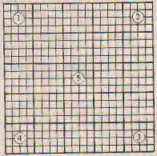 | Elythrocyte counting area showing position  of sets for counting.
The erythrocytes lying over upper and left edges of small square should be counted; those or right and lower edges should be ignored.
Calculation
1
Erythrocyte count = C x ------- x 200 per cu. mm
0.02
= C x 10,000 per cu. mm
Where C is the count in 5 x 16 squares, 0.02 the volume of counted space and 200 the dilution factor.
Leucocyte Counting
Proceed as with erythrocyte counting, using Turk's fluid. Take blood to mark 0.5 and dilute to mark 11.
Count the leucocytes in four large squares at the corners and divide with 4 to get the average.
Calculation
1
Leucocytes count = C x --------- x 20 per cu. mm
0.1
= C x 200 per cu. mm.
where C is the average count in one large square (16 small squares), 0.1 the volume covered and 20 the dilution used.
Differential leucocyte count
Differential leucocyte counting is done on a stained peripheral blood smear.
The slides used should be cleaned and defatted. Used slides should be cleaned by boiling in sodium carbonate 1% solution. The slides should then be rinsed with distilled water, kept under a stream of running water for a few hours and finally stored in ethanol-ether mixture (1 + 1). Before usi the slides should be dried and then wiped with linen cloth.
In order to prepare a blood smear touch the slide surface with the blood welling up from the finger tip or ear lobe. Take a cle~m polished coverslip (square shape), hold it between thumb and index finger, and press its edge gently over the droplet until the droplet runs along the edge. The holding the coverslip at an angle of 451, spread the blood with a motion to give a uniform even smear. Make two or three smears and stain one at a time.
Leishman Staining
The staining solution is prepared by dissolving 1.5g powdered stain in a litre of methanol. The solution should be shaken vigorously during the first 24 hours.
The blood smear is covered with 10 drops of Leishman stain for 30-60 seconds, making sure that the smear remains wet. More stain may be poured, if necessary. 20 drops of distilled water are then poured over the stain. The slide is rocked gently in order to mix the stain well with distilled water. After 10 minutes, the smear is rinsed with running tap water, dried in air and examined under oil immersion lens.
Types of Leucocytes
At least one hundred leucocytes should be differentiated into neutrophils (polymorphnuclears), lymphocytes, monocytes, eosinophils, basophils and abnormal cells.
Thrombocyte Counting
Any of the following solutions may be used as platelet diluting fluid.
1. Ammonium oxalate 1% in benzoic acid 0.1% solution.
2. Sodium citrate 3.8% 100 ml
Formaldehyde 40% 0.2 ml
Brilliant cresyl blue 0.1 g
3. Sodium oxalate 1.6 g
Formaldehyde 40% 6 ml
Crystal violet 0.05 g
Distilled water 94 ml
The first solution is preferred by experienced technicians whereas the latter 2 solutions are more suitable for freshers.
The blood is diluted 1:10 with diluting fluid with the help of leucocyte pipette. Further procedure is same as for erythrocyte counting. Multiplication factor is 1,000 in place of 10,000.

Chapter 16 : Urine examination
URINE EXAMINATION
Collection of Specimen
A. For routine examination. Spontaneous urine sample should be collected in a clean jar. Time of passing urine sample should be such that urine is most likely to contain the pathological constituent being sought viz.
1. Inflammatory disease. Morning sample.
2. Orthostatic proteinuria. Before and after the patient gets up.
3. Glycosuria. Two hours after meals.
4. Urobilinogen tests. Afternoon.
Only fresh urine should be used to study the urinary sediments.
B. For bacteriological examination. Preferably a morning specimen should be collected in a clean sterile flask. A catheter specimen is essential in female patients and desirable in male patients. In males, an inferior alternative is mid-stream urine. Glans penis and urethral meatus are cleaned with several swabs soaked in normal saline. The first portion of urine is discarded and mid-stream sample is collected in a sterile flask. The last portion is also discarded.
C. For chorionic gonadotrophin test. For UCG pregnancy test, a morning specimen is desirable. Patient should not take water in the morning till specimen is collected. Drugs such as salicylates, barbiturates should not be taken for at least two days prior to collection.
D. For quantitative estimations. A 24 hour collection of urine should be pooled in a sterile (or hot water washed) glass vessel. At the beginning of the stipulated 24 hour period the bladder must be emptied and the urine collected discarded. At the end of 24 hour period, the hladder should again be emptied and urine included in the pool; 5 mI of 10% thymol should be added to preserve 24 hour pool. Alternatively 3-4 drops of toluene should be added to form a thin film on the surface.
General tests
Urine output. 24 hour urine output varies with:
(i) Fluid intake
(ii). Fluid loss in sweating
(iii). Substances excreted
Nonnal Values
Adults | 1000 - 1600 ml
8-14 years | 800 - 1400 ml
5-8 years | 650 - 1000 ml
3-5 years | 600 - 700 ml
1-3 years | 500 - 600 ml
2-12 months | 400 - 500 ml
10-60 days | 250 - 450 ml
3-10 days | 100 - 300 ml
1-2 days | 30-60 ml
The day time output is 2-4 times the night time output. The reverse (nycturia) is an early sign of.
(i) Pyelitis (ii) Nephrosclerosis.
Oliguria. Urine output less than 500 ml/24 hours.
Observed in:
(i) Renal diseases
(ii) Cardiac insufficiency
(iii) Fever
(iv) Diarrhoea and vomiting
(v) Severe sweating
(vi) Fluid deprivation
(vii) Prostatic hypertrophy
(viii). Organic nervous disorders
(ix) Psychopathic disorders.
Polyuria. Urine output more than 2500 ml/24 hours.
Observed in:
(i) Excessive fluid intake
(ii) Cold atmosphere
(iii) Diuretic therapy
(iv) Pituitary tumours
(v) Hydropephrosis
(vi) Renal tuberculosis
(vii) Chronic nephritis (compensation stage)
(viii) Diabetes insipidus and mellitus
(ix) Paroxysmal tachycardia.
Urine Colour
(i) Pale yellow to golden yellow ... Normal.
(ii) Colourless to pale yellow.,
(a) Chronic interstitial nephritis
(b) Diabetes mellitus
(c) Untreated diabetes insipidus a
(d) Chronic Womerulonephritis
(e) Diuretic therapy.
(iii) Orange yellow:
(a) Fluid losses-Sweating, diarrhoea, vomiting, fever
(b) Low fluid intake
(c) Urobilin, pyrazolone derivatives, carotenes.
(iv) Red. High concentration. of uroerythrin, blood, haemoglobin, myoglobin, porphyrins, aminopyrine, antipyrine, aniline dyes.
(v) Brown. Haemoglobin, melanin, salicylic acid.
(vi) Greenish. Biliverdin, methylene blue, indigo carmine, carbolic acid, following long period of standing up.
(vii) Blue. Methylene blue, indigo carmine.
(viii) Milky. Fats, pus.
Urine turbidity. Normal urine when passed is clear. On standing for some time a flocculent sediment (nubecula) settles down. Turbidity of urine can be assessed by the following scheme.
Heat a few ml of urine in a water bath or over a flame
1. Turbidity disappears-Uric acid salts or uric acid.
2. Turbidity intensifies - Protein, carbonates or phosphates.
3. Turbidity does not clear
(i) Add a few drops of 10% acetic acid; clearance of turbidity indicates phosphates or carbonates.
(ii) Add a few ml of 12.5% hydrochloric acid. Clearance of turbidity indicates oxalates, leucine, tyrosine or cystine.
(iii) Add a few ml of 20% sodium hydroxide.
(a) Red colouration of precipitated phosphates indicates blood.
(b) Gelatinous coagulation indicates pus.
(iv) Shake with ethanol/ether mixture. Milky appearance indicates fat.
Specific gravity. The specific gravity is conventionally measured as milligrams per cubic centimetre. Thus a specific gravity of 1.015 is written as 1015. It is measured with a urinometer having callibrations of 1000-1040. The urinometer is made to float in a glass container (flask or wide tube) so that it does not touch the bottom or sides of the container. The normal value is 1015-1025. Sugar and protein increase the density of urine. To make specific gravity an index of renal function the following allowances should be made.,
1. Add 0001 for every 30C above callibration temperature (usually 15ºC of the urinometer. Subtract 0001 for every 3ºC below the callibration temperature.
2. Subtract 0003.7 for every 1% glucose and 0002.6 for every 1 % protein.
Reaction. Normal urine is acidic (pH 4.8 - 7.4).
Strongly acidic in:
(i) Malignancy (ii) Fever (iii) Severe diarrhoea (iv) Diabetic and metabolic acidosis.
Alkaline in:
(i) Urinary infections
(II) Respiratory and metabolic alkalosis.
Chemical Tests
1. Protein. Normally the urine contains very little amount of proteins with low molecular weight. In pathological conditions, the permeability of glomeruli changes thus increasing the protein content of urine mainly of serum albumin. The proteins excreted in urine may be of following types:
(i) Serum albumin (ii) Albumoses (iii) Peptones (iv) Bence-Jones proteins.
Detection of proteins may be made by the following tests
1 Purdy's heat test. Check the reaction of urine and if alkaline, add 10% acetic acid drop by drop till the litmus paper shows just acidic reaction. Incline at an angle and boil the top 2 cm over a flame holding the bottom of the test tube. Examine against a dark background. A cloudy appearance indicates protein or phosphates. Add a few drops of 10% acetic acid and boil again. If cloud disappears it indicates phosphates; a persistent cloud indicates protein. False positive results may be observed in patients receiving tolbutamide, high doses of penicillin or radiographic contrast media.
2. Robert's test. Place 2-3 ml Robert's reagent in a test tube and gently layer a few drops of urine over it. Albumin gives a white ring which varies in densityxxith the amount of albumin present.
3. Heller's test. The procedure is the same as for Robert's test. Concentrated nitric acid is used in place of Robert's reagent.
4. Sulphosalicylic acid test. Take 5 nil urine in a test tube. Add 0.5 nil sulphosalicylic acid 20%. Albumin gives white precipitate.
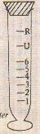 | Fig. 15.1.. Esbach's albuminometer
Quantitative test forprotein
Fill up the albuminometer to mark U with urine. Add Esbach's reagent to mark R. Close the tube with a rubber stopper invert it slowly several times an set it aside in a cold place. At the end of 24 hours read the height of the precipitate in grams/ litre. Divide it with 10 to get percentage.
Causes of Proteinuria
1. Functional or physiological:
(i) Postural or orthostatic
(ii) Exertion
(iii) Mental strain
(iv) Prolonged exposure to cold
(v) Pregnancy and premenstrual period
(vi) First week of neonatal period.
2. Organic or pathological:
(i) Pre-renal:
(a) Cardiac decompensation
(b) Fever
(c) Toxaemia
(d) Ascites and intraabdominal tu mours
(e) Heavy metals, e.g., bismuth, mercury
(f) Drugs, e.g., salicylic acid.
(ii) Renal:
(a) Chronic glomerulonephritis
(b) Nephrotic syndrome
(c) Renal tuberculosis
(d) Infarction of the kidney
(e) Malignancy.
(iii) Postyrenal
a. Pyelitis
b. Cystitis
c. Urethritis
Bence-Jones Proteins
Bence-Jones proteins are paraproteins rich in carbohydrates and lipids. These are present in patients with:
(i) Multiple myeloma
(ii) Sarcomatosis
(iii) Hypernephroma
(iv) Leukaemia
(v) Bronchogenic carcinoma.
These proteins produce milky turbidity at 45ºC which clears on further heating to 60ºC.
2. Sugar. Normal urine contains minute quantity of glucose not detected by ordinary tests. A detectable concentration of glucose in urine is termed glycosuria. The usually employed method of detection is Benedict's test.
Benedict's test. To 5 ml of Benedict's qualitative reagent add 8 drops of urine. Boil for 2 minutes and allow to cool. Note the change in colour or precipitate formation. The result may be interpreted as under:
(i) Light green turbidity 0.5%
(ii) Green precipitate 1%
(iii) Yellow precipitate 1.5%
(iv) Red precipitate over 2%
False positive results maybe given by the presence
of reducing agents, e.g., uric acid, creatinine,
ascorbic acid, glueuronic acid, penicillin, tetra
cycline, paraaminosalicylic acid, salicylates.
Causes of Glycosuria
(a) Glycosuria with hyperglycaernia
(i) Diabetes mellitus
(ii) Thyrotoxicosis
(iii) Grave's disease (iv) Raised intracranial tension (v) Ether anaesthesia (vi) Emotional upset.
(b) Glycosuria without hyperglycaernia: (i) Renal glycosuria (ii) Excessive carbohydrate intake (iii) Pregnancy (iv) Myocardial infarction.
3. Acetone bodies. Presence of acetone bodies such as acetone, diacetic (acetoacetic) acid and betaoxybutyric acid is always abnormal. It occurs in diabetes mellitus and starvation due to neoglucogenesis after glycogen stores in the liver have been depleted
Tests for Acetone
(i) Rothera's test. Place about 5 nil urine in a test tube and add about 1 g ammonium sulphate followed by 2-3 drops of concentrated sodium nitroprusside solution. Add 1 nil concentrated ammonium hydroxide solution. A permanganate coloured ring indicates the presence of acetone.
(ii) Lange's test. As above but adding 5 drops of glacial acetic acid in place of ammonium sulphate.
(iii) Frommer's test. Add 2-3 nil sodium hydroxide 10 N to 10 nil urine. Add 10-12 drops of 10% salicylaidehyde (alcoholic). Heat the upper portion to about 700C without reaching boiling point for at least 5 minutes. A yellow, orange, red or brown colour indicates acetone.
Tests for Diacetic Acid
1. Gerhardt's test. Add 10% ferric chloride solution to about 5 m] urine drop by drop until phosphates are precipitated. Filter and to the filtrate add more ferric chloride solution. Diacetic acid produces a red colour.
The test should be confirmud, if positive, on urine diluted with equal volume of water and boiled off to original volume. Colour due to diacetic acid will not appear in confirmatory test. Colour in confirmatory test is due to other substances such as phenol ' salicylates, antipyrine and sodium bicarbonate. Lindematin's test should be performed in such cases.
2. Lindemann's test. To 10 in] urine, add 5 drops of 30% acetic acid and 5 drops of 5% iodine solution (in 10% potassium iodide). Then add 2-3 drops of chloroform. In the presence of diacetic acid, chloroform will not become reddish violet.
Tests for Beta-oxybutytic Acid
Mix 800 ing ammonium sulphate, 3 drops of conce,ntrated ammonium hydroxide solution and two drops of sodium nitropresside 5% (freshly prepared). Add 1 ml urine and after 5-6 minutes, 5 ml water. A deep blue colour indicates beta-oxy
butyric acid.
4. Bile salts.
Hay's test. Fill half the test tube with urine. Sprinkle finely powdered dry sulphur over the surface. In normal urine the particles will float on the surface, if bile salts are present, particles will sink.
False positive results may be given by high concentrations of urobilin or if thymol is used as preservative.
Causes
(i) Obstructive jaundice.
(ii) Parenchymal liver damage.
5. Bile pigment.
(a) Fouchet's test. If the urine is alkaline or neutral, acidify it with a few drops of 2% acetic acid. Take 10 mI of acidic (or acidified) urine in a test tube. Add half this quantity of 10% barium chloride. Mix well, filter, and add a drop of Fouchet's reagent on the filter paper. A green or blue colour indicates bilirubin.
(b) Gmefin's test. Take 3 ml of concentrated nitric acid in a test tube. Add an equal amount of urine. A green or blue ring indicates bilirubin.
6. Urobilin (urobilinogen)
Elirlich's test. To about 5 mI urine add 1 ml Elirlich's reagent. A cherry red colour indicates abnormal urobilin. A light red colour appears with normal urine.
7. Blood. Benzidine test. Dissolve a pinch of benzidine in glacial acetic acid. Add 2 nil of urine, previously boiled and cooled, to 1 ml benzidine solution. Mix and add 1 nil of 3% hydrogen peroxide. Wait for 5 minutes. A green or blue colour
indicates blood.
Causes
(a) In the kidney:
(i) Acute glomerulonephritis
(ii) Subacute bacterial endocarditis
(iii) Nephrolithiasis
(iv) Polycystic kidney
(v) Embolic nephritis
(vi) Renal infarcts
(vii) Renal tuberculosis
(viii) Tumours of kidney and pelvis
(ix) Malignant nephrosclerosis.
(b) In the lower urinary tract:
(i) Inflammation or calculus in ureter
(ii) Inflammation or calculus in bladder
(iii) Tumours.
(c) Others:
(i) Purpura
(ii) Leukaemia
(iii) Polyarteritis nodosa.
8. Haemosidern
Rous'test. Centrifuge a fresh sample of urine and pour off the supernatant.-Add a mixture of 5 ml 2% potassium ferrocyanide plus 5 ml 1% hydrochloric acid. After 10 minutes, centrifuge and discard the supernatant. Examine the sediment covered with cover-glass, under the microscope. Haemosiderin will appear as blue granules.
9. Porphobilinogen
Watson & Schwares test. Mix 2 ml urine with 2 ml Ehrlich's reagent. Add 2 nil saturated Zinc acetate solution followed by 2 ml chloroform. Mix thoroughly. A red colour in the bottom layer (chloroform) indicates urobilinogen whereas red colour in upper portion indicates porphobilinogen.
10. melanin
(i) Add a few drops of 10% ferric chloride to 10 in] urine. A gray precipitate turning black on standing, indicates melanin.
(ii) Mix equal volumes of urine and bromine water. A yellow precipitate, which gradually turns black, indicates melanin.
11. Diazo substances
Prepare diazo reagent by mixing 10 ml 0.5% sulphanilic acid solution with 0.1 ml 0.5% sodium nitrite solution. Mix 5 ml -each of urine and diazo reagent by inversidn. Add 1-2 nil liquid ammonia. If the reaction is positive, garnet ring will appear at the junction and on shaking the foam will be coloured deep red. Yellow or orange colour should beignored.
The reaction becomes positive on 4-5th day of typhoid fever and fades during third week. An early fading is a favourable sign. It may also be positive in pulmonary tuberculosis and measles.
Microscopic Examination
A sample of urine is centrifuged at 1000-1500 r.p.m. for about 3 minutes. The upper clear portion is discarded as much as possible and the centrifuge tube is then. shaken to form homogenous suspension of the sediment. A drop is placed on the slide and covered with a cover slip. The slide is examined under high power objective of the microscope and a search is made for the following:
1. Erythrocytes. Normal urine shows upto one erythrocyte per high power field. Excess blood in urine is termed haematuria.
Causes of Haematuria
(i) Acute glomerulonephritis
(ii) Embolic nephritis
(iii) Malignant hypertension
(iv) Polyarteritis nodosa
(v) Renal lupus erythematosus
(vi) Renal tuberculosis
(vii) Congenital polycystic disease
(viii) Haemorrhagic diseases
(ix) Renal infarction
(x) Renal trauma
(xi) Renal tumour
(xii) Subacute bacterial endocarditis.
2. Leucocytes. A few leucocytes or pus cells are present in normal urine. Upto 5 cells per high power field may be considered as normal. Abnormal amount of leucocytes in urine is seen in inflammatory conditions of the urinary tract, renal tuberculosis and following catheterisation.
3. Casts. Hyaline casts result from precipitation of mucoprotein in the renal tubules. On hyaline casts materials such as erythrocytes, leucocytes, epithelial cells may be deposited. On microscopic examination casts are recognised as cylinderical bodies with sharply dofined outline and rounded ends one of which may be 'broken'. Casts of following
types may be detected:
(i) Hyaline casts:
(a) Subacute glomerulonephritis
(b) Chronic glornerulonephritis
(c) Chronic venous congestion
(d) Nephrosclerosis.
(ii) Finely granular casts:
(a) Chronic glomerulonephritis (b) Fever (c) After exercise (d) Diuretic therapy.
(iii) Densely granular casts:
(a) Glomerulonephritis
(b) Diabetic nephropathy
(c) Renal arnyloidosis
(d) Malignant hypertension.
(iv) Fatty casts-Nephrotic syndrome
(v) Waxy casts-Amyloidosis
(vi) Cellular casts: Renal failure Glomerulonephritis Malignancy (d) Pyelonephritis.
4. Crystals
(a) In acid urine:
(i) Calcium oxalate
(ii) Uric acid
(iii) Urates.
(b) In Alkaline urine:
(i) Amorphous phosphates
(ii) Ammonium urate.

Chapter 17 : Stool examination
STOOL EXAMINATION
Gross Examination
1. Colour. Normal stool is light brown in colour.
(i) Green. Infantile diarrhoea
(ii) Clay..
(a) Obstructive jaundice
(b) Excess of fat
(c) Tuberculous peritonitis
(d) Achylia pancreatica
(iii) Dark brown or bright red.,
(a) Bleeding from distal colon (b) Haemorrhoids (c) Fissure (d) Carcincnaa rectum.
(iv) Black:
2. Odour
(a) Gastrointestinal bleeding (b) Tuberculosis of large bowel (c) Malignancy of large bowel (d) Iron intake.
(i) Odourless. Antibiotic therapy
(ii) Foul smelling (a) Acute enteritis (b) Malignant ulcer in rectum and distal colon.
(iii) Foul, frothy and buk. Malabsorption
syndrome.
3. Mucus
(i) Small in apnount and inixed intimately
Lesion in small intestine
(ii) Large amounts not well mixed. Lesion in
large intestine
(iii) Large aniount streaked with blood
(a) Dysentery
(b) lleocolitis
(c) Intussception.
4. Pus. (with blood and mucus)
(i) Ulcerative colitis
(ii) Bacillary dysentery
(iii) Regional enteritis.
5. Concretions. Gallstones.
6. pH. Normal pH is 6.8 - 7.3. Excess of carbohydrate produces acidity and excess of protein alkalinity.
7. Occult blood
(i) Benzidine test. Already described.
(ii) Orthotoluidine test. Prepare thick suspension of faeces. Add 1 mJ, of orthotoluidine reagent and 1 mI of 3% hydrogen peroxide. Observe for a minute. Bluish green colour indicates occult blood.
Microscopic Examination
Transfer one drop of thick stool suspension (in normal saline) onto a slide. Cover with coverslip and examine first under low power objective and then under high power objective. One more slide should be prepared and examined in the same way adding a drop of weak iodine solution.
Concentration Methods
1. De Riva's inethod. Place about 1 g stool in a test tube. Add 5 ml 5% acetic acid. Close the tube and shake vigorously for half a minute. Keep still for half a minute coarse particles will sink rapidly to the bottom. Pipette out homogeneous supernatant into a centrifuge tube. Add an equal volume of ether. Close the tube and shake vigorously for half a minute. Centrifuge for 5 minutes. The contents will differentiate into four layers:
(i) Ethereal layer (for occult blood)
(ii) Detritus plug comprising bile, soap and protein matter
(iii) Acetic acid
(iv) Bottom sediment with ova and cysts. Pipette and the sediment for examination and detection of ova and cysts.
2. Zinc sulphate method. Dilute about 5 g stool with 4 times its volume of warm water. Strain the mixture through a cloth into a centrifuge tube. Centrifuge for a minute at top speed. Pour off the supernatant. Add more water and centrifuge. Similarly wash the sediment with water 3-4 times till the supernatant is clear. Pour off the last supernatant and add 3-4 ml 33% zinc sulphate solution. Break up the sediment and fill up the zinc sulphate solution upto 2 cm from the rim. Centrifuge at top speed for a minute. Examine the top floating material with a drop of iodine for ova and cysts.
Findings
Cysts of protozoa viz.
(i) Entamoeba histolytica
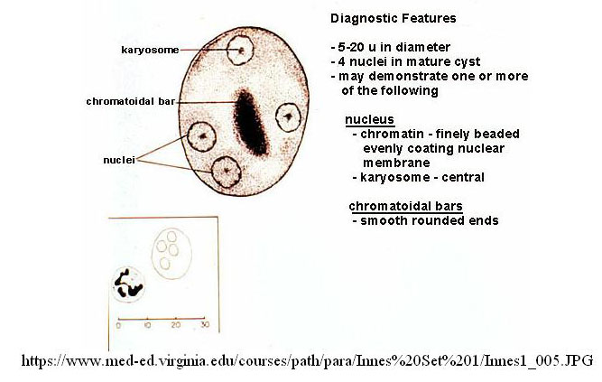
Cyst of Entamoeba histolytica
(ii) Entamoeba coli
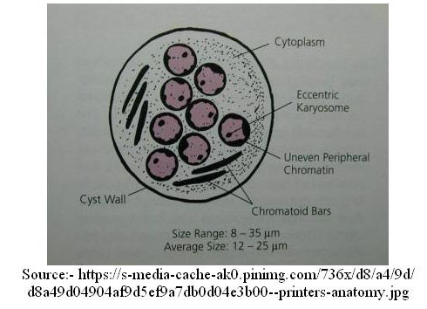
Cyst of Entamoeba coli
(iii) Giardia intestinalis
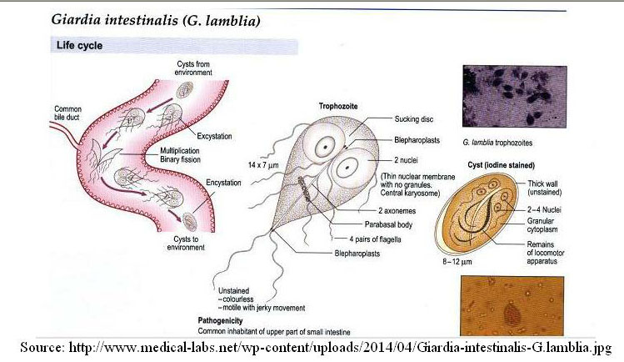
Ova of helminths viz.
(i) Ascaris lumbaricoides
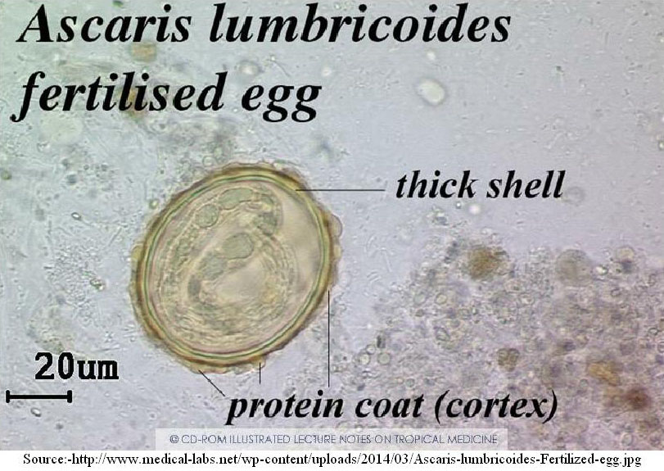
(ii) Enterobius vermicularis
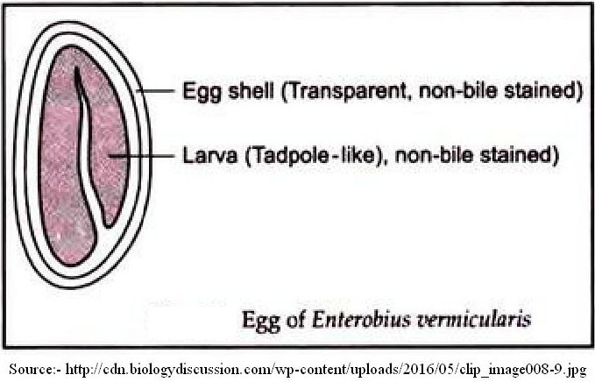
(iii) Ankylostoma duodenale
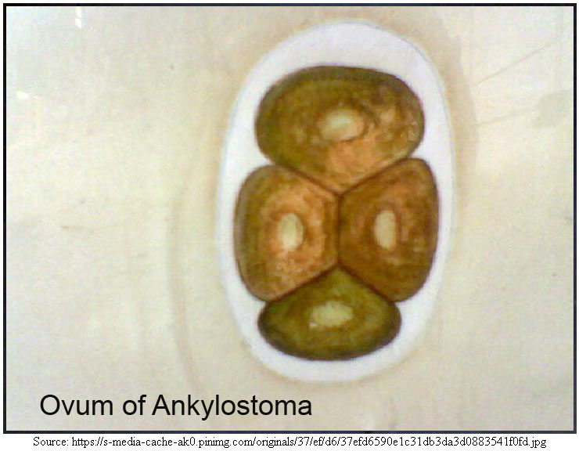
(iv) Taenia saginata and Taenia solium
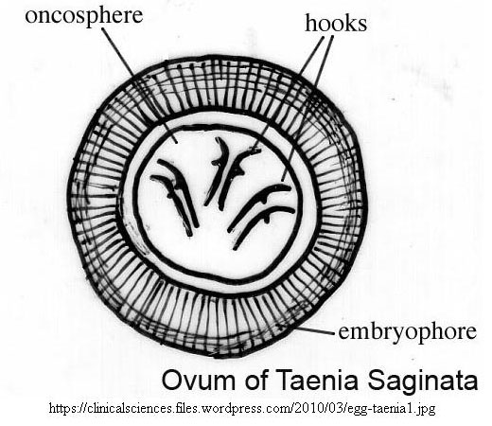
(v) Hymenolepsis nana
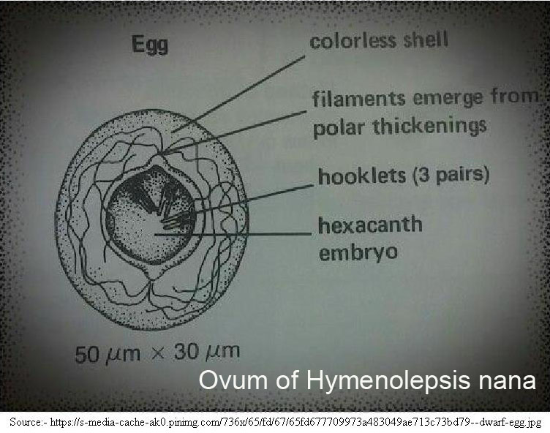
(vi) Trichuris trichura
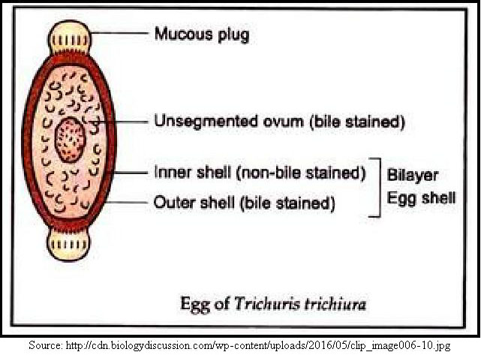
Gross Examination
1. Colour. Normal stool is light brown in colour.
(i) Green. Infantile diarrhoea
(ii) Clay..
(a) Obstructive jaundice
(b) Excess of fat
(c) Tuberculous peritonitis
(d) Achylia pancreatica
(iii) Dark brown or bright red.,
(a) Bleeding from distal colon (b) Hemorrhoids (c) Fissure (d) Carcincnaa rectum.
(iv) Black:
2. Odour
(a) Gastrointestinal bleeding (b) Tuberculosis of large bowel (c) Malignancy of large bowel (d) Iron intake.
(i) Odourless. Antibiotic therapy
(ii) Foul smelling (a) Acute enteritis (b) Malignant ulcer in rectum and distal colon.
(iii) Foul, frothy and buk. Malabsorption
syndrome.
3. Mucus
(i) Small in apnount and inixed intimately
Lesion in small intestine
(ii) Large amounts not well mixed. Lesion in
large intestine
(iii) Large aniount streaked with blood
(a) Dysentery
(b) lleocolitis
(c) Intussception.

4. Pus. (with blood and mucus)
(i) Ulcerative colitis
(ii) Bacillary dysentery
(iii) Regional enteritis.
5. Concretions. Gallstones.
6. pH. Normal pH is 6.8 - 7.3. Excess of carbohydrate produces acidity and excess of protein alkalinity.
7. Occult blood
(i) Benzidine test. Already described.
(ii) Orthotoluidine test. Prepare thick suspension of feces. Add 1 mJ, of orthotoluidine reagent and 1 mI of 3% hydrogen peroxide. Observe for a minute. Bluish green colour indicates occult blood.
Microscopic Examination
Transfer one drop of thick stool suspension (in normal saline) onto a slide. Cover with coverslip and examine first under low power objective and then under high power objective. One more slide should be prepared and examined in the same way adding a drop of weak iodine solution.
Concentration Methods
1. De Riva's inethod. Place about 1 g stool in a test tube. Add 5 ml 5% acetic acid. Close the tube and shake vigorously for half a minute. Keep still for half a minute coarse particles will sink rapidly to the bottom. Pipette out homogeneous supernatant into a centrifuge tube. Add an equal volume of ether. Close the tube and shake vigorously for half a minute. Centrifuge for 5 minutes. The contents will differentiate into four layers:
(i) Ethereal layer (for occult blood)
(ii) Detritus plug comprising bile, soap and protein matter
(iii) Acetic acid
(iv) Bottom sediment with ova and cysts. Pipette and the sediment for examination and detection of ova and cysts.
2. Zinc sulphate method. Dilute about 5 g stool with 4 times its volume of warm water. Strain the mixture through a cloth into a centrifuge tube. Centrifuge for a minute at top speed. Pour off the supernatant. Add more water and centrifuge. Similarly wash the sediment with water 3-4 times till the supernatant is clear. Pour off the last supernatant and add 3-4 ml 33% zinc sulphate solution. Break up the sediment and fill up the zinc sulphate solution upto 2 cm from the rim. Centrifuge at top speed for a minute. Examine the top floating material with a drop of iodine for ova and cysts.
Findings

Cysts of protozoa viz.
(i) Entamoeba histolytica
(ii) Entamoeba coli
(iii) Giardia intestinalis.

Chapter 18 : Sputum examination
SPUTUM EXAMINATION
A. Macroscopic Examination
1. Quantity
Slight -
Incipient tuberculosis
Small
(i) Acute bronchitis (ii) Lobar pneumonia.
Large
(i) Advanced tuberculosis (H) Pulmonary oedema (iii) Bronchiectasis (iV) Ruptured lung abscess (v) Empyema.
2. Colour
Yellowish green
(i) Advanced tuberculosis (ii) Chronic bronchitis.
Bright green
(i) Jaundice (ii) Lobar pneumonia (iii) Caseous pneumonia.
Red (i) Haemoptysis.
Rusty red
(i) Lobar pneumonia (ii) Pulmonary infarction. Brown (i) Chronic venous congestion.
Grayish black (i) Coal depot workers (ii) Smokers.
3. Consistency
Tenacious - Lobar pneumonia
Mucoid
(i) Early acute bronchitis (ii) After asthmatic attack.
Serous, bloody - Pulmonary oedema
4. Layer formation. When placed into tall glass vessel, sputum separates into three layers. It occurs in bronchiectasis, lung abscess and gangrene.
5. Dittrich's plugs. Yellowish or gray masses, a few millimetres in diameter; may be exporated alone or in sputum. They may be passed by normal persons or may be found in bronchitis and bronchiectasis.
6. Pneumoliths. These are mostly calcified nodules of tuberculous tissue. Some foreign bodies such as gun-shots may be passed out as pneumoliths.
7. Bronchial casts. Branching (tree-like) fibrinous structures, upto 15 cm long. May appear like a ball and can be recognized only by floating over water. Present in lobar pneumonia, fibrinous bronchitis and diphtheria.
B. Microscopic Examination (unstained)
1. Elastic fibres
(i) Pulmonary tuberculosis (ii) Lung abscess (iii) Gangrene.
2. Curschmann~s spirals - Bronchial asthma
3. Charcot-Leydon crystals- Bronchial asthma
4. Pigmented cells
(i) Haemosiderin cells - Venous congestion (ii) Carbon-laden cells
(a) Coal depot works (b) Smokers.
5. Myeline globules - No significance
6. Molds, yeasts and parasites.
C. Microscopic Examination (stained)
Several smears should be stained with AJFB stain, Gram stain and for capsules.
1. AFB Staining
A thin smear should be fixed by heating the slide, smear up, over the flame. The slide should be passed slowly over the fidme thrice and brought to room temperature. It may subsequently be stained with either hot or cold method.
a. Hot method. Cover the smear with carbol fuchsin (strong). Heat it over flame till it steams for 3 minutes. Stain should not dry out; add more staining solution as necessary. Rinse with water and pour sulphuric acid 20% or, preferably, hydrochloric acid 3% in ethanol till pink stain ceases to flow out. Rinse with water and counterstain with Loffier's methylene blue for two minutes.
b. Cold method. The smear slide is air dried on a warming plate. The slide is prefixed in a Coplin jar of absolute methanol for 5 to 10 s, stained in carbol fuchsin-DMSO solution in a Coplin jar for 5 min, and rinsed individually in gently running tap water until excess solution no longer ran off (10 to 30 s per slide). Slide is then placed in the decolorizer-counterstain for 1 min or until a green background appeared and then is rinsed under running tap water for 10 s, drained, blotted, and placed on a warming plate until thoroughly dry (5 or 10 min). A thin film of immersion oil is applied over smear with an applicator stick.
For the carbol fuchsin-DMSO stain, 4 g of basic fuchsin crystals is dissolved in 25 ml of 99% ethyl alcohol. 12 grams of phenol crystals liquefied in a water bath (or 12 ml of liquefied phenol) is added and mixed well with a glass stirring rod. Then, 25 ml of glycerol, chemically pure, 25 ml of DMSO and 75 ml of distilled water are added and mixed well. The solution is allowed to stand for 30 min and then filtered, The stain may be used immediately or kept indefinitely at room temperature in an amber glass bottle. | For the decolorizer-counterstain solution, 220 ml of a 2% aqueous solution of malachite green is prepared; 30 ml of glacial acetic acid (99.5%) and 50 ml of glycerol, chemically pure, are added and mixed well. Filtration is unnecessary. This solution keeps indefinitely in a closed container at room temperature.
The smear examined with either method should be examined under oil-immersion lens. The tubercle bacilli appear as dark-red dots in a blue or green background.
Concentration Method
Mix equal volumes of sputum and sodium hypochloride 5.25%. Centrifuge the mixture at high speed for 10 minutes. Pour off the supernatant and drain the tube for 2 minutes.
Transfer the sediment to the slide, fix and stain the smear with AFB stains.
2. Gram's staining
Cover the heat-fixed smear with crystal violet stain for half a minute. Rinse with water and cover with Lugol's iodine for half a minute. Decolorize with acetone (or 95% ethanol) till the purple colour ceases to come off. Counterstain with safranin 0.5%.
3. Capsule staining
(i) Smith's method
(a) For Gram-positive bacteria. Dip the heat-fixed smear into 10% phosphomolybdic acid for 4-5 seconds. Rinse in water. Cover with aniline-gentian violet and steam gently for 15-30 seconds. Rinse in water cover with Lugol's iodine and steam gently fw 15-30 seconds. Decolorize with 95% ethamol as in Gram's method. Rinse in water. Cover with eosin 2% and gently warm for 30~60 seconds. Rinse in water and dry by blotting.
(b) For gram-negative bacteria. Stain with phosphomolybdic acid as above. Cover with eosin 2% and gently warm for 30-60 second. Rinse in water, Cover with Loffler's methylene blue solution and warm gently for 15-30 seconds. Rinse in water.
(ii) Hiss' method
Dry the film in air without heating cover with crystal violet solution for two minutes. Wash with 20% copper sulphate solution. Dry by blotting.
The organisms frequently encountered are mycobacterium tuberculosis, staphylococci, streptococci, Diplococcus pneumoniae, Mebsiella pneumoniae Haernephillus influenzae, Haemophillus pertussis, and neisseria.
Wrights stain preparation should be examined for leucocytes, epithelial cells and erythrocytes.
A. Macroscopic Examination
1. Quantity
Slight -
Incipient tuberculosis
Small
(i) Acute bronchitis (ii) Lobar pneumonia.
Large
(i) Advanced tuberculosis (H) Pulmonary oedema (iii) Bronchiectasis (iV) Ruptured lung abscess (v) Empyema.
2. Colour
Yellowish green
(i) Advanced tuberculosis (ii) Chronic bronchitis.
Bright green
(i) Jaundice (ii) Lobar pneumonia (iii) Caseous pneumonia.
Red (i) Hemoptysis.
Rusty red
(i) Lobar pneumonia (ii) Pulmonary infarction. Brown (i) Chronic venous congestion.
Grayish black (i) Coal depot workers (ii) Smokers.
3. Consistency
Tenacious - Lobar pneumonia
Mucoid
(i) Early acute bronchitis (ii) After asthmatic attack.
Serous, bloody - Pulmonary oedema
4. Layer formation. When placed into tall glass vessel, sputum separates into three layers. It occurs in bronchiectasis, lung abscess and gangrene.
5. Dittrich's plugs. Yellowish or gray masses, a few millimetres in diameter; may be exporated alone or in sputum. They may be passed by normal persons or may be found in bronchitis and bronchiectasis.
6. Pneumoliths. These are mostly calcified nodules of tuberculous tissue. Some foreign bodies such as gun-shots may be passed out as pneumoliths.
7. Bronchial casts. Branching (tree-like) fibrinous structures, upto 15 cm long. May appear like a ball and can be recognized only by floating over water. Present in lobar pneumonia, fibrinous bronchitis and diphtheria.
B. Microscopic Examination (unstained)
1. Elastic fibres
(i) Pulmonary tuberculosis (ii) Lung abscess (iii) Gangrene.
2. Curschmann~s spirals - Bronchial asthma
3. Charcot-Leydon crystals- Bronchial asthma
4. Pigmented cells
(i) Hemosiderin cells - Venous congestion (ii) Carbon-laden cells
(a) Coal depot works (b) Smokers.
5. Myeline globules - No significance
6. Molds, yeasts and parasites.
C. Microscopic Examination (stained)
Several smears should be stained with AJFB stain, Gram stain and for capsules.
1. AFB Staining
A thin smear should be fixed by heating the slide, smear up, over the flame. The slide should be passed slowly over the fidme thrice and brought to room temperature. It may subsequently be stained with either hot or cold method.
a. Hot method. Cover the smear with carbol fuchsin (strong). Heat it over flame till it steams for 3 minutes. Stain should not dry out; add more staining solution as necessary. Rinse with water and pour sulphuric acid 20% or, preferably, hydrochloric acid 3% in ethanol till pink stain ceases to flow out. Rinse with water and counterstain with Loffier's methylene blue for two minutes.
b. Cold method. The smear slide is air dried on a warming plate. The slide is prefixed in a Coplin jar of absolute methanol for 5 to 10 s, stained in carbol fuchsin-DMSO solution in a Coplin jar for 5 min, and rinsed individually in gently running tap water until excess solution no longer ran off (10 to 30 s per slide). Slide is then placed in the decolorizer-counterstain for 1 min or until a green background appeared and then is rinsed under running tap water for 10 s, drained, blotted, and placed on a warming plate until thoroughly dry (5 or 10 min). A thin film of immersion oil is applied over smear with an applicator stick.
For the carbol fuchsin-DMSO stain, 4 g of basic fuchsin crystals is dissolved in 25 ml of 99% ethyl alcohol. 12 grams of phenol crystals liquefied in a water bath (or 12 ml of liquefied phenol) is added and mixed well with a glass stirring rod. Then, 25 ml of glycerol, chemically pure, 25 ml of DMSO and 75 ml of distilled water are added and mixed well. The solution is allowed to stand for 30 min and then filtered, The stain may be used immediately or kept indefinitely at room temperature in an amber glass bottle. | For the decolorizer-counterstain solution, 220 ml of a 2% aqueous solution of malachite green is prepared; 30 ml of glacial acetic acid (99.5%) and 50 ml of glycerol, chemically pure, are added and mixed well. Filtration is unnecessary. This solution keeps indefinitely in a closed container at room temperature.
The smear examined with either method should be examined under oil-immersion lens. The tubercle bacilli appear as dark-red dots in a blue or green background.
Concentration Method
Mix equal volumes of sputum and sodium hypochlosite 5.25%. Centrifuge the mixture at high speed for 10 minutes. Pour off the supernatant and drain the tube for 2 minutes.
Transfer the sediment to the slide, fix and stain the smear with AFB stains.
2. Gram's staining
Cover the heat-fixed smear with crystal violet stain for half a minute. Rinse with water and cover with Lugol's iodine for half a minute. Decolorize with acetone (or 95% ethanol) till the purple colour ceases to come off. Counterstain with safranin 0.5%.
3. Capsule staining
(i) Smith's method
(a) For Gram-positive bacteria. Dip the heat-fixed smear into 10% phosphomolybdic acid for 4-5 seconds. Rinse in water. Cover with aniline-gentian violet and steam gently for 15-30 seconds. Rinse in water cover with Lugol's iodine and steam gently fw 15-30 seconds. Decolorize with 95% ethamol as in Gram's method. Rinse in water. Cover with eosin 2% and gently warm for 30~60 seconds. Rinse in water and dry by blotting.
(b) For gram-negative bacteria. Stain with phosphomolybdic acid as above. Cover with eosin 2% and gently warm for 30-60 second. Rinse in water, Cover with Loffler's methylene blue solution and warm gently for 15-30 seconds. Rinse in water.
(ii) Hiss' method
Dry the film in air without heating cover with crystal violet solution for two minutes. Wash with 20% copper sulphate solution. Dry by blotting.
The organisms frequently encountered are mycobacterium tuberculosis, staphylococci, streptococci, Diplococcus pneumonie, Mebsiella pneumoniae Haernephillus influenzae, Haemophillus pertussis, and neisseria.
Wrights stain preparation should be examined for leucocytes, epithelial cells and erythrocytes.

Chapter 19 : CSF examination
Components of CSF. examination
1. Physical examination:
(i) Pressure
(ii) Appearance.
2. Chemical examination:
(i) Proteins
(ii) Chlorides (iii) Sugar.
3. Cell count:
(i) Total cell count
(ii) Differential cell count.
4. Bacteriology
5. Special investigations
(i) Colloidal gold test
(ii) Pandy’s test

Physical examination

- Pressure:
Normal - 60-150 mm. of water (Lying)
200-250 mm of water (Sitting)
Raised in:
(a) Intracranial tumours
(b) Meningitis
(c) Hydrocephalus
(d) General paralysis of insane (G.P.I).
Lowered in:
(a) Head injury
(b) Repeated lumbar puncture
(c) Subarachnoid block.

- Appearance:
Normal - clear and colourless
Turbid - in pyogenic meningitis
Cob-web coagulum - in tuberculous meningitis.

Blood:
(a) Trauma of needle
(b) Intracranial haemorrhage
(c) Subarchnoid haemorrhage.

Xanthochromia:
(a) Spinal block
(b) Auditory nerve tumour
(c) Chronic jaundice
(d) Polyneuritis.
Chemical Examination
1. Proteins.
Normal 20-30 mg/100 ml.
Raised in:
(a) Meningitis.
(b) Encephalitis
(c) Neurosyphilis
(d) Cerebral arteriosclerosis.
Cyto-albumin dissociation seen in:
(a) Poliomyelitis (early stage) (b) Neurosyphilis (c) Disseminated sclerosis.
2. Chlorides:
Normal 700-750 mg/100 MI. Raised in: Uraemia. Lowered in: (a) Purulent meningitis (b) Tuberculous meningitis.
3. Sugar: Normal 50-80 mg/100 ml Absent in: Pyogenic meningitis Reduced in: Tuberculous meningitis Nonnal in: Viral infections.
Cell-Count
Normal 0-5 cells/cu. mm. (usually lymphocytes).
5-100 cells/cu. mm. in:
(a) Neurosyphilis
(b) Encephalitis
(c) Poliomyelitis.
100-500 cells/cu. mm. in:
(a) Tuberculous meningitis
(b) Syphilitic meningitis
(c) Aseptic meningitis.
Beyond 500 cells/cu mm. in:
Purulent meningitis.
Causes of lymphocytosis:
(a) Neurosyphilis
(b) Poliomyelitis
(c) Encephalitis
(d) Tuberculous meningitis
(e) Cerebral tumour
(f) Lymphatic leukaemia
(g) Chloroma.

Causes of Polymorphonuclear leukocytosis:
(a) Pyomeningitis
(b) Poliomyelitis (early stages).
Bacteriology
Gram positive cocci : Pyogenic meningitis
Acid fast bacilli : Tuberculous meningitis
Special Investigations
- Colloidol gold test. Depends upon proportion of a-globulin and other proteins. a-globulin precipitates colloidal gold whereas albumin and P-globulin inhibit it.
Serial dilutions of C.S.F. are prepared with a solution of colloidal gold and allowed to stand overnight. Normal C.S.F does not show precipitation. Precipitation indicates three types of patterns.
(a) Paretic pattern. Maximum precipitation in the tubes containing high concentration of C.S.F.
Seen in G.P.I.
(b) Leutic pattern. Precipitation in the tubes
with relatively less concentration of C.S.F.
Seen in Tabes dorsalis.
(c) Meningitic pattern. Precipitation in tubes with least concentration of C.S.F.
Seen in Meningitis.
2. Pandy's test. Depends upon the precipitation of globulin by aqueous phenol.
Positive in meningitis
Slightly positive in neurosyphilis.

Chapter 20 : Semen Examination
Around 15% of the couples are infertile. The cause may be in male or in female, or in both – perhaps 30% in each division. Cause is unknown in remaining 10% infertile couples. Evaluation of male infertility is often limited to a semen analysis that comprises sperm count, motility, and morphology.

Two samples should be analyzed at an interval of 1- 3 weeks. If the results from the two samples are substancially different, additional samples should be examined.

Ejaculation Produces semen from a concentrated suspension of spermatozoa, stored in the paired epididymides, mixed with, and diluted by fluid secretions from the accessory sex organs. It is emitted in several small round masses. Comparison of pre- and post-vasectomy semen volumes reveals that about 90% of semen volume is made up of secretions from the accessory organs, mainly the prostate and seminal vesicles, with minor contributions from the bulbourethral glands and epididymides.

Semen Sperm has two major attributes of measurement:-

- Total number of spermatozoa. This reflects sperm production by the testes and the patency of the post-testicular duct system;

- Total fluid volume contributed by the various accessory glands. This reflects the secretory activity of the glands.

The nature of the spermatozoa (their vitality, motility and morphology) and the composition of seminal fluid are also important for sperm function. Semen production in Bulls is highest during Winter, least during Summer, and midway during rainy season.

During sexual intercourse, the initial, sperm-rich prostatic fraction of the ejaculated semen may come into contact with cervical mucus extending into the vagina, with the rest of the fluid remaining as a pool in the vagina. In contrast, in the laboratory setting, the entire ejaculate is collected in one container, where spermatozoa are trapped in a coagulum developed from proteins of seminal vesicular origin. This coagulum is subsequently liquefied by the action of prostatic proteases, during which time its osmolality rises.
The quality of semen specimens varies depending on how the ejaculate is produced. Ejaculates produced by masturbation and collected into containers in a room near the laboratory can be of lower quality than those recovered from non-spermicidal condoms used during intercourse at home. This difference may reflect a different form of sexual arousal, since the time spent producing a sample by masturbation reflecting the extent of seminal emission before ejaculation also influences semen quality.

Under given conditions of collection, semen quality depends on factors that usually cannot be modified, such as sperm production by the testes, accessory organ secretions and recent (particularly febrile) illness, as well as other factors, such as abstention time, that should be recorded and taken into account in interpreting the results.

Sample Collection
Sample should be collected by masturbation into a wide-mouthed plastic or glass container certified as nontoxic to spermatozoa.

1. Near the laboratory
- to minimize temperature variation;
- to control time elapsed between collection and testing.

- Abstinence of 2-7 days before sample collection. Abstinence period should be uniform for patients visiting the laboratory.

- Sample should be complete ejaculate. In case of initial loss or terminal loss of fraction, a fresh sample should be collected after 2-7 days of fresh abstinence.

- Sample should be kept at room temperature – not in refrigerator or ice-box.

Container Certification

A lot of containers should be checked up against a control container previously certified. Half the ejaculate should be added to Control container and the remaining half in Test container. Sperm motility is tested every hour. If the motility in two containers matches, test container should be Certified. To be more sure three or more containers of a lot should be checked.

Collection of semen in Condom

A sample may be collected in a condom during sexual intercourse.
Condoms should be non-toxic.

Usage the condom and its handling for transport it to the laboratory should be printed on Condom pack.

Time of semen collection should be recorded and sample delivered o the laboratory within 1 hour of collection.

During transport to the laboratory, the sample should be kept at 20ºC to 37ºC – No ice-wraps.

Statement of Condom collection should be included in the Report.

Sample handling

Semen sample may carry infections such as HIV, Hepatitis, Herpes. Sample handling should be treated as a biohazard and all precautions taken.

Macroscopic Examination
Semen Age

Semen collection time should be noted and recorded in the report. For a procedure, time elapsed should be as uniform as feasible.

At any instance, ejaculation is not complete. Some penultimate ejaculate gets mixed with fresh ejaculate. That mildly affects Semen age factor but seldom taken into account.

Liquefaction
Freshly ejaculated semen is a semi-solid coagulated mass. Liquefication begins within a few minutes at room temperature, with appearance of a heterogeneous mixture of lumps in the fluid. With time, the semen becomes more homogeneous and watery, and finally only small areas of coagulation remain. The complete liquefaction takes 15 minutes at room temperature, but that may take up to an hour or more. If complete liquefaction does not occur within hour, this should be reported. Semen samples collected at home or by condom are normally received in the laboratory in liquefied state.
Normal liquefied semen may contain unliquefied gelatinous bodies or jelly-like granules. These bodies or granules have no clinical significance. Mucus strands, however, may interfere with semen analysis.
Samples may not liquefy and hence create difficulty in analysis. In such cases, liquefaction may be induced by mechanical mixing or enzymatic digestion. Samples may also be liquefied by the addition of an equal volume of physiological medium such as Dulbecco’s phosphate-buffered saline, followed by repeated pipetting.
Heterogeneity may be reduced by repeated gentle passage through a blunt gauge 18 or gauge 19 needle attached to a syringe.

Digestion with Bromelain
Liquefaction may be promoted with Digestion by bromelain, a broad-specificity proteolytic enzyme.
- Prepare 10 IU/ml bromelain in Dulbecco’s phosphate-buffered saline by mixing for 30 minutes.
- Dilute semen with equal volume of 10 IU/ml bromelain
- Stir with a pipette tip, and incubate at 37 °C for 10 minutes.
- Mix the sample well before further analysis

These treatments may affect seminal plasma biochemistry, sperm motility and sperm morphology. Dilution of semen with bromelain sould be accounted for when calculating sperm concentration.

Appearance
A normal liquefied semen sample appears homogeneous, grey-opalescent. With very low sperm concentration, it may appear less opaque. The semen colour may be red-brown when red blood cells are present (haemo-spermia), or yellow in a man with jaundice or taking certain vitamins or drugs.
Color and Odor

Volume
Aspermia:

Hypospermia
Hyperspermia

Viscosity
Viscosity measures the semen's resistance to flow. High viscosity may interfere with determination of sperm motility, concentration, and antibody coating of spermatozoa. Normally, semen coagulates upon ejaculation and usually liquefies within 15-20 min.
Measurement of Viscosity
a. Pippete method :-
- Aspirate Liquefied sample into a wide-bore (1.5 mm diameter) plastic disposable pipette.
- Allow the semen to drop by gravity
- Observe the length of any thread.

A normal sample leaves the pipette in small discrete drops. With high viscosity samples, the drop will form a thread over 2 cm long.
b. Rod method :-
Introducing a glass rod into the sample and observe the length of the thread that forms upon withdrawal of the rod. Viscosity should be reported as abnormal when the thread exceeds 2 cm.
c. Rotational Viscometer
The seminal viscosity one hour after ejaculation is 8.35- 10.35 centipoise.
Seminal viscosity shows a significant negative correlation with the percentage of motile sperm (p < 0.05).

No significant correlation between seminal viscosity and sperm concentration.
The seminal viscosity of the oligoasthenospermic group is significantly higher than that of the normospermic group.

There is also a trend towards higher viscosity in the semen of asthenospermia and oligospermia when compared with the normospermic group.
Seminal viscosity may be higher in cases of poor-quality semen; however, sperm motility and concentration are not the sole determinants of viscosity.
pH
The pH of semen reflects the balance between the pH values of the different accessory gland secretions, mainly the alkaline seminal vesicular secretion and the acidic prostatic secretion. The pH should be measured after liquefaction at a uniform time, preferably after 30 minutes, but in any case within 1 hour of ejaculation since it is influenced by the loss of CO₂ that occurs after production.
pH paper in the range 6.0 to 10.0 should be used.
Mix the semen sample well.
Spread a drop of semen evenly onto the pH paper.
Wait for the colour of the impregnated zone to become uniform (<30 seconds). Compare the colour with the calibration strip to read the pH.
Note: The accuracy of the pH paper should be checked against known standards.
For viscous samples, the pH of a small aliquot of the semen can be measured using a pH meter designed for measurement of viscous solutions.

Microscopic Examination
Wet Preparation Examination
Sperm Concentration
Hemocytometry
Specialized Counting Chamber
a. Makler chamber
b. Disposable counting chambers
Loading the Chamber
Sperm Motility Assessment

Computer Analysis
- Curvilinear velocity

ii. : Curvilinear velocity

- Average path velocity

- Straight-line velocity

- Linearity

- Amplitude of lateral head displacement

Staining Techniques
Evaluation of Morphology Assessment
Smear Preparation
Staining Methods
Papanicolaou Stain
Diff-Quik Staining
Scoring Sperm Morphology
Leukocytospermia Test
Eosin-Nigrosin Stain
Hypo-osmotic Swelling Test (HOS)
Antisperm Antibodies

Immunobead Test
Direct Immunobead Test
Indirect Immunobead Test

Infections
Pyospermia
Collection of Semen Specimens
Organisms Found in Semen
Ureaplasma and Mycoplasma
Chlamydia trachomatis
Neisseria gonorrhoeae
Trachomonas vaginalis and E. coli
Viruses

Semen Biochemistry
Measurement of Zinc
Measurement of Citric Acid in Seminal Plasma

Measurement of Neutral α-glucosidase in Seminal Plasma
Fructose
Identification of fructose as the main source of energy in bull semen has stimulated interest in semen fructose assay. Consequently a colorimetric method for the determination of fructose in biological fluids was advanced by Roe and later on modified by Mann and El-Sawaf to estimate semen fructose. The commonly used method of Roe as modified by Mann and other investigators involves the use of Seliwanoff’s reagent, which is unstable. Newer methods modified after El-Sawaf and Dr K Chaudhry (Author of this Book) are described in this book.
Fructose Content of Seminal Plasma
Fructose level in normal human semen is over 120-450 mg/dl at 30 minutes after ejaculation. Fructose is utilised rapidly during sperm activity and fructose level drops by over 40% at 4 hours after ejaculation.
Semen fructose dimished in :-
- Inflammation of the seminal vesicles
- Androgen deficiency
- Abstinence for 8 days or more

Within normal values, Semen fructose is higher in young men and lower with age.
In postpubescent interstitial-cell insufficiency with Normospermia, the patient is infertile with diminished Semen fructose. After treatment with methyltestosterone or chorionic gonadotrophin the fructose value returns to normal and the patients become fertile.
The fructolysis of human semen depends on the presence of normal spermatozoa; centrifuged cell-free seminal plasma shows no fructolysis.
In FRUCTOSE DROP TEST, fructose level is determined at 30 minutes and at 4 hours after ejaculation. The result is reported as % drop from the first level.
Fructose level in semen with dead sperms is 150-250 mg/dl and may show a little drop over time.
Absence of both fructose and spermatozoa in the semem indicates obstruction distal to the ejaculatory duct. These findings may be used to confirm vasectomy operation.
Reappearance of fructose in semen is used to assess the success of recanalization operation.
Other uses of Fructose Estimation
1. Placental fructose estimation
Whole homogenates of human full-term placenta produce fructose when incubated in vitro with fructose 6-phosphate, glucose 6-phosphate, or sorbitol and diphosphopyridine nucleotide.
Human placenta contains a ketose reductase but does not contain an aldose reductase or significant amounts of sorbitol, so that the production of fructose observed in slice preparations cannot be explained on the basis of a combination of the action of these two enzymes. No evidence exists for the presence in placenta of a specific fructose 6-phosphatase.
Production of fructose by human term placenta is likely result of the action of a non-specific alkaline phosphatase.
- Urine fructose estimation.

- Urine inulin estimation in inulin tolerance test. Inulin is hydrolysed into glucose and fructose in the procedure itself.

- Fructose estimation in sugar industry. Here also sucrose is hydrolysed into glucose and fructose in the procedure itself.

Methods of Estimation
A. MVD Kit
Available on Mobile: +91-7503578515, 8130824823 – Ready stocks on Demand.
FREE Supplies for Research Projects in Universities and Institutions – Total Project Needs.
Indole 3-Acetic acid reagent developed by Author of this book is stable at Room temperature.
Introduction

Fructose in presence of hydrochloric acid, forms a pink coloured complex with indole-3-acetic acid. The complex has maximum absorbance at 500-530 nm.
Reagents supplied
Reagent |  | Storage |  | Stability
Fructose Reagent: Indole-3-acetic acid 10 ml |  | R.T. |  | 1 years
Standard : 200 mg/dl 5 ml |  | R.T. |  | 1 years
Extra Reagent Required : Hydrochloric acid LR / AR / GR
After first use, the reagent and the standard should be stored in refrigerator.

Procedure
- Pour over 0.005 ml sample, 5 ml Hydrochloric acid.
- Add 0.1 ml Fructose Reagent. Mix by inversion.
- Incubate at 50ºC for exact 50 minutes.
- Cool and read absorbance against water adjusted to zero with bluish green filter (500-530 nm).

For standard, take 0.005 ml standard in place of sample in step 1. For blank, omit sample/standard addition. Proceed further with both tubes as with the test.
The quantity of sample/standard may be adjusted to get standard reading within acceptable range, 0.30-0.60.
In case micropipette is not available, the sample and standard may be diluted 1:20 with deionised water and 0.1 ml measured in place of 0.05 ml.
Calculation
Abs test - Abs blank
Fructose = ------------------------------ x 200 mg/dl
Abs std - Abs blank

Standard reading may be suitably adjusted to match the expected results.
For more accurate result, make serial dilutions of Fructose Standard with water and use either a Graph or Calibration table.
B. Mann Method
Reagents
- Trichloroacetic acid 10%.

  - Serum. Any serum sample with low bilirubin and glucose may be used. Serum facilitates coprecipitation of semen proteins.

  - Indole reagent. Dissolve 525 mg indole-3-acetic acid in 100 ml 95% ethanol. Store in refrigerator and discard on discoloration.

- Hydrochloric acid, concentrated.
- Fructose standard 200 mg/dI in benzoic acid 1%.

Procedure
- Mix 0.1 ml semen, 0.1 ml serum and 1 ml trichloroacetic acid in a centrifuge tube. After 10 minutes, centrifuge to get a firm deposit. Transfer the supernatant into another tube.

- Mix 0.25 ml supernatant with 0.25 ml indole reagent. Add 5 ml hydrochloric acid. Shake to mix.

- Incubate at 37ºC for 75 minutes. Cool rapidly and shake.

- Read absorbance against water adjusted to zero with green filter (520-550 nm).

For standard, take 0.1 ml standard and for blank, take 0.1 ml water in place of semen.
Calculation

Fructose =

Abs. test - Abs. blank
--------------------------------
Abs. std. - Abs. blank

x 200mg/dl

Comment

The method is slightly cumbersome, particularly at infertility clinics where serum investigations may not be performed. Blank reading is high and increases during the short stability period of indole reagent.
A stable reagent without deproteinization step is available in kit form (Maa Vaishno Diagnostics).
C. Karvonen and Malm Method
On heating and at low pH, fructose forms a coloured complex with indole.
Fructose + indole heat + acid complex, which absorbs light of wavelength 470 nm.
Reagents
- Deproteinizing agent 1. Dissolve 1.8 g of ZnSO₄.7H₂O in 100 ml of water.
- Deproteinizing agent 2. Dissolve 0.4 g of NaOH in 100 ml water.
- Colour reagent. Dissolve 25 mg of indole in saturated benzoic acid and make up to 100 ml with water. Filter and store at 4ºC.
- Hydrochloric acid LR/AR/GR
- Fructose standard. Dissolve 200 mg of D-fructose in 100 ml of water. Store at 4ºC.

Procedure
Centrifuge the semen sample for 10 minutes at 1000g. Decant and store the sperm-free seminal plasma at 20ºC until analysis. Sperm-free seminal plasma can be pooled with other samples to provide a standard for internal quality control in future assays.
Thaw the sperm-free seminal plasma and mix well on a vortex mixer.
- Mix 0.5ml water 50 µl of seminal plasma.
- Add 125 µl Zinc sulphate reagent and 125 µl NaOH 0.1 M and mix.
- Allow to stand for 15 minutes, then centrifuge at 8000g for 5 minutes.
- Transfer 0.5 ml of supernatant to a test tube.
- Add 0.5 ml of indole reagent and mix.
- Add 5 ml of Hydrochloric acid, cover with self-sealing, mouldable laboratory film and mix carefully in a fume cupboard.
- Heat for 20 minutes at 50ºC in a water bath. Mix and cool in ice-water for 15 minutes.
- Read absorbance at 470 nm wavelength.
For standard, use 50 µl Standard in place of 50 µl and for blank, use 50 µl
Calculation
Abs test - Abs blank
Fructose = ------------------------------ x 200 mg/dl
Abs std - Abs blank

For more accurate result, make serial dilutions of Fructose Standard with water and use either a Graph or Calibration table.
D. Barakat & El-Sawaf Method
Equipment and Reagents
- Photoelectric Colorimeter

- Ammonium molybdate reagent: To 70 ml of an 8% freshly prepared aqueous solution of ammonium molybdate add 60 ml of 10% sulfuric acid and 70 ml of 5% hydrochloric acid and mix well. Keep the reagent in a stoppered dark bottle.

- Fructose Standard 200mg/dl: Dissolve 1 gm of fructose in 20% trichloroacetic acid and bring to 500 ml in a standard flask.

Procedure
- Mix 0.4 ml Semen with 0.4 ml of 2.9% sodium citrate solution in a micro test tube.
- Add 0.1 ml of this mixture to 3.9 ml 20% Trichloroacetic acid.
- Add 200 mg of manganese dioxide and shake mixture thoroughly 2 minutes.
- Allow to stand at room temperature, and filter or centrifuge.

- Add 8 ml of Ammonium molybdate reagent to 2 ml of Supernatant/filtrate in a Pyrex test tube.

- Shake the mixture thoroughly and immerse the test tube in a boiling water-bath for 10 minutes.
- Cool the test tube under tap water.
- Measure absorbance with Colorimeter at 520 nm.

For Standard, use 0.4 ml Fructose standard in place of 0.4 ml Semen.

For Blank, Mix 8 ml Ammonium molybdate reagent with 2 ml of 20% trichloroacetic acid.

Calculation

Abs Sample – Abs Blank
Fructose= ----------------------------------- x 200 mg/dl
Abs Standard – Abs Blank

For more accurate result, make serial dilutions of Fructose Standard with 20% Trichloroacetic acid and use either a Graph or Calibration table.
E. Indole method

Reagents

Reagent 1 - 50ml TCA solution
Reagent 2 - 25ml Concentrated HCl (32%)
Reagent 3 - 3ml Indole 200mg/dl in methanol
Reagent 4 - 25ml NaOH (0.5M)
Fructose Standard - 500mg/dl

Working Standard – Just before use mix 2ml Standard with 3ml water.

SPECIMEN TYPE

Perform the test preferably on (frozen/thawed) semen plasma instead of the whole semen sample, especially in cases where the sample is not immediately analyzed (i.e. not within 3 hours after ejaculation). This, to avoid that spermatozoa metabolize fructose leading to an underestimation of fructose concentrations.

METHOD
1. Allow the semen sample to liquefy at room temperature
- Measure total semen(plasma) volume (e.g. with a sterile syringe)
- Pipet 100µL of semen sample/seminal plasma into separate test tubes
- Pipet 100µL of the Working Standard into a test tube and treat like a semen sample
- Add 500µL of Reagent 1 (TCA solution) to the samples and standards and mix
- Centrifuge for 10 minutes at 1000g or more
- Pipette 20µL of supernatant/standard from step 6 into an empty Eppendorf tube or small reagent tube
- Blank sample: pipette 20µL of purified water into an empty Eppendorf tube or small reagent tube
- Add 200µL of Reagent 2 (HCl) to each tube Remark: perform step 10-13 under a fume hood because Reagent 3 is toxic by inhalation.
- Add 20µL of Reagent 3 (indole) to each tube

- Close or seal tubes and incubate for 30 minutes at 37°C in a water bath or fitting heat block, or 60 minutes at 37°C in a dry incubator

- Add 200µL of Reagent 4 to stop the colour reaction

- Pipette 200µL of sample into an empty well and read results at 450- 492nm in a Colorimeter

Calculation

Abs Sample – Abs Blank

Frucose= ----------------------------------- x 200 mg/dl

Abs Standard – Abs Blank

For more accurate result, make serial dilutions of Fructose Standard with 20% Trichloroacetic acid and use either a Graph or Calibration table.

F. Enzymatic method
Fructose is reduced with Sorbitol dehydrogenase with the concomitant oxidation of NADH. The initial rate of NADH oxidation is proportional to the fructose content of seminal plasma and can be measured with a Spectrophotometer.
Reaction mixture
NADH 1.5 mmol per liter
Sorbitol dehydrogenase preparation (0.01 mg of protein)

Sodium phosphate (0.1 mol/L, pH 6.8)
- Centrifuge whole semen to sediment spermatozoa. Add 0.025-0.1 ml of seminal plasma to water and make to 0.5 ml.

- Place the tube in a boiling water bath for 7 minutes.

3. Centrifuge in a clinical centrifuge for 20 minutes to remove precipitated material.
- Add 0.1-0.3 ml of the supernate to to give a reaction mixture containing 1.5 mmol of NADH per liter and sorbitol dehydrogenase preparation (10 µg of protein) in sodium phosphate (0.1 mol/L, pH 6.8). These are final concentrations; the total volume is 1 mL.

- Determine the concentration of fructose by comparing the initial rate of decrease in absorbance at 340 nm (25ºC) to that for fructose standards treated identically.

Alternatively, quantitate seminal plasma fructose by a two-point kinetic assay: 3 mm after adding sample to the reaction mixture as described above, determine the absorbance at 340 nm, and again after 23 mm. Compare the total change in absorbance at 340 nm with that for fructose standards.
G. Seliwanoff’s Test
Seliwanoff Test is a qualitative test to differentiate keto sugars structure from Aldo sugars. Keto sugars get dried out in presence of concentrated acids to yield furfurals which react with resorcinol in Seliwanoff reagent to yield a cherry-red complex. Fructose gives a cherry-red colour.

Glucose gives pink colour.
Seliwanoff reagent
Dissolve 1 g resorcinol in 330 ml Hydrochloric acid LR/AR/GR, dilute to one liter.
This reagent is stable for a year.
Procedure
Add 5 ml of Seliwanoff’s reagent in a test tube.

Pour 1 ml sample down in the test tube.
Boil the solution in boiling water bath for 5 minutes.
Wait for 10 minutes and observe color change in the test tube.
Chromatography

Giri and Nigam method
Rate of fructolysis of human spermatozoa can give an indication of their activity. Fructose is metabolised in bull semen incubated in vitro and the rate of fructolysis as assessed by the colorimetric estimation of disappearing fructose gives an accurate measure of the activity of spermatozoa. However, unlike bull semen, human semen contains a large amount of reducing material other than fructose which can seriously interfere with the conventional methods of Semen determinations. The non-fructose reducing content increases during incubation of semen
in vitro. Hence if fructose is separated from other reducing substances occurring in human semen and then estimated, such values would be more accurate.
Reagents
- Potassium hydroxide 1% in 95% Ethanol
- Triphenyl tetrazolium chloride 2% Butanol saturated with water.
- Tetrazolium reagent (TTC). Just before use, mix the above two solutions in equal parts.
- Irrigation Fluid. Mix 20 ml Butanol, 70 ml Acetone, and 10 ml Water.

Procedure
- Cut a circular disk 18 cm in diameter, from Whatman filter paper No.1.
- Draw a circle of 2 cm radius at the centre of disk.
- Mark 4 equidistant points along the circumference of the circle.
- Apply 10 µl semen at one of these points.
- Apply 10 µl standard solution of fructose 400mg/dl, 200mg/dl, 100 mg/dl at the remaining 3 points.
- Let the spots dry in air.
- Run the chromatogram in the usual way by irrigating with Irrigation fluid.

- After the solvent has travelled a distance of about 8 cm from the centre, dry the paper at room temperature.
- Place the paper on a glass plate and apply TTC reagent with a cotton applicator.

- Place the chromatogram in an incubator at 37.5°C in a moist atmosphere for 1 hour; intense red bands would appear.

- Washed with water and dry at room temperature.

- Cut out zones corresponding to the red bands extract the colour with 10 ml of 95 % Ethanol.
- Read absorbance using a green filter.

Draw calibration curve with three Standard Absorbance readings and read test concentration from the curve.
Citric acid
Secretory products of the prostate gland form about one-third of the seminal fluid in which spermatozoa are suspended. The level of Citric Acid in semen gives a reliable measure of prostate gland secretion¹. It has been speculated that citric acid may be important in maintaining the osmotic equilibrium of semen; this, in turn will affect the membrane function and morphology of the spermatozoa.
Citric acid estimation may help in assessing the diagnosis and the management of male infertility.

PRINCIPLE

- Spermatozoa and particles are removed by precipitation with isopropanol.
- Fe³⁺-ions and citrate form a yellow complex measured in a colorimeter with violet filter.

Reagents
- FeCl3 solution - Foams easily; Do not shake.

.2. Isopropanol

3. Citric Acid standard 400mg/dl

Sample

Frozen/thawed semen plasma should be used instead of whole semen sample to avoid the formation of excessive precipitation during the analysis. Freeze seminal plasma if the sample cannot be tested immediately.

Method

- Add 0.1 ml of Isopropanol to 0.1 ml of sample and mix gently.

- Standard: gently mix 0.1 ml of standard solution with 0.1 ml of Isopropanol

- Centrifuge for 20 minutes at 2500 rpm

- Add 0.025 ml of supernatant to 0.2 ml of Ferric chloride. Mix gently to avoid foam formation.

Read absorbance of the sample and the standard with violet filter (405 nm)
Calculation
Abs Sample
Citric acid = ------------------------ x 400 mg/dl
Abs Std

