

Share Trading - How to Buy and Sell Indian and US Shares?
by
Shreyas Chaudhry

If Stock Trading Experts knew how to mint money, they would be buying Shares on their Computer rather than advising us on Television or writing their Money making tips in book.
Information in books or on internet may be misleading.

TRADE MY WAY
Divide the Investment amount in 3 approximately equal parts. From Watchlist sorted by %CHANGE, buy top 3 stocks.
Keep only those stocks with keep gaining continuously.
If A Stock fails to gain during first 10 minutes, sell it.
Keep recording Peak Value. At any time Value drops by 1% Sell it.
At the day close you may be left with one or two stocks. You may even finish all three stocks much before day close.
You should remain trading ALL Trading hours. In case you need some hours break in Emergency, Sell all stocks before leaving for break.

Contents
 | Chapter | Page
1 | Getting Started with Stock Trading | 3
2 | Stock Trading Basics | 19
3 | Stock Market | 22
4 | Trading Modes | 31
5 | Popular Stocks | 33
6 | Depository Services | 60
7 | Mutual Funds | 61
8 | Personal Finance | 64
9 | Real Estate | 65

Chapter 1 : Getting Started with Share Trading
Please go through this book and other relevant literature to know Pros and Cons of Share Trading. Once to find Stock Trading of use to you, sign up Trading Account with a ShareTrading Company.
Share trading is the buying and selling of company shares on a stock exchange.
We earn a profit from price changes.
Someone buying a share owns a tiny part of that company.
As Traders, we try to buy shares at a low price and sell them later at a higher price.
Stock Exchanges
A stock exchange is an organized and regulated marketplace where buyers and sellers trade shares of publicly listed companies and other financial securities.
Working
1. Matching Orders: 1. The exchange uses computer systems to match people who want to buy a stock with people who want to sell it.
2. Price Discovery: Prices go up or down based on market demand and company performance.
3. Electronic Trading: Modern exchanges operate entirely through digital networks rather than physical trading floors.
Functions
1. Capital Raising: Helps businesses raise money from the public by selling shares.
2. Liquidity: Allows investors to easily convert their shares back into cash.
3. Regulation: Protects investors by enforcing strict rules set by financial authorities like SEBI in India or the SEC in the U.S.
Examples
India: 1. National Stock Exchange (NSE) 2. Bombay Stock Exchange (BSE)
United States: 1. New York Stock Exchange (NYSE) 2. Nasdaq
Stock Brokers
Stock brokers or Share trading companies provide platforms and services to buy and sell shares on stock exchanges like the NSE and BSE.
India
Stock brokers fall into two main types:
1. Discount brokers (low fees, self-managed portfolios).
Charge low or flat fees per trade.
Best for independent traders who do not need advice.
Examples: Zerodha, Groww, Upstox
2. Full-service brokers (higher fees, personal advice and research)
Charge higher commissions but offer dedicated advisors, offline branch support, and detailed research reports.
Examples: ICICI Direct, HDFC Securities, Motilal Oswal, Sharekhan
ICICI Drect Account and HDFC Securities are directly connected with Associated Bank Account. No mannual fund transfer required.
Zerodha
India's largest discount broker, known for a clean interface, low flat-fee pricing, and educational tools like Varsity.
Groww
A popular, beginner-friendly discount broker with a simple app interface for stocks, mutual funds, and IPOs.
Angel One
A major hybrid/discount broker offering low-cost trading alongside advisory tools and research reports.
Upstox
A widespread discount brokerage platform featuring advanced charts and tools for futures, options, and equity trading.
ICICI Direct
A leading full-service bank-backed broker providing 3-in-1 accounts, research, and margin trading facilities.
Motilal Oswal
A traditional full-service broker focused on deep research, advisory, and personalized portfolio management.
.Startup
Share Trading is studded with risks. A natural calamity like Corona or Government collapse may crash Share Market and carry away all your money.
Invest only that amount where you can bear 100% Loss. Do not invest money kept for running Household or Business.
As a fresher invest only the money you put in.
After making sure of winning, use - Buy Now and Pay Later - and - Limit against Shares. That way investing Rs3 lakhs you my keep Shares worth Rs5 lakhs.
Use eATM feature wherever available. That makes funds available immediately on Sale of Shares. Else you have to wait till next day close time.
Just like Banks and Educational Institutions, Share Companies miserably lack Software Maintenance. You begin signup but seldom complete online without making phone calls and creating Support Tickets.
Begin signup with 3 Share Companies and use the one you end up First. That way you can avoid making Phone Calls and creating Support Tickets.
Currently I use ICICI Direct. Subsequent subsequent description tells about Signup and Working of ICICI Direct.

ICICI Direct: Corporate 3-in-1 Account
For startups managing institutional capital, corporate investments, or equity portfolios, ICICI Direct provides a Corporate 3-in-1 Account which integrates: [1]
- Current Account: For day-to-day business capital and cash flow management. [1, 2]
- Demat Account: To store securities digitally under the company’s legal entity name. [1]
- Trading Account: Allowing the startup to invest surplus funds directly into multiple asset classes (Stocks, Mutual Funds, ETFs, and Fixed Income). [, 2]
- Key Benefits: Low brokerage rates (from 0.07% on delivery trades), a dedicated corporate trade advisor, and instant digital capital gains/P&L tracking for accounting
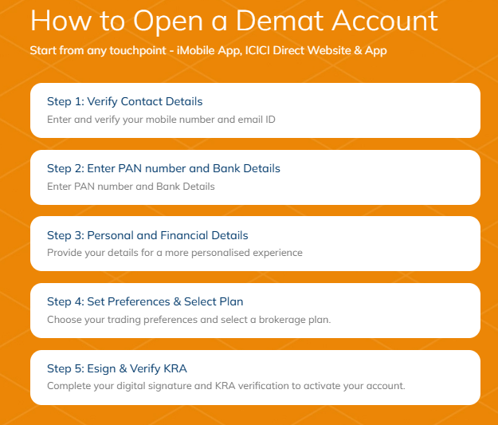


Open Signup Page
https://opendemat.icicidirect.com/

Fill up Mobile number and Click GET OTP.
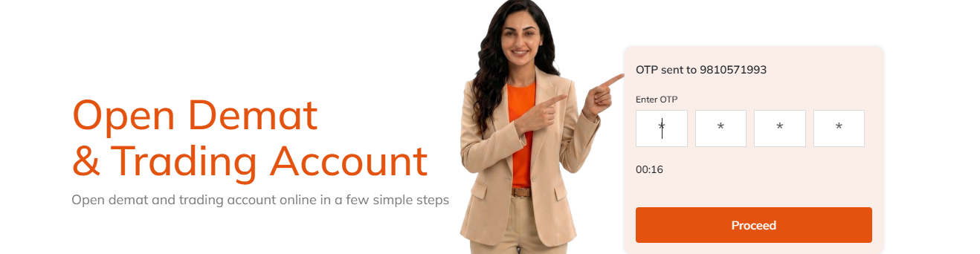
Enter OTP received on your Mobile and click Proceed.
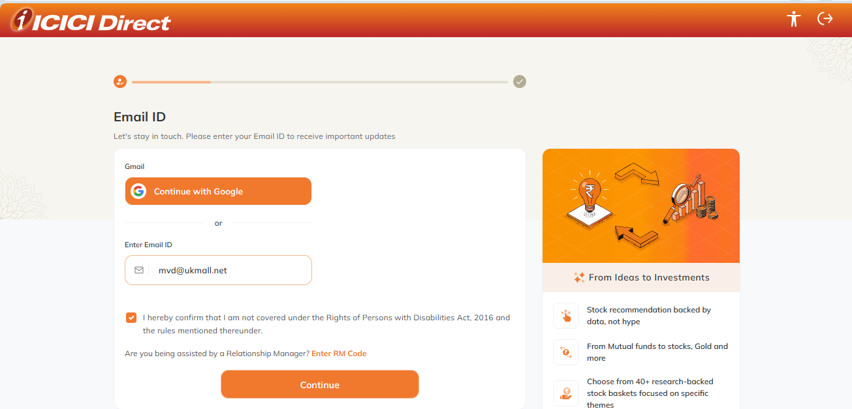
Enter Email address and click Continue.
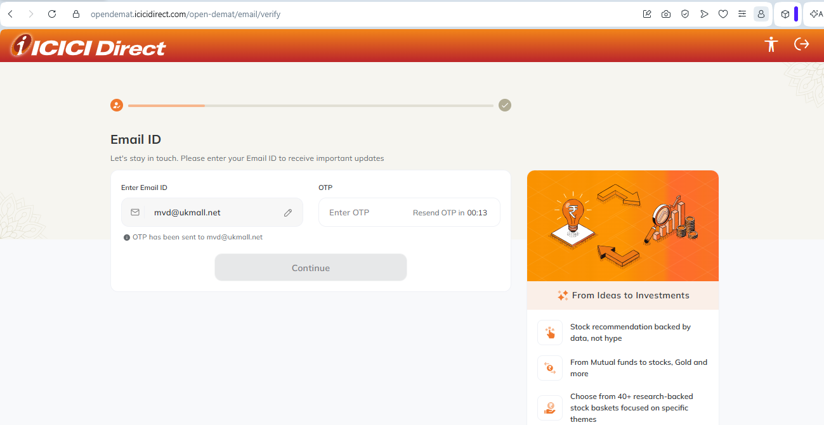
Enter OTP received in Email and Continue.
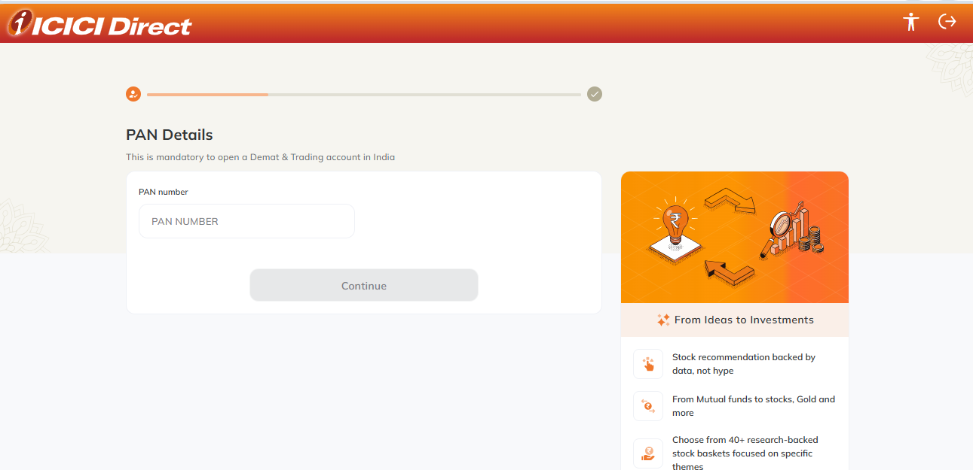
Enter PAN Number
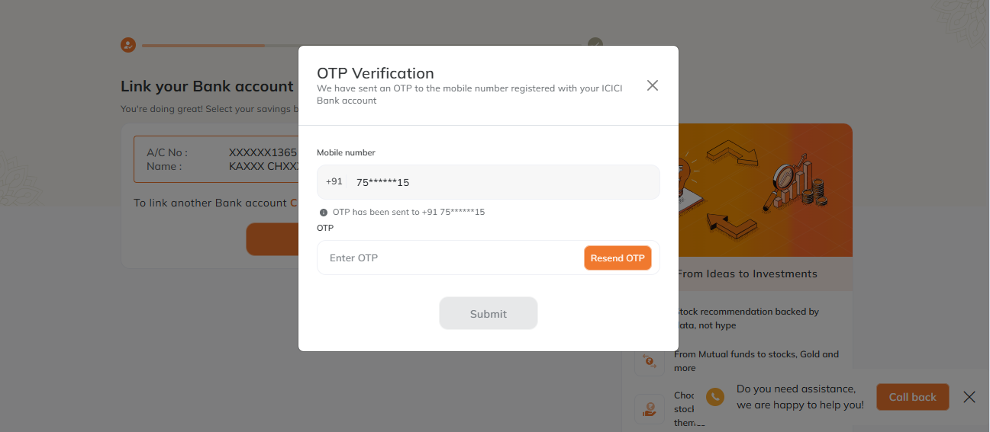
Enter OTP and press Submit.
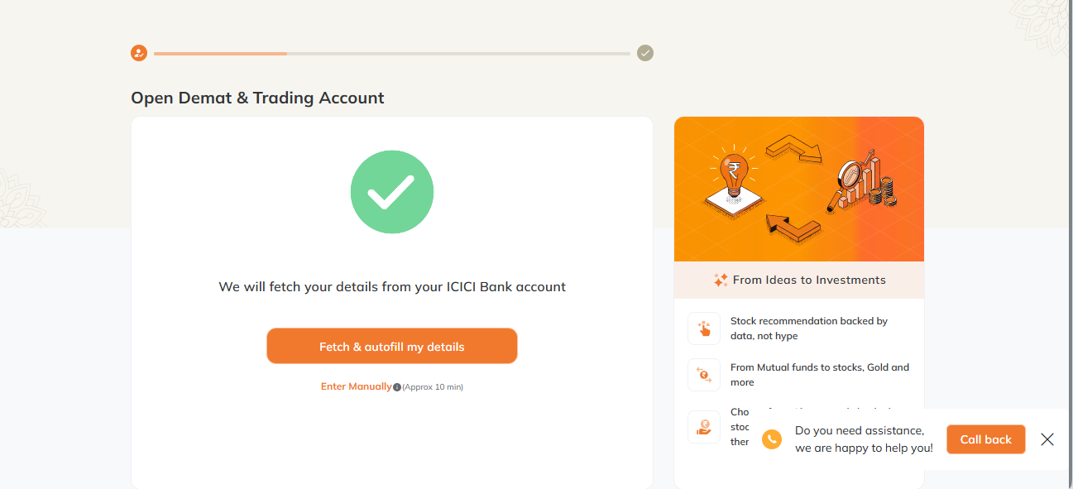
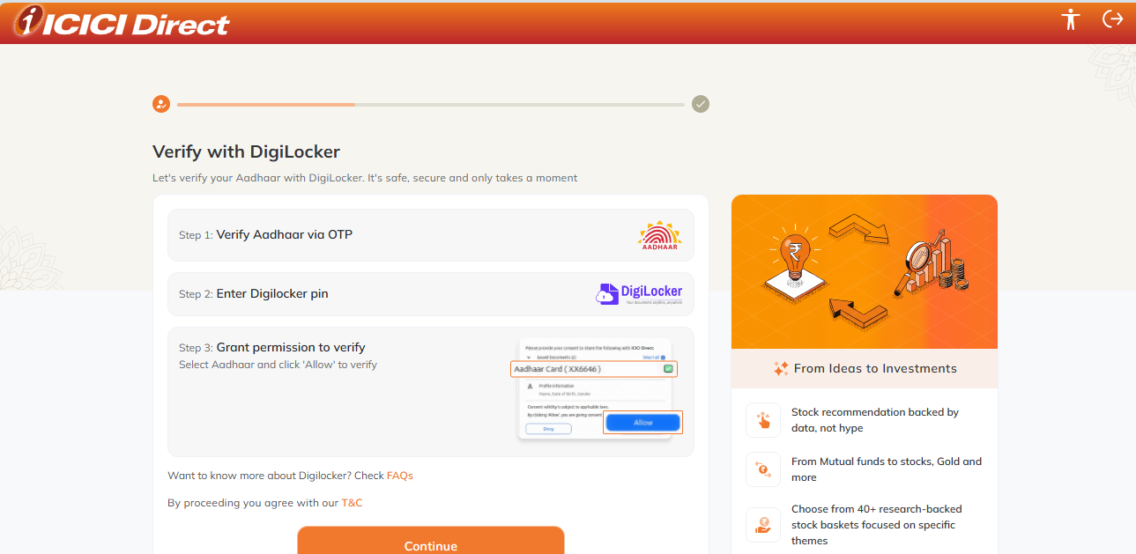

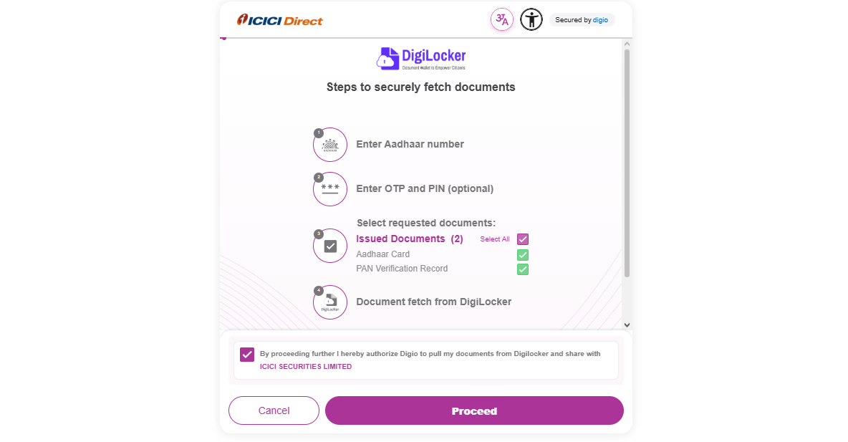
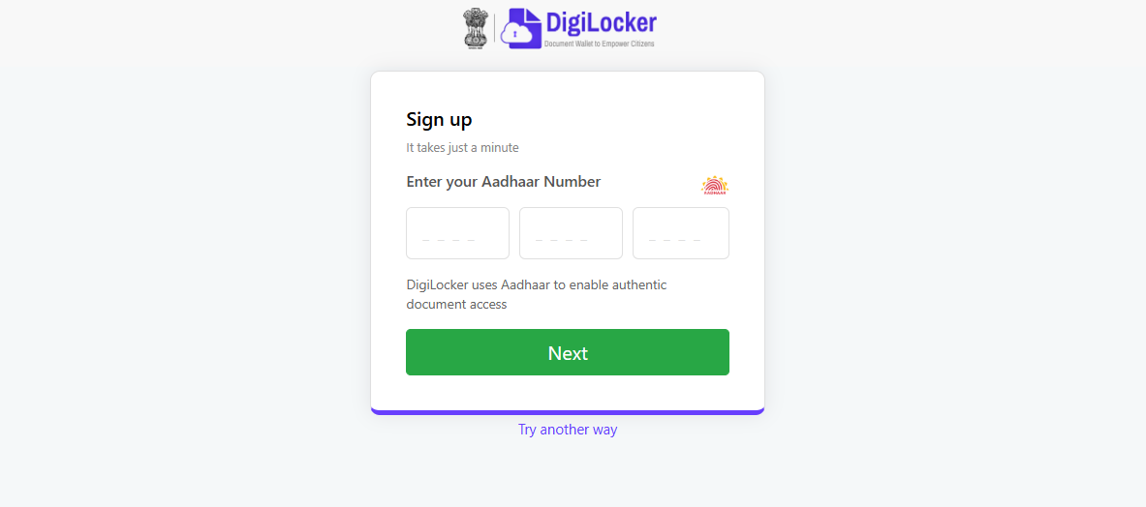
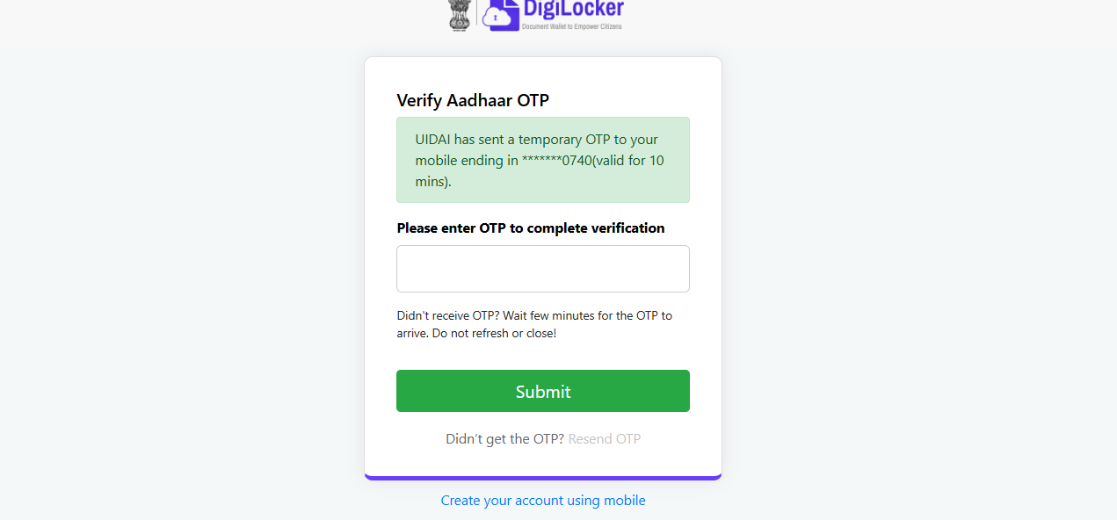
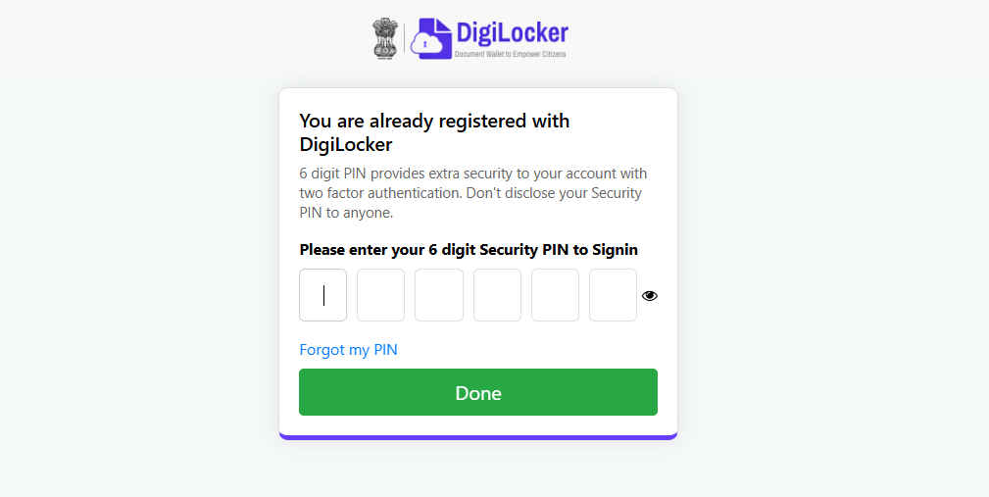
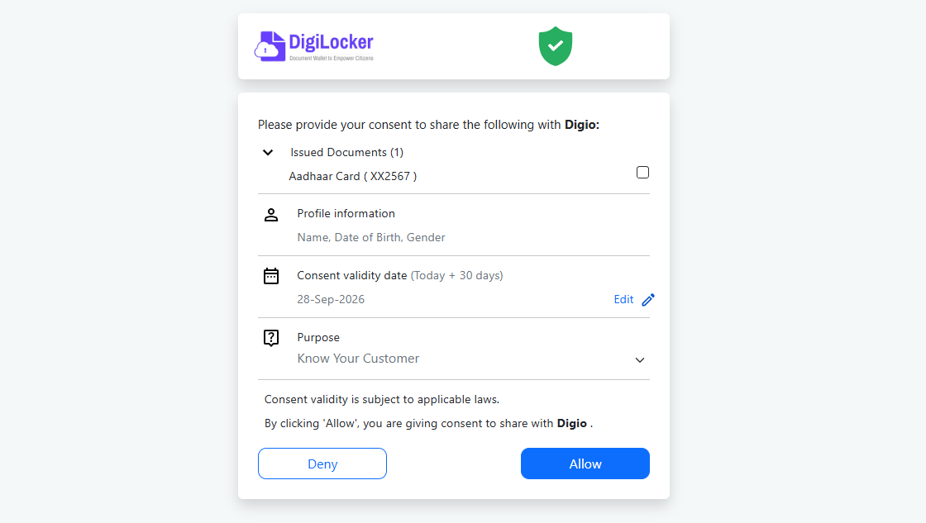
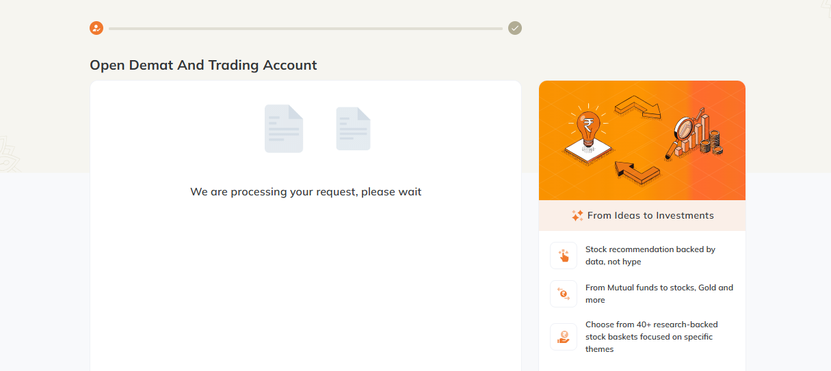
Now you have Opened DEMAT account and Trading Account.

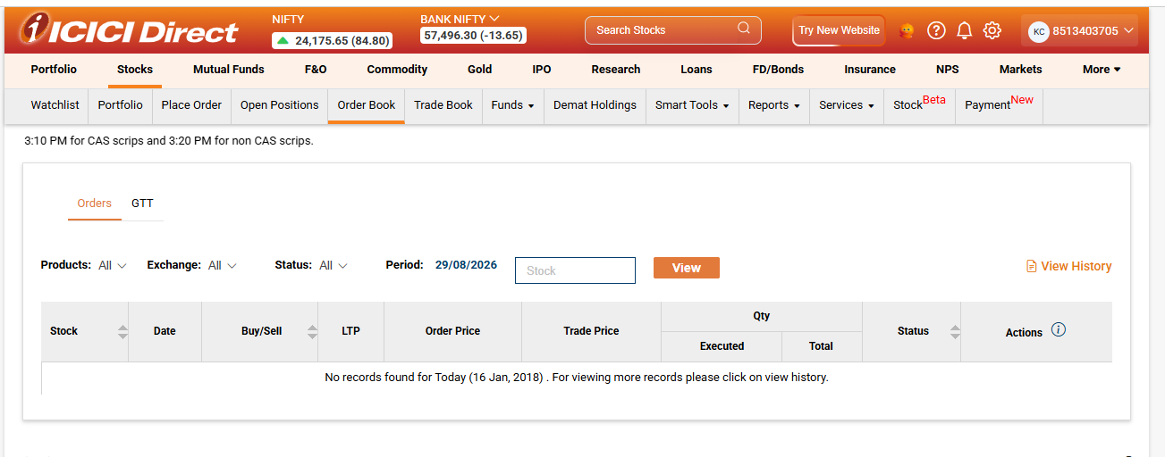
You are now on your Account Homepage.
Search Top Gaining Share Companies on Google and add those Companies on Watchlist (First Column under Stocks).
3M
ABBOTT
APOLLO HOSPITAL
AXISBANK
BAJAJ FINANCE
BOSCH
CG POWER CROGRE
ELCID INVESTMENT
ENTERO HEALTHCARE
GRASIM
HCC RE
HCLTECH
HDFC BANK
HINDALCO
HITACHI
HONEYWELL AUTOMATION
ICICI BANK
INFY
INOX INDIA
LARSEN & TOUBRO
MAXHEALTH
MRF
NMDC STEEL NSL NISP
PAGE INDUSTRIES
POWERGRID
RELIANCE INDUSTRIES
SBI
SHREE CEMENT
SOLAR INDUSTRIES
SUNPHARMA
TCS
TECHM
TITAN
TRENT
TMPV
WHIRLPOOL
WIPRO
YAMUNA SYNDICATE
Watchlist shows Current Price, Profit/Loss value, Profit/Loss %. You may sort Watchlist by Name, Price, or % Change.
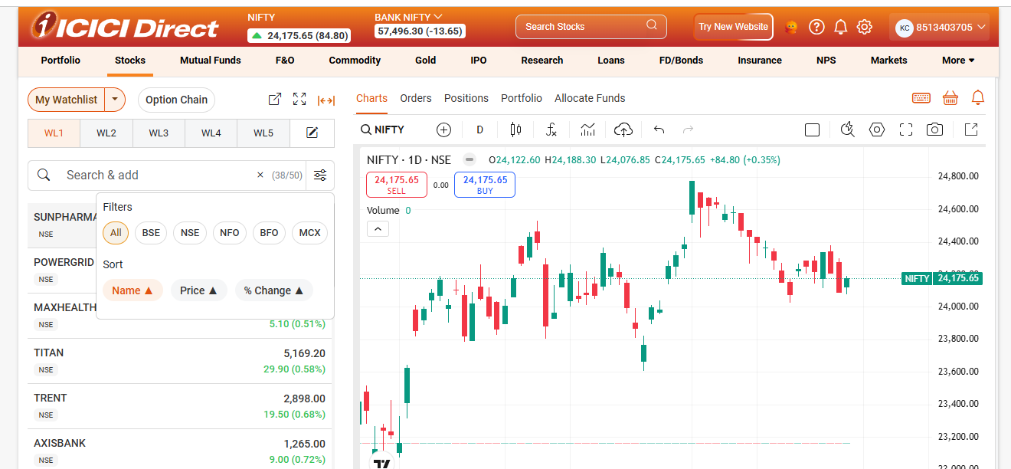
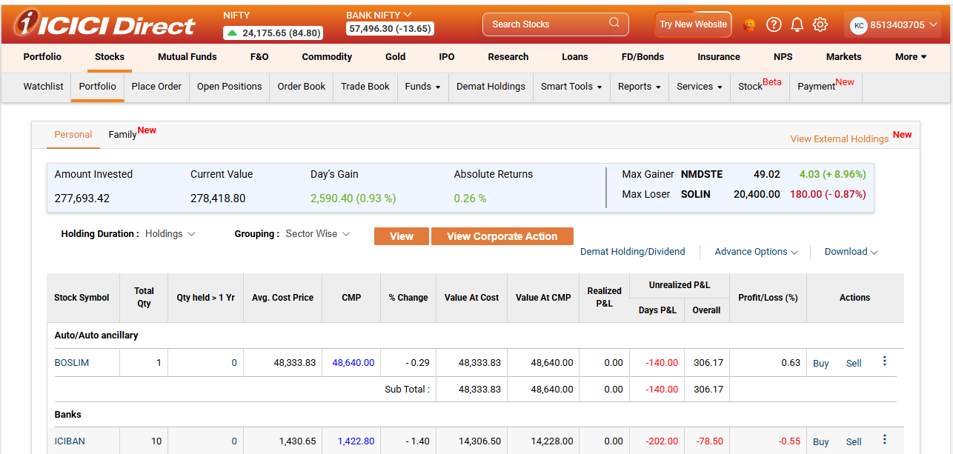
Next Column under Stocks is Portfolio. I Portfolio you find Statement of Stocks Held, their Cost Price and Current Price.
Chapter 2 : Stock Trading Basics
Asset Classes
An asset class is a group of investmentswhich :-
- exhibit similar characteristics
- are subject to the same laws and regulations.
List of Asset Classes
- Liquid assets
- Equities (stocks)
- Fixed Income (bonds)
- Cash and cash equivalents
- Alternative Asset Classes
- Real estate
- Commodities
- Futures
Asset Classes are not interrelated and facilitate diversity in portfolio.

Markets
Types of Markets
- Dealers
- Brokers
- Exchanges

Fixed Income Market

Online Savings Accounts
Certificates of Deposit
Corporate Bonds
Defined-Maturity Bond ETF
High-Yield Bond ETF
Municipal Bonds

Money Market
Money market is a componet of economy which deals with short term loans.
Money Market instruments are short term financial instruments which aim at increasing financial liquidity of businesses.
Stock Trading Tools and Indicators
- Sector analysis or Sectorial analysis. Statistical analysis of a sector of the economy covering :-
- Size
- Demographic
- Pricing
- Competitivedimensions
Sector analysis may be done by industry or by company.
- Seasonal trend analysis. Analysis of Seasonal Trend in Stock market.
- Contrarian indicators or Volatility indices. Measure of how pessimistic or optimistic the maket is.
- Price patterns. Price patterns are formationson on Stock charts with some predictive value.
- Double top and Double bottom
- Triple top and Triple bottom
- Head & shoulder top
- Inverse head and shoulder
- Rectangle
- Contracting triangle
- Ascending triangle
- Descending triangle
- Expanding broadening pattern
- Ascending broadening pattern
- Descending broadening pattern
- Flags and pennants
- Rising wedge
- Falling wedge
- Rounding bottom
- Rounding top

- Momentum indicators. Momentum indicators are tools utilized by traders to get a better understanding of the speed or rate at which the price of a stock changes.
- Volume studies. Study of Trading volume in Stock market.Trading volume is the total number of shares of a Stock that were traded over given period of time.
- Breadth indicators.Mathematical formulae to measure number and/or volume of advancing or declining stocks to calculate their participation in price movements of a Stock Index
- Moving average tools. Moving averageis a simple data analysis tool that simplifies price data by creating a constantly updated average price.
- Support and resistance. Support price represents low level stock price over a time. Resistance price represents high level stock price over a time.
Chapter 3 : Stock Market

Stock Exchanges in India
- Bombay Stock Exchange
- National Stock Exchange
- Calcutta Stock Exchange
- Metropolitan Stock Exchange
- India International Exchange
- NSE IFSC Ltd
Stock Broking Companies
5Paisa Capital Ltd
Aditya Birla Money Ltd
Alice Blue Fin Svcs Pvt Ltd
Anand Rathi Share and Stock Brokers Ltd
Angel Broking Ltd
Axis Securities Ltd
Edelweiss Broking Ltd
Geojit Financial Services Ltd
HDFC Securities Ltd
ICICI Securities Ltd
IDBI Capital Markets and Securities Ltd
IIFL Securities Ltd
Jainam Share Consultants Pvt Ltd
Karvy Stock Broking Ltd
Kotak Securities Ltd
Mansukh Securities and Finance Ltd : Plot No. 6, Patparganj Road, Pandav Nagar, Delhi 110092 T: 011-47617800 E: contact@moneysukh.com W: moneysukh.com
Marwadi Shares and Finance Ltd
Monark Networth Capital Ltd
Motilal Oswal Financial Services Ltd
Nextbillion Technology Pvt Ltd
Nirmal Bang Securities Ltd
Reliance Securities Ltd
Religare Broking Ltd
RKSV Securities India Pvt Ltd
Samco Securities Ltd
SBICAP Securities Ltd
Sharekhan Ltd
SMC Global Securities Global Ltd
Tradebulls Securities Pvt Ltd
Upstox Ltd
Ventura Securities Ltd
Zeroda Broking Ltd

Companies Dealing in US Stocks
ICICI Direct
HDFC Securities
Indmoney

Small Cap Stocks
Dilip Buildcon
Rallis India
Cyient
VIP Inds.
MRPL

Mid Cap Stocks
Aarti Inds
Supreme Industries
Aditya Birla Capital
Atul
Bata india

Large Cap Stocks
Reliance Industries
TCS
HDFC Bank
Hindustan Unilever
Infosys

Blue Chip Stocks (Self compiled)
Asian Paints Ltd
Axis Bank Ltd
Bajaj Auto Ltd
Bajaj Finance Ltd
Bajaj Finserv Ltd
Bharti Airtel Ltd
Cipla Ltd
Dr Reddy’s Laboratories Ltd
Eicher Motors Ltd
Grasim Industries Ltd
HCL Technologies Ltd
HDFC Bank Ltd
ICICI Bank Ltd
Infosys Ltd
IPCA Labs Ltd
JSW Steel Ltd
Kotak Mahindra Bank Ltd
Mahindra & Mahindra Ltd
Maruti Suzuki India Ltd
Reliance Industries Ltd
Tata Consultancy Services Ltd
Tata Steel Ltd
Tech Mahindra Ltd
Titan Company Ltd
Ultratech Cement Ltd
UPL Ltd
Wipro Ltd
Costliest Stocks in India
One year and Five year graphs of some socks are diaplayed. These are old graphs and not current. Share prices are approximate, indicative, old.
MRF Rs77,000
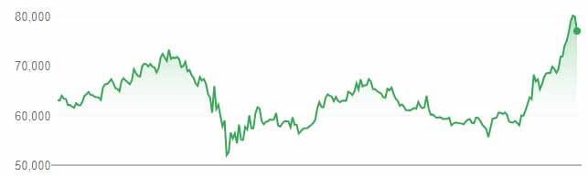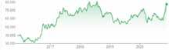
Honeywell Rs30,775
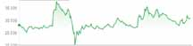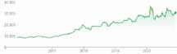
Shree Cement Rs23,800
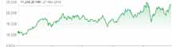
Page Industries Rs22,600
3M India Rs21,600
Nestle India Rs17,000
Abbott India Rs15,400
Bosch Rs12,800
Tasty Bite Rs11,400
Procter & Gamble Hygiene & Health Care (PGHH) Rs10,500
Dixon Technologies Rs11,800
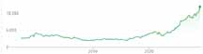
Bharat Rasayan Rs9,500
Yamuna Syndicate Rs8,600
Bajaj Finserv Rs8,700
Sanofi India Rs8,000
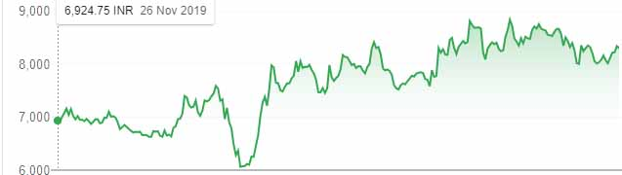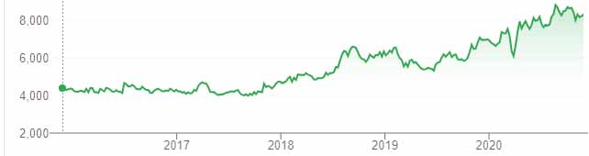
Maruti Suzuki Rs7,000
Atul Rs6,300
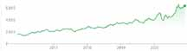
P&G Health Ltd (PGHL) 6,900
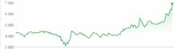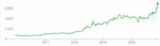
WABCO India Rs5,500
TTK Prestige Rs5,700

US Stocks – Penny Stocks for Beginners
3D Systems Corporation
Actuate Therapeutics, Inc. Common stock
ADC Therapeutics SA
AirSculpt Technologies, Inc.
Algoma Steel Group Inc.
All American Gold Corp.
Altimmune, Inc.
AMC Entertainment Holdings, Inc.
American Diversified Holdings Corporation
American EcoFuels Inc.
Artificial Intelligence Technology Solutions Inc.
ASP Isotopes Inc.
Baosheng Media Group Holdings Limited
Bell Buckle Holdings, Inc.
BioElectronics Corporation
Biomea Fusion, Inc.
BiomX Inc.
BLAQclouds, Inc.
Buyer Group International, Inc.
Byrna Technologies Inc.
CDT Environmental Technology Investment Holdings Limited
CleanCore Solutions, Inc.
CL Workshop Group Limited
Cypherpunk Technologies Inc.
Editas Medicine, Inc.
Eledon Pharmaceuticals, Inc.
Embarr Downs, Inc.
Eos Energy Enterprises, Inc.
Evercore Holdings, Inc.
EVgo, Inc.
Exxe Group Inc.
Faraday Future Intelligent Electric Inc.
Ferroglobe PLC
Fifty 1 Labs, Inc.
Generation Income Properties, Inc.
Genesis Holdings, Inc.
Geron Corporation
Gold and GemStone Mining Inc.
GoPro, Inc.
GRI Bio, Inc.
Heron Therapeutics, Inc.
Hypha Labs, Inc.
Ideal Group of Companies Inc.
Immuron Limited
indie Semiconductor, Inc.
Infrax Systems, Inc.
Innovative Payment Solutions, Inc.
Innoviz Technologies Ltd.
Inovio Pharmaceuticals, Inc.
Keel Infrastructure Corp.
Knightscope, Inc.
Lelantos Holdings, Inc.
LexinFintech Holdings Ltd.
Lianhe Sowell International Group Ltd
LiveWire Group, Inc.
Metavesco, Inc.
Mundus Group, Inc.
Nano-X Imaging Ltd.
NeuroSense Therapeutics Ltd.
NN, Inc.
NxGen Brands Inc.
OFA Group
Onconetix, Inc.
Optec International, Inc.
Pacific Biosciences of California, Inc.
Petco Health and Wellness Company, Inc.
Pineapple Express Cannabis Company
Planet Green Holdings Corp.
ProKidney Corp.
Pyxis Oncology, Inc.
Quantum Cyber N.V.
Recursion Pharmaceuticals, Inc.
Rekor Systems, Inc.
Rich Sparkle Holdings Limited
Rocket Pharmaceuticals, Inc.
Sabre Corporation
Sibannac, Inc.
Sixty Six Oilfield Services, Inc.
SKYX Platforms Corp.
Star8 Corporation
Streamex Corp.
SunHydrogen, Inc.
Tenax Therapeutics, Inc.
Torrid Holdings Inc.
Transglobal Management Group, Inc.
TScan Therapeutics, Inc.
Unique Global Innovative Solutions Corp
Veraxa Biotech AG
Veritone, Inc.
Viper Networks, Inc.
Vivos Therapeutics, Inc.
Volato Group, Inc.
Wave Life Sciences, Inc.
XCF Global, Inc.
XTI Aerospace, Inc.
YYForce Inc.
Zenta Group Company Limited

Chapter 4 : Trading Modes
- Intraday Trading
- Delivery Trading
- MTF (Margin Trading Facility Trading
- Options Trading
Options Trading is Out of Syllabus for me and my book

TRADE MY WAY
Divide the Investment amount in 3 approximately equal parts. From Watchlist sorted by %CHANGE, buy top 3 stocks in MTF Mode.
Keep only those stocks with keep gaining continuously.
If A Stock fails to gain during first 10 minutes, sell it.
Keep recording Peak Value. At any time Value drops by 1% Sell it.
At the day close you may be left with one or two stocks. You may even finish all three stocks much before day close.
You should remain trading ALL Trading hours. In case you need some hours break in Emergency, Sell all stocks before leaving for break.
You have Little chance of Little Loss only if All the five stocks deceive you.

Intraday Trading
You buy and sell Shares same day. At 3:30 PM every day all your money is with you.You are in Full Control of Investment Minute after Minute.
You may only 20% of the Cost as Margin money, rest is funded by Broking Company.
Most companies pay you sale proceeds next day at close. In ICICI Direct I often receive money mements after sale and I can buy more Shares immediately.

Delivery Trading
You buy Shares and keep with you for any number of days. Then you sell shares at their Current Price.

MTF Trading
MTF Trading is just like Delivery Trading but you don’t have to pay full price of shares. Margin Money 25% Share Cost is borne by you rest is funded by Broker Company. When you sell or Square Off the Shares, Company keeps own fund and pays you your Margin Money adjusted with Profit/Loss.

Options Trading
Options trading is a financial strategy where you buy or sell a contract that gives you the right, but not the obligation, to buy or sell an underlying asset at a set price within a specific timeframe.

Chapter 5 : Popular Stocks
Last Traded Price (LTP) below is only indicative. It may be too old for any practical reference.

Share | LTP
ACC | 1436
Aditya Birla ABFRL | 158
Ambuja Cement | 227
Asian Paint | 2160
Axis Bank | 604
Bajaj Auto | 3059
Bajaj Finance | 4717
Bajal Finserv | 8548
Bank of Baroda | 47
Bharti Airtel | 483
BHEL | 38
BPCL | 408
Cipla | 740
Coal India | 137
Coforge Limited | 1942
DLF | 158
Dr Reddy | 4677
Eicher Motors | 2583
GAIL | 100
Gillette | 5870
GMDC | 44
Grasim | 859
HCL Technology | 820
HDFC | 2334
HDFC AMC | 2419
HDFC Bank | 1405
Hero Motor | 2954
Hindalco | 195
Hindustan Unilever | 2117
Housing Development Finance Corpn | 2329
ICICI Bank | 477
IDFC | 28
IFCI | 115.90
Indiabulls | 174
Indusind Bank | 806
Infosys | 1104.45
Infy | 962
IPCA Labs | 2057
ITC | 199
JSW Steel | 335
Kotak Bank | 1882
LT | 902.55
Lupin | 982
Mahindra &Mahindra | 714
Maruti | 6959
Mc Dowell | 594
NMDC | 95
NTPC | 95
ONGC | 81
PNB | 34
Power Grid | 177
Reliance | 1901
SBIN | 239.50
Sun Pharma | 529
Tata Motors | 168
Tata Power | 57
Tata Steel | 531
TCS | 2657
TECHM | 838
Titan Company | 1362
Ultra Cement | 4862
UPL | 419
VEDL | 128
Wipro | 347

|
Adani Ports and Special Economic Zone Limited Analysis
Technical analysis forecast of Stock is that its in a uptrend for shortterm, and I will avoid taking a SHORT or SELL trade in this stock. Look for opportunities to BUY or go LONG in at this time. Stock is rising and might rise more.
Stock is getting in over sold or over bought zones very quickly. A short reversal can happen anytime.
Stock of () is trading above an important moving average line, and it has been above this line for quite some time now. This is a good sign, and the stock might keep rising and move higher!
My analysis of is bullish for shortterm, but trade for tomorrow is selective. Take a BUY trade only if stays above 341.5, but if it comes below 341.5, then a intra day sell could be more profitable. If you take a sell trade below 341.5, then use 341.5 as stoploss and 329.33 as target. However if you take a buy trade in , then use 341.5 as stoploss and 356 as target.
|
Andhra Bank Analysis
Technical analysis forecast for Stock is that its in a downtrend for shortterm, and I will avoid taking a BUY or a LONG trade in this stock. Look for opportunities to sell or SHORT at this time. Stock is falling and might fall more.
Stock is getting in over sold or over bought zones very quickly. A short reversal can happen anytime.
Stock of () is trading below an important moving average line, and it has been below this line for quite some time now. This is not a good sign, stock might keep falling and stock might move lower...
My analysis of is bearish for shortterm, but trade for tomorrow is selective. Take a sell trade only if stays below 9.7, but if it comes above 9.7, then a intra day buy could be more profitable.
If you take a sell trade below 9.7, then use 9.7 as stoploss and 7.2 as target. However if you take a buy trade in , then use 9.7 as stoploss and 11.86 as target.
|
Asian Paints Limited Analysis
Technical analysis forecast of Stock is that its in a uptrend for shortterm, and I will avoid taking a SHORT or SELL trade in this stock. Look for opportunities to BUY or go LONG in at this time. Stock is rising and might rise more.
Stock is getting in over sold or over bought zones very quickly. A short reversal can happen anytime.
Stock of () is trading above an important moving average line, and it has been above this line for quite some time now. This is a good sign, and the stock might keep rising and move higher!
My analysis of is bullish for shortterm, but trade for tomorrow is selective. Take a BUY trade only if stays above 1789.4, but if it comes below 1789.4, then a intra day sell could be more profitable. If you take a sell trade below 1789.4, then use 1789.4 as stoploss and 1753.16 as target. However if you take a buy trade in , then use 1789.4 as stoploss and 1832.8 as target.
|
Atul Auto Limited Analysis
Technical analysis forecast of Stock is that its in a uptrend for shortterm, and I will avoid taking a SHORT or SELL trade in this stock. Look for opportunities to BUY or go LONG in at this time. Stock is rising and might rise more.
Stock is getting in over sold or over bought zones very quickly. A short reversal can happen anytime.
Stock of () is trading above an important moving average line, and it has been above this line for quite some time now. This is a good sign, and the stock might keep rising and move higher!
My analysis of is bullish for shortterm, but trade for tomorrow is selective. Take a BUY trade only if stays above 183.8, but if it comes below 183.8, then a intra day sell could be more profitable. If you take a sell trade below 183.8, then use 183.8 as stoploss and 173.23 as target. However if you take a buy trade in , then use 183.8 as stoploss and 196.4 as target.
|
Atul Limited Analysis
Technical analysis forecast of Stock is that its in a uptrend for shortterm, and I will avoid taking a SHORT or SELL trade in this stock. Look for opportunities to BUY or go LONG in at this time. Stock is rising and might rise more.
Stock is getting in over sold or over bought zones very quickly. A short reversal can happen anytime.
Stock of () is trading above an important moving average line, and it has been above this line for quite some time now. This is a good sign, and the stock might keep rising and move higher!
Although my analysis for is bullish for shortterm, but stock is over bought and there are high chances of some profit booking tomorrow. You might want to sell the stock tomorrow in intra day with a stoploss of 5942.5, for a target of 5627.2 or 5364.34
|
Axis Bank Limited Analysis
Technical analysis forecast for Stock is that its in a downtrend for shortterm, and I will avoid taking a BUY or a LONG trade in this stock. Look for opportunities to sell or SHORT at this time. Stock is falling and might fall more.
Stock is slowly closing in and getting inside a small range. This happens when a stock is near a support or a resistance. Wait for a breakout or a breakdown depending on its trend.
Stock of () is trading below an important moving average line, but it crossed this line recently, which means that it could show a small or a large recovery soon enough depending on its trend.
My analysis of is bearish for shortterm, and stock might move down till 424.2 or till 408.4. Use a stoploss of 437.49 and if the stock hits stoploss, then it can shoot up till 450.73

Bajaj Auto Limited Analysis
Technical analysis forecast for Stock is that its in a downtrend for shortterm, and I will avoid taking a BUY or a LONG trade in this stock. Look for opportunities to sell or SHORT at this time. Stock is falling and might fall more.
Stock is slowly closing in and getting inside a small range. This happens when a stock is near a support or a resistance. Wait for a breakout or a breakdown depending on its trend.
Stock of () is trading below an important moving average line, but it crossed this line recently, which means that it could show a small or a large recovery soon enough depending on its trend.
My analysis of is bearish for shortterm, and stock might move down till 2946.9 or till 2896.8. Use a stoploss of 2988.73 and if the stock hits stoploss, then it can shoot up till 3030.51
|
Bajaj Finance Limited Analysis
Technical analysis forecast of Stock is that its in a uptrend for shortterm, and I will avoid taking a SHORT or SELL trade in this stock. Look for opportunities to BUY or go LONG in at this time. Stock is rising and might rise more.
Stock is getting in over sold or over bought zones very quickly. A short reversal can happen anytime.
Stock of () is trading above an important moving average line, and it has been above this line for quite some time now. This is a good sign, and the stock might keep rising and move higher!
My analysis of is bullish for shortterm, and stock might move up till 3393.9 or till 3506.4. Use a stoploss of 3300.16 and if this stock hits its stoploss, then it can fall down till 3206.4
|
Bajaj Finserv Limited Analysis
Technical analysis forecast for Stock is that its in a downtrend for shortterm, and I will avoid taking a BUY or a LONG trade in this stock. Look for opportunities to sell or SHORT at this time. Stock is falling and might fall more.
Stock is slowly closing in and getting inside a small range. This happens when a stock is near a support or a resistance. Wait for a breakout or a breakdown depending on its trend.
Stock of () is trading below an important moving average line, but it crossed this line recently, which means that it could show a small or a large recovery soon enough depending on its trend.
My analysis of is bearish for shortterm, and stock might move down till 6168.3 or till 6025. Use a stoploss of 6287.8 and if the stock hits stoploss, then it can shoot up till 6407.27
|
Bandhan Bank Limited Analysis
Technical analysis forecast for Stock is that its in a downtrend for shortterm, and I will avoid taking a BUY or a LONG trade in this stock. Look for opportunities to sell or SHORT at this time. Stock is falling and might fall more.
Stock is slowly closing in and getting inside a small range. This happens when a stock is near a support or a resistance. Wait for a breakout or a breakdown depending on its trend.
Stock of () is trading below an important moving average line, and it has been below this line for quite some time now. This is not a good sign, stock might keep falling and stock might move lower...
My analysis of is bearish for shortterm, but stock is semi over sold and there are some chances of seeing a recovery tomorrow. Use 285.9 as stoploss in an intra day buy trade for a target of 302.89. However, stock will show a bearish move below 285.9.
|
Bank of Baroda Analysis
Technical analysis forecast for Stock is that its in a downtrend for shortterm, and I will avoid taking a BUY or a LONG trade in this stock. Look for opportunities to sell or SHORT at this time. Stock is falling and might fall more.
Stock is slowly closing in and getting inside a small range. This happens when a stock is near a support or a resistance. Wait for a breakout or a breakdown depending on its trend.
Stock of () is trading below an important moving average line, but it crossed this line recently, which means that it could show a small or a large recovery soon enough depending on its trend.
My analysis of is bearish for shortterm, but trade for tomorrow is selective. Take a sell trade only if stays below 46.6, but if it comes above 46.6, then a intra day buy could be more profitable.
If you take a sell trade below 46.6, then use 46.6 as stoploss and 45.2 as target. However if you take a buy trade in , then use 46.6 as stoploss and 47.67 as target.
|
Bank of Maharashtra Analysis
Technical analysis forecast of Stock is that its in a uptrend for shortterm, and I will avoid taking a SHORT or SELL trade in this stock. Look for opportunities to BUY or go LONG in at this time. Stock is rising and might rise more.
Stock is getting in over sold or over bought zones very quickly. A short reversal can happen anytime.
Stock of () is trading above an important moving average line, and it has been above this line for quite some time now. This is a good sign, and the stock might keep rising and move higher!
Although my analysis for is bullish for shortterm, but stock is over bought and there are high chances of some profit booking tomorrow. You might want to sell the stock tomorrow in intra day with a stoploss of 14.4, for a target of 13.4 or 12.58
|
Bharat Dynamics Limited Analysis
Technical analysis forecast of Stock is that its in a uptrend for shortterm, and I will avoid taking a SHORT or SELL trade in this stock. Look for opportunities to BUY or go LONG in at this time. Stock is rising and might rise more.
It appears as if gave a large move recently.
Stock of () is trading above an important moving average line, and it has been above this line for quite some time now. This is a good sign, and the stock might keep rising and move higher!
My analysis of is bullish for shortterm, but stock is in semi over bought zones and there are some chances of seeing a fall tomorrow. Use 445.9 as stoploss in an intra day sell trade for a target of 423.32. However, stock will show a bullish move above 445.9.
|
Bharti Airtel Limited Analysis
Technical analysis forecast for Stock is that its in a downtrend for shortterm, and I will avoid taking a BUY or a LONG trade in this stock. Look for opportunities to sell or SHORT at this time. Stock is falling and might fall more.
It appears as if gave a large move recently.
Stock of () is trading below an important moving average line, and it has been below this line for quite some time now. This is not a good sign, stock might keep falling and stock might move lower...
Although my analysis for is bearish for shortterm, but stock is in heavy over sold zones and there are high chances of some recovery tomorrow. You might want to buy the stock tomorrow in intra day with a stoploss of 529.3, for a target of 542.6 or 553.73
|
Bharti Infratel Limited Analysis
Technical analysis forecast of Stock is that its in a uptrend for shortterm, and I will avoid taking a SHORT or SELL trade in this stock. Look for opportunities to BUY or go LONG in at this time. Stock is rising and might rise more.
Stock is slowly closing in and getting inside a small range. This happens when a stock is near a support or a resistance. Wait for a breakout or a breakdown depending on its trend.
Stock of () is trading above an important moving average line, but it crossed this line recently, which means that it could show a small or a large fall soon enough depending on its trend.
My analysis of is bullish for shortterm, and stock might move up till 201.7 or till 206.6. Use a stoploss of 197.7 and if this stock hits its stoploss, then it can fall down till 193.67
|
Bharat Petroleum Corporation Limited Analysis
Technical analysis forecast for Stock is that its in a downtrend for shortterm, and I will avoid taking a BUY or a LONG trade in this stock. Look for opportunities to sell or SHORT at this time. Stock is falling and might fall more.
Stock is slowly closing in and getting inside a small range. This happens when a stock is near a support or a resistance. Wait for a breakout or a breakdown depending on its trend.
Stock of () is trading below an important moving average line, but it crossed this line recently, which means that it could show a small or a large recovery soon enough depending on its trend.
My analysis of is bearish for shortterm, and stock might move down till 399.7 or till 376.3. Use a stoploss of 419.13 and if the stock hits stoploss, then it can shoot up till 438.58
|
Biocon Limited Analysis
Technical analysis forecast for Stock is that its in a downtrend for shortterm, and I will avoid taking a BUY or a LONG trade in this stock. Look for opportunities to sell or SHORT at this time. Stock is falling and might fall more.
Stock is slowly closing in and getting inside a small range. This happens when a stock is near a support or a resistance. Wait for a breakout or a breakdown depending on its trend.
Stock of () is trading below an important moving average line, and it has been below this line for quite some time now. This is not a good sign, stock might keep falling and stock might move lower...
My analysis of is bearish for shortterm, but trade for tomorrow is selective. Take a sell trade only if stays below 390.9, but if it comes above 390.9, then a intra day buy could be more profitable.
If you take a sell trade below 390.9, then use 390.9 as stoploss and 381.3 as target. However if you take a buy trade in , then use 390.9 as stoploss and 398.89 as target.
|
Britannia Industries Limited Analysis
Technical analysis forecast for Stock is that its in a downtrend for shortterm, and I will avoid taking a BUY or a LONG trade in this stock. Look for opportunities to sell or SHORT at this time. Stock is falling and might fall more.
Stock is slowly closing in and getting inside a small range. This happens when a stock is near a support or a resistance. Wait for a breakout or a breakdown depending on its trend.
Stock of () is trading below an important moving average line, but it crossed this line recently, which means that it could show a small or a large recovery soon enough depending on its trend.
My analysis of is bearish for shortterm, and stock might move down till 3754.4 or till 3686. Use a stoploss of 3811.35 and if the stock hits stoploss, then it can shoot up till 3868.34
|
Canara Bank Analysis
Technical analysis forecast for Stock is that its in a downtrend for shortterm, and I will avoid taking a BUY or a LONG trade in this stock. Look for opportunities to sell or SHORT at this time. Stock is falling and might fall more.
Stock is slowly closing in and getting inside a small range. This happens when a stock is near a support or a resistance. Wait for a breakout or a breakdown depending on its trend.
Stock of () is trading below an important moving average line, but it crossed this line recently, which means that it could show a small or a large recovery soon enough depending on its trend.
My analysis of is bearish for shortterm, but stock is semi over sold and there are some chances of seeing a recovery tomorrow. Use 100.9 as stoploss in an intra day buy trade for a target of 102.12. However, stock will show a bearish move below 100.9.
|
Cipla Limited Analysis
Technical analysis forecast of Stock is that its in a uptrend for shortterm, and I will avoid taking a SHORT or SELL trade in this stock. Look for opportunities to BUY or go LONG in at this time. Stock is rising and might rise more.
Stock is getting in over sold or over bought zones very quickly. A short reversal can happen anytime.
Stock of () is trading above an important moving average line, and it has been above this line for quite some time now. This is a good sign, and the stock might keep rising and move higher!
My analysis of is bullish for shortterm, but trade for tomorrow is selective. Take a BUY trade only if stays above 765, but if it comes below 765, then a intra day sell could be more profitable. If you take a sell trade below 765, then use 765 as stoploss and 721.29 as target. However if you take a buy trade in , then use 765 as stoploss and 817.5 as target.
|

City Union Bank Limited Analysis
Technical analysis forecast of Stock is that its in a uptrend for shortterm, and I will avoid taking a SHORT or SELL trade in this stock. Look for opportunities to BUY or go LONG in at this time. Stock is rising and might rise more.
Stock is slowly closing in and getting inside a small range. This happens when a stock is near a support or a resistance. Wait for a breakout or a breakdown depending on its trend.
Stock of () is trading above an important moving average line, but it crossed this line recently, which means that it could show a small or a large fall soon enough depending on its trend.
My analysis of is bullish for shortterm, and stock might move up till 124.1 or till 127.8. Use a stoploss of 121.1 and if this stock hits its stoploss, then it can fall down till 118.05
|
CORE Education & Technologies Limited Analysis
Technical analysis forecast for Stock is that its in a downtrend for shortterm, and I will avoid taking a BUY or a LONG trade in this stock. Look for opportunities to sell or SHORT at this time. Stock is falling and might fall more.
It appears as if gave a large move recently.
Stock of () is trading below an important moving average line, and it has been below this line for quite some time now. This is not a good sign, stock might keep falling and stock might move lower...
My analysis of is bearish for shortterm, but stock is semi over sold and there are some chances of seeing a recovery tomorrow. Use 1.7 as stoploss in an intra day buy trade for a target of 2.15. However, stock will show a bearish move below 1.7.
|

CSB Bank Limited Analysis
Technical analysis forecast of Stock is that its in a uptrend for shortterm, and I will avoid taking a SHORT or SELL trade in this stock. Look for opportunities to BUY or go LONG in at this time. Stock is rising and might rise more.
Stock is slowly closing in and getting inside a small range. This happens when a stock is near a support or a resistance. Wait for a breakout or a breakdown depending on its trend.
Stock of () is trading above an important moving average line, and it has been above this line for quite some time now. This is a good sign, and the stock might keep rising and move higher!
My analysis of is bullish for shortterm, and stock might move up till 195.6 or till 201.6. Use a stoploss of 190.49 and if this stock hits its stoploss, then it can fall down till 185.43
|
DCB BANK LIMITED Analysis
Technical analysis forecast of Stock is that its in a uptrend for shortterm, and I will avoid taking a SHORT or SELL trade in this stock. Look for opportunities to BUY or go LONG in at this time. Stock is rising and might rise more.
It appears as if gave a large move recently.
Stock of () is trading below an important moving average line, but it crossed this line recently, which means that it could show a small or a large recovery soon enough depending on its trend.
|
Dena Bank Analysis
Technical analysis forecast of Stock is that its in a uptrend for shortterm, and I will avoid taking a SHORT or SELL trade in this stock. Look for opportunities to BUY or go LONG in at this time. Stock is rising and might rise more.
It appears as if gave a large move recently.
Stock of () is trading above an important moving average line, but it crossed this line recently, which means that it could show a small or a large fall soon enough depending on its trend.
My analysis of is bullish for shortterm, but trade for tomorrow is selective. Take a BUY trade only if stays above 12.3, but if it comes below 12.3, then a intra day sell could be more profitable. If you take a sell trade below 12.3, then use 12.3 as stoploss and 11.77 as target. However if you take a buy trade in , then use 12.3 as stoploss and 13 as target.
|
Dhanlaxmi Bank Limited Analysis
Technical analysis forecast for Stock is that its in a downtrend for shortterm, and I will avoid taking a BUY or a LONG trade in this stock. Look for opportunities to sell or SHORT at this time. Stock is falling and might fall more.
It appears as if gave a large move recently.
Stock of () is trading below an important moving average line, but it crossed this line recently, which means that it could show a small or a large recovery soon enough depending on its trend.
My analysis of is bearish for shortterm, and stock might move down till 12.3 or till 11.9. Use a stoploss of 12.69 and if the stock hits stoploss, then it can shoot up till 13.05
|
Dr. Reddy's Laboratories Limited Analysis
Technical analysis forecast of Stock is that its in a uptrend for shortterm, and I will avoid taking a SHORT or SELL trade in this stock. Look for opportunities to BUY or go LONG in at this time. Stock is rising and might rise more.
It appears as if gave a large move recently.
Stock of () is trading above an important moving average line, and it has been above this line for quite some time now. This is a good sign, and the stock might keep rising and move higher!
My analysis of is bullish for shortterm, and stock might move up till 4650.7 or till 4939.9. Use a stoploss of 4409.72 and if this stock hits its stoploss, then it can fall down till 4168.74
|
Eicher Motors Limited Analysis
Technical analysis forecast for Stock is that its in a downtrend for shortterm, and I will avoid taking a BUY or a LONG trade in this stock. Look for opportunities to sell or SHORT at this time. Stock is falling and might fall more.
Stock is slowly closing in and getting inside a small range. This happens when a stock is near a support or a resistance. Wait for a breakout or a breakdown depending on its trend.
Stock of () is trading below an important moving average line, but it crossed this line recently, which means that it could show a small or a large recovery soon enough depending on its trend.
My analysis of is bearish for shortterm, but stock is semi over sold and there are some chances of seeing a recovery tomorrow. Use 20102.5 as stoploss in an intra day buy trade for a target of 20834.92. However, stock will show a bearish move below 20102.5.
|
Everonn Education Limited Analysis
Technical analysis forecast for Stock is that its in a downtrend for shortterm, and I will avoid taking a BUY or a LONG trade in this stock. Look for opportunities to sell or SHORT at this time. Stock is falling and might fall more.
Stock is getting in over sold or over bought zones very quickly. A short reversal can happen anytime.
Stock of () is trading below an important moving average line, and it has been below this line for quite some time now. This is not a good sign, stock might keep falling and stock might move lower...
My analysis of is bearish for shortterm, but trade for tomorrow is selective. Take a sell trade only if stays below 12.8, but if it comes above 12.8, then a intra day buy could be more profitable.
If you take a sell trade below 12.8, then use 12.8 as stoploss and 9.4 as target. However if you take a buy trade in , then use 12.8 as stoploss and 15.66 as target.
|
Global Education Limited Analysis
Technical analysis forecast for Stock is that its in a downtrend for shortterm, and I will avoid taking a BUY or a LONG trade in this stock. Look for opportunities to sell or SHORT at this time. Stock is falling and might fall more.
It appears as if gave a large move recently.
Stock of () is trading below an important moving average line, and it has been below this line for quite some time now. This is not a good sign, stock might keep falling and stock might move lower...
Although my analysis for is bearish for shortterm, but stock is in heavy over sold zones and there are high chances of some recovery tomorrow. You might want to buy the stock tomorrow in intra day with a stoploss of 139.4, for a target of 157 or 171.74
|
Gujarat Mineral Development Corporation Limited Analysis
Technical analysis forecast of Stock is that its in a uptrend for shortterm, and I will avoid taking a SHORT or SELL trade in this stock. Look for opportunities to BUY or go LONG in at this time. Stock is rising and might rise more.
Stock is getting in over sold or over bought zones very quickly. A short reversal can happen anytime.
Stock of () is trading above an important moving average line, and it has been above this line for quite some time now. This is a good sign, and the stock might keep rising and move higher!
Although my analysis for is bullish for shortterm, but stock is over bought and there are high chances of some profit booking tomorrow. You might want to sell the stock tomorrow in intra day with a stoploss of 43.9, for a target of 42.8 or 41.84

HDFC Bank Limited Analysis
Technical analysis forecast for Stock is that its in a downtrend for shortterm, and I will avoid taking a BUY or a LONG trade in this stock. Look for opportunities to sell or SHORT at this time. Stock is falling and might fall more.
Stock is getting in over sold or over bought zones very quickly. A short reversal can happen anytime.
Stock of () is trading below an important moving average line, but it crossed this line recently, which means that it could show a small or a large recovery soon enough depending on its trend.
My analysis of is bearish for shortterm, but stock is semi over sold and there are some chances of seeing a recovery tomorrow. Use 1018.5 as stoploss in an intra day buy trade for a target of 1057.69. However, stock will show a bearish move below 1018.5.
|
HDFC Standard Life Insurance Co Ltd Analysis
Technical analysis forecast for Stock is that its in a downtrend for shortterm, and I will avoid taking a BUY or a LONG trade in this stock. Look for opportunities to sell or SHORT at this time. Stock is falling and might fall more.
It appears as if gave a large move recently.
Stock of () is trading below an important moving average line, but it crossed this line recently, which means that it could show a small or a large recovery soon enough depending on its trend.
My analysis of is bearish for shortterm, but trade for tomorrow is selective. Take a sell trade only if stays below 591.3, but if it comes above 591.3, then a intra day buy could be more profitable.
If you take a sell trade below 591.3, then use 591.3 as stoploss and 574.7 as target. However if you take a buy trade in , then use 591.3 as stoploss and 605.04 as target.
|

Housing Development Finance Corporation Limited Analysis
Technical analysis forecast for Stock is that its in a downtrend for shortterm, and I will avoid taking a BUY or a LONG trade in this stock. Look for opportunities to sell or SHORT at this time. Stock is falling and might fall more.
Stock is slowly closing in and getting inside a small range. This happens when a stock is near a support or a resistance. Wait for a breakout or a breakdown depending on its trend.
Stock of () is trading below an important moving average line, but it crossed this line recently, which means that it could show a small or a large recovery soon enough depending on its trend.
My analysis of is bearish for shortterm, and stock might move down till 1766.9 or till 1714.8. Use a stoploss of 1810.4 and if the stock hits stoploss, then it can shoot up till 1853.85
|

ICICI Bank Limited Analysis
Technical analysis forecast of Stock is that its in a uptrend for shortterm, and I will avoid taking a SHORT or SELL trade in this stock. Look for opportunities to BUY or go LONG in at this time. Stock is rising and might rise more.
Stock is slowly closing in and getting inside a small range. This happens when a stock is near a support or a resistance. Wait for a breakout or a breakdown depending on its trend.
Stock of () is trading above an important moving average line, and it has been above this line for quite some time now. This is a good sign, and the stock might keep rising and move higher!
My analysis of is bullish for shortterm, and stock might move up till 373.2 or till 388.8. Use a stoploss of 360.15 and if this stock hits its stoploss, then it can fall down till 347.12
|
IndusInd Bank Limited Analysis
Technical analysis forecast of Stock is that its in a uptrend for shortterm, and I will avoid taking a SHORT or SELL trade in this stock. Look for opportunities to BUY or go LONG in at this time. Stock is rising and might rise more.
It appears as if gave a large move recently.
Stock of () is trading above an important moving average line, but it crossed this line recently, which means that it could show a small or a large fall soon enough depending on its trend.
My analysis of is bullish for shortterm, but trade for tomorrow is selective. Take a BUY trade only if stays above 531.3, but if it comes below 531.3, then a intra day sell could be more profitable. If you take a sell trade below 531.3, then use 531.3 as stoploss and 517.41 as target. However if you take a buy trade in , then use 531.3 as stoploss and 548.1 as target.
|
Karur Vysya Bank Limited Analysis
Technical analysis forecast of Stock is that its in a uptrend for shortterm, and I will avoid taking a SHORT or SELL trade in this stock. Look for opportunities to BUY or go LONG in at this time. Stock is rising and might rise more.
Stock is slowly closing in and getting inside a small range. This happens when a stock is near a support or a resistance. Wait for a breakout or a breakdown depending on its trend.
Stock of () is trading above an important moving average line, and it has been above this line for quite some time now. This is a good sign, and the stock might keep rising and move higher!
Although my analysis for is bullish for shortterm, but stock is over bought and there are high chances of some profit booking tomorrow. You might want to sell the stock tomorrow in intra day with a stoploss of 39.1, for a target of 37 or 35.19
|
Kotak Mahindra Bank Limited Analysis
Technical analysis forecast of Stock is that its in a uptrend for shortterm, and I will avoid taking a SHORT or SELL trade in this stock. Look for opportunities to BUY or go LONG in at this time. Stock is rising and might rise more.
It appears as if gave a large move recently.
Stock of () is trading above an important moving average line, but it crossed this line recently, which means that it could show a small or a large fall soon enough depending on its trend.
Although my analysis for is bullish for shortterm, but stock is over bought and there are high chances of some profit booking tomorrow. You might want to sell the stock tomorrow in intra day with a stoploss of 1409.7, for a target of 1378.6 or 1352.72
|
Navneet Education Limited Analysis
Technical analysis forecast of Stock is that its in a uptrend for shortterm, and I will avoid taking a SHORT or SELL trade in this stock. Look for opportunities to BUY or go LONG in at this time. Stock is rising and might rise more.
Stock is getting in over sold or over bought zones very quickly. A short reversal can happen anytime.
Stock of () is trading above an important moving average line, and it has been above this line for quite some time now. This is a good sign, and the stock might keep rising and move higher!
My analysis of is bullish for shortterm, but stock is in semi over bought zones and there are some chances of seeing a fall tomorrow. Use 77.7 as stoploss in an intra day sell trade for a target of 75.96. However, stock will show a bullish move above 77.7.
|
Nifty Bank Analysis
Technical analysis forecast of Stock is that its in a uptrend for shortterm, and I will avoid taking a SHORT or SELL trade in this stock. Look for opportunities to BUY or go LONG in at this time. Stock is rising and might rise more.
It appears as if gave a large move recently.
Stock of () is trading below an important moving average line, but it crossed this line recently, which means that it could show a small or a large recovery soon enough depending on its trend.
|
Oriental Bank of Commerce Analysis
Technical analysis forecast of Stock is that its in a uptrend for shortterm, and I will avoid taking a SHORT or SELL trade in this stock. Look for opportunities to BUY or go LONG in at this time. Stock is rising and might rise more.
Stock is slowly closing in and getting inside a small range. This happens when a stock is near a support or a resistance. Wait for a breakout or a breakdown depending on its trend.
Stock of () is trading above an important moving average line, but it crossed this line recently, which means that it could show a small or a large fall soon enough depending on its trend.
My analysis of is bullish for shortterm, and stock might move up till 45.9 or till 50.3. Use a stoploss of 42.2 and if this stock hits its stoploss, then it can fall down till 38.51
|
Punjab National Bank Analysis
Technical analysis forecast for Stock is that its in a downtrend for shortterm, and I will avoid taking a BUY or a LONG trade in this stock. Look for opportunities to sell or SHORT at this time. Stock is falling and might fall more.
Stock is slowly closing in and getting inside a small range. This happens when a stock is near a support or a resistance. Wait for a breakout or a breakdown depending on its trend.
Stock of () is trading below an important moving average line, but it crossed this line recently, which means that it could show a small or a large recovery soon enough depending on its trend.
My analysis of is bearish for shortterm, but stock is semi over sold and there are some chances of seeing a recovery tomorrow. Use 32.2 as stoploss in an intra day buy trade for a target of 33.12. However, stock will show a bearish move below 32.2
|
RBL Bank Analysis
Technical analysis forecast of Stock is that its in a uptrend for shortterm, and I will avoid taking a SHORT or SELL trade in this stock. Look for opportunities to BUY or go LONG in at this time. Stock is rising and might rise more.
Stock is getting in over sold or over bought zones very quickly. A short reversal can happen anytime.
Stock of () is trading above an important moving average line, and it has been above this line for quite some time now. This is a good sign, and the stock might keep rising and move higher!
My analysis of is bullish for shortterm, but stock is in semi over bought zones and there are some chances of seeing a fall tomorrow. Use 189.1 as stoploss in an intra day sell trade for a target of 181.64. However, stock will show a bullish move above 189.1.
|

State Bank of India Analysis
Technical analysis forecast of Stock is that its in a uptrend for shortterm, and I will avoid taking a SHORT or SELL trade in this stock. Look for opportunities to BUY or go LONG in at this time. Stock is rising and might rise more.
Stock is getting in over sold or over bought zones very quickly. A short reversal can happen anytime.
Stock of () is trading above an important moving average line, and it has been above this line for quite some time now. This is a good sign, and the stock might keep rising and move higher!
My analysis of is bullish for shortterm, but stock is in semi over bought zones and there are some chances of seeing a fall tomorrow. Use 197.5 as stoploss in an intra day sell trade for a target of 193.37. However, stock will show a bullish move above 197.5
||
Sun Pharmaceuticals Industries Limited Analysis
Technical analysis forecast of Stock is that its in a uptrend for shortterm, and I will avoid taking a SHORT or SELL trade in this stock. Look for opportunities to BUY or go LONG in at this time. Stock is rising and might rise more.
Stock is slowly closing in and getting inside a small range. This happens when a stock is near a support or a resistance. Wait for a breakout or a breakdown depending on its trend.
Stock of () is trading above an important moving average line, and it has been above this line for quite some time now. This is a good sign, and the stock might keep rising and move higher!
My analysis of is bullish for shortterm, and stock might move up till 529.6 or till 538.2. Use a stoploss of 522.33 and if this stock hits its stoploss, then it can fall down till 515.1
|
Sun Pharma Advanced Research Company Limited Analysis
Technical analysis forecast of Stock is that its in a uptrend for shortterm, and I will avoid taking a SHORT or SELL trade in this stock. Look for opportunities to BUY or go LONG in at this time. Stock is rising and might rise more.
Stock is slowly closing in and getting inside a small range. This happens when a stock is near a support or a resistance. Wait for a breakout or a breakdown depending on its trend.
Stock of () is trading above an important moving average line, and it has been above this line for quite some time now. This is a good sign, and the stock might keep rising and move higher!
My analysis of is bullish for shortterm, and stock might move up till 183.2 or till 187.5. Use a stoploss of 179.59 and if this stock hits its stoploss, then it can fall down till 176.01
|
The Federal Bank Limited Analysis
Technical analysis forecast of Stock is that its in a uptrend for shortterm, and I will avoid taking a SHORT or SELL trade in this stock. Look for opportunities to BUY or go LONG in at this time. Stock is rising and might rise more.
Stock is slowly closing in and getting inside a small range. This happens when a stock is near a support or a resistance. Wait for a breakout or a breakdown depending on its trend.
Stock of () is trading above an important moving average line, and it has been above this line for quite some time now. This is a good sign, and the stock might keep rising and move higher!
My analysis of is bullish for shortterm, but trade for tomorrow is selective. Take a BUY trade only if stays above 55.8, but if it comes below 55.8, then a intra day sell could be more profitable. If you take a sell trade below 55.8, then use 55.8 as stoploss and 54.49 as target. However if you take a buy trade in , then use 55.8 as stoploss and 57.4 as target.
|
The Karnataka Bank Limited Analysis
Technical analysis forecast of Stock is that its in a uptrend for shortterm, and I will avoid taking a SHORT or SELL trade in this stock. Look for opportunities to BUY or go LONG in at this time. Stock is rising and might rise more.
Stock is getting in over sold or over bought zones very quickly. A short reversal can happen anytime.
Stock of () is trading above an important moving average line, and it has been above this line for quite some time now. This is a good sign, and the stock might keep rising and move higher!
Although my analysis for is bullish for shortterm, but stock is over bought and there are high chances of some profit booking tomorrow. You might want to sell the stock tomorrow in intra day with a stoploss of 49, for a target of 46.5 or 44.43
|
Tree House Education & Accessories Limited Analysis
Technical analysis forecast of Stock is that its in a uptrend for shortterm, and I will avoid taking a SHORT or SELL trade in this stock. Look for opportunities to BUY or go LONG in at this time. Stock is rising and might rise more.
Stock is getting in over sold or over bought zones very quickly. A short reversal can happen anytime.
Stock of () is trading above an important moving average line, and it has been above this line for quite some time now. This is a good sign, and the stock might keep rising and move higher!
Although my analysis for is bullish for shortterm, but stock is over bought and there are high chances of some profit booking tomorrow. You might want to sell the stock tomorrow in intra day with a stoploss of 9, for a target of 7.7 or 6.56
|
Ujjivan Small Finance Bank Analysis
Technical analysis forecast for Stock is that its in a downtrend for shortterm, and I will avoid taking a BUY or a LONG trade in this stock. Look for opportunities to sell or SHORT at this time. Stock is falling and might fall more.
Stock is slowly closing in and getting inside a small range. This happens when a stock is near a support or a resistance. Wait for a breakout or a breakdown depending on its trend.
Stock of () is trading below an important moving average line, but it crossed this line recently, which means that it could show a small or a large recovery soon enough depending on its trend.
My analysis of is bearish for shortterm, and stock might move down till 33.6 or till 32.4. Use a stoploss of 34.63 and if the stock hits stoploss, then it can shoot up till 35.64
|
Usha Martin Education & Solutions Limited Analysis
Technical analysis forecast of Stock is that its in a uptrend for shortterm, and I will avoid taking a SHORT or SELL trade in this stock. Look for opportunities to BUY or go LONG in at this time. Stock is rising and might rise more.
Stock is getting in over sold or over bought zones very quickly. A short reversal can happen anytime.
Stock of () is trading above an important moving average line, and it has been above this line for quite some time now. This is a good sign, and the stock might keep rising and move higher!
Although my analysis for is bullish for shortterm, but stock is over bought and there are high chances of some profit booking tomorrow. You might want to sell the stock tomorrow in intra day with a stoploss of 1.4, for a target of 1.2 or 1.05
|

Chapter 6 : Depository Services
- Depository services are services in which the securities of investors are kept in a digital form just as bank keeps all cash in its account and provides all services related to cash transaction cash. Depository Services dematerialize Shares, Mutual Funds and Commodities in electronic form.

Depository Services provide services to :-
- Exchanges
- Clearing Corporations
- Depository Participants (DPs)
- Issuers
- Investors
Poular Depository Services are :-
- National Securities Depository Ltd (NSDL)
- Central Depository Services Ltd (CDSL)
Mansukh Securities provide own Depository Services

Chapter 7 : Mutual Funds
Funds are invested by Mutual Fund Companies on behalf of Investors. Returns are divided amongs investors on bases of amount invested.
Types
- Equity or growth funds
Funds are invested in shares of many companies. Investment is subject to risks involved in Share investing. Professional mangement and diversity of invested companies minimize risk involved.
- Tata Digital India Fund
- ICICI Prudential Technology Fund
- Aditya Birla Sun Life Digital India Fund
- SBI Technology Opportunities Fund
- Franklin India Technology Fund

- Fixed income funds
Funds are invested in :-
- Government securities or bonds
- Commercial papers and debentures
- Bank certificates of deposits
- Money market instruments.
Fixed income funds are safe but less remunerative than Equity funds
- Hybrid funds
Funds are invested in both Equity and Fix income. Hybrid funds balance remunerations againt safety.
Popular Mutual Funds
Aditya Birla Sunlife Mutual Fund
Axis Mutual Fund
Baroda Pioneer Mutual Fund
BNP Paribas Mutual Fund
BOI Axa Mutual Fund
Canara Robeco Mutual Fund
DHFL Pramerica Mutual Fund
DSP Blackrock Mutual Fund
Edelweiss Mutual Fund
Escorts Mutual Fund
Essel Mutual Fund
Franklin Templeton Mutual Fund
HDFC Mutual Fund
HSBC Mutual Fund
ICICI Prudential Mutual Fund
IDBI Mutual Fund
IDFC Mutual Fund
IIFL Mutual Fund
Indiabulls Mutual Fund
Invesco Mutual Fund
JM Financial Mutual Fund
Kotak Mutual Fund
L and T Mutual Fund
LIC Mutual Fund
Mahindra Mutual Fund
Mirae Asset Mutual Fund
Motilal Oswal Mutual Fund
PPFAS Mutual Fund
Principal Mutual Fund
Qauntum Mutual Fund
Reliance Mutual Fund
SBI Mutual Fund
Sundaram Mutual Fund
TATA Mutual Fund
Taurus Mutual Fund
Union Mutual Fund
UTI Mutual Fund

Chapter 8 : Personal Finance
Saving Schemes
Fixed Deposit (FD)
Unit Linked Insurance Plan (ULIP)
Equity Linked Saving Scheme (ELSS)
Sukanya Samridhi Yojana (SSY)
National Pension Scheme (NPS)
Pradhan Mantri Vaya Vandana Yojana (PMVVY)
Senior Citizens Saving Scheme (SCSS)
Government Saving Schemes
- Public Provident Fund
- National Savings Certificate
- Post Office Savings Account
- Post Office Time Deposit
- Post Office Recurring Deposit
- Post Office Monthly Income Scheme (POMIS)
- Kisan Vikas Patra

Chapter 9 : Real Estate
Types

- Builder Projects
- Commercial Buildings
- Commercial Plots
- Residential Builings
- Residential Plots

Paperback and Kindle Links at ukmall.net

Medical Mnemonics – MBBS ALL by Dr K Chaudhry
Medical Mnemonics – MBBS III by Dr K Chaudhry
Medical Mnemonics – MBBS II by Dr K Chaudhry
Medical Mnemonics – MBBS I by Dr K Chaudhry
BUSY Made Easy by Dr K Chaudhry
Astrology Made Easy by Dr K Chaudhry
Publish On Amazon Free by Dr K Chaudhry
ITI : Fitter Mnemonics by Dr K Chaudhry
Free Localhost : Make Your Computer A php Machine by Dr K Chaudhry
Publish On Createspace Free by Dr K Chaudhry
Anatomy Mnemonics by Dr K Chaudhry
Physiology Mnemonics by Dr K Chaudhry
Biochemistry Mnemonics by Dr K Chaudhry
Pathology Mnemonics by Dr K Chaudhry
Pharmacology Mnemonics by Dr K Chaudhry
Forensic medicine Mnemonics by Dr K Chaudhry
Medicine Mnemonics by Dr K Chaudhry
Surgery Mnemonics by Dr K Chaudhry
Obstetrics & Gynaecology Mnemonics by Dr K Chaudhry
Ophthalmology Mnemonics by Dr K Chaudhry
Medicine Made Easy by Dr K Chaudhry
Patho Micro Made Easy by Dr K Chaudhry
Medical Laboratory Techniques by Dr K Chaudhry
MCQuestions in Paraclinical Sciences by Dr K Chaudhry
Mere Geet, Meri Awaaz, Meri Sanvednaayen by Dr K Chaudhry
Astrology Made Easy by Dr K Chaudhry
Affiliate Marketing Tips & Scripts by Dr K Chaudhry
________________________________________
Dr K Chaudhry
MBBS (AMU 1970)
5 Alpha International City, Fatehabad Haryana 125050
M: 9810570740, 9810571993
ukmall.net facebook.com/doctorkc

